Gold Loan Management Demonstration

1. Displaying the gold loan schemes present for choice.

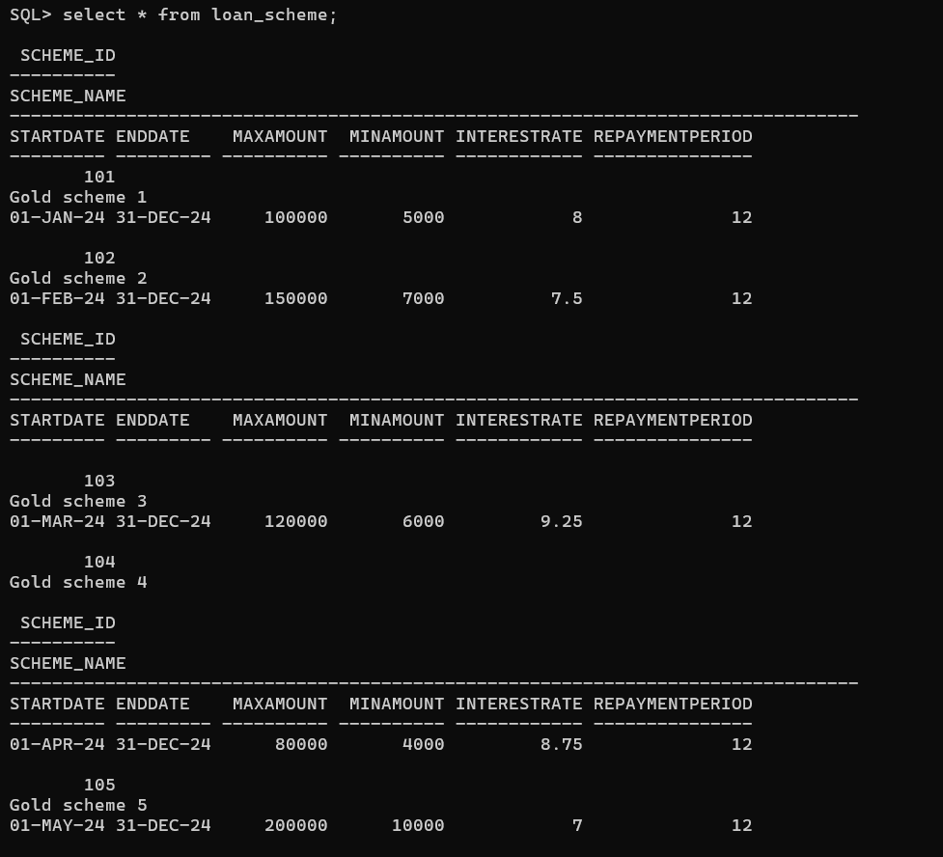

From the given options we are going to be using scheme 102 which has a 7.5 percent interest rate and a repayment period of 12 months.

1. Entering all the details of the customer in the respective tables:

Inserting Entry to the customer table:

SQL> Insert into Customer values(2,'Arjun','Bade','Male',TO_DA

TE('1991-06-12','YYYY-MM-DD'),'Active');

SQL> select * from customer;

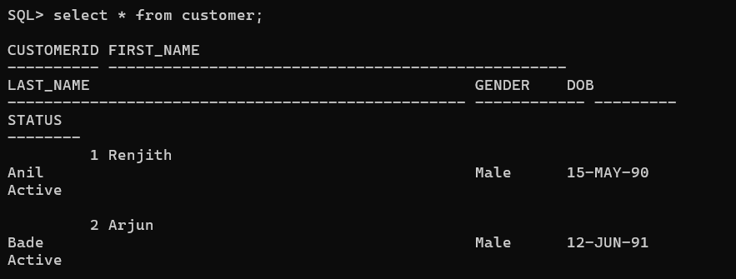

Inserting Values into Phone_Number Table:

INSERT INTO Phone_number (CustomerId,PhoneID,Phone_Number) VALUES (2, 3, 3112435375);

INSERT INTO Phone_number (CustomerId,PhoneID,Phone_Number) VALUES (2, 4, 1235426533);

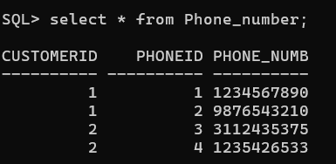

Inserting Values into Email Table:

INSERT INTO Email (CustomerID, EmailID, Email)

VALUES (2, 3, 'arjun@gmail.com');

INSERT INTO Email (CustomerID, EmailID, Email)

VALUES (2, 4, 'bade@gmail.com');

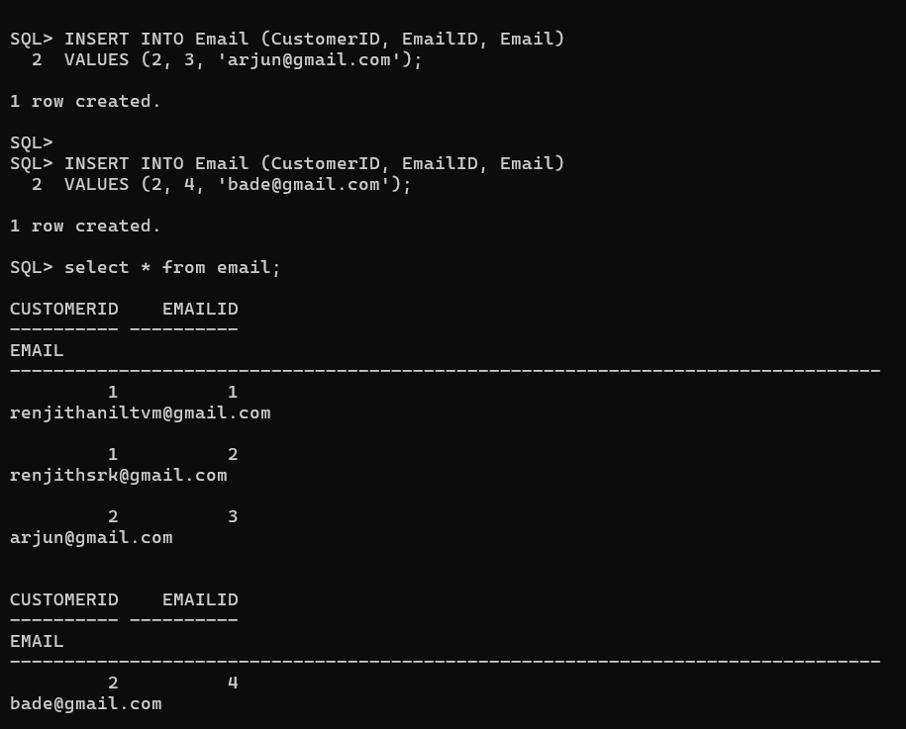

Inserting KYC Docs:

INSERT INTO KYC_Docs (CustomerID, DOC_ID, DOC_NUMBER, ExpiryDate, TypeID, Status)

VALUES (2, 3, 123466, TO_DATE('2025-12-31', 'YYYY-MM-DD'), 'Aadhar', 'Verified');

INSERT INTO KYC_Docs (CustomerID, DOC_ID, DOC_NUMBER, ExpiryDate, TypeID, Status)

VALUES (2, 4, 987214, TO_DATE('2024-10-15', 'YYYY-MM-DD'), 'Pan Card', 'Verified');

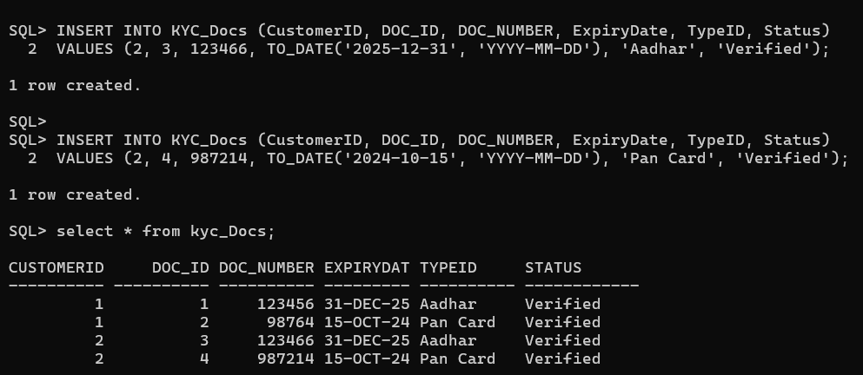

Inserting into Customer_Address:

INSERT INTO Customer_Address (CustomerID, AddressID, Address, AddressType, Country, State, City, Pincode)

VALUES (2, 3, '123 Main Street', 'Permanent', 'India', 'Bangalore', 'Indhira Nagar', '695027');

INSERT INTO Customer_Address (CustomerID, AddressID, Address, AddressType, Country, State, City, Pincode)

VALUES (2, 4, '456 Main Street', 'Temporary', 'India', 'Kerala', 'Jayanagar', '692329');

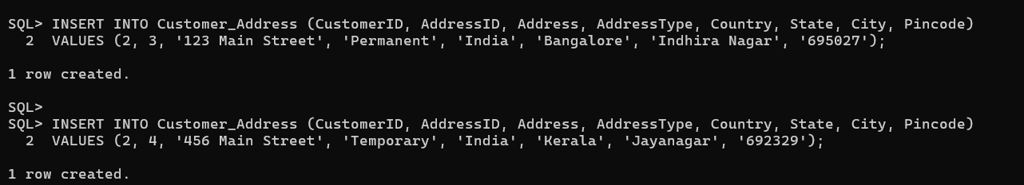

1. Creating a Loan Application:

INSERT INTO Loan_Application (ApplicationID, CustomerID, SchemeID, ApplicationDate, LoanAmount, Profession, Salary, Bank_card_number, Status)

VALUES (2, 2, 102, TO_DATE('2024-04-25', 'YYYY-MM-DD'), 60000.00, 'Doctor', 70000.00, '1234567890533211', 'Pending');

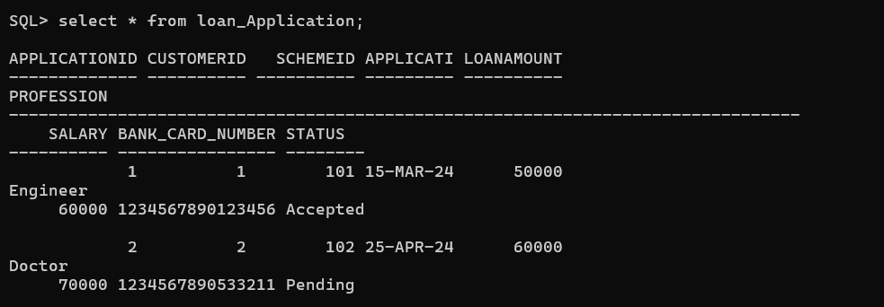

1. Inserting Data into gold ornament table and calculating the price of each ornament.

INSERT INTO Gold_Ornament (ApplicationID, OrnamID, Ornam_Type, Gross_Weight, Net_Weight, Purity, RatePerGram, Price, Remark) VALUES (2, 3, 'Crown', 20.00, 19.50, 22, 5000, NULL, 'good condition');

INSERT INTO Gold_Ornament (ApplicationID, OrnamID, Ornam_Type, Gross_Weight, Net_Weight, Purity, RatePerGram, Price, Remark) VALUES (2, 4, 'Bangle', 30.00, 28.50, 24, 4200, NULL, 'slightly bent');

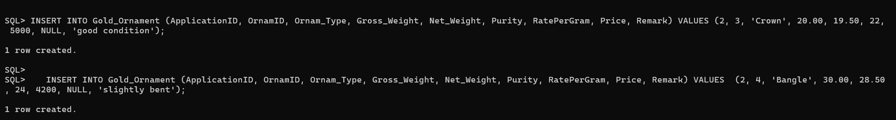

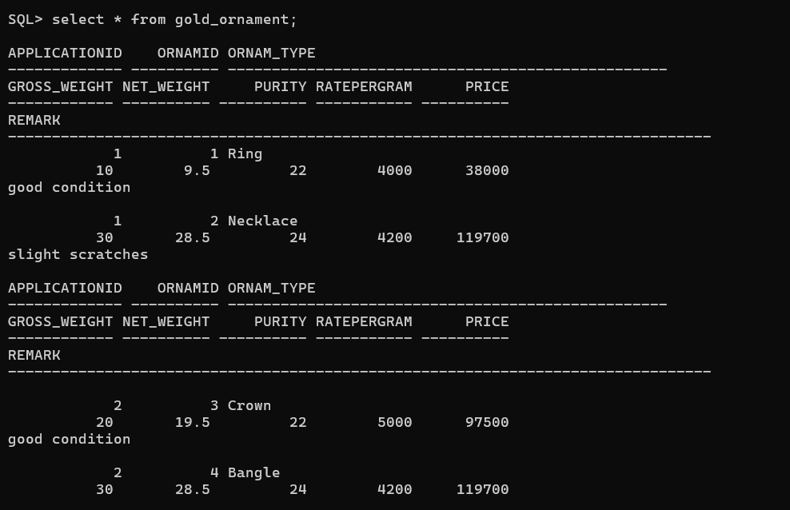

Here the price of each ornament was calculated by a trigger that activates when an entry is entered into the gold ornament table.

Updating the Loan application to Accepted for further entry creation:

SQL> UPDATE Loan_Application SET Status = 'Accepted' WHERE ApplicationID = 2;

1. Gold Loan table:

Since the loan application status is not accepted for the applicationID ‘2’ an entry is created under gold loan table like this:

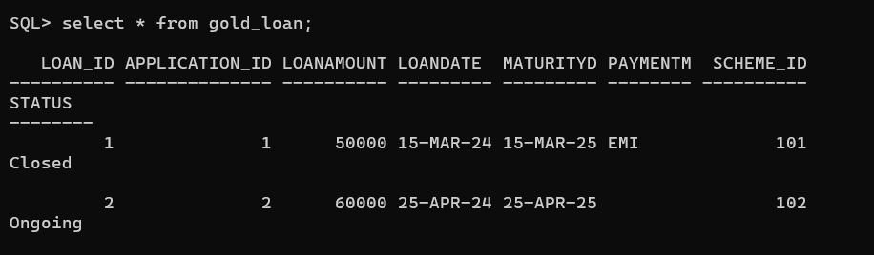

Setting the payment mode to ‘EMI’ to represent how the loan schedule is going to be created.

UPDATE Gold_Loan

SET PaymentMode = 'EMI'

WHERE Loan_ID = 2;

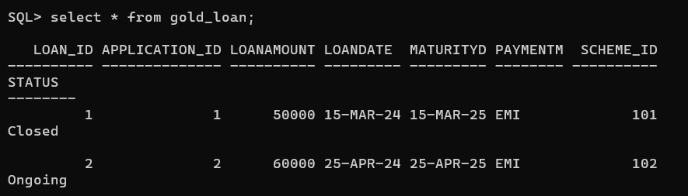

1. Loan Disbursal table:

INSERT INTO Loan_Disbursal (Disbursal_ID, LoanID, AmountPaid, PaymentDate, PaymentTypeID, Transaction_ID, Status) VALUES (2, 2, 60000.00, TO_DATE('2024-04-25', 'YYYY-MM-DD'), 'Cash', 123556, 'Paid');

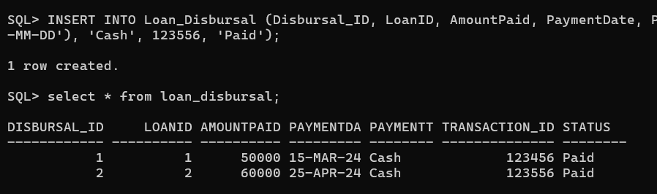

1. Loan Schedule:

Now since the loan amount has been paid to the person a schedule is created for the particular loan. Since the payment mode is EMI 12 entries(repayment period in this case is 12 months) are created under loan id 2.

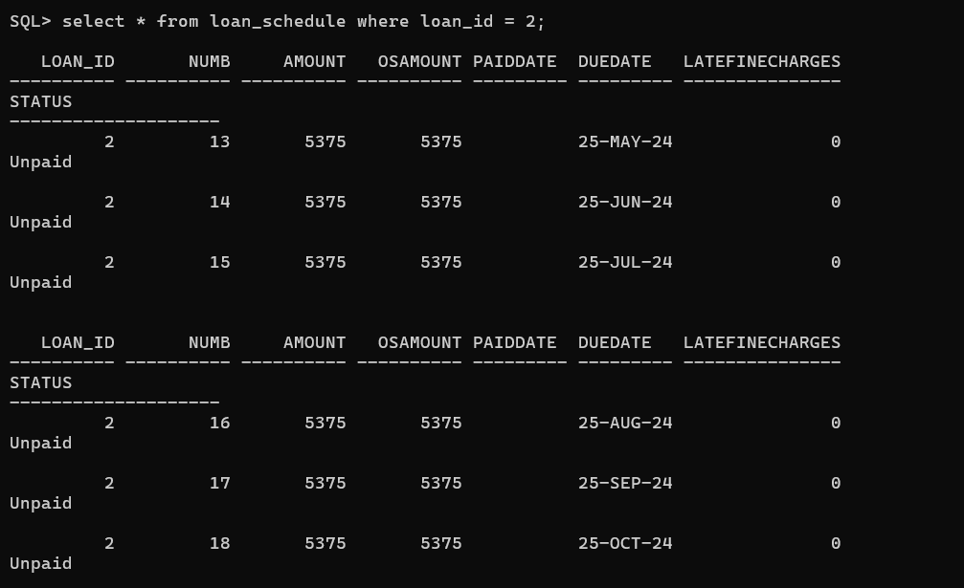

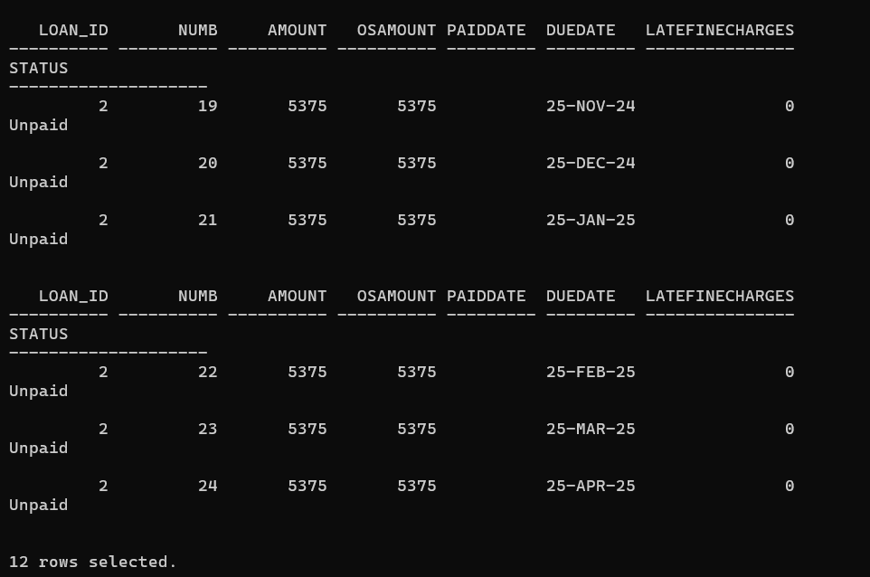

1. Loan Repayment table:

INSERT INTO Loan_Repayment (RepaymentID, LoanID, Num, AmountRepaid, PaymentDate, PaymentType, Transaction_ID) VALUES (14, 2, 13, 5375, TO_DATE('2024-05-16', 'YYYY-MM-DD'), 'Online', 221122);



INSERT INTO Loan_Repayment (RepaymentID, LoanID, Num, AmountRepaid, PaymentDate, PaymentType, Transaction_ID) VALUES (15, 2, 14, 5375, TO_DATE('2024-06-16', 'YYYY-MM-DD'), 'Online', 221123);



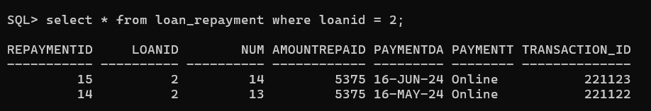

Select * from loan_schedule where loan_id = 2;

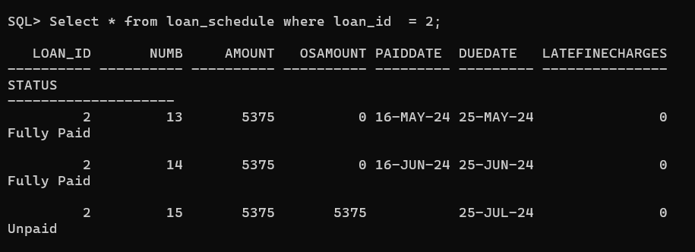

If the person pays after the due date a late fine charge of 75 is added to the osamount which the user will have to pay extra.

INSERT INTO Loan_Repayment (RepaymentID, LoanID, Num, AmountRepaid, PaymentDate, PaymentType, Transaction_ID) VALUES (18, 2, 17, 5375, TO_DATE('2024-10-26', 'YYYY-MM-DD'), 'Online', 122127);



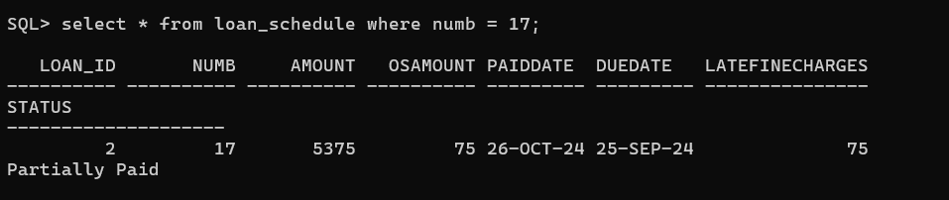

Now paying the late fine charges:

INSERT INTO Loan_Repayment (RepaymentID, LoanID, Num, AmountRepaid, PaymentDate, PaymentType, Transaction_ID) VALUES (19, 2, 17, 75, TO_DATE('2024-10-26', 'YYYY-MM-DD'), 'Online', 122128);

