LOVELY PROFESSIONAL UNIVERSITY
PHAGWARA, PUNJAB
INT-331


SUBMITTED BY
Name of student: Shubham Kumar
Section :- KO026
Roll:- 04
Registration Number: 12318062
SUBMITTED TO: - Dr. Varsha

GitHub link :- https://github.com/Shubham-kumar2507/AI-Assistant

Table of Contents
- 1. Project Overview
- 2. Technology Stack
- 3. Project Architecture
- 4. Key Features
- 5. Project Structure
- 6. Source Code Explanation
- 6.1 Main Application Class
- 6.2 Controller Layer
- 6.3 Service Layer
- 6.4 Model Classes
- 6.5 Frontend (HTML/CSS/JavaScript)
- 7. Docker Containerization
- 8. Application Screenshots
- 9. Setup and Installation
- 10. Testing the Application
- 11. Conclusion

1. Project Overview
This project is a modern, full-stack web-based chatbot application built using Spring Boot framework. It demonstrates the integration of a backend REST API with Google's Gemini Pro AI model to create an intelligent conversational assistant.
The application showcases several important software development concepts:
- RESTful API design and implementation
- Integration with third-party APIs (Google Gemini)
- Layered architecture (Controller → Service → Model)
- Responsive web interface with modern UI/UX
- Docker containerization for easy deployment
- Maven-based project management
- Hardcoded fallback responses for offline testing

2. Technology Stack

Backend Technologies
- Java 17 - Programming language
- Spring Boot 3.2.0 - Application framework
- Spring Web - RESTful web services
- Spring WebFlux - Reactive HTTP client for API calls
- Thymeleaf - Server-side template engine
- Maven - Build automation and dependency management

Frontend Technologies
- HTML5 - Structure and markup
- CSS3 - Styling with modern design patterns
- JavaScript (ES6+) - Client-side interactivity
- Font Awesome - Icon library
- Google Fonts (Outfit) – Typography

DevOps & Deployment
- Docker - Containerization
- Docker Compose - Multi-container orchestration
- Multi-stage Docker builds - Optimized image size
- Health checks - Container monitoring

3. Project Architecture
The application follows a layered architecture pattern, separating concerns into distinct layers:

Architecture Layers
1. Presentation Layer (Frontend)
- HTML/CSS/JavaScript interface
- Handles user interactions
- Sends AJAX requests to backend API
- Displays chat messages dynamically
2. Controller Layer
- ChatController.java
- Handles HTTP requests (GET, POST)
- Routes requests to appropriate services
- Returns JSON responses
3. Service Layer
- ChatService.java
- Contains business logic
- Manages API integration with Gemini
- Provides hardcoded responses for testing
- Handles error scenarios
4. Model Layer
- ChatRequest.java - Request data structure
- ChatResponse.java - Response data structure
- POJOs (Plain Old Java Objects)
5. External Integration
- Google Gemini Pro API
- WebClient for reactive HTTP calls
- JSON request/response handling

4. Key Features
🤖 AI-Powered Responses: Integration with Google Gemini Pro for intelligent conversations
💬 Real-time Chat Interface: Modern, responsive chat UI with message bubbles and avatars
🎨 Theme Toggle: Dark/Light mode support with persistent preferences
📝 Hardcoded Responses: Fallback responses for common queries (DevOps, Maven, Spring Boot)
🔄 Loading Indicators: Visual feedback during API calls with typing animation
🗑️ Clear Chat: Ability to clear conversation history
⌨️ Keyboard Shortcuts: Ctrl+K (focus input), Ctrl+L (clear chat), Ctrl+Shift+T (toggle theme)
🐳 Docker Support: Fully containerized with multi-stage builds
❤️ Health Checks: Container health monitoring for production deployments
📱 Responsive Design: Works seamlessly on desktop and mobile devices

5. Project Structure
Project Directory Structure
chatbot/
├── src/
│ ├── main/
│ │ ├── java/com/example/chatbot/
│ │ │ ├── ChatbotApplication.java # Main Spring Boot application
│ │ │ ├── controller/
│ │ │ │ └── ChatController.java # REST API endpoints
│ │ │ ├── service/
│ │ │ │ └── ChatService.java # Business logic & API integration
│ │ │ └── model/
│ │ │ ├── ChatRequest.java # Request model
│ │ │ └── ChatResponse.java # Response model
│ │ └── resources/
│ │ ├── application.properties # Configuration
│ │ ├── templates/
│ │ │ └── index.html # Main HTML page
│ │ └── static/
│ │ └── style.css # Stylesheet
│ └── test/ # Unit tests
├── pom.xml # Maven dependencies
├── Dockerfile # Docker build instructions
├── docker-compose.yml # Container orchestration
└── DOCKER_FLOW.md # Docker documentation

6. Source Code Explanation

6.1 Main Application Class
The ChatbotApplication.java is the entry point of the Spring Boot application. It uses the @SpringBootApplication annotation which combines @Configuration, @EnableAutoConfiguration, and @ComponentScan.
ChatbotApplication.java
package com.example.chatbot;
import org.springframework.boot.SpringApplication;
import org.springframework.boot.autoconfigure.SpringBootApplication;
@SpringBootApplication
public class ChatbotApplication {
public static void main(String[] args) {
SpringApplication.run(ChatbotApplication.class, args);
}
}

6.2 Controller Layer
The ChatController handles HTTP requests. It has two main endpoints:
- • GET / - Serves the main HTML page
- • POST /api/chat - Handles chat messages and returns JSON responses
ChatController.java (Key Methods)
@Controller
public class ChatController {
private final ChatService chatService;
@Autowired
public ChatController(ChatService chatService) {
this.chatService = chatService;
}
@GetMapping("/")
public String index() {
return "index"; // Returns index.html template
}
@PostMapping("/api/chat")
@ResponseBody
public ResponseEntity<ChatResponse> chat(@RequestBody ChatRequest request) {
if (request == null || request.getMessage() == null ||
request.getMessage().trim().isEmpty()) {
return ResponseEntity.badRequest()
.body(new ChatResponse("Please provide a valid message."));
}
ChatResponse response = chatService.getChatResponse(request.getMessage());
return ResponseEntity.ok(response);
}
}

6.3 Service Layer
The ChatService contains the core business logic. It first checks for hardcoded responses for common queries (like 'hello', 'what is devops?'), and if no match is found, it calls the Gemini API using Spring WebFlux's WebClient.
ChatService.java (Simplified)
@Service
public class ChatService {
@Value("${gemini.api.key}")
private String apiKey;
@Value("${gemini.api.url}")
private String apiUrl;
private final WebClient webClient;
public ChatResponse getChatResponse(String message) {
try {
// Check for hardcoded responses first
String response = getHardcodedResponse(message);
if (response != null) {
return new ChatResponse(response);
}
// Prepare Gemini API request
Map<String, Object> requestBody = new HashMap<>();
// ... build request structure ...
// Make API call
String fullUrl = apiUrl + "?key=" + apiKey;
Map<String, Object> apiResponse = webClient.post()
.uri(fullUrl)
.bodyValue(requestBody)
.retrieve()
.bodyToMono(Map.class)
.block();
String responseText = extractResponseText(apiResponse);
return new ChatResponse(responseText);
} catch (Exception e) {
return new ChatResponse("Error: " + e.getMessage());
}
}
private String getHardcodedResponse(String message) {
String lowerMessage = message.toLowerCase().trim();
if (lowerMessage.equals("hello") || lowerMessage.equals("hi")) {
return "Hello! 👋 Welcome to the Web-Based Chatbot.";
}
if (lowerMessage.contains("what is devops")) {
return "DevOps is a set of practices that combines software " +
"development (Dev) and IT operations (Ops)...";
}
// ... more hardcoded responses ...
return null; // No match found
}
}

6.4 Model Classes
Simple POJOs (Plain Old Java Objects) for request and response data:
Model Classes
// ChatRequest.java
public class ChatRequest {
private String message;
public String getMessage() { return message; }
public void setMessage(String message) { this.message = message; }
}
// ChatResponse.java
public class ChatResponse {
private String response;
public ChatResponse(String response) {
this.response = response;
}
public String getResponse() { return response; }
public void setResponse(String response) { this.response = response; }
}

6.5 Frontend (HTML/CSS/JavaScript)
The frontend consists of a modern, responsive chat interface with:
- Sidebar navigation with logo and user profile
- Chat message area with scrollable message history
- Input field with send button
- Theme toggle (dark/light mode)
- Clear chat functionality
- Loading animations and typing indicators
- Keyboard shortcuts for better UX
JavaScript - Chat Functionality
// JavaScript - Sending a chat message
chatForm.addEventListener('submit', async (e) => {
e.preventDefault();
const message = messageInput.value.trim();
if (!message) return;
// Add user message to UI
addMessage(message, 'user');
messageInput.value = '';
// Show loading indicator
const loadingId = addLoadingBubble();
try {
// Send POST request to backend
const response = await fetch('/api/chat', {
method: 'POST',
headers: { 'Content-Type': 'application/json' },
body: JSON.stringify({ message: message })
});
const data = await response.json();
// Remove loading and show bot response
document.getElementById(loadingId)?.remove();
addMessage(data.response, 'bot');
} catch (error) {
document.getElementById(loadingId)?.remove();
addMessage('Sorry, something went wrong.', 'bot', true);
}
});

7. Docker Containerization
The application uses a multi-stage Docker build to create an optimized production image:
Stage 1: Builder
- Base image: maven:3.9.11-eclipse-temurin-17
- Copies source code and pom.xml
- Runs 'mvn clean package' to build JAR file
- Output: chatbot-1.0.0.jar (~45MB)
Stage 2: Runtime
- Base image: eclipse-temurin:17-jre-alpine (minimal JRE)
- Copies only the JAR file from builder stage
- Exposes port 8085
- Configures health checks
- Final image size: ~380MB (optimized)
Dockerfile
# Stage 1: Build stage
FROM maven:3.9.11-eclipse-temurin-17 AS builder
WORKDIR /build
COPY pom.xml .
COPY src ./src
RUN mvn clean package -DskipTests -q
# Stage 2: Runtime stage
FROM eclipse-temurin:17-jre-alpine
WORKDIR /app
COPY --from=builder /build/target/chatbot-1.0.0.jar app.jar
EXPOSE 8085
HEALTHCHECK --interval=30s --timeout=3s --start-period=5s --retries=3 \
CMD wget --no-verbose --tries=1 --spider http://localhost:8085/ || exit 1
ENTRYPOINT ["java", "-jar", "app.jar"]

Benefits of Docker containerization:
- Consistent environment across development and production
- Easy deployment and scaling
- Isolated dependencies
- Reproducible builds
- Smaller image size with multi-stage builds
- Built-in health monitoring

8. Application Screenshots
Below are screenshots demonstrating the application in action:

8.1 Initial Landing Page
The chatbot interface when first loaded, showing the welcome message and modern UI design:
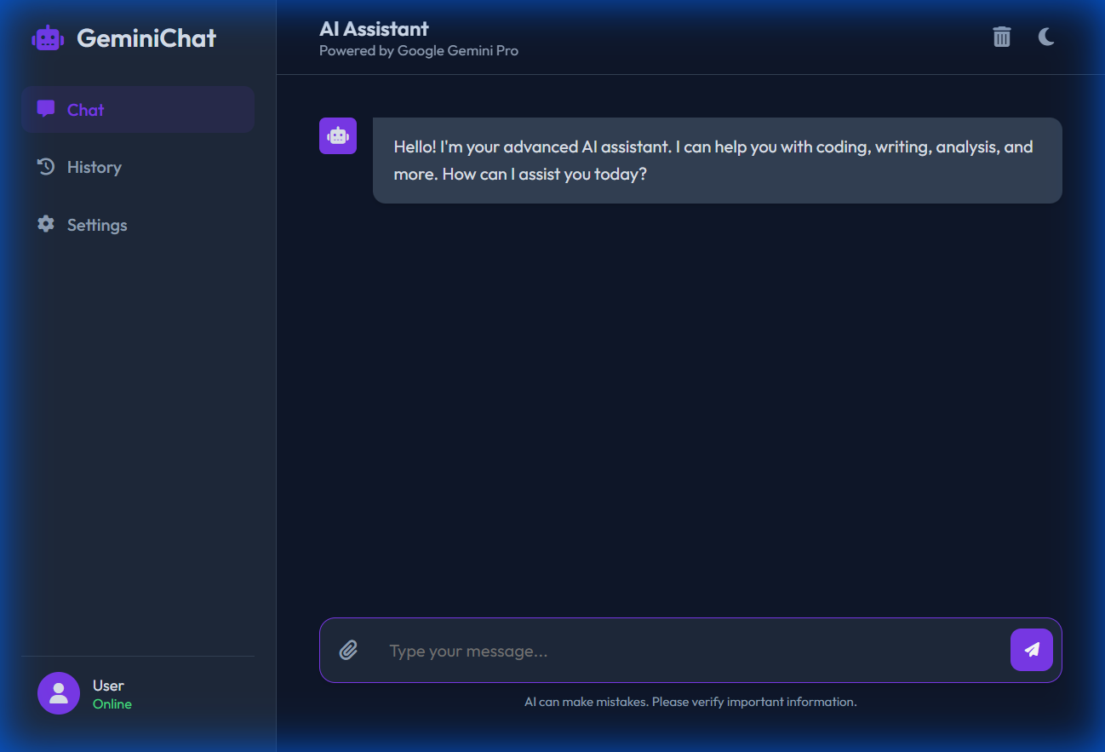

8.2 Greeting Interaction
User sends 'hello' and receives a friendly hardcoded response from the chatbot:
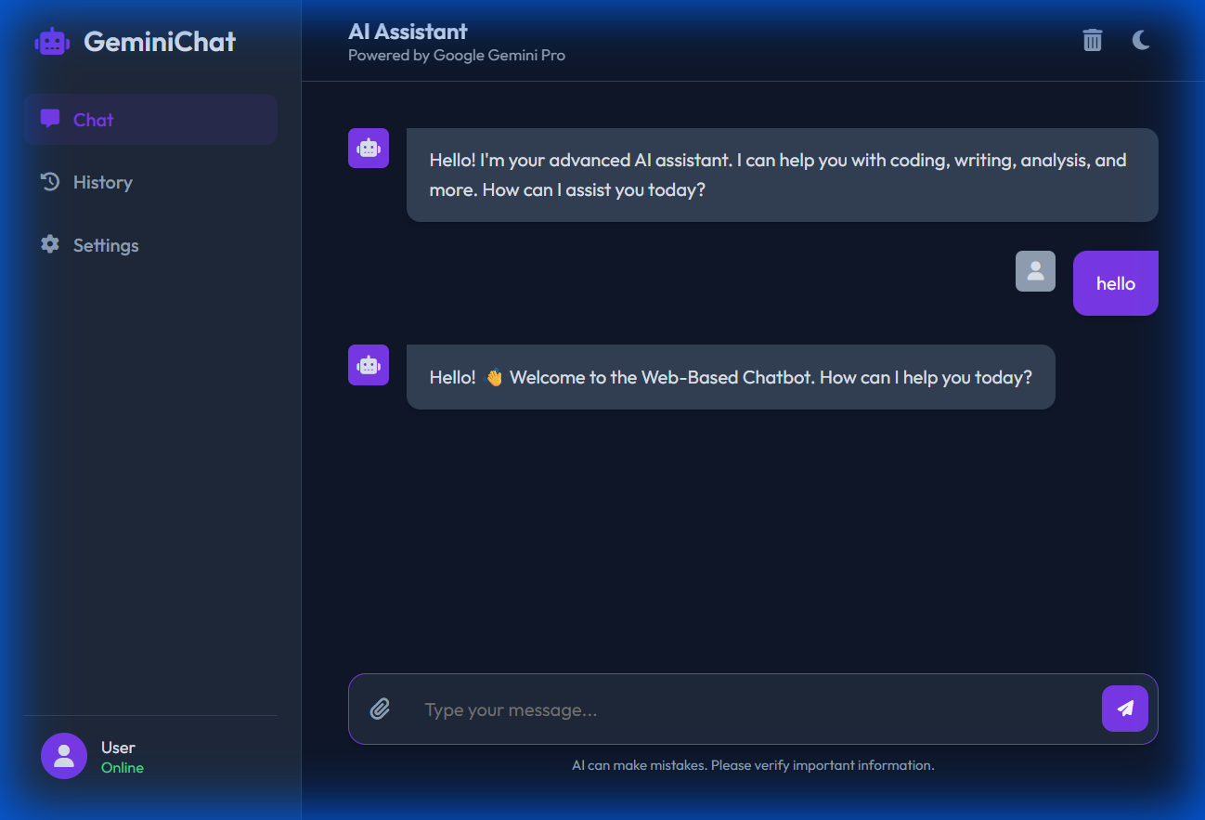

8.3 Technical Question Response
User asks 'what is devops?' and receives a detailed, informative response:
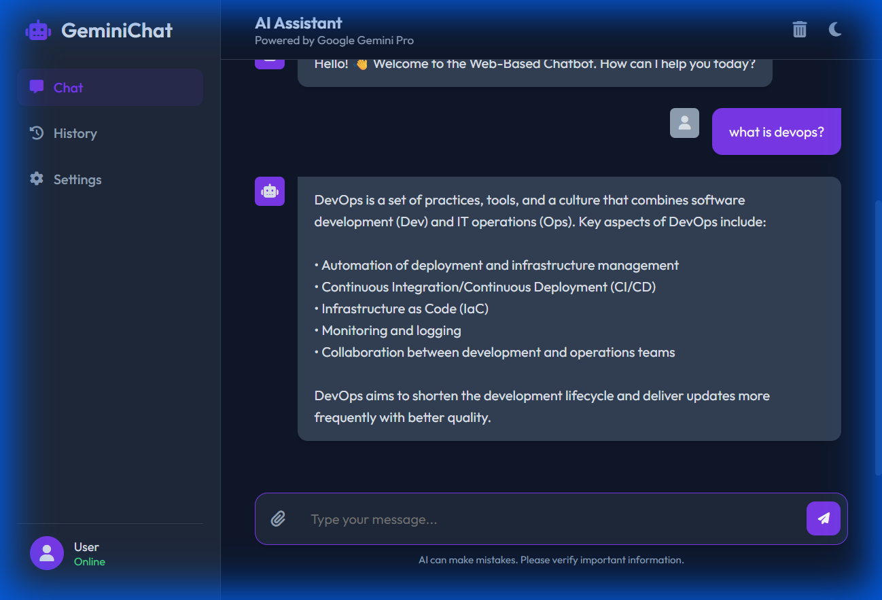

8.4 Additional Application View
Another view of the application interface:
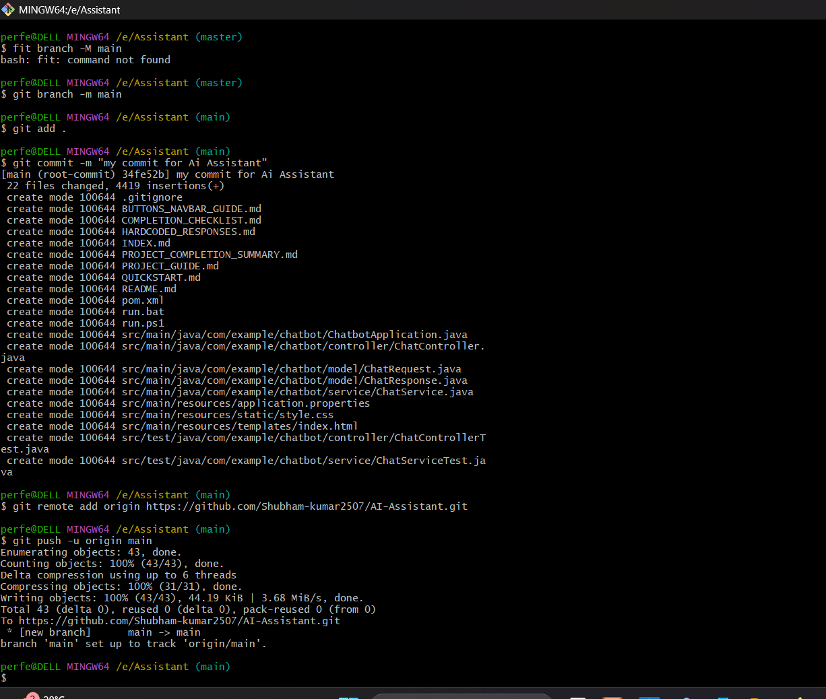

9. Setup and Installation

9.1 Prerequisites
- Java 17 or higher
- Maven 3.6+
- Docker Desktop (for containerized deployment)
- Google Gemini API key (optional, for live API integration)

9.2 Running with Maven
1. Clone or download the project
2. Navigate to project directory
3. Configure API key in src/main/resources/application.properties:
gemini.api.key=your_api_key_here
4. Run the application:
mvn spring-boot:run
5. Open browser and navigate to:
http://localhost:8085

9.3 Running with Docker
1. Build the Docker image:
docker build -t chatbot:latest .
2. Run the container:
docker run -d -p 8085:8085 chatbot:latest
3. Or use Docker Compose:
docker-compose up --build
4. Access the application:
http://localhost:8085

10. Testing the Application
The application includes hardcoded responses for testing without a valid API key. Try these test queries:
- hello / hi / hey - Greeting responses
- what is devops? - Detailed DevOps explanation
- what is maven? - Maven build tool information
- what is spring boot? - Spring Boot framework details
- how are you? - Friendly response
- help - List of available topics
- thank you - Acknowledgment response

For queries not in the hardcoded list, the application will attempt to call the Gemini API (if a valid API key is configured) or return a helpful error message.

11. Conclusion
This Spring Boot Chatbot application demonstrates a complete full-stack development workflow,
from backend API design to frontend user interface, with modern DevOps practices including
Docker containerization.
Key Learning Outcomes:
• Understanding of Spring Boot framework and layered architecture
• REST API design and implementation
• Integration with third-party APIs (Google Gemini)
• Modern web UI development with responsive design
• Docker containerization and deployment strategies
• Maven project structure and dependency management
The application serves as an excellent foundation for building more complex chatbot systems
and can be extended with features like:
• User authentication and session management
• Chat history persistence with database integration
• File upload and processing capabilities
• Multi-language support
• Advanced AI features and custom training
• Real-time notifications with WebSockets
This project showcases industry-standard practices and provides a solid understanding of
modern web application development and deployment.

