Hand-In Problem 1 Ph 211—Fall 2021

*Please turn your scanned homework into GradeScope by 11:59pm on the due date. Include a completed copy of your homework as well as a copy of the scoring rubric that you can find at minirov.info/ph211. Make sure that you self-grade the scoring rubric.*



The picture to the right has 2413 visible galaxies in it. This pictures covers 1/9,891,000th of the entire sky. Our galaxy has 455 billion suns in it. The visible part of the universe is made up of mostly Hydrogen. Our sun has a mass of 1.99·1030 kg. A Hydrogen atom has a mass of 1.674·10-27kg.

1. With the above information estimate the number of atoms in the universe. Please use the proper significant figures when presenting your final answer. Include a discussion of every assumption you are making in order to solve the problem. (Ok, for the purists, when estimating, you don’t use sig. figs. Please just play along with me on this one.)

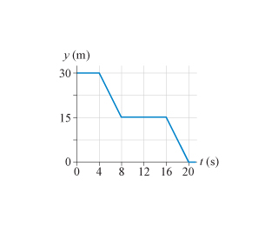

2a. Write a short description for the motion of a real object for which the given position vs. time graph would be realistic.

2b. Draw a velocity vs. time graph that would correspond to the given position vs. time graph.

3. The light turns green, and a bicyclist starts forward with an acceleration of 1.5m/s2. How far must she travel to reach a speed of 8.0m/s? Solve this question graphically. If you know how, you may also solve this problem algebraically, but it is the graphical solution I want to see this week.

**Chapter 1:**

In chapter 1 we are introduced to the concepts of position, velocity and acceleration.

***Chapter 1 Outcomes -- what you should be able to do by the end of this chapter:***

* You should be able to clearly define position, velocity and acceleration.
* You should be able to distinguish between SI, mks, cgs and King George units. You should most specifically be able to work in SI units. Most problems in the book will be done in SI units. SI units are similar too (but not exactly the same as) mks units. This means that we will almost always for this class use meters, kilograms and seconds in all our problems. Generally, as long as you always resort to mks, units almost always come out correct.
* You should know the values off these common prefixes such as:

T = 1012,G = 109, M = 106, k = 103, c=10-2, m=10-3, μ=10-6, n = 10-9 and p=10-12

* You should be able to complete calculations using appropriate significant digits.

***Main Problem Solving Strategies for Chapter 1***

* When solving a physics problem, the first step is almost always to draw a picture. Drawing a picture allows you to discover and focus upon the important components of the situation you are trying to analyze.
* You should always clearly show all your work and all calculations should always include units.