Hand-In Problem 2 PH 211—Fall 2021

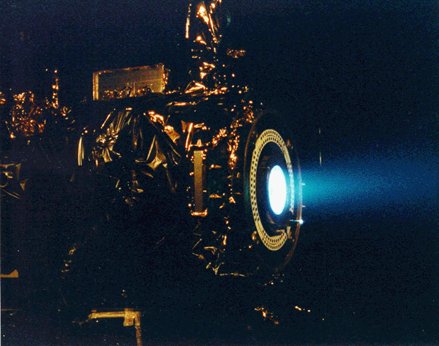This problem uses concepts from Chapter 1 and Chapter 2.

*Deep Space 1, launched in 1998, was the human race’s first attempt at an ion drive space ship. DS1, when supplied with either solar collectors or a nuclear fission (or hopefully someday a nuclear fusion) energy source, can accelerate indefinitely with an acceleration of 85.7mm/s2. DS1 has a mass of 486.32kg.*

1. The most difficult part of space travel is simply getting off the Earth. You launch straight up with constant acceleration. 4.00s after liftoff, a bolt falls off the side of the rocket. The bolt hits the ground 6.30s later. What was the rocket’s acceleration? Derive your solution graphically.
2. Calculate your solution analytically.

*In outer space there is no friction to worry about. Assume that DS1 accelerates uniformly at 85.7mm/s2 for one year starting from zero velocity.*

After one year:

1. How fast would DS1 be traveling?
2. How far would DS1 have gone?

*In order to miss a possible small rock floating in space, DS42 will be designed (hopefully) to be able to accelerate to the left or the right.*

1. After 10 seconds of the rocket firing, how far to the left would DS42 move if it fired a rocket that had a time dependent acceleration that looked like a(t) = (3m/s4)t2 + 5 (m/s3)t.
2. Use VPython to calculate the position, velocity and acceleration of an object starting at rest undergoing an acceleration of a(t) = (3m/s4)t2 + 5 (m/s3)t for every half-second for 10.0 seconds. Print out a screen shot of your results along with the code to hand in. Use Euler’s method to do these calculations. If part f and most VPython exercises this term, if it takes you more than 10 minutes to complete, ask the help desk, an instructor or someone in class for help.

In this chapter we began to investigate the mathematics of motion.

***General Concepts Covered***

* You should be able to currently communicate the vector nature of velocity and acceleration.
* You should be able to solve problems utilizing the definition of instantaneous velocity: 
* You should be able to solve problems utilizing the definition of instantaneous velocity: 
* You should realize that there is only one equation: a = a(t). All other equations come from this.
* You should be able to solve problems using Euler’s Method: Using the definitions of velocity and acceleration above, you should be able to derive sf = si + v*dt and vf = vi + a*dt which can be used in a computer program to solve any kinematics problem and ultimately any integration problem.

***Main Problem Solving Strategies for Chapter 2***

* First, draw your picture!
* Next, add your coordinate system.
* Then, in motion problems, determine if you are dealing with a constant acceleration or a varying acceleration. If you have a varying acceleration you are going to have to integrate or differentiate in some manner, if the acceleration is constant, then at this stage of class it is good practice to still integrate, even though you might soon, via oft use, memorize these equations.
* Use diagrams to further clarify the problem. Most of the time you can solve problems graphically, which allows you to be confident in your analytical solution.