HIP 3 Fall 2021

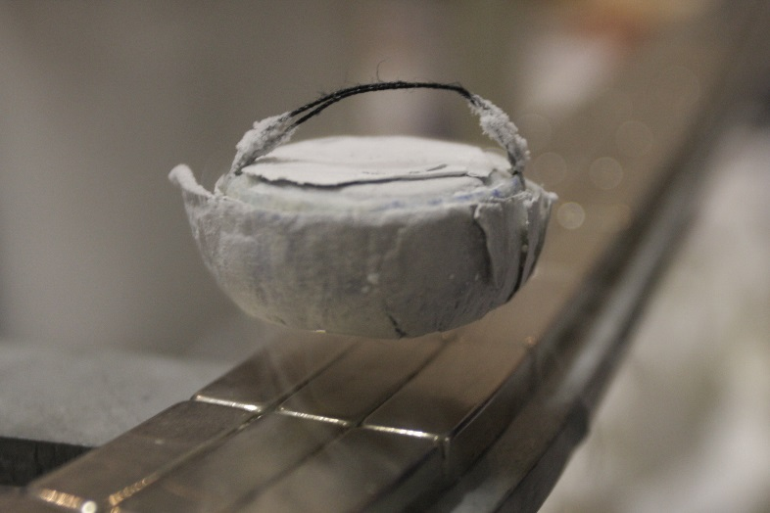A levitating superconductor on Earth starts at rest and is accelerated down a flat, straight track that is sitting on a table. The track has a length **L=30.1cm**. Its acceleration can be described using the equation a(t)= **b**t where **b** = 1.1m/s3.

At the end of the track it falls a distance h=52.1cm before it hits the ground. While falling the superconductor continues to experience the horizontal acceleration it felt before.

Questions to answer:

1. How far horizontally from the edge of the track does the superconductor land?
2. At what angle does the superconductor impact the ground?
3. If this experiment were repeated on the moon, how far horizontally from the edge of the track does the superconductor land?
4. If this experiment were repeated on Mars, far horizontally from the edge of the track does the superconductor land?
5. Simulate part a of this problem computationally using Euler’s method.

As always, don’t forget to attach a HIP rubric and follow all of the steps.

Extra Credit:

As always you can embellish your solutions on paper or computationally for additional credit.

**Chapter 3:** This chapter focused on vectors and how we might use them in physics.

***General Concepts Covered:***

* vectors have both direction and magnitude
* you should be able to add and subtract vectors both graphically and using components.
* You should be able to decompose a vector into its components and to reassemble vector components into a magnitude and a direction.

***Main Problem-Solving Strategies Discussed***

Putting your x- and y-coordinate systems in the “correct” place can make a problem a lot easier.

Thus: First, draw your picture! Next, find the coordinate system that makes your problem the easiest to solve.

***Equations encountered:***

There were no new physics equations, but it might be useful to recall that:

sinθ = opp/hyp

cosθ = adj/hyp

tanθ = sinθ/cosθ = opp/adj

Too, rather than having to resort to your calculator, you should remember that sin0°=0 and cos0°=1. Once you memorize those definitions you can build the following chart of common angles:

|  |  |
| --- | --- |
| sin 0° = 0/2 = 0 | cos 90° = 0/2 = 0 |
| sin 30° = /2 = ½ | cos 60° = /2 = ½ |
| sin 45° = /2 | cos 45° = /2 |
| sin 60° = /2 | cos 30° = /2 |
| sin 90° = /2 = 1 | cos 0° = /2 = 1 |

**Chapter 4:** This chapter introduces the concept of motion in two dimensions and begins to introduce us to the concept of rotational motion.

***General Concepts Covered:***

* The equations are the same, the concepts are the same, now, it’s just happening in 2D.
* Never mix what is going on in the different dimensions.
* If something is rotating, you should be able to calculate the period of rotation and you should be able to create angular position vs. time, angular velocity vs. time, and angular acceleration vs. time graphs for that rotational motion.

***New equations introduced:***

There is still only one equation we need to memorize, and that is $\vec{a}=\vec{a}$. But in this chapter we need to realize that vector nature of acceleration means that a = a in each dimension independently. This means that you now we need to be careful to denote the different dimensions. For example, the previous equations of motion for a constant acceleration turn into:

sx(t) = ½axt2 + voxt + sxo andsy(t) = ½ayt2 + voyt + syo

vx(t) = axt + vox and vx(t) = ayt + voy

It’s important to remember that the above equations only work for constant acceleration. If you have non-constant acceleration, you know that you will probably need to integrate and/or differentiate.

***Main Problem Solving Strategies Discussed:***

We’ve added a complexity to our standard “to do” list:

* Draw a picture!
* Set up a “good” coordinate system
* Make sure that you analyze each dimension.