HIP 5 Fall 2018

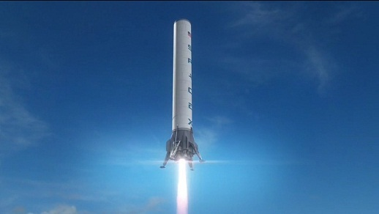

Many problems, such as this one below, have no analytical solution. Thus, you are going to need to use the computational skills we gained in lab this week to solve this problem.

The first stage of a SpaceX Falcon 9 Rocket (diameter=3.7m, height=68.4m) burns fuel for 180 seconds. During this time it experiences a constant thrust force of 5885kN and starts with a mass of 505,846kg that decreases linearly to a mass of 13,150kg by the end of the fuel burn.

The rocket experiences wind drag that can be simplified to be described by the equation D = ½ρCdAv2 where the drag coefficient of a rocket is Cd=0.8. The density of the earth’s atmosphere, however, changes with altitude by an equation that be modeled as

$ρ\left(h\right)=\left(0.289e^{1.73-0.000157h}\right)\frac{kg}{m^{3}}$ where h is the height above sea level given in meters.

**Find the speed of the rocket 137 seconds into its flight.**

Please print out your program and your numerical answer to this problem. Your program should be fully commented in your own words. Don’t forget to do a reasonable check on your computational solution.

Note: In the above problem you don’t need to take into consideration effects such as Earth’s rotation and that the force due to gravity decreases with respect to altitude. We’ll discuss both of these effects in Ph212. But, if you do want to make this problem still more realistic, you can add in these or other effects for self-fulfillment and extra-credit.

**Chapter 5:**

This chapter continues working on forces concentrating on the concept of Fnet = manet .

***General Concepts Covered:***

We continued to practice with FBD’s.

We looked at the force due to friction

We looked at the force due to wind drag

***New Empirical Equations encountered:***

**f** = μ**N** D = ½CdρAv2

***Main Problem Solving Strategies Discussed:***

We’re still where we were in Chapter 4

1. Draw a picture!
2. Set up a “good” coordinate system
3. Draw a FBD
4. Create an equation using Fnet = manet
5. Always check to see if you have constant accelerations or changing accelerations.