HIP 8 Fall 2018

Paul Stender’s car has a rocket attached to it. While on, the rocket provides a thrust force of 51,500 Newtons. The car has as mass of 3,222kg. The coefficients of friction with the road and the tires are μk=.321, μs=.432, μr=.111, and the coefficient of drag is 0.800. The car is 3.0 meters long, 2.0 meters wide and 1.5 meters tall. The density of air is ρ=1.3kg/m3.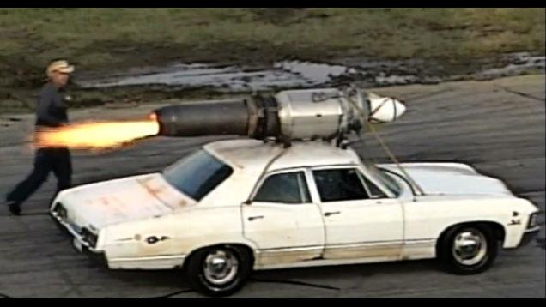

Remember that the equation for the force of drag is: D = ½ρACdv2.

Create a program that keeps track of for every tenth of a second for the first 5 seconds…:

* …the amount of chemical energy burnt by the rocket
* …the amount of energy that is turned into thermal energy through wind drag
* …the amount of energy that is turned into thermal energy through rolling friction
* …The amount of energy that ends up as Kinetic Energy

You may assume a 100% efficient chemical process in the rocket. You may also assume that the mass change of the rocket is negligible.

As always, attach the normal scoring rubric and make sure that you complete all sections including the “problem setup” and “reasonableness” sections.