Ph 211—Practice Exam 1

1. A positive point charge is brought near a permanent electric dipole that is ori­ented as shown. Describe *and explain* how the dipole responds.

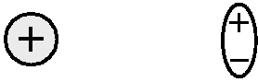

2. A positively charged glass rod is held over a thin, uncharged piece of metal foil. How does the foil respond? Give a step-by-step explanation, using both words *and* pictures.

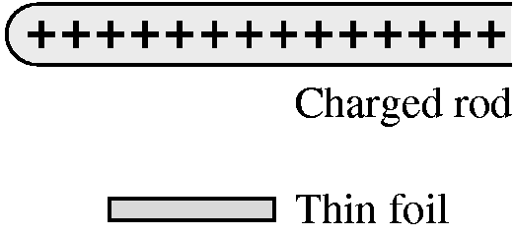

1. Two negative rings with unequal amounts of charge are placed on the *x*-axis. Draw *on the figure* the electric field vectors at the three points shown as dots. The lengths of your vectors should indicate the relative field strengths at each of these points.

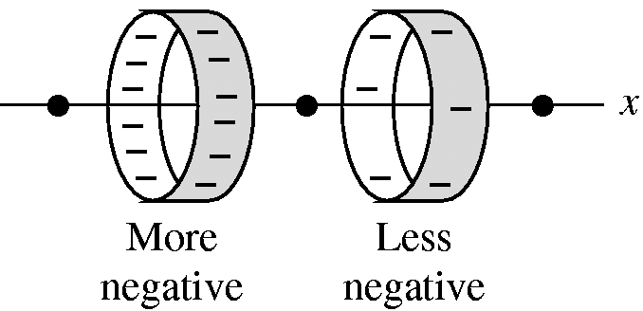

4. Charges 2 nC and 8 nC are located at *x*  2 cm and *x*  2 cm, respectively. At what point or points on the *x*-axis is ? Explain.

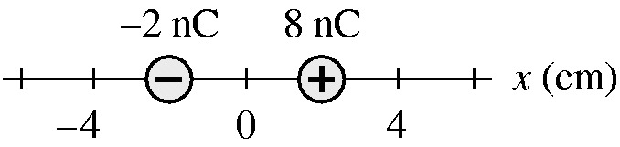

10

5. Five charges are arranged as shown. The figure shows five Gaussian surfaces and the electric flux through each. What are the five charges *q*1 to *q*5?

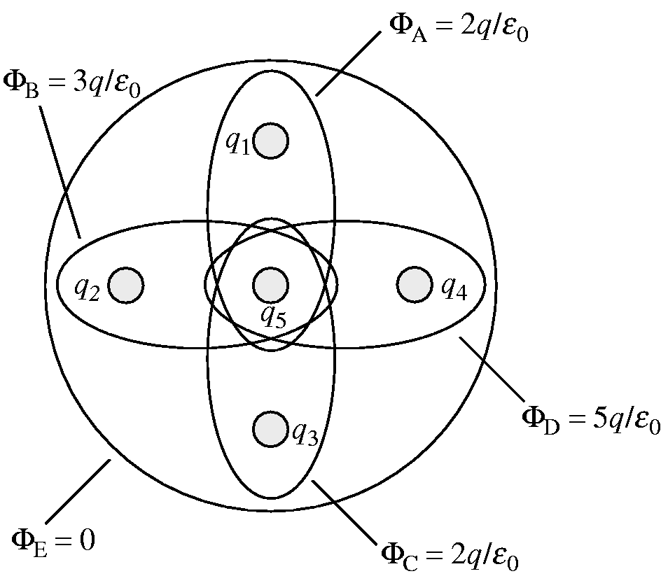

6. Charges A and B exert repulsive forces on each other. *q*A = 4*q*B. Which statement is true?

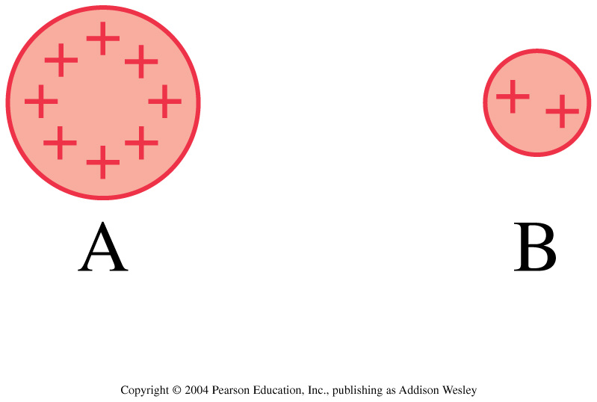

1. *F*A on B > *F*B on A

2. *F*A on B < *F*B on A

3. *F*A on B = *F*B on A

7. Which electric field is responsible for the trajectory of the electron?

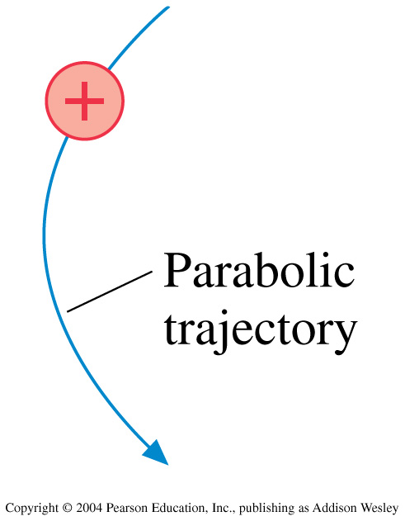

8. These are two-dimensional cross sections through three-dimensional closed spheres and a cube. Rank order, from largest to smallest, the electric fluxes Φa to Φe through surfaces a to e.

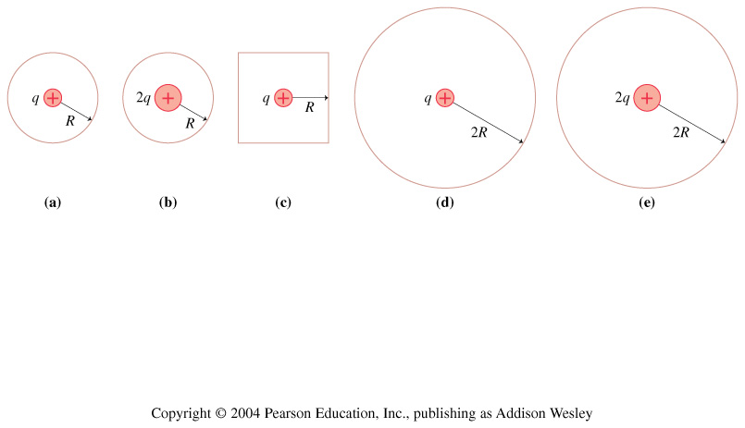

1. Φe > Φd > Φb > Φc > Φa

2. Φa > Φc > Φb > Φd > Φe

3. Φb = Φe > Φa = Φc = Φd

4. Φb > Φa > Φc > Φe > Φd

5. Φd = Φe > Φc > Φa = Φb

10

7a. A 100 mg pith ball hangs by a thread in the center of a parallel-plate capacitor. The capacitor plates are 5.0 cm  5.0 cm and are spaced 1.0 cm apart. When the ball is charged to +10 nC and the capacitor plates are charge to *Q*, the ball hangs at a 3° angle. What is *Q*?

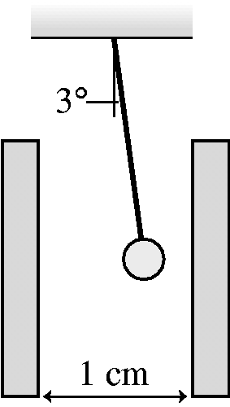

7b. Describe any assumptions that you have made in above problem.

10

8a. One lone Cyberman has escaped your trap from PH212. Your only chance to disable him is to create an electric field of exactly field strength **E** in his brain.

All you have available is a bendable conducting rod of length **L** and a sonic screwdriver which can put any amount of charge that you desire wherever you want it.

Where will you put the bendable conducting rod, what shape will it have, and what charge will put on the rod in order to disable the Cyberman? (State your answer in terms of the given variables **E** and **L**.)

Note the dimensions of the Cyberman’s head and the location of his brain in the picture below.

½L

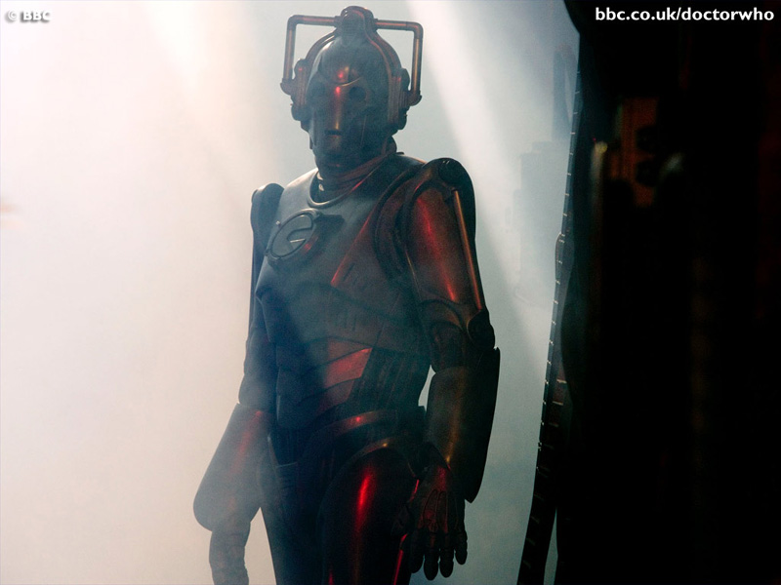

¼L

8b. Sketch out the basics of a computer program that will solve this problem computationally.

10

9. Mount Eyjafjallajokull has been erupting for several days now. In the column of volcanic ash seen below you can see lightening. The presence of lightening tells us that the E-field just outside the edge of this column of ash is 3.0·106 N/C. The column has a radius of 955m and is 30,000m tall. From this information, estimate the amount of excess charge in the ash plume. Make sure that you clearly discuss any approximations or assumptions that you make.

