Ph 213: Exam 2 Spring 2017

*This is a 55 minute exam. You may use only a non-programmable/non-graphing calculator. As always make sure that you show all of your work in order to maximize your partial credit.*

*There is a formula sheet available in the front of the room – if you do not use the formula sheet, you receive 3pts of extra-credit. If you do use the formula sheet, please sign the sheet in the front of the room.*

**Some useful constants:**

Speed of light = 3.00·108 m/s

G = 6.67·10-11 Nm2/kg2

Mearth=5.98·1024kg

Msun=1.99·1030kg

Radius of Earth = 6.37·106 m

Radius of Sun = 6.96·108 m

Earth’s mean distance from the sun: 1.50·1011 meters

e = 1.6·10-19 C

ε0 = 8.85·10-12 C2/Nm2

μ0 =1.26·10-6 Tm/A

h = 6.63·10-34 Js

me=9.11·10-31kg

mp = 1836me

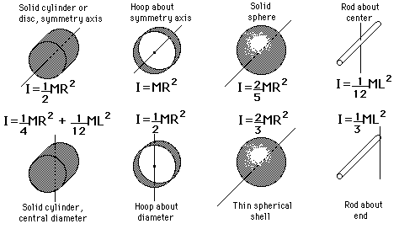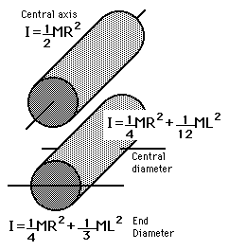

**Some potentially useful Moment’s of Inertia:**

**The Electromagnetic Spectrum**

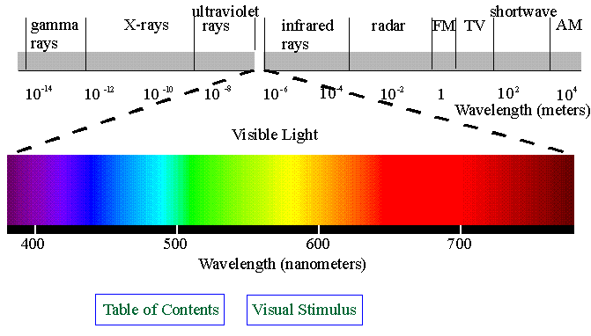

Ph 213—Exam 2 Spring 2017

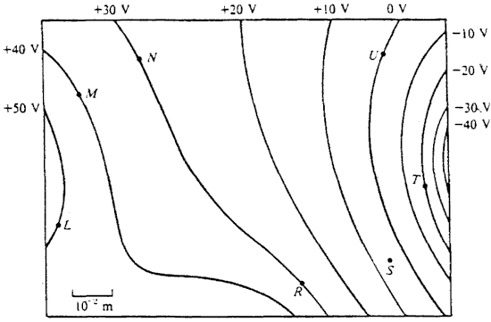Questions 1-5 refer to this image: *(5 points)*

1. Where is the electric field strongest? L, M, N, R, S, T, U
2. Where is the electric field weakest? L, M, N, R, S, T, U
3. Draw in on the map the direction of the electric field at R?
4. How much work would it take an external agent to move a +3μC charge from R to N?
5. How much work would it take an external agent to move a +3μC charge from R to T?

6. *(3 points)* What happens to the resistance in a typical semi-conductor as you increase the temperature of the semi-conductor?

a. The resistance: increases decreases stays the same

b. Explain your answer.

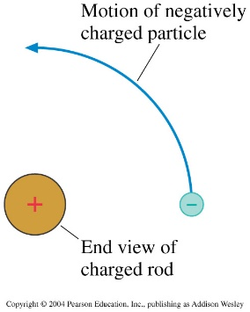7. *(2 points)* The positive charge in the diagram is the end view of a positively charged glass rod. A negatively charged particle moves in a circular arc around the glass rod.

1. Draw in the E-field of the glass rod on the diagram.
2. If the glass rod has a linear charge density of λ=5C/m and electron is 10cm away from the rod, what is the work done on the charged particle as it makes one complete circle around the rod.

8. *(4 points)* What are the following Electric Potentials for the below circuit?

ΔVae=

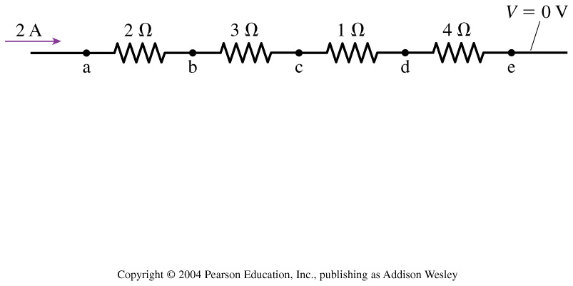ΔVbc=

What is the current at the following points in the above circuit?

Ic=

Ie=

10. *(2 points)* In words, explain the difference between electron current and electrical current.

11. Here is a beam of electrons used in an Electron Beam Melting (EBM) manufacturing process. The electron density of the beam can be described by the equation: J(r) = br where b=2μAmps/meter up to a radius of 1mm. After a radius of 1 mm, the electron density drops off quickly to zero.



1. *(2 points)* Draw a cross-sectional picture of the electron density of this beam that will help a person visualize the electron density of the beam.
2. *(2 points)* What is the overall electrical current of the beam?

12. A bar of charge has a total charge of Q and a total length of L is sitting horizontally in front of you. Find the electric potential of a point in space a distance D above the right end of the bar.

13a. *(5 points)* You take a bed sheet out of the dryer and lay it out flat. Due to built up static charges the sheet is found the have an electric potential field on it that you measure and find to be described by the equation: V(x,y) = 2x2 + 3xy + y2 where one corner is defined as the origin. In which direction and with what force would a jumping spider of the dreaded **Salticidae Madeupicus** species of mass 50grams experience if it were charged up to +0.5C and placed at x=1meter and y=2meters?

13b. *(5 points)* The spider leaps into the air from the (1,2)meter spot described above with an initial launch speed of 5m/s (the buggers are fast) and lands on the corner of sheet that you defined as the origin. At what speed does the spider hit that corner of the sheet?

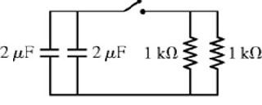14. *(10 points)* The capacitors in the circuit shown here is charged to 12 Volts. The top of both capacitors are positively charged.

A

1. Draw a current vs. time of the electrical current going through points A once you close the switch. On your graph, clearly denote the value of the time when the curve gets to 4.44 Volts.
2. Draw a charge vs. time graph for the charge on the top of the left capacitor. Clearly denote the value of the initial charge of the top plate of the left capacitor.