Ph 213 – Final Exam Part A Retake 2013

1. An electron is placed at the position marked by the dot. The force on the electron is…

a. …to the left.

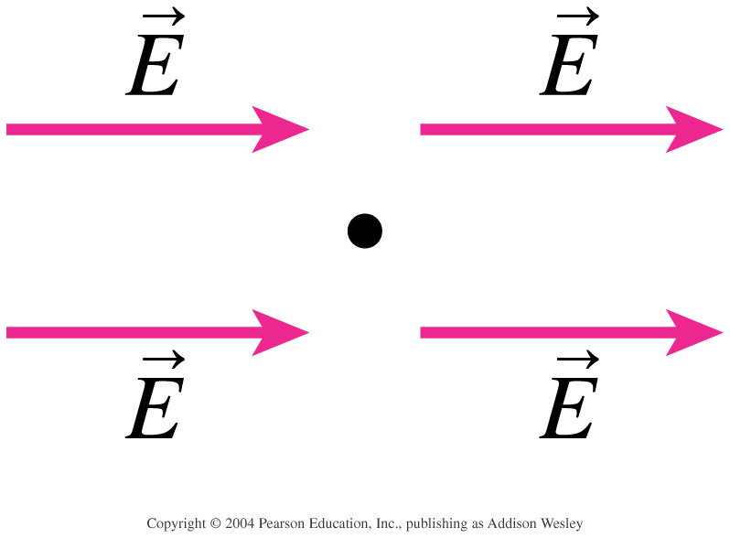

b. …to the right.

c. …zero.

d. …There’s not enough information to tell.

2. Rank in order, from largest to smallest, the forces *F*a to *F*e a proton would experience if placed at points a – e in this very long, narrow parallel-plate capacitor.

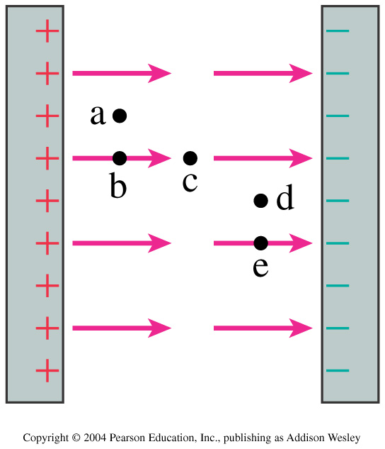

λ=±2C/m

a. *F*a = *F*b = *F*c = *F*d = *F*e

b. *F*a = *F*b > *F*c > *F*d = *F*e

c. *F*a = *F*b = *F*d = *F*e > *F*c

d. *F*e > *F*d > *F*c > *F*b > *F*a

e. *F*e = *F*d > *F*c > *F*a = *F*b

3.The total electric flux through the dotted box in the above problem is:

a. 0 Nm2/C.

b. 1 Nm2/C.

c. 2 Nm2/C.

d. 4 Nm2/C.

e. 6 Nm2/C

4. For the previous image, rank in order, from largest to smallest, the potentials Va to Ve at the points a to e.

5. The two charged rings are a model of the surface charge distribution along a wire. Rank in order, from largest to smallest, the electron currents *E*a to *E*e at the midpoint between the rings.

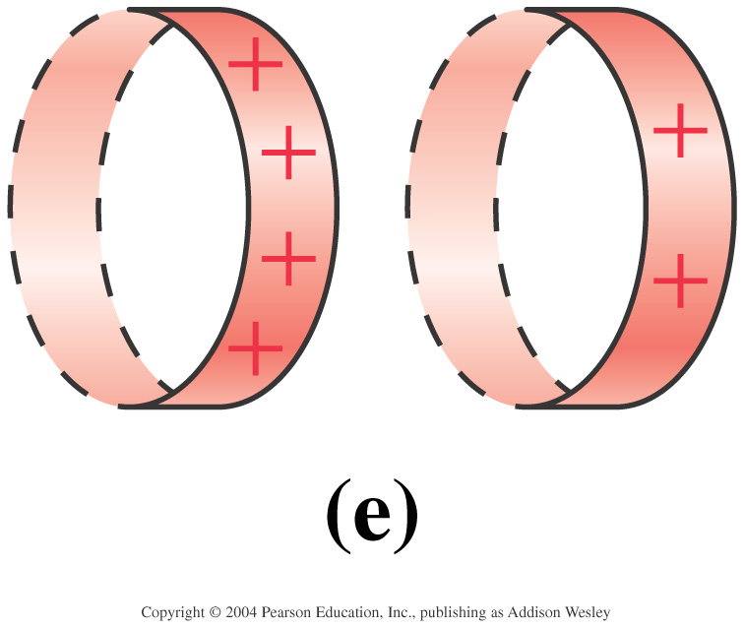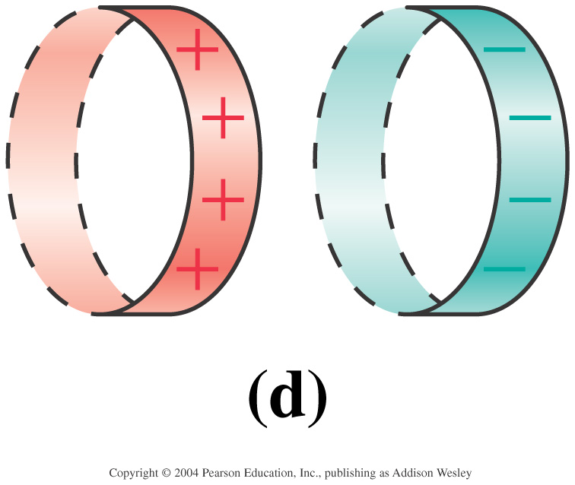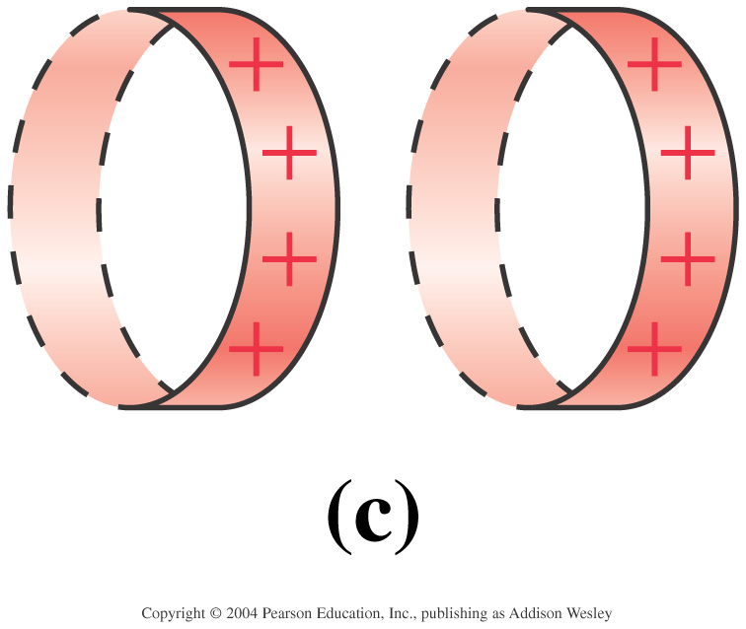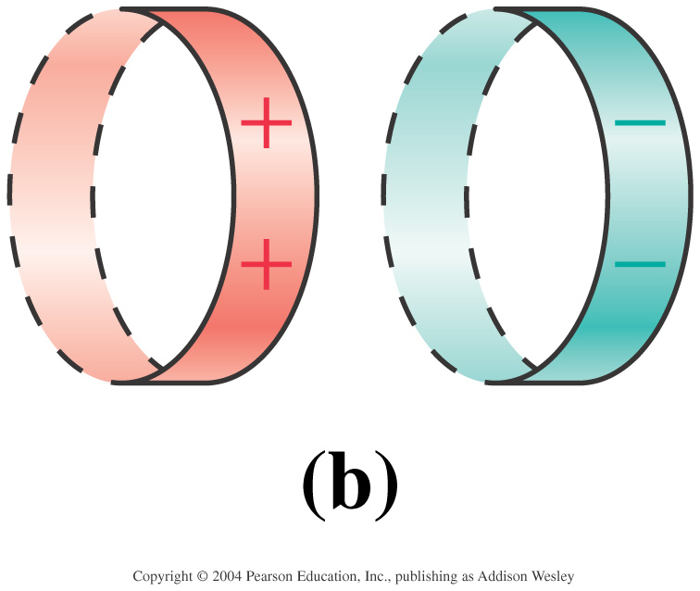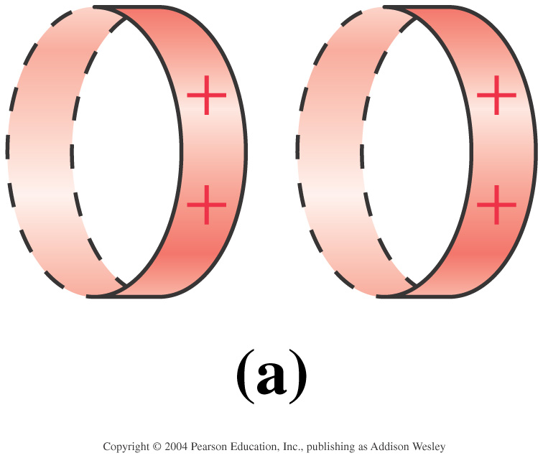

10

6. A square loop of copper wire is pulled through a region of magnetic field. Rank in order, from weakest to strongest, the pulling forces F1 through F4 that must be applied to keep the loop moving at constant speed.

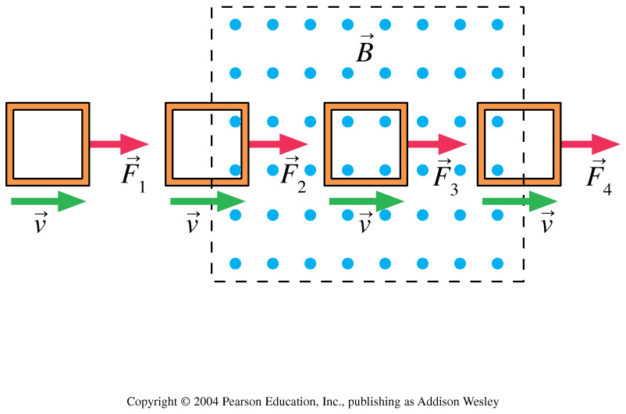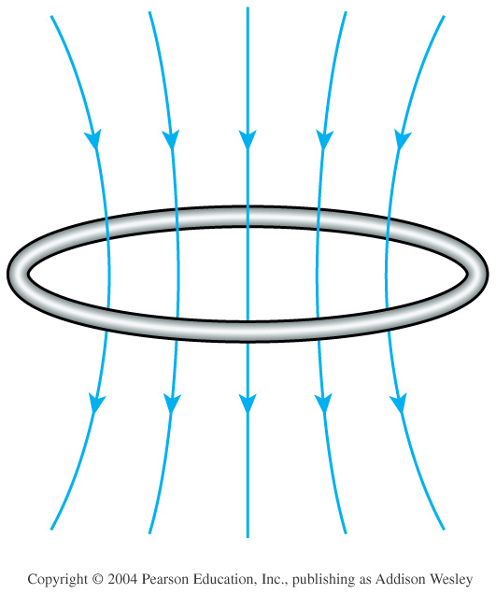

7. This image depicts a conducting wire with a magnetic field.

a) In what direction are the electrons in the wire moving?

b) Which side of the loop represents the North pole?

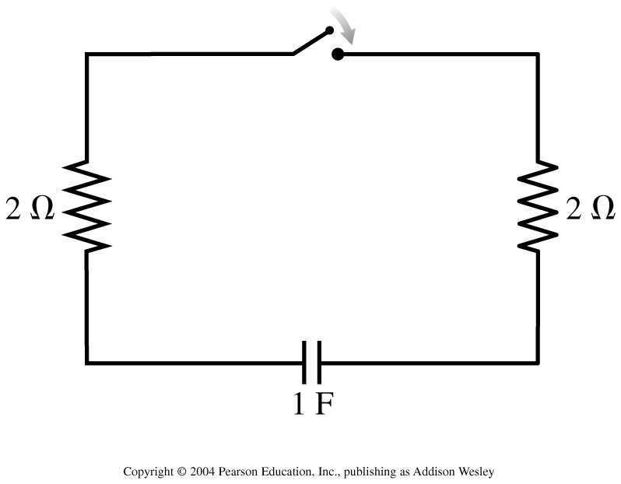

8. The time constant for the discharge of this capacitor is:

9a. Which potential-energy graph describes this electric field?

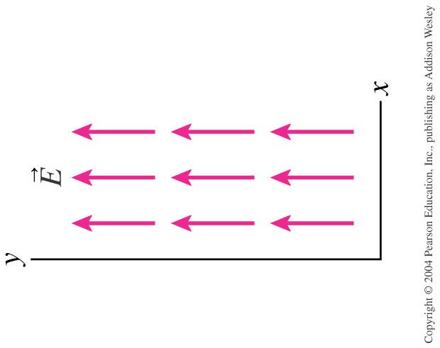

9b. Which set of equipotential surfaces matches this electric field?

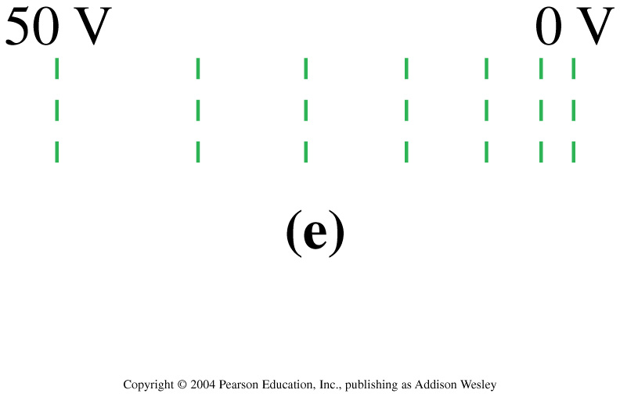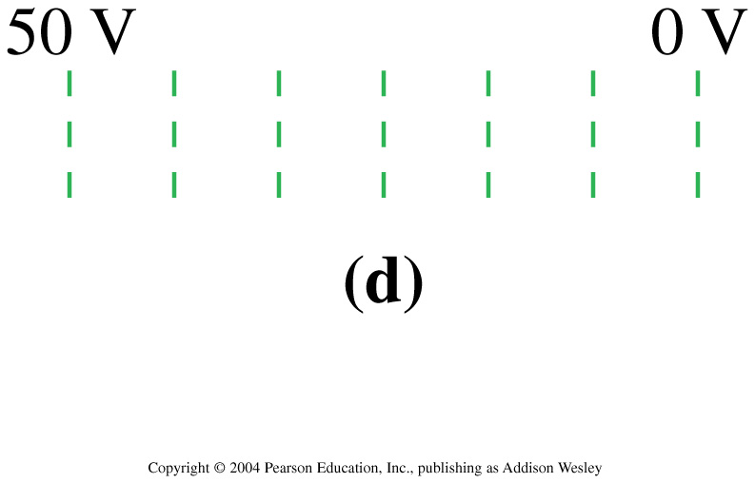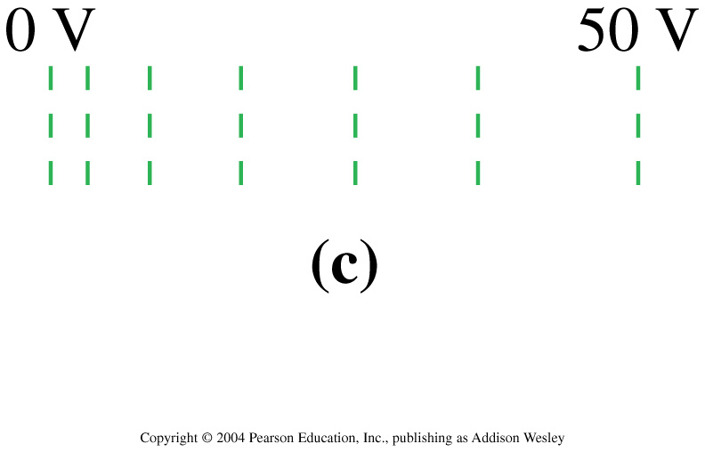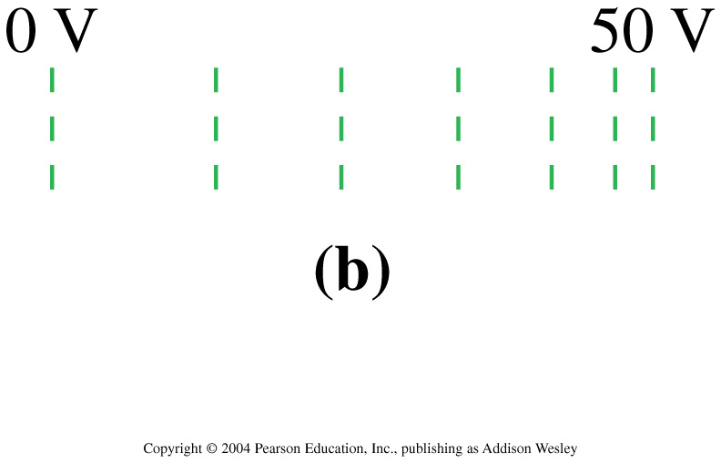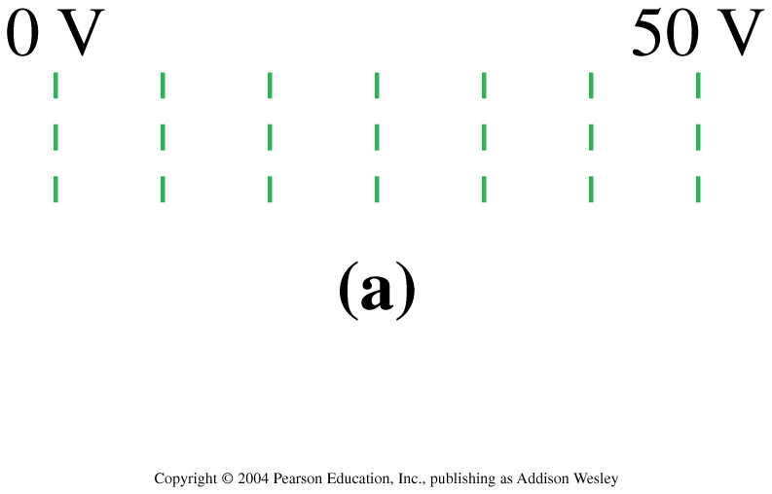

10. An electromagnetic wave is propagating in the positive   
*x*-direction. At this instant of time, what is the direction of **E** at the center of the rectangle?

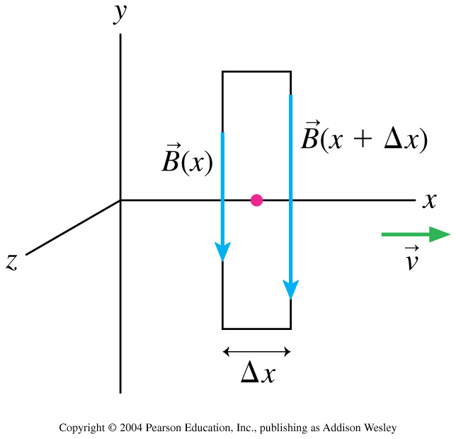

a. In the positive *x*-direction

b. In the negative *x*-direction

c. In the positive *y*-direction

d. In the positive *z*-direction

e. In the negative *z*-direction

10

11&12. What are the fundamental SI units for:

a. Current:

b. Electric Field:

c. Electric Charge:

d. Electric Potential:

13. A charged rod attracts bits of dry cork dust, which, after touching the rod, often jump violently away from it. Explain.

14. Three small spheres, x, y, and z carry charges of equal magnitudes and with signs shown in the figure. They are placed at the vertices of an isosceles triangle with the distance between x and y equal to the distance between x and z. Spheres y and z are held in place but sphere x is free to move on a frictionless surface. Which path will sphere x take when released?

15. By analogy with ΦE, how would you define the flux Φg of a gravitational field? What is the flux of the Earth’s gravitational field through the boundaries of a room, assumed to contain no matter? Through a spherical surface closely surrounding the Earth? Through a spherical surface the size of the Moon’s orbit?

10

16. Why is it possible to shield a room against electrical forces but not against gravitational forces?

17. Can two different equipotential surfaces intersect?

18. Imagine that you are sitting in a room with your back to one wall and that an electron beam, traveling horizontally from the back wall to the front wall, is deflected to your right. What is the direction of the uniform magnetic field that exists in your room?

19. Aluminum is not magnetic. Yet, when you drop a magnet down an aluminum tube, the magnet does not accelerate at 9.8m/s2 as you’d predict on Earth. Why not?

10

20. Take a breath. Make sure that your name is on the front page of this exam. Go up and get Part 2 of the exam

Ph 213 – Final Exam Part B Retake 2013

*Choose any 5 questions to answer. If you answer 6 questions, then you get extra credit. A formula sheet is attached at the end fo this exam.*

1. You wan to make a proton/electron plasma. In order to do this, you need to ionize a collection of hydrogen atoms. A hydrogen atom is 24 nm in diameter.

a. How strongly is the nucleus holding onto the electron?

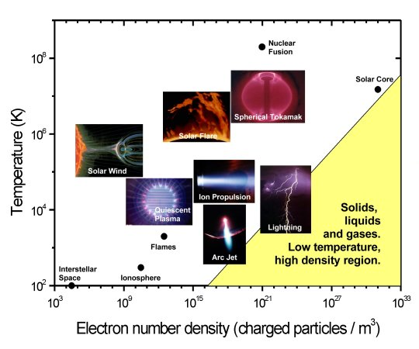

*Various examples of plasmas.*

b. How much energy does it take to ionize the atom?

10

2. (10 points) Nanotechnology allows us to manipulate our environment at the near-atomic scale. A nano-probe is designed to deliver small amounts of electrons in a controlled fashion.

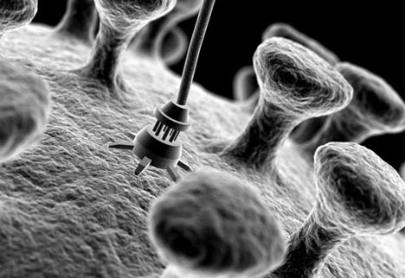

The total amount of charge in Coulombs that has entered a nano-wire at time t is given by the expression Q(t) = 4t – t2.

1. How many electrons have traveled through the wire after 1 second?
2. What is the electrical current in the nano-wire at 1 second?

10

3a. Five charges are arranged as shown. The figure shows five Gaussian surfaces and the electric flux through each. What are the five charges *q*1 to *q*5?

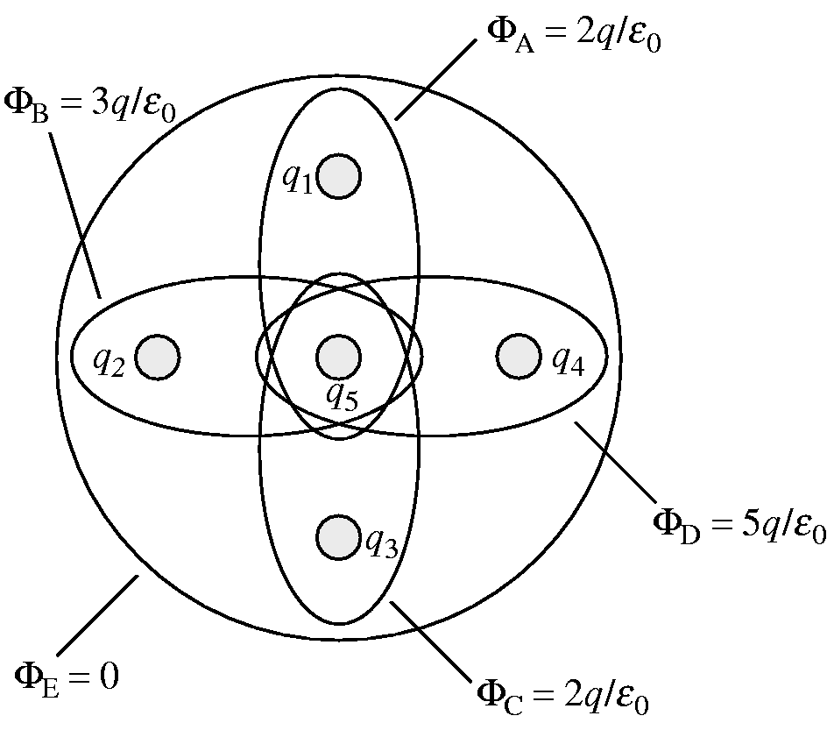

3b. 47 randomly oriented bar magnets are placed in a box. Each bar magnet has a strength of .05 Tesla. What is the magnetic flux through the surface described by the six walls of the box?

10

4. An electron travels with speed 1.50٠107 m/s between the two parallel charged plates shown in the figure. The plates are separated by 1.0 cm and are charged by a 200 V battery.

a. What magnetic field strength will allow the electron to pass between the plates without being deflected?

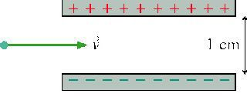

b. What is the direction of the magnetic field?

10

5. The loop in the figure is being pushed into the 0.20 T magnetic field at 50 m/s. The resistance of the loop is 0.10 Ohms.

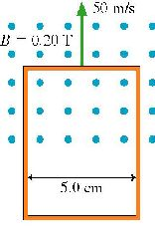

a. What is the magnitude of the current in the loop?

b. What is the direction of the current in the loop?

Clockwise

Counterclockwise

Into the page

Out of the page

There is no current

10

6. You have a light source creating randomly polarized photons.

a. If you place a polarizing sheet between your eyes and the light source, what will the intensity of the light be compared to the unfiltered intensity Io?

b. Next, you place a second identical polarizing sheet between you and the first sheet with the 2nd sheet’s angle of polarization at 90 degrees with respect to the first. How much light gets through now?

c. You now place a third sheet BETWEEN the first two sheets. It’s axis of polarization is at 30 degrees with respect to the first sheet. How much light gets through now?

10

Some potentially useful equations:

















p1 + ρgh1 + ½ ρv12= p2 + ρgh2 + ½ ρv22



D(x,t)=Ae-t/2Tsin(kx - ωt)



λ = h/p

dsinθm = mλ ym = Ltanθm

n1sinθ1 = n2sinθ2











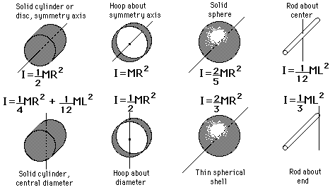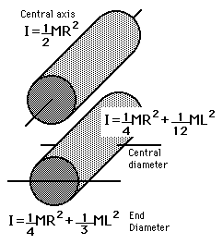

**Some potentially useful Moment’s of Inertia:**

**Some useful constants:**

Speed of light = 3.00·108 m/s

G = 6.67·10-11 Nm2/kg2

Mearth=5.98·1024kg

Msun=1.99·1030kg

Radius of Earth = 6.37·106 m

Radius of Sun 6.96·108 m

Earth’s mean distance from the sun: 1.50·1011 m

h = 6.63·10-34 J·s

melectron = 9.11·10-31 kg

εo = 8.85·10-12 C2/(Nm2)

μo = 1.26·10-6 Tm/A