Hand-In Problem 1 Ph 213

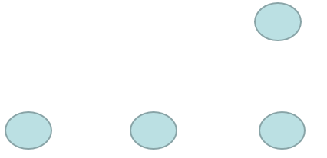We have three 0.5gram Styrofoam peanuts each with a charge of +3nC each separated by 0.1 meters. A 4th peanut is placed 20 cm above the right hand side peanut—it has a charge of -5nC.

1. Using analytical problem solving, what is the initial acceleration of the 4th peanut?
2. Create a VPython program that calculates the initial acceleration of the 4th peanut.
3. What is the E-field due to the 4 peanuts at a place 10 cm above the left-hand side peanut?

Please complete your work and scan your work into a pdf. Make sure that you include the self-scored rubric on the next page as the last page of your pdf. Upload the homework file into your account in GradeScope.

Main topics of Chapter 22:

* The force between two charged objects is quantified with the equation:



* A “fundamental charge unit” is the smallest* indivisible unit of charge. Protons carry a charge of +1.6·10-19C of charge. Electrons carry a charge of -1.6·10-19C. (*It was later discovered that protons could be split into smaller charged units – but, that is something we will discuss in Ph 299)
* An Electric Field vector at a point in space points in the direction a positive charge would feel if placed at that point in space. The magnitude of force that a charge Q feels at that point in space is F = qE.
* Positive charges are “sources” of E-Field. Negative charges are “sinks” of E-field. The E-field created by a point charge is described by the equation .

If you need a reminder of what each of these categories means, take a look at the course website: minirov.info/ph213.

|  |  |  |
| --- | --- | --- |
| CATEGORY | Your Self-Grade | Grader’s Greg |
| Problem Statement and Introduction |  |  |
| Picture |  |  |
| Physics Tools |  |  |
| Problem Solution Presentation |  |  |
| Form |  |  |
| Units |  |  |
| Solution |  |  |
| Significant Figures |  |  |
| Reasonableness |  |  |
| All Self Graded |  |  |