HIP 8 Spring 2020

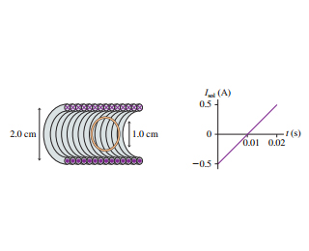The figure here shows a 1.0-cm-diameter loop with R = 0.50 Ω inside a 2.0-cm-diameter solenoid. The solenoid is 8.0 cm long, has 130 turns, and carries the current shown in the graph. A positive current is cw when seen from the left.

What is the current in the loop at t = 0.010 seconds?