Ph 211—Exam 1 Fall 2010

You have 55 minutes to complete this exam. As always, make sure that you show all of your work in order to maximize the number of points to get on each problem. If you are taking this exam early, you are on your honor not to sure what is on this exam with other students who have yet to take it.

1. (3 points) 1.00 cm³ of air contains 2.471·10¹⁹ molecules of air. This room is 15.2 meters by 25.4 meters by 3.2 meters in size. If this room were emptied of everything except air molecules, how many molecules would be in this room? State your answer using correct significant figures.

2. (3 points) Our sun has a mass of 1.99∙10³⁰kg. The mass of a hydrogen atom is 1.67∙10⁻²⁴ grams. If our sun were made up entirely of hydrogen, how many atoms of hydrogen would this be?

3. (2 points) Convert the following to SI units:
a. 9.12 μs

b. 44 cm/ms

c. 1.00 year

d. 5.32 Mg

4. (2 points) A soccer ball is kicked and given an initial velocity of v_{o} that that is 45 degrees with respect to the horizontal.
At the top of the trajectory made by the soccer ball, the velocity is:
|v_{top}| > |v_{o}| |v_{top}| = 0m/s |v_{top}| < |v_{o}| (but not equal to zero)
10
5. (5 points) From the information given for Particle A in the graph:
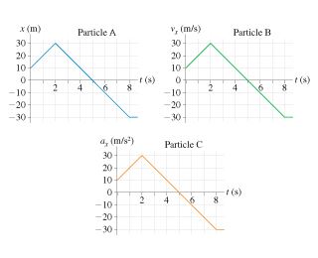
a) What is the velocity of the particle at t = 4 sec?

b) What is the acceleration of the particle at t = 4 sec?

6. (5 points) At t = 0 seconds particle C is standing at rest at 10 meters from the origin. From the information given for Particle C in the graph:

a) What is the velocity of the particle at t = 4 seconds?

b) What is the velocity of the particle at t = 8 seconds?

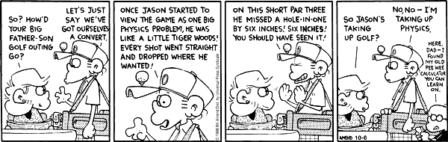

10
7. (8 points) Super-spy Sarah Stout is racing down the street at 42 m/s. In order to evade pursuing bad-people, she ignites specially installed rockets to boost the speed of her car. The rockets provide a time dependent acceleration of a(t) = kt⁴.

a) What units does k have?

b) If k has a numerical value of 3.0, at what speed is Sarah traveling 2.0 seconds after she ignites the rocket?

c) Again, if k=3.0, how far has Sarah traveled 2.0 seconds after she ignites the rocket?

8. (2 points) In the figure showing the A-vector and B-vector what is the magnitude of B׀׀ with respect to A?
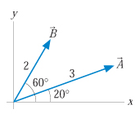

10
9. Jon and Katie are standing on a bridge 50 meters above a river. Katie throws a rock straight down with a speed of 20m/s. Jon, at exactly the same instant of time and the same height, throws a rock straight up with the same speed.

a. (7 points) How much time elapses between the first splash and the second splash? (You can ignore wind resistance.)

b. (3 points) Which one hits the water at a higher speed (ignoring wind resistance)?
Jon’s rock hits at a higher speed
Katie’s rock hits at a higher speed.
Both hit at the same speed

Explain your answer either by a written explanation or by numerical calculation:

10
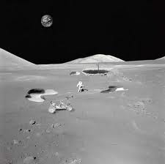
10. On the Apollo 14 mission to the moon, astronaut Alan Shepard hit a golf ball with a club. The free-fall acceleration on the moon is 1/6 of its value on Earth. Suppose he hit the ball with a speed of 25 m/s at an angle of 30° above the horizontal.

a. How much farther did the ball travel on the moon than it would have on the earth?

b. For how much more time was the ball in flight?

10
Here is a sample VPython Question: Below is a VPython Program that describes the motion of a cow that (voluntarily) was launched from a catapult.
There is a typo in the program that makes work not as expected.
- Create a position vs. time graph and a velocity vs time graph that describes the visual output of this program as it is in its currently incorrect state.
- What value will printed the 2nd time the program works through the loop.

# This program will simulate a projectile's trajectory
from visual import *
from time import *

a = vector(0,9.8,0) #m/s^2
v = vector(6.0,0.0,0.0) #m/s
s = vector(0.0,1.2,0.0) #m
t = 0.0 #s
dt = 0.05 #s

scene=display(title="Projectile Launch",x=0,y=0,
width=500,height=500,autoscale=0,range=vector(10,10,10),
center=vector(0,0,0))

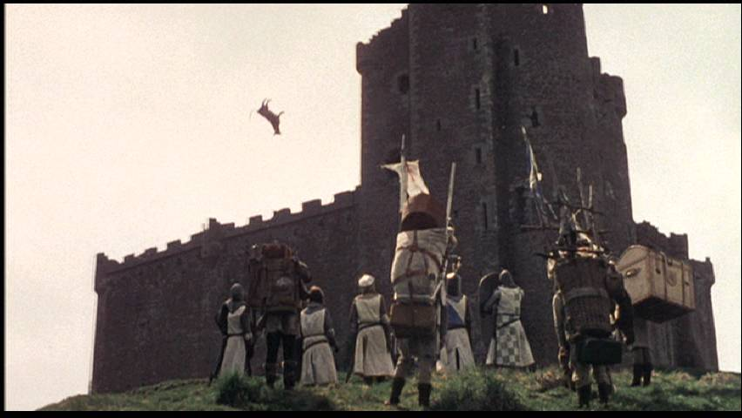
projectile=sphere(pos=s,radius=.1, color=color.yellow)
All cows in this picture, although not spherical, are purely simulated. No animals were hurt in this important film documenting an important battle in our history.

while t < 1:
rate (5)
s = s + v*dt
v = v + a*dt
t = t + dt
print (t,s,v)
projectile.pos=s

