Ph 211 Final Exam Part A Fall 2010

Part A of the exam consists of 20 questions. Remember that even though some of these questions are multiple choice questions, if your answer is wrong you still can get partial credit by showing your work. When you are done with this part of the exam, turn it in at the front of the class and pick up Part B. Have fun!

1. An object has a velocity directed to the right, and an acceleration directed to the left. Which statement is true?
The position of the object is increasing to the left with time, and its speed is increasing.
The position of the object is increasing to the right with time, and its speed is increasing.
The position of the object is not changing in time.
The position of the object is increasing to the right with time, and its speed is decreasing.
There is not enough information given to answer this question

2. Since vectors always have positive magnitudes, the sum of two vectors must have a magnitude greater than the magnitude of either one of them.
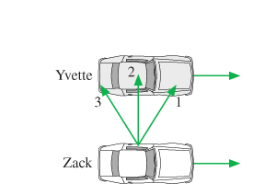
True False
Savannah

Zac

3. In the figure, Savannah and Zac are driving down the freeway side by side with their windows down. Zac wants to toss his physics book out the window and have it land in Savannah's front seat.
Ignoring air resistance, which way should he aim his throw?
1 2 3

4. A grasshopper leaps into the air at a 62° angle above the horizontal. At its highest point…:
a. …the velocity = 0 m/s True False
b. …the acceleration = 0 m/s² True False

5. An object is moving to the right, and experiencing a net force that is directed to the right. The magnitude of the force is decreasing with time. The speed of the object is...
increasing decreasing constant in time
12½
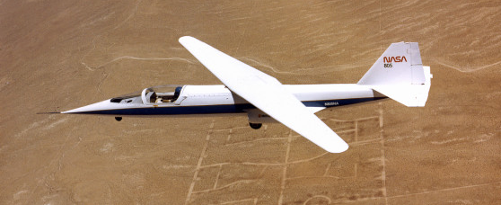
6. This airplane if flying at a constant velocity. Draw a free-body diagram for the airplane.

7. A stalled car is being pushed up a hill by three people, and it is moving at a constant speed. The net force on the car is...
Zero
In the same direction as the car’s motion
In the opposite direction as the car’s motion
None of the above
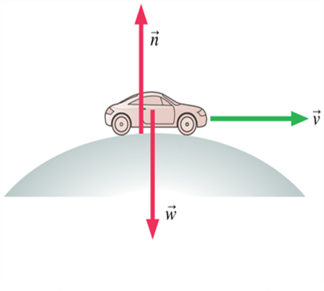
There’s not enough information to know.

8. A car is rolling over the top of a hill at speed v. At this instant which is true:
n < w
n > w
n = w
we can’t tell about n without knowing v.

9. Draw a free body diagram for a crate sliding down a rough-surfaced ramp at constant speed.

10. An elevator suspended by a vertical cable is moving downward but slowing down. Draw a free-body diagram for the elevator.

12½
11. A ball tossed straight up has v = 0 at its highest point.
a) Draw an energy vs. distance graph for the ball

b) Is the ball in equilibrium at the ball’s highest point?
Yes
No

12. Can the friction force on an object ever point in the direction of the object's motion?
Yes
No
If yes, give an example. If no, explain why not.

13. A 0.2 kg plastic cart and a 20 kg lead cart can both roll without friction on a horizontal surface. Equal forces are used to push both carts forward for a time of 1 s, starting from rest. After the force is removed at t=1s, the momentum of the lead cart is _____ the momentum of the plastic cart and the velocity of the lead cart is _____ the velocity of the plastic cart.
greater than, greater than  greater than, less than  greater than, equal to | less than, greater than  less than, less than  less than, equal to | equal to, greater than  equal to, less than  equal to, equal to

14. A 10 g rubber ball and a 10 g clay ball are thrown at a wall with equal speeds. The rubber ball bounces, the clay ball sticks. Which ball exerts a larger impulse on the wall?
the rubber ball
the clay ball
both exert equal impulse upon the wall

15. A spring-loaded dart gun is used to shoot a dart straight up into the air, and the dart reaches a maximum height of 12 meters. The same dart is shot up a second time from the same gun, but this time the spring is compressed only half as far (compared to the first shot). How far up does the dart go this time (neglect friction and assume the spring obeys Hooke's law)?
12½
3 meters 6 meters 12 meters 24 meters 48 meters
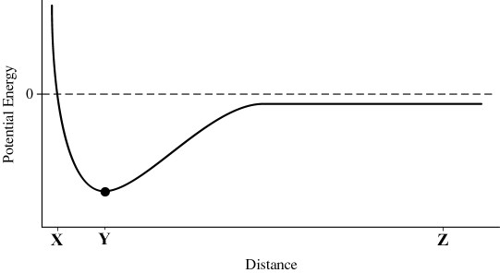
16. The plot below shows the potential energy of a particle, due to the force exerted on it by another particle, as a function of distance. For which region(s) is the force exerted on the particle zero?
A B C D
A B C D
A
B
C
D

17. A person drops one rock from rest and it falls 100 meters down a cliff before hitting the ground. The person then throws an identical rock downward. The amount of kinetic energy gained by the rock dropped from rest is ________ that of the second rock, and the magnitude of the change in speed (between hitting the ground and its initial speed) of the rock dropped from rest is ________ that of the second rock.
greater than, greater than  greater than, less than  greater than, equal to | less than, greater than  less than, less than  less than, equal to | equal to, greater than  equal to, less than  equal to, equal to

18. Four students run up the stairs in the time shown. Rank in order, from largest to smallest, their power outputs P_{a} to P_{d}.
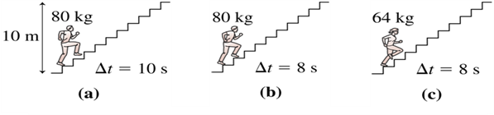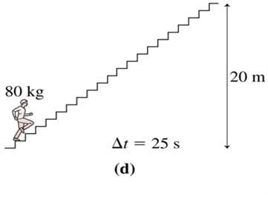

19. What energy transformations occur as a skier glides down a gentle slope at constant speed?

20. Make sure that your name is on the front page of this part of the exam and turn it in at the front of the room. Then, pick up Part B and keep going!
12½

