Ph 211 Final Exam Part B Fall 2010

Choose 5 of the following 6 problems to answer. Clearly cross out the one question that you don’t want me to grade by circling and crossing out the score on the lower left hand corner of that page. If you do not clearly denote which page you don’t want me to include in the grade I will assume that you don’t want me to grade the last question.

1. We’ll discover next term that all you need to do to escape the Earth’s gravitational pull is to reach a speed of 11km/s. It doesn’t matter too much how you do it, be car, plane or you jogging down the road at 11km/s, once you get to that speed, you can escape the Earth.

One way of escaping the Earth is to build a “launch rail”. A launch rail is basically a track upon which you can accelerate a space vessel down to reach the “escape velocity” of 11km/s.

- Choose a numerical acceleration for your launch vehicle. Explain why you chose the value that you did.

- Assuming no wind resistance, how many meters long does your launch rail have to be to get to escape velocity?

- Once you are in outerspace, and far away from the gravity of any planet, sun or other object, you have a 1Mg rocket that is capable of exerting a time-variable force that looks like F(t) = (50,000 + 20t²). How far has your probe traveled after 1-year? (Ignore relativistic effects and assume that you are using an ion drive that uses fuel as it finds it in outspace).

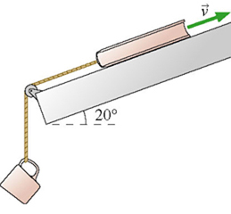
2. In this picture the following is known:
θ
The mass of the cup is m_{cup}.
The mass of the book is m_{book}.
Currently the book is traveling at a speed of v downward and the book is a distance d from the edge of the shelf tilted at angle θ as shown.
The coefficients of friction between the shelf and the book are μ_{s} and μ_{k}.

Assuming the cup is heavy enough so that there is always enough force to keep the book sliding, find out how fast book is moving when it gets to the edge of the shelf.

State your answer in terms of variables given up above.

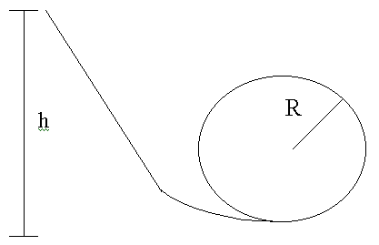
3. The diagram to the right represents a loop-d-loop roller-coaster ride. There is a certain height at which a roller-coaster cart would need to be released to make sure that it has sufficient velocity to make it around the loop-d-loop? The radius of the loop is R. The mass of the car is m. Assume zero drag and friction.

If the cart is to be released from a resting position, at what height will the cart need to be released to be able to just make it around the loop? State your answer in terms of the given variables R, m and any relevant constants of nature.

4. The (massless) spring shown in the figure is compressed 50 cm and used to launch a 100 kg physics student. The track is frictionless until it starts up the incline. The student's coefficient of kinetic friction on the 30º incline is μ_{k}=0.15.
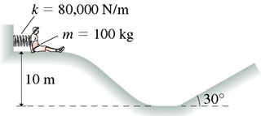
- What is the student's speed just after losing contact with the spring?

- How far up the incline does the student go?

- This time, instead of using a spring, we are going to use a “Sproing” to launch the student. A “Sproing” does not follow Hooke’s law. Instead, the Force that a Sproing exerts as it is compressed follows the equation F = k(Δs)³. In this case, if the Sproing was compressed 50cm, what will the student’s speed be just after losing contact with the Sproing?

5. A 75 kg shell is fired with an initial speed of 145m/s at an angle 55 degree above horizontal. Air resistance is negligible. At its highest point, the shell explodes into two fragments, each moving exactly horizontally with respect to each other, one four times more massive than the other. The heavier fragment lands directly below the point of the explosion.

How far does the second fragment land from the first?

6. (2 points) A typical person needs 1800 Calories of food per day. 100 Watts/m² of power via sunlight reach the ground on average throughout a 24 hour day. About 1% of this energy gets turned into edible “food energy”. If you were a complete vegetarian and no fertilizers were used to grow your food how many acres of land are needed to support you for a year? (1 Calorie = 4186 Joules; there are 4000m² in one acre).

b. (2 points) If you decide to base most of your diet on beef will you need more land, less land or the same amount of land dedicated to agriculture?
You will need: more land less land the same amount

c. (2 points) If you use fertilizer, will you need more land, less land, or the same amount of land dedicated to agriculture?
You will need: more land less land the same amount

d. (2 points) If you drive like an average American then you consume 1200 gallons of gasoline per year to move your automobile around. In this case, if 100% of your gasoline were to come from ethanol (or other bio fuel source) how many acres of land would be needed to grow the organic material needed for your car at current consumption rates? Assume that your car is 10% efficient at converting chemical energy into kinetic energy.
(1 gallon of gasoline = 130MJ)

10
e. (2 points) Make sure that you write your name on the front of this part of the exam and have a great Winter Break!

