CIVE 202 Project 2: Automation of Concrete Mix Design
Technical Report
Group 151-08
Date Submitted: February 23rd 2026
- Introduction
Project Goals:
The goal of this project is to convert an existing concrete mix design model from Excel into Python. The Client wants the group to reproduce and automate the calculations that are done in the mid design excel worksheet file in Python, so that the user is able to input material proportions and receive the final weight chart that is easily understandable and applicable. The four tasks that the client wants the group to achieve are to translate the Excel logic into Python, implement sequential user inputs, generate a final mix design output, and finally prepare and evaluate four concrete mix scenarios in order to verify the code and calculations.

Project Tasks:
Task 1:
The first task was to translate the excel logic into python. This can be done by defining multiple equations and assigning what the inputs are to those equations. Some of the equations that will need to be defined are calculations for the water weight, volume of the cementitious materials, volume of the aggregates, and etc.

Task 2:
The next task was to implement Sequential user inputs. This will be done by using the input function and it will tell what variable for the user to input. After the user has typed in or inputted the value, it will assign that value to a variable that can be used by the program.

Task 3:
This task is to generate a final mix design output for one cubic yard of concrete, and the outputs must be in a readable format. This will be done by applying the numbers that the client imported in the last task and putting them through the equations that we defined in task 1. Finally, the last step of this process is to output the data that was calculated. This can be done by using the print function and implementing f-strings in order to print a phrase while also printing the needed values to the correct decimal place that apply to that variable.

Task 4:
The client asked the group to prepare and evaluate four concrete mix scenarios. The bulk of this task will be research and finding out what mix designs the NDOT or other reliable engineering sources use. These mix scenarios will be used to verify or validate the Python code that is written by the group. The group will use the provided files and PDFs that the client has provided initially to get a baseline research level over their mix of scenarios.

Deliverables:
The materials that the client has requested to receive at the end of the submittal are the code that was used to replicate the Excel file, a Gantt chart that shows what the team will be working on at a certain point, a scope of work, an annotated code document, and a well-written report to summarize the results.

- Methods

Task 1:
The first thing to do was to translate the Excel functions into Python code. This was done by defining equations and assigning which inputs should be used in those equations. In each Python function, there might be one or several calculations done, for example for calculating the water weight, it was necessary to find what the total cementitious weight was, then use that in the next equation of multiplying by the water-cement ratio.

Task 2:
The second thing was making the code able to receive input and understand what those values should be used for. This was done by using the input function and writing a string inside of that function in quotation marks to ask the user for a certain value. This was done because it makes the code more user-friendly, so they know what values to input into the code at what time. Next was to assign these inputs to a certain variable that can be used later in the code when needed.

Task 3:
The third task is to provide the outputs in a easy to understand format of a weight chart. This chart includes weights of cement, fly ash, silica fume, other scms, fine, coarse, and other aggregates, and finally the water weight. This is accomplished by using print functions to print out the variables and phrases that easily categorize the values and put them into sections that can be understood.

Task 4:
The fourth and final task for this project is to research and implement four different mix designs of concrete that are used in today’s society. The main mixes that were discovered while researching were different strengths of 47B, 47BD, and 47B-HE. These mixes weren’t necessarily given out to the public because there is so much variance in those mix types, but the NDOT gives out minimums to some of the values to accurately classify the type of concrete.

- Results and Discussion
The following mix designs are generated using the minimum and max standard ranges for air volume, water-cement ratios, and other factors. This was done because the NDOT doesn’t create the mixes but sets the general standards. The actual mix designs are owned by the concrete plants and not widely distributed.

Mix Design 1:
This mix design was categorized as 47B by the NDOT. This design is used for pavement patches, sidewalks, curbs, gutters, etc. This is deemed as the workhorse concrete design because of how widely used for multiple tasks.
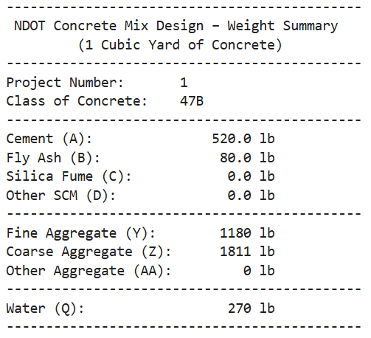

Mix Design 2:
This mix design is categorized as 47BD. This mix is an enhanced 47B mix that is stronger in durability. This is mainly used for projects that demand stronger concrete, including bridge decks, or concrete in harsh environments.
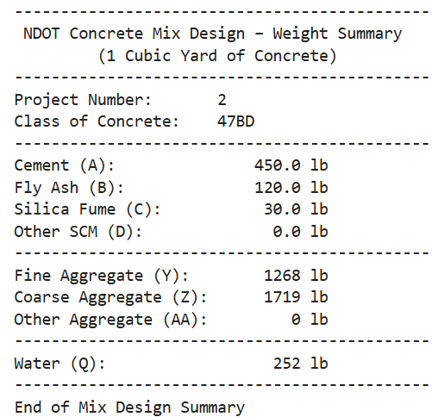

Mix Design 3:
This design is categorized as 47B-HE. This mix is a fast-curing 47B mix, which is used in projects that need to be done quickly. While 47B takes about 28 days to reach full strength, this mix only takes about a day or two to reach the full compressive strength that it is rated for.
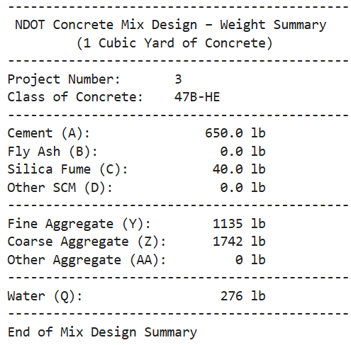

Mix Design 4:
This mix design is classified as 47B-3500. This is very similar to the first mix design, but it is only rated for 3500 psi, whereas the other mix is rated for a minimum of 3625 psi. This is used for highway pavement, shoulders, and concrete overlays. This is used less than the other type of 47B but it is used because it can be cheaper, saving money on projects that don’t need to support as much.
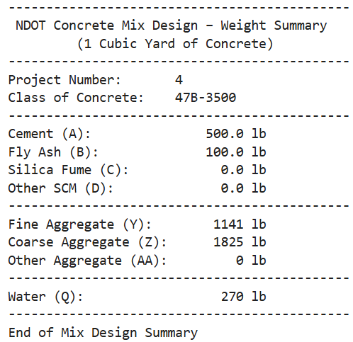

- References

Oie, C. (2002). ADDENDUM NO. 3 AND ELECTRONIC BIDDING SYSTEM AMENDMENT NO. 1. In STATE OF NEBRASKA DEPARTMENT OF ROADS. http://www.nebraskatransportation.org/letting/c-let-020314/f07ad303.pdf

PORTLAND CEMENT CONCRETE. (n.d.). In PORTLAND CEMENT CONCRETE (pp. 679–684). http://www.nebraskatransportation.org/ref-man/specbooke/1000/1000-e20.pdf

Heyen, W., Halsey, L., Robert Rea, Mick Syslo, Tim Krason, Tom Gernert, Jeremy Weigel, Debra Swanson, & Jim Beason. (n.d.). Optimized Aggregates Gradations for Portland Cement Concrete Mix Designs Evaluation. https://dot.nebraska.gov/media/3isfdv45/final-report-p336.pdf

James J. Knott, P.E. & Moe Jamshidi, PE. (2017). Standard Specifications for Highway Construction 2017 Edition. Nebraska Department of Transportation. https://dot.nebraska.gov/media/g4qp4y0d/2017-specbook.pdf

