CIVE 202 Project 4:

Technical Report

  - Group 151-10:
  - Sydney Bird
  - Jamie Krab
  - Cody Hunter
  - Miles Poppleton

  - Date Submitted: April 21st 2026

Introduction
The National Risk Index, NRI, is a way to measure risk of natural disaster events in the U.S. designed by the Department of Homeland Security. Risk is calculated as the product of probability of an event occurring times the impact of the event. The NRI produces a final relative risk score based on the expected annual loss, social vulnerability, and community resilience and compares the risk nationally. The result is categories in a range from vert low to very high.
The client of project 4 is Risk Averse, LLC, which is a risk analysis consulting research group. We were tasked with reviewing the National Risk Index scoring methodology through sensitivity analysis. Our group compared the NRI method with a method we researched to determine if the scoring methodology has categorical bias.

Project Goals:
- The first task is to download and clean the data from two different states from what the client provided to the group through the NRI website, so it is viable for our use. This data is used to inform the reader of the communities that are in the most danger for eighteen different natural disasters. This task it very simple and the group can just filter out the data that we don’t necessarily need to make a report.
- The second task is to clarify some of the data in the file so it is easily understandable. Something the group could do is split up the census data by the value of risk from the five different categories. After that, the group can figure out what the values are that are causing that type of risk.
- The third task is to download and use the SVI database from ASTDR. This can be done by importing the csv file and make it into a database. This can also be used for our own classification of risk in the communities.
- The fourth task is to combine the SVI database and the NRI data so it is easier to use the data and make assumptions about discoveries that the group found in the data.
- The fifth task is to remove the null values, which will be very easy to achieve because the group can just use the null function to remove those values.
- Task 6 is to generate two summary tables about risk scoring using the NRI definition and the definition the group came up with to more accurately describe risk. Our risk definition will be based on a couple of research papers on risk and how it should be represented.
- Finally step 7, the different tables can now be used with GeoPandas to create a map that shows the risk evaluation in different areas for the two selected states.

Deliverables:
- Raw and cleaned Data Files
- Python Code
- Annotated Code Document
- Scope of Work
- Gantt Chart
- Timesheet
- GitHub Repository link
- Written Document report

Methods
The NRI calculates risk by multiplying the impact and the frequency of a risk. Our group normalized each variable in a 0 to 1 scale. This makes the hazards easier to compare and would all have the same scoring scale. This can be done by using the min-max scaling formula shown below. The frequency would be scaled, then the impact. These would be multiplied like the NRI calculated risk. We also additionally divided our risk by tract population to determine the risk that an individual person experiences.
$$Scaled Value = \frac{X-Xmin}{Xmax - Xmin}$$
We completed this method on Jupyter Notebook, a python software. The code first loads the SVI, NHI census tracts, and state shapefiles. All data was cleaned and separated by state. We used def function(x): in python to calculate the min and max scaling as well as the percentile and risk per capita. The hazards chosen to investigate are tornados, earthquakes, and wildfires in Oklahoma and Washington. The code prints out summaries of the NRI scoring against our scaled value per capita. The code also printed our spatial distributions of the listed risks in the chosen states. In the results section, we discuss and explain the summaries and figures.

Results and Discussion
Below are the results of our code and proposed risk measurements. For Oklahoma and Washington, we used Python to clean and calculate our proposed risks. Table 1 shows the composite alternative risk summary. Table 2 shows the Oklahoma risk per capita. By calculating the risk per capita, we can see how risk will impact not just one county but each person in the region. We can see a difference in the risk percenatges. The per capita risk becomes less varied when the individual person is taken into account.
Table 1: Oklahoma composite Alternative Risk
 | STATE | TRACTFIPS | EAL_VALT | Total frequency | Alt risk composite | Alt risk composite pct | Alt risk composite rating
0 | Oklahoma | 40001376600 | 8.973094e+05 | 120.914997 | 0.020514 | 83.103796 | Very High
1 | Oklahoma | 40001376700 | 1.631193e+06 | 126.018140 | 0.039141 | 97.010413 | Very High
2 | Oklahoma | 40001376800 | 1.251305e+06 | 138.139342 | 0.032874 | 94.625462 | Very High
3 | Oklahoma | 40001376900 | 1.241647e+06 | 143.265279 | 0.033843 | 94.894189 | Very High
4 | Oklahoma | 40001377000 | 1.441900e+06 | 139.864462 | 0.038413 | 96.741686 | Very High

Table 2: Oklahoma Per Capita Alternative Risk
 | STATE | TRACTFIPS | Population clean | Alt risk per capita | Alt risk per capita pct | Alt risk per capita rating
0 | Oklahoma | 40001376600 | 2305.0 | 0.000009 | 92.768248 | Very High
1 | Oklahoma | 40001376700 | 4647.0 | 0.000008 | 91.120081 | Very High
2 | Oklahoma | 40001376800 | 3839.0 | 0.000009 | 91.523713 | Very High
3 | Oklahoma | 40001376900 | 4305.0 | 0.000008 | 89.337370 | Very High
4 | Oklahoma | 40001377000 | 4349.0 | 0.000009 | 92.633703 | Very High

The NRI methodology can now be compared with our methodology. This is shown in table 3 for Oklahoma and Washington. The NRI score shows the states with less relative deviation while our proposed method shows more of a relative variation. This is also shown in the percentages as well. What the NRI results show is that Oklahoma is a risker state, however, not by much. Both are average risk states. What our method shows is that Oklahoma is a high-risk state, and Washington is a low-risk state. Our method is more sensitive to hazard frequency, hazard impact, and population exposed to hazards.
Table 3: State-level Comparison of the NRI and Proposed Risk
STATE | Mean nri risk score | Mean nri percentile | Mean alt composite | Mean alt composite pct | Median alt composite | Tract count
Oklahoma | 62.5189 | 50.0415 | 0.0206 | 79.1156 | 0.0184 | 1205
Washington | 65.2345 | 50.0282 | 0.0016 | 30.2290 | 0.0008 | 1772

Table 4 shows the variability between the two methods. Based on the table, it looks like our method tends to categorize the risks in the same category of NRI scoring or slightly higher. NRI tracts are sometimes higher than our method, but not as often. Overall, we see that our method shows a new distribution of risk, meaning it addresses and has new bias.
NRI has biases mainly from its national normalization of risk. It compares each tract to the U.S. which can make local extremes less hazardous. Both methods have fixed values according to the hazard. However, a tornado in a city in Oklahoma is very different from a tornado in a field. There are many factors that play into a hazardous event, from the events leading up to it to the measures taken afterwards. The wildfire in Nebraska that happened earlier this month will have devastating effects on the prairie and soil there. It’s difficult for plants to recover in the sandhills. However, a wildfire in Washington may only take a couple of years to get new growth to return. Both methods also rely on historical data. Recently, with changes in climate, so have weather pattern, wildfires, etc. Been affected. Hurricanes can be more dangerous and more common. Similarly, Tornado Alley is shifting more East, causing some states to have more tornados and some states to have less. This is not accounted for in our methodologies. Our methodology tends to produce greater contrast between hazards, focusing on localized hazard intensity. However, this can make our results overemphasize the high-frequency hazards.
Table 4: Category Comparison between NRI and Proposed Risk
alt_risk_composite_rating | Very Low | Low | Moderate | High | Very High
nri_rating_from_percentile
Very Low | 219 | 88 | 118 | 167 | 3
Low | 189 | 102 | 64 | 207 | 33
Moderate | 126 | 146 | 83 | 130 | 111
High | 48 | 167 | 139 | 41 | 200
Very High | 13 | 92 | 192 | 50 | 249

Our group mapped risk across Oklahoma and Washington using spatial data. In Figure 1, the composite risk of Oklahoma is mapped. Based on mapping, the Eastern panhandle is riskier than the western side of the state.
Figure 1: Oklahoma Composite Alternative Risk

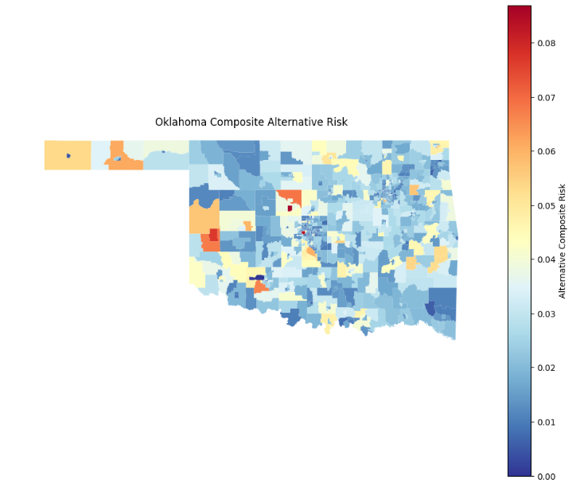
Shown below is figure 2 which shows the composite alternative risk map for Washington. The state overall has a low risk, with only one region of high risk. This region is mountainous which could explain potential hazards.
Figure 2: Washington Composite Alternative Risk Map
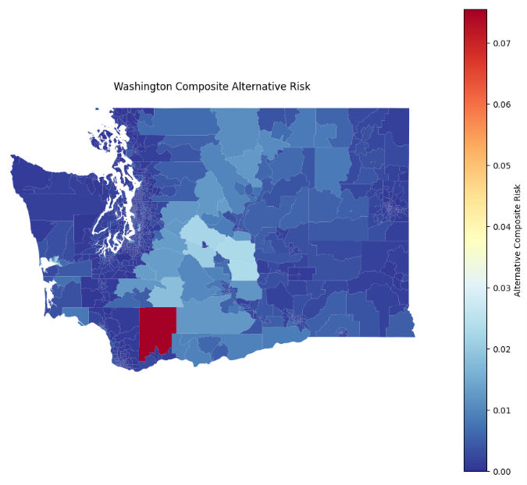
Below in figure 3, the Oklahoma tornado risk is mapped. Central Oklahoma is of very high risk, with the Western side being slightly riskier than the East. Tornados are more common in central Oklahoma, so this map is an accurate depiction of teh distribution of tornado risk in Oklahoma.
Figure 3: Oklahoma Tornado Alternative Risk Map
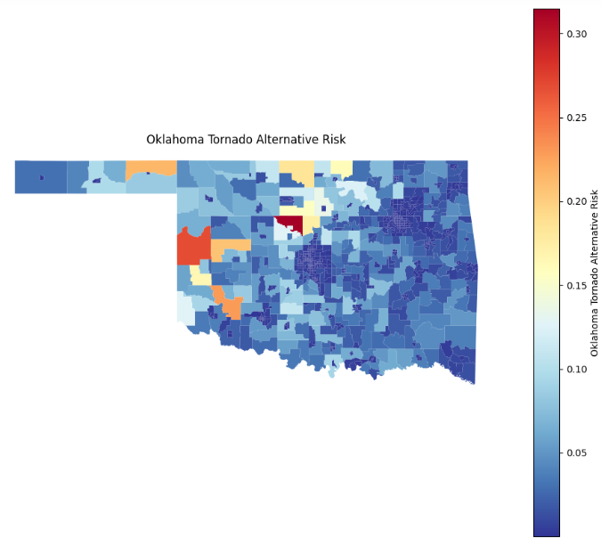
The earthquake risk in Washington was mapped in figure 4. Washington has a very low risk of earthquakes, according to the figure, with only one area of low risk.
Figure 4: Washington Earthquake Alternative Risk Map
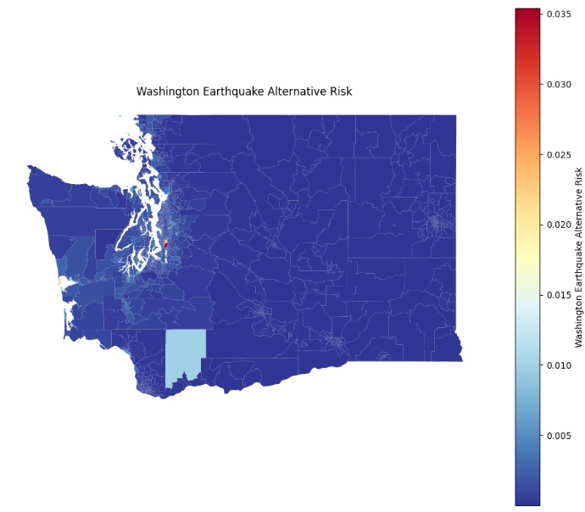
Finally, the washington wildfire risk was mapped in figure 5. The distribution of risk shows a higher risk straight through central Washington. This strip lines perfectly with the Cascade Range, a mountain range in Washington. Mountains often have denser g=forests and dry vegetation which can fuel wildfires. Campfires can cause wildfires, which is a common practice in mountainous regions.
Figure 5: Washington Wildfire Alternative Risk
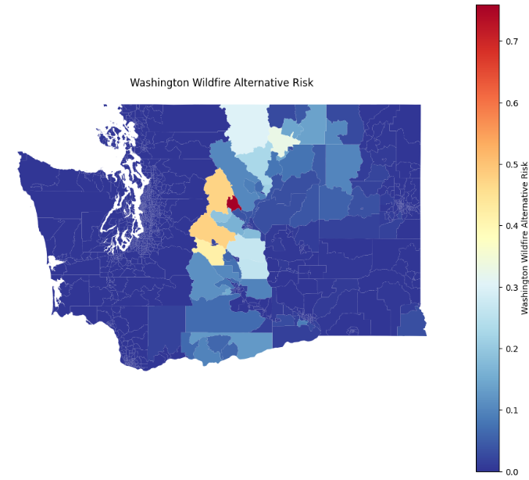
Overall, what these figures show is how our proposed method of calculated risk can be mapped. Its mapping shows accurate results that align with real climate and geographical data. Through the tables and mapping, we found that the NHI method underestimates local extreme hazards by standardizing events nationally. Our method is standardized by population, which makes our values smaller but more variable. Both have many biases in how risk is determined and how each state would have different reactions/impacts.

References
  - National Risk Index: Future Risk Technical Documentation. (2024). https://eelp.law.harvard.edu/wp-content/uploads/2025/03/NRI_Future_Risk_Technical_Document.pdf
  - ‌FEMA. (n.d.). Understanding Scores and Ratings | National Risk Index. Hazards.fema.gov. https://hazards.fema.gov/nri/understanding-scores-ratings
  - ‌FEMA. (n.d.). Data Resources | National Risk Index. Hazards.fema.gov. https://hazards.fema.gov/nri/data-resources
  - ‌CDC. (2024, October 22). SVI Data & Documentation Download. Place and Health - Geospatial Research, Analysis, and Services Program (GRASP). https://www.atsdr.cdc.gov/place-health/php/svi/svi-data-documentation-download.html
  - ‌Cremen, G., Galasso, C., & McCloskey, J. (2021). Modelling and quantifying tomorrow’s risks from natural hazards. Science of the Total Environment, 152552. https://doi.org/10.1016/j.scitotenv.2021.152552

