**[DOING PHYSICS WITH MATLAB](https://d-arora.github.io/Doing-Physics-With-Matlab/)**

**THE FINITE DIFFERENCE METHOD FOR THE NUMERICAL ANALYSIS OF CIRCUITS CONTAINING RESISTORS, CAPACITORS AND INDUCTORS**

Ian Cooper

Please email any corrections, comments, suggestions or additions: matlabvisualphysics@gmail.com

[Matlab Download Directory](https://drive.google.com/drive/u/3/folders/1j09aAhfrVYpiMavajrgSvUMc89ksF9Jb)

**CN01.m**

Voltage and current for a resistor, capacitor and inductor calculations using the finite difference method.

**CN02.m**

Animation of the phasors for a resistor, capacitor and inductor.

[view animation](https://d-arora.github.io/Doing-Physics-With-Matlab/mpDocs/ag_CN02.gif)

Numerical methods are often used to study mechanical systems. However, these same methods can be employed to investigate the response of circuits containing resistors, capacitors and inductors. A wide range of circuit responses for different signal inputs can be modelled very easily. For example, the transient response of circuits; the frequency response of filters and tuned circuits; resonance, damped and forced oscillations; voltage, current, power, energy and phase relationships. Also, the method can be used for circuit design.

No differential equations need to be solved and no integrals evaluated. All that is necessary is to model the incremental changes that occur in currents and voltages in a brief time period where the derivative of a function is approximated using a finite difference.

Resistors, capacitors and inductors are basic components of circuits. These components are connected to a source of electrical energy. A simple model for the source of electrical energy is to consider it to be a voltage source called the emf  and a series resistance called the internal resistance *Rint*. The potential difference applied to a circuit is called the terminal voltage or **input voltage** . If a current  is supplied from the electrical energy source to a circuit, the input (terminal) voltage is

(1) 

In the computer modelling of circuit behaviour, the effects of internal resistance of the source can be considered. Suitable electrical sources include step, on/off/on, sinusoidal and pulsed functions.

The script **CN01.m** is used to model the voltage across and current through the passive elements resistor, capacitor and inductor.

**RESISTOR**

For a **resistor** *R*, the voltage  across it and the current  through it are always in phase and related by the equation

­*v*R(*t*) = *R i*(*t*)

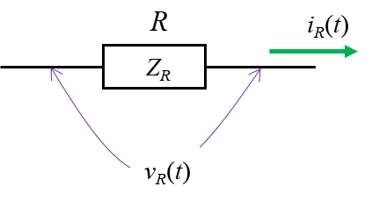

For a sinusoidal current through the resistor and the voltage across it are given by

(2) 

Lowercase letters are used for currents and voltages which are functions of time whereas uppercase letters are used for peak values (amplitude).

Figures 1 and 2 show the graphical output from the script **CN01.m**. The voltage across the resistor is in phase with the current such that the voltage is proportional to the current.

The ratio of the peak voltage to the peak current is called **the impedance**.

(3) 

The resistance is independent of the input frequency.

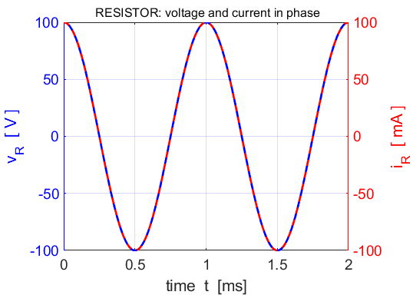

Fig. 1. The voltage across a 1000  and the current through it as functions of time. The current and voltage are in phase.  **CN01.m**

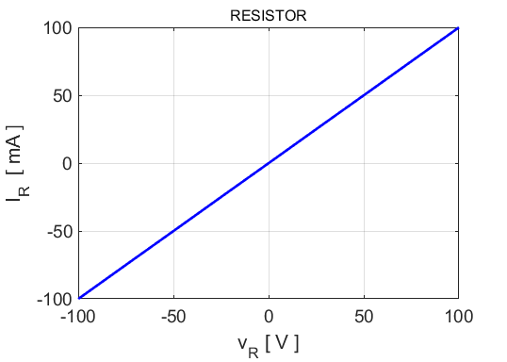

Fig. 2. The phase plot of the voltage across a 1000  against and the current through the resistor is a straight line. The reciprocal of the slope of the line is equal to the resistance.

Numerical results are summarised in the Command Window:

input frequency f = 1000.00 Hz

resistance R = 1000.00 ohms

peak voltage VR = 100.00 V

peak current IR = 100.00 mA

impedance ZR = 1000.00 ohms

theoretical impedance ZR_T = 1000.00 ohms

**CAPACITOR**

A **capacitor** consists of two metal plates separated by an insulating material. When a potential difference *v*C exists across a capacitor, one plate has a positive charge +*q* and the other plate a charge –­*q*. The charge *q* is proportional to the potential difference between the plates of the capacitor. The constant of proportionality is called the **capacitance** (farad F).

(4) 

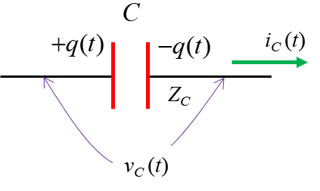

Differentiating both sides of this equation with respect to *t* and using the fact that  we get

(5) 

We can write this equation in terms of differences rather than differentials

(6) 

Thus, a capacitor will resist changes in the potential difference across it because it requires a time Δ*t* for the potential difference to change by ΔvC. The potential difference across the capacitor decreases when it discharges and increases when charging. The larger the value of *C*, the slower the change in potential. If Δ*t* is “small”, then to a good approximation, the potential difference across the capacitor at time *t* is

Forward difference

(7A) 

Central difference

(7B) 

The magnitude of the impedance  of a capacitor is called the **capacitive reactance**  and is equal to the ratio of peak voltage  to peak current 

(8A) 

(8B) 

Figures 3 and 4 show the graphical output of the script **CN01.m**. It shows that the phase of the voltage lags the phase of the current by  rad. The phase plot for the capacitor (figure 4) sweeps out an ellipse with time in a clockwise sense.

The input corresponds to the current

(9) 

as shown by the red cosine curve in figure 3. The blue curve corresponds to the voltage across the capacitor calculated using the finite difference method. The voltage across the capacitor corresponds to a sine curve

(10) 

The voltage and current are not in phase. The instantaneous voltage  lags the instantaneous current  by  rad.

The Command Window displays a summary of the results for the capacitor calculations using the script **CN01.m**

input frequency f = 1000.00 Hz

capacitance C = 1.00e-06 F

peak voltage VC = 15.93 V

peak current IC = 100.00 mA

impedance ZC = 159.26 ohms (equation 8A)

theoretical impedance ZC_T = 159.15 ohms (equation 8B)

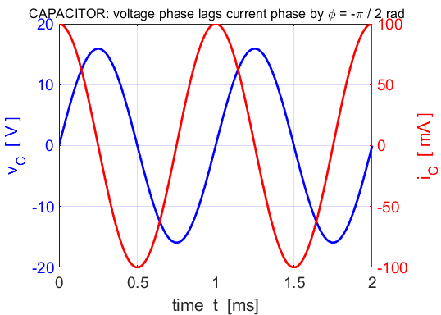

Fig. 3. The voltage across a 1.00 capacitor and the capacitor current as functions of time. The capacitor voltage lags the capacitor current by  rad.  **CN01.m**

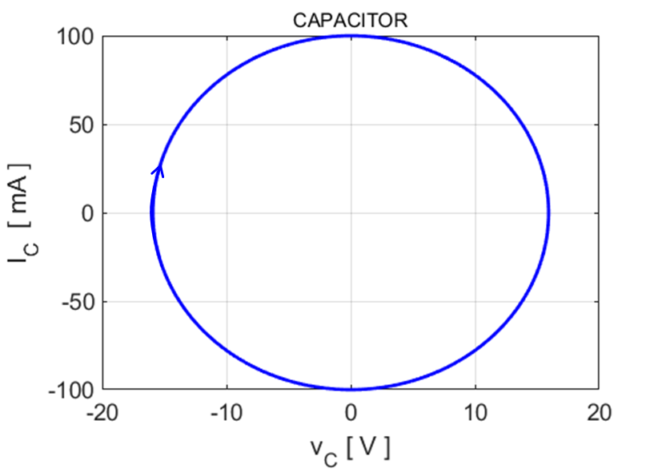

Fig. 4. The phase plot of the voltage across a 1.00 capacitor against and the capacitor current is an **ellipse** that is swept out with time in a clockwise sense.

**INDUCTOR**

An **inductor** can be considered to be a coil of wire. When a varying current passes through the coil, a varying magnetic flux is produced and this in turn induces a potential difference across the inductor. This induced potential difference opposes the change in current. The potential difference across the inductor is proportional to the rate of change of the current, where the constant of proportionality *L* is known as the **inductance** of the coil (henrys H) and is given by the equation

(11) *v*L = *L* d*i*/d*t*

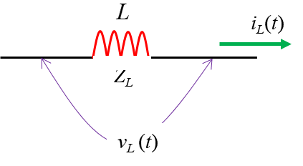

This equation can be expressed in terms of differences,

(12) 

Thus, an inductor will resist changes in the current through it because it requires a time Δ*t* for the current to change by Δ*i*.

If Δt is “small”, then to a good approximation, the current through the inductor at time *t* is

Forward difference

(13A) 

Central difference

(13B) 

The magnitude of the impedance  of an inductor is called the **inductive reactance**  and is equal to the ratio of peak voltage  to peak current 

(14A) 

(15B) 

Figures 5 and 6 show the graphical output of the script **CN01.m**. It shows that the voltage leads the current by  rad. The phase plot for the inductor (figure 6) sweeps out an ellipse with time in an anticlockwise sense.

The input corresponds to the voltage

(9) 

as shown by the blue sine curve in figure 5. The red curve corresponds to the inductor current calculated using the finite difference method (equation 13). The inductor current corresponds to a negative cosine curve

(10) 

The voltage and current are not in phase. The instantaneous current  lags the instantaneous voltage  by  rad. Alternatively, the instantaneous voltage  leads the instantaneous current  by  rad.

The Command Window displays a summary of the results for the capacitor calculations using the script **CN01.m**

input frequency f = 1000.00 Hz

inductance L = 1.00e-02 H

peak voltage VL = 10.00 V

peak current IL = 159.13 mA

impedance ZL = 62.84 ohms (equation 14A)

theoretical impedance ZL_T = 62.83 ohms (equation 14B)

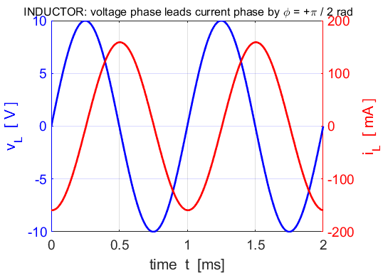

Fig. 5. The voltage across a 10.0 mH inductor and the inductor current as functions of time. The inductor voltage leads the capacitor current by  rad.  **CN01.m**

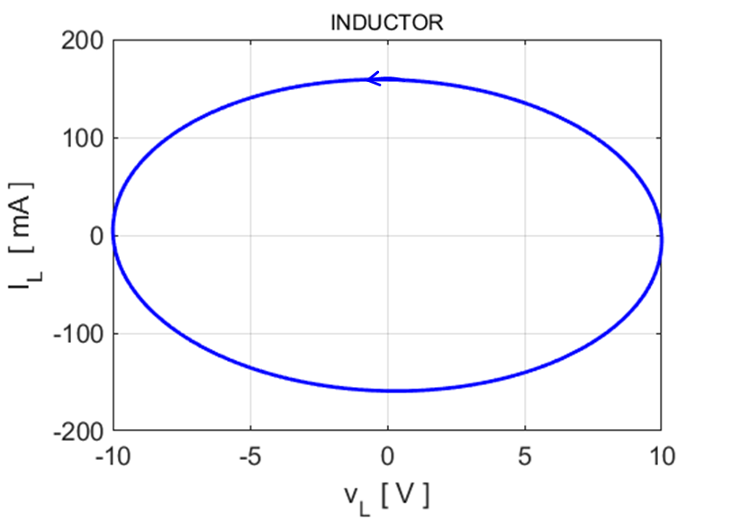

Fig. 6. The phase plot of the voltage across a 100 mH inductor against and the inductor current is an **ellipse** that is swept out with time in a clockwise sense.

The phases between the voltage and currents can be shown in phasor diagrams such as shown in figure 7. The phasors rotate anticlockwise with an angular velocity . One rotation is completed in a time interval of one period . An animation of the phasors was created with the script **CN02.m**.

[view animation](https://d-arora.github.io/Doing-Physics-With-Matlab/mpDocs/ag_CN02.gif)

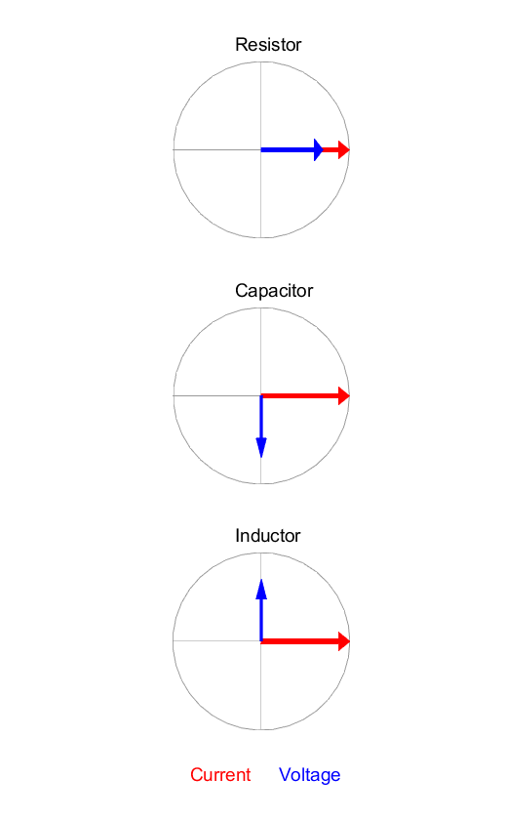

Fig. 7. Phasor diagrams for a resistor, capacitor and inductor. The phasors rotate anticlockwise with an angular velocity . Resistor: voltage and current in phase. Capacitor: voltage lags current by . Inductor: Voltage leads current by .

**Matlab Script CN01.m**

All parameters are expressed in S.I. Units unless stated otherwise.

The input parameters are specified in the INPUT section

% INPUTS: S.I. UNITS =================================

R = 1.0e3;

C = 1e-6;

L = 10e-3;

IR = 0.10;

IC = 0.10;

VL = 10;

f = 1e3;

N = 200;

It is very easy to implement the finite difference routines.

% CALCULATIONS ==========================================================

T = 1/f;

w = 2*pi*f;

tMax = 2*T;

t = linspace(0,tMax,N);

dt = t(2)-t(1);

iR = IR.*cos(w*t);

vR = R .* iR;

kC = 2*dt/C;

iC = IC.* cos(w*t);

vC = zeros(1,N);

vC(2) = vC(1)+(dt/C)*iC(1);

kL = 2*dt/L;

vL = VL .* sin(w*t);

iL = zeros(1,N);

iL(2) = iL(1)+(dt/L)*vL(1);

for c = 3 : N-1

vC(c) = vC(c-2) + kC*iC(c-1);

iL(c) = iL(c-2) + kL*vL(c-1);

%iL(c) = iL(c-1)+(dt/L)*vL(c-1);

end

iL = iL - max(iL)/2;

% not sure why need to shift the current

% Peak values /Impedances / reactances

VR = max(vR);

IR = max(iR);

VC = max(vC);

IC = max(iC);

VL = max(vL);

IL = max(iL);

ZR = VR/IR; % resistance

ZC = VC/IC; % capacitive reactance

ZL = VL/IL; % inductive reactance

% Theorteical values for impedance

ZR_T = VR/IR;

ZC_T = 1/(w*C);

ZL_T = w*L;