**[DOING PHYSICS WITH MATLAB](https://d-arora.github.io/Doing-Physics-With-Matlab/)**

**FINITE DIFFERENCE METHOD:**

**NUMERICAL ANAYSIS OF RC CIRCUITS**

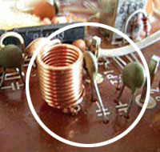

Ian Cooper

Please email any corrections, comments, suggestions or additions: matlabvisualphysics@gmail.com

[Matlab Download Directory](https://drive.google.com/drive/u/3/folders/1j09aAhfrVYpiMavajrgSvUMc89ksF9Jb)

**CN03.m**

Modelling RC circuits using the finite difference method to approximate the voltage across the capacitor. Many different input signals can be used to calculate the response of the circuit. Circuit parameters in set in the INPUT section of the script. The variable flagV is used to select the input signal voltage using the switch/case commands. The input signal and time scales are changed within the switch/case statements. The load is placed across the capacitor. Thus, the output voltage is calculated across the capacitor. The code can be easy changed so that the load is placed across the resistor instead of the capacitor. Also, the code can be modified to analyse RL circuits.

**CN04.m**

Script for RC circuit that is used to model the flash rate for strobe lighting. The voltage changes are calculated using the finite difference method.

**CN05.m**

Script for a simple series RC circuit that is excited by a square wave function as the source emf. An elegant algorithm is used to produce the square wave source emf.

**Finite Difference Method and RC Circuits**

Using the finite difference method, RC circuits can be investigated in much more detail than could be done by the traditional analytical methods most often employed. The response of RC circuits can be model for a wide range of input signals with just one Matlab script. The script **CN03.m** models a RC circuit with the load resistance connected in parallel to the capacitor as shown in figure 1.

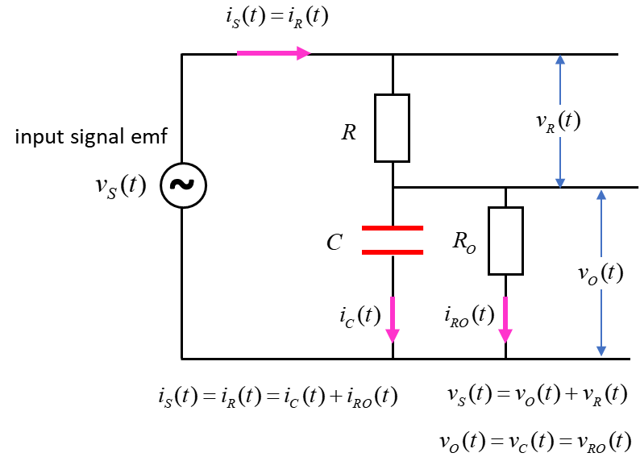

Fig. 1. RC circuit model with the script **CN03.m**

Some of the concepts that can be investigated with different input signals include transient effects; charging and discharging a capacitor; low and high pass filters; differentiating circuits and smoothing.

The response of the circuit to an input signal is calculated using Kirchhoff’s Voltage and Current Laws and using the finite difference approximation for the voltage across the capacitor



The first step is to specify the input source voltage  as a function of time. This is done within the switch/case statements.

Step 2: Set all the initial values for the variables: voltages, currents, charge on capacitor, powers and energies. We always assume that at time  that the capacitor is uncharged,.

|  |
| --- |
| % Initialise values  vR = zeros(1,N);  vC = zeros(1,N);  iR = zeros(1,N);  iRO = zeros(1,N);  iC = zeros(1,N);  qC = zeros(1,N); |

Step 3: Evaluate the voltages and currents at the first time step.

|  |
| --- |
| % Time Step #1  vR(1) = vS(1);  vC(1) = 0; % assume capacitor initially uncharged  iR(1) = vR(1)/R;  iC(1) = iR(1);  iRO(1) = 0; |

Step 4: Calculate the voltages, currents and capacitor charge at all time steps.

|  |
| --- |
| k = dt/C;  % Time Steps #2 to #N  for c = 2 : N  vC(c) = vC(c-1) + k*iC(c-1);  vR(c) = vS(c) - vC(c);  iR(c) = vR(c)/R;  iRO(c) = vC(c)/RO;  iC(c) = iR(c) - iRO(c);  qC(c) = qC(c-1) + iC(c-1)*dt;  end |

Step 5: Calculate the power and energies absorbed or supplied to the circuit. The power  for an element is calculated from the relationship



and the energies  at time step *c* from the relationship



|  |
| --- |
| % Powers and energy  iS = iR;  pS = vS .* iS;  pO = vC .* iRO;  pC = vC .* iC;  uS = zeros(1,N); uO = zeros(1,N); uC = zeros(1,N);  for c = 2 : N  uS(c) = uS(c-1) + pS(c)*dt;  uO(c) = uO(c-1) + pO(c)*dt;  uC(c) = uC(c-1) + pC(c)*dt;  end |

For accurate results the time increment  should be chosen so that

  where is the time constant

The time step is set to  in the script **CN03.m**.

|  |
| --- |
| % Time constant and time step  tau = R*C;  dt = tau/100; |

**Transient Response of RC Circuits:**

**Charging and Discharging of the capacitor**

The term  is called the **time constant** and has units of time.

The **discharging** of the capacitor is described by the equation



In a time of one time constant , the voltage across the capacitor drops to  where  is the initial voltage across the capacitor. The capacitor can be regarded as fully discharged after a time interval of .

The **charging** of the capacitor is described by the equation



In a time of one time constant , the voltage across the capacitor rises to  where  is the voltage across the capacitor when it is fully charged. The capacitor can be regarded as fully charged after a time interval of .

Figure 2 shows the response of the circuit to the step function (on/off). At time *t* = 0 s, the capacitor is fully discharged. It then charges and after a time , the capacitor becomes fully charged and the voltage across it remains constant until the source voltage (input voltage) drops to zero. The capacitor then discharges. Figure 2 clearly shows how the capacitor will resist changes in the voltage across it, because it requires a time  for the voltage to change . The values of *R* and *C* can be easily changed in the script **CN03.m** to show the dependence of the transient response to the time constant . The Matlab Data Cursor tool can be used to measure the time constant  for either the charging or discharging of the capacitor.

It easy to calculate the circuit parameters as functions of time and plot them. For example, figure 3 shows the capacitor current and charge as functions of time for the step function (on/off) voltage source as shown in figure 2.

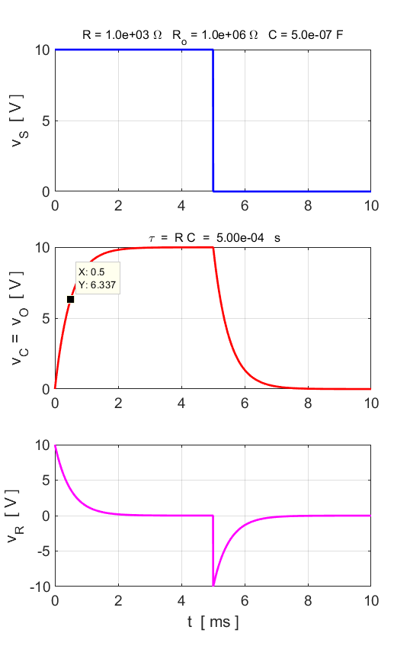

Fig. 2. The transient response of the RC circuit to a step function (ON/OFF) which shows the charging and discharging of the capacitor. The time constant is  **CN03.m** flagV = 2.

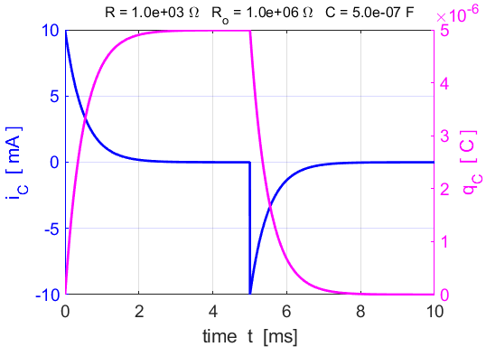

Fig. 3. The transient response of the RC circuit to a step function (ON/OFF) which shows the charging and discharging of the capacitor in terms of the capacitor current and charge. The time constant is  **CN03.m** flagV = 2.

We can also examine the energy exchanges that take place in the circuit. When a current passes through a resistance, energy is always lost from the circuit as thermal energy that causes a rise in temperature of the resistor. The power dissipated in the resistor is always greater or equal to zero and zero energy is stored by the resistor. When power is given to the circuit by the voltage source, the capacitor charges and energy is stored in the electric field created by the charges stored on the plates of the capacitor. However, when the power supplied by the source is zero, the capacitor discharges and the stored energy of the capacitor is returned to the circuit. There is no energy dissipation in our ideal capacitor – energy is either stored or supplied to the circuit. The energy exchanges that occur in the RC circuit is best illustrated graphically as shown in figures 5 and 6 for the supply voltage shown in figure 4. The plots show the power and energy as functions of time.

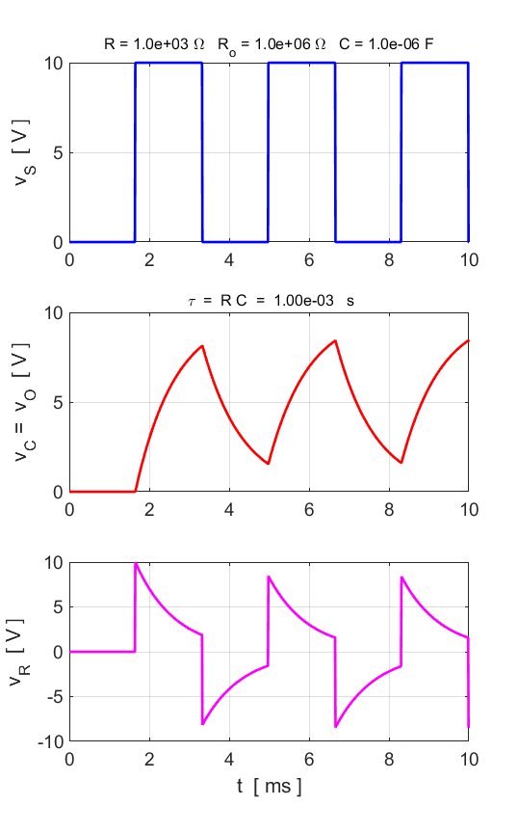

Fig. 4. A pulsed input supply emf.

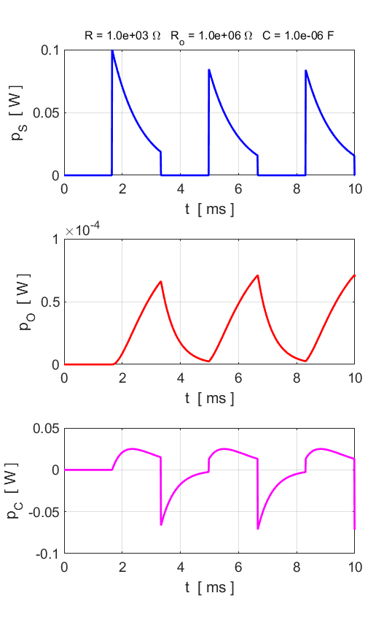

Fig. 5. The power supplied to the circuit *pS,* the power dissipated *pO* in the output (load) resistance and the power stored or supplied by the capacitor *pC.*

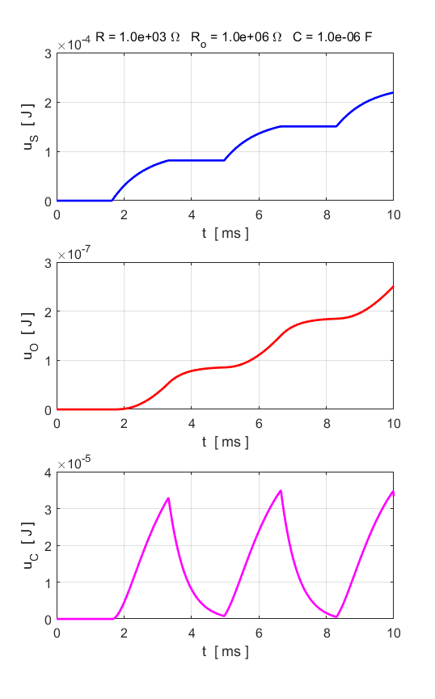

Fig. 6. The energy supplied to the circuit *uS,* the energy dissipated *uO* in the output (load) resistance and the energy stored or supplied by the capacitor *uC.*

The response of the RC circuit to a simple step function (OFF/ON) is shown in figures 7, 8, 9 and 10.

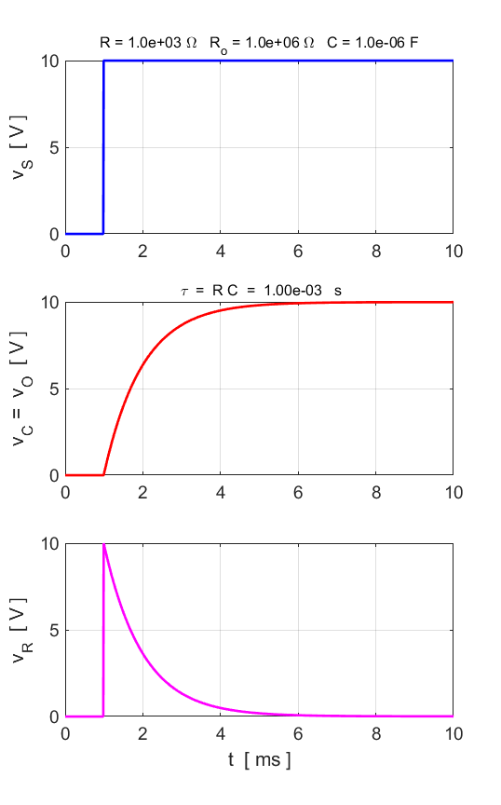

Fig. 7. A simple step (OFF/ON) input supplied voltage.

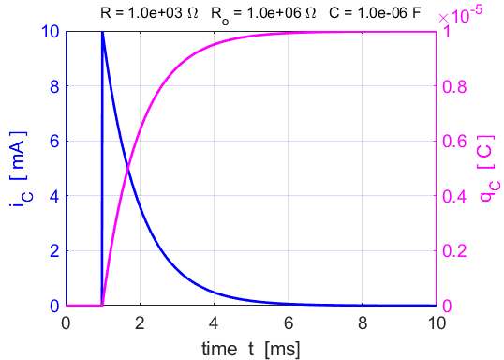

Fig. 8. Capacitor charging.

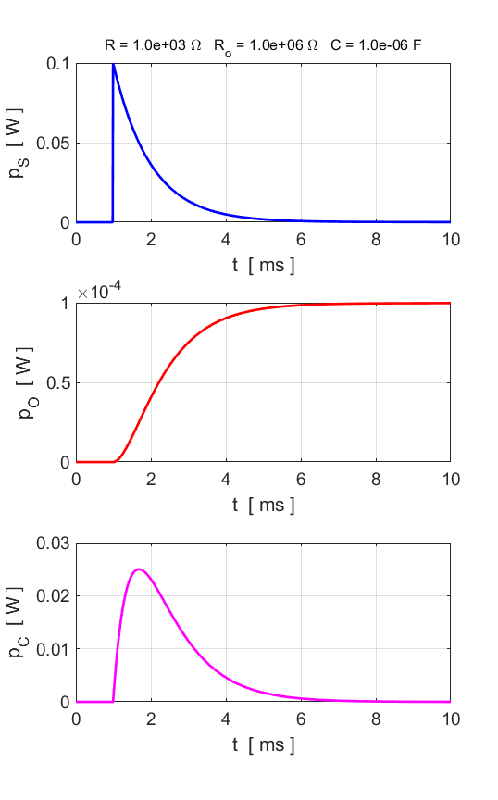

Fig. 9. The power exchanges as functions of time.

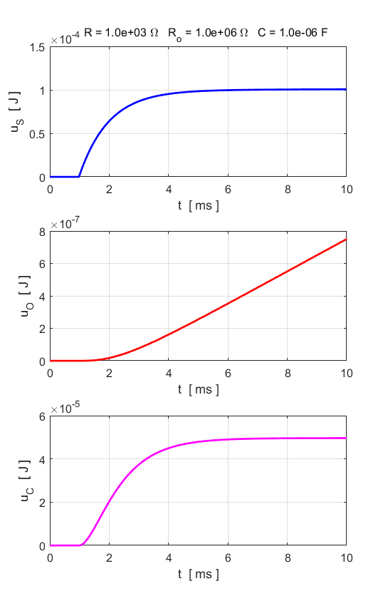

Fig. 10. The energy exchanges as functions of time. The capacitor becomes fully charged and stores energy.

**Differentiating Circuit**

The voltage across the resistor *R* can be expressed as



For a large load resistance and when  is small, we can make the approximations





Then,



Hence, the series RC circuit can act as a differentiating circuit, since  is approximately proportional to  as shown in figure 11.

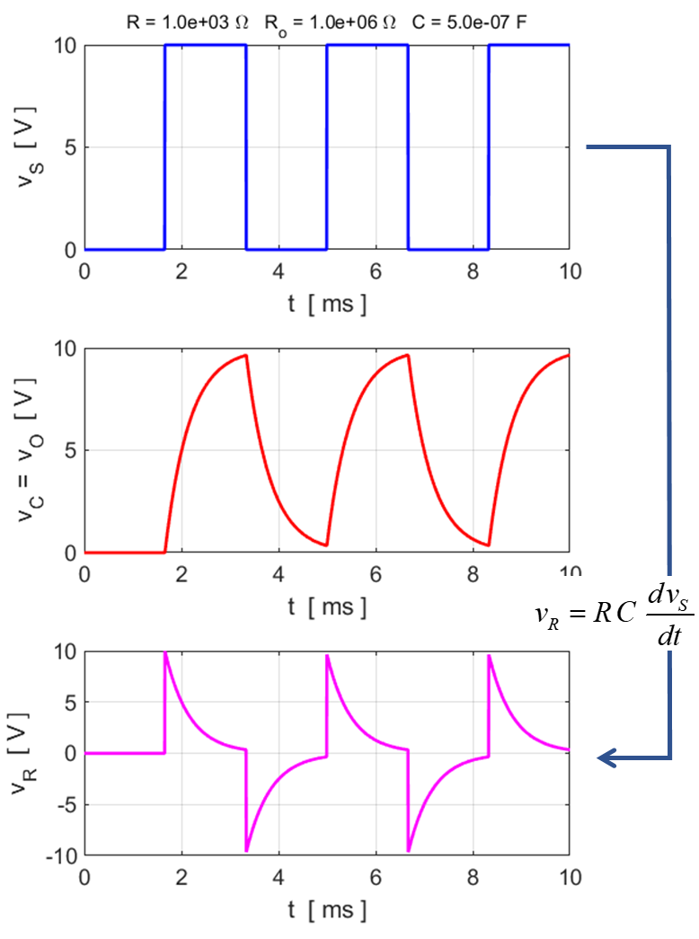

Fig. 11. The series RC circuit can act as a differentiating circuit, since  is approximately proportional to  .

**CN03.m** (flagV = 3).

**Sinusoidal Source emf**

We can model the RC circuit acting a filter by calculating the response of the circuit to a sinusoidal source (input) voltage.

In the switch/case statements, FlagV = 4 gives the calculation for the sinusoidal source emf. The frequency of the source is set within this segment of the code. The circuit acts as a low pass filter when the output is measured across the parallel combination of the capacitor and output (load) resistor. The voltage across the series resistor can be used to model the behaviour of a high pass filter. By varying the source frequency f, you will observe how the low pass filter attenuates higher frequency inputs but not the lower frequencies. Whereas, for the voltage across the resistor, the lower frequencies are more attenuated.

|  |
| --- |
| case 4 % sinusoidal input  f = 320;  w = 2*pi*f;  T = 1/f;  nT = 3;  tMax = nT*T;  t = 0:dt:tMax;  N = length(t);  vS = VS .* sin(w*t); |

The frequency at which the output (load) power is half the maximum power at the lowest frequencies is called the **cut-off frequency** *fc.* The cut-off frequency *fc* for an RC filter shown in figure 1 is given by



Figure 12 shows the source emf, the voltage across the capacitor (output) voltage and the voltage across the resistor at a low frequency . At low frequencies, the source voltage is in phase with the voltage across the capacitor (output voltage) while the voltage across the resistor leads the source voltage by . Figure 13 shows powers absorbed or supplied. The maximum power absorbed by the load is 1.00x10-4 W. The power to the output is always positive meaning that energy is dissipated and not stored by the output resistance. The power as a function of time for the capacitor shows that during a half-cycle the energy is stored  and the other half-cycle the stored energy is returned to the circuit . So, the average power for the capacitor is zero for each complete cycle.

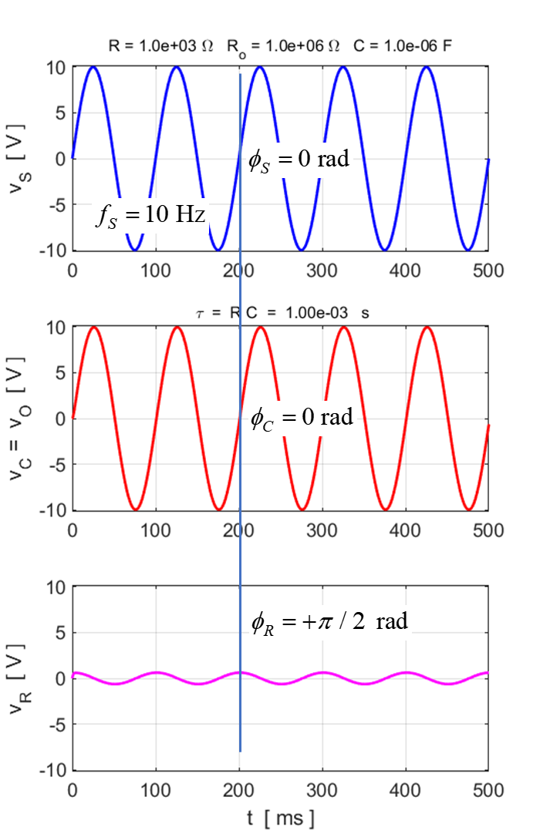

Fig. 12. A sinusoidal source voltage applied to the RC circuit. 

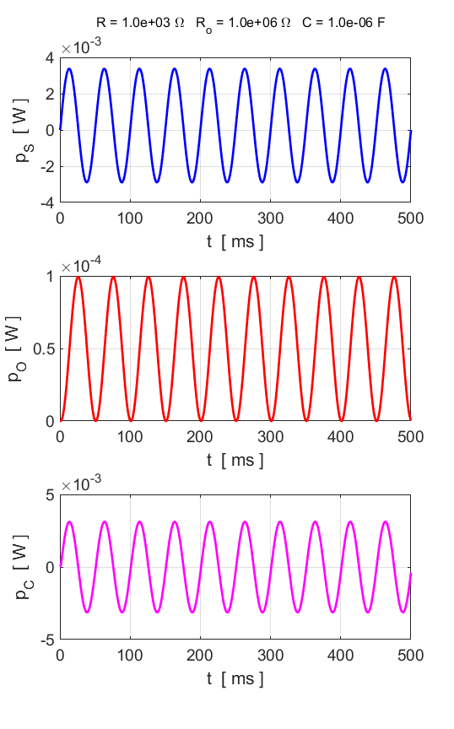

Fig. 13. The power as a function of time for the source, capacitor and output resistance. 

Figures 14 and 15 show the results of the modelling when the source frequency is equal to the cut-off frequency . The voltage across the capacitor (output) lags the source voltage by 1/8 cycle or .

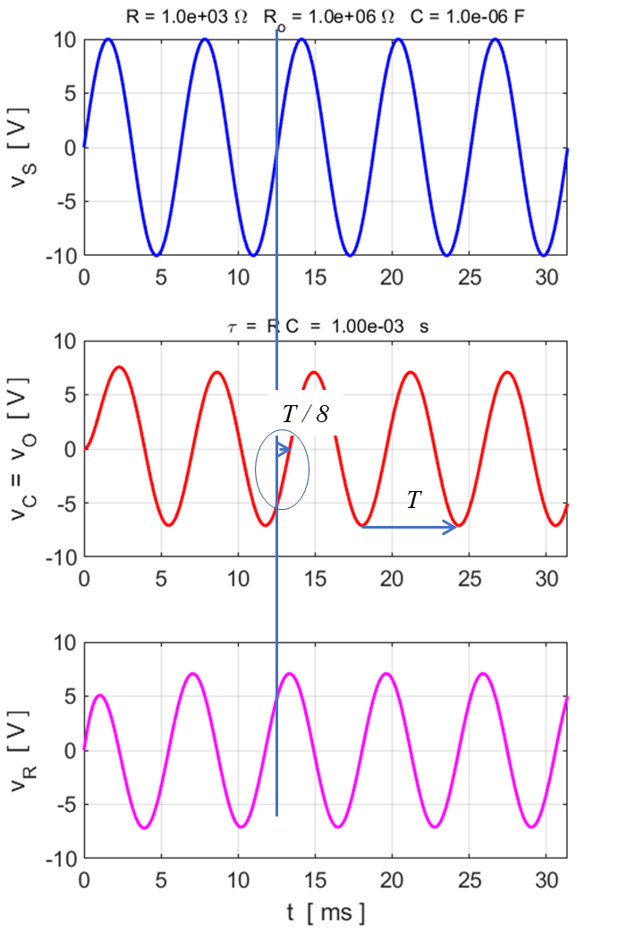

Fig. 14. A sinusoidal source voltage applied to the RC circuit. 

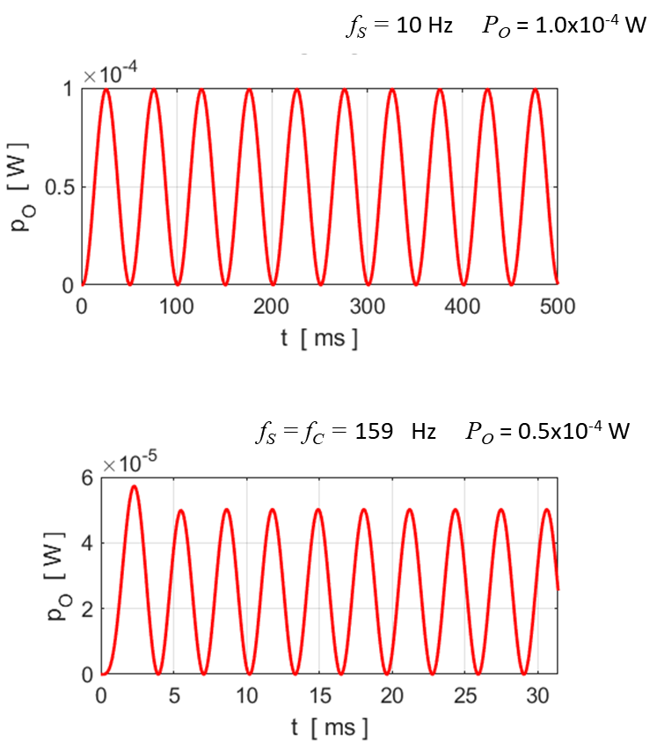

Fig. 15. When the source frequency equals cut-off frequency, the peak power is half the maximum peak power absorbed by the output resistance at frequencies much smaller than the cut-off frequency.

At high frequencies above the cut-off frequency, the larger voltage is across the series resistor and not the capacitor as shown in figure 16.

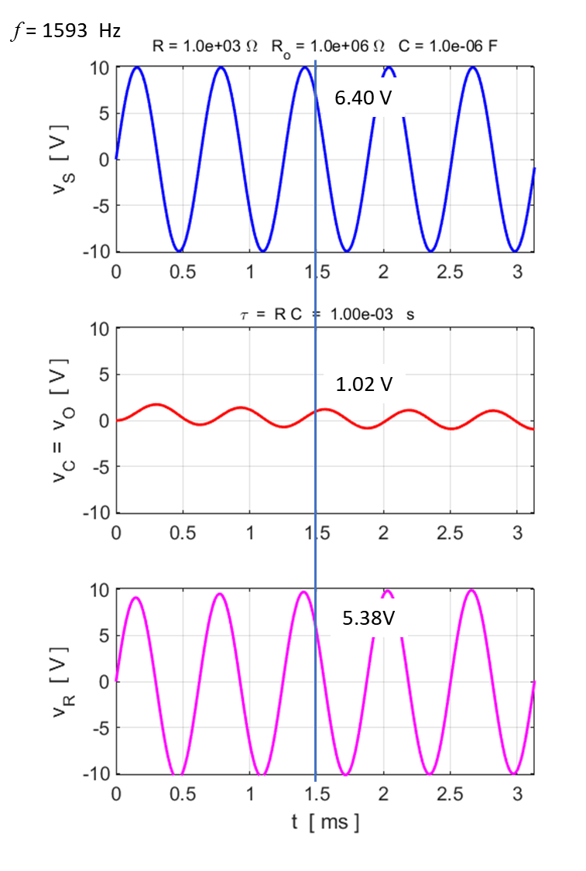

Fig. 16. For frequencies above the cut-off frequency, the larger voltage is across the series resistor and not the capacitor (high pass filter if output across the series resistor). Note, that Kirchhoff’s Voltage Law is satisfied at all time.



**Filters: Superposition of sinusoidal input voltages**

We can observe the filtering effects of a low pass filter by selecting the source voltage as a superposition of two sinusoidal voltages: one voltage has a low frequency and the other a high frequency.

Use flagV = 6 for the source voltage. The code from the script **CN03.m** for case 6 is shown in the Table.

|  |
| --- |
| case 6 % Input: superposition of sinusoidal signals  f = 100;  w = 2*pi*f;  T = 1/f;  nT = 3;  tMax = nT*T;  t = 0:dt:tMax;  N = length(t);  vS = VS .* sin(w*t) + (0.25*VS) .* sin(20*w*t); |

Fig. 17 shows the graphical output. Notice how the high frequency signal is attenuated in the voltage across the output, making it smooth with the high frequency fluctuations reduced.

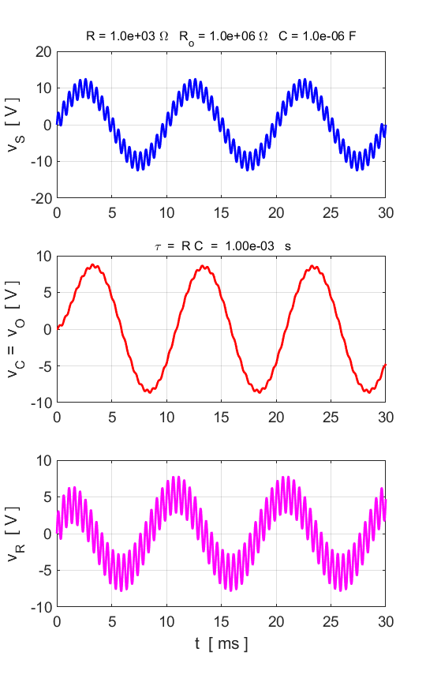

Fig. 17. A low pass filter attenuates the high frequency components of the source voltage. The source voltage is the superposition of two sinusoidal voltages.



**Smoothing a rectified signal**

Capacitors are often used to reduce the fluctuations in a voltage signal that has been rectified. This is often referred to as smoothing a rectified signal. The rectified signal is calculated by taking the absolute value of a sinusoidal source voltage .

Use flagV = 5 for the source voltage. The code from the script **CN03.m** for case 5 is shown in the Table.

|  |
| --- |
| case 5 % sinusoidal input - rectified  dt = tau/500;  f = 200;  w = 2*pi*f;  T = 1/f;  nT = 8;  tMax = nT*T;  t = 0:dt:tMax;  N = length(t);  vS = abs(VS .* sin(w*t)); |

Fig. 18 shows the graphical output. Notice how the high frequency signal is attenuated in the voltage across the output.

The action of the low pass filter smooths the voltage across the capacitor by attenuating the fluctuations as a capacitor opposes any voltage fluctuations across it. The larger the capacitor, the greater the smoothing effect (figure 18).

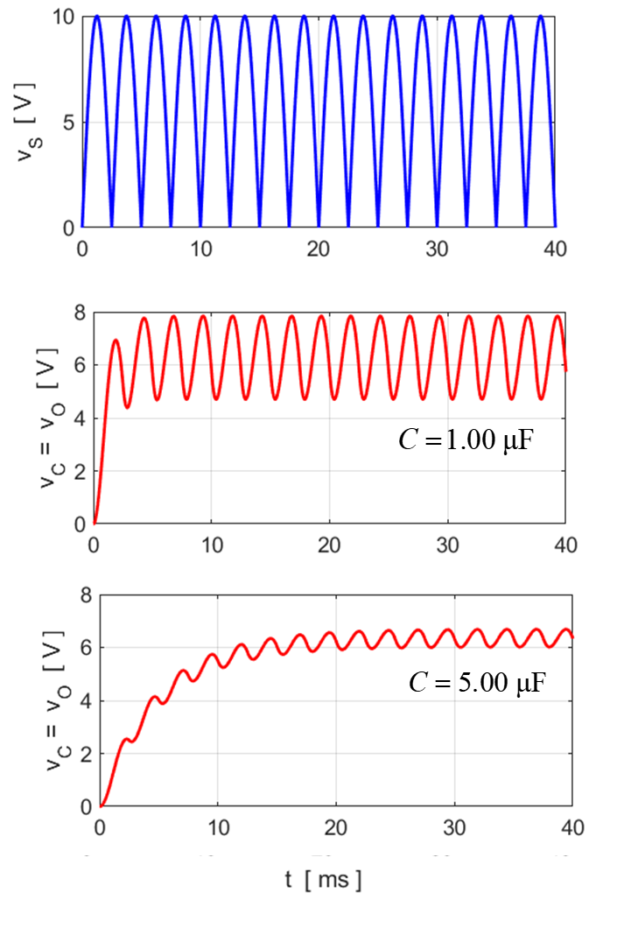

Fig. 18. The capacitor opposes any changes in the voltage across it. So, a capacitor is often used in a circuit to smooth a rectified voltage. The larger the capacitor, the greater the smoothing.



The script **CN03.m** can be easily modified to investigate:

* High pass filter circuits in more detail. The output is across the series resistance.
* *R L* circuits: use



**MODELLING A STROBE LIGHT**

One method for producing strobe lighting is to use the RC circuit as shown in figure 19. After the switched is closed, the capacitor charges through the resistor. When the potential difference across the capacitor reaches the breakdown potential for the flash tube, it discharges through the tube very rapidly to a lower potential difference. The capacitor then charges and discharges repeatedly at regular intervals. We can use the finite difference numerical procedure to find the time between the flashes and the flash rate from the plot of the voltage across the capacitor as a function of time as shown in figure 20.

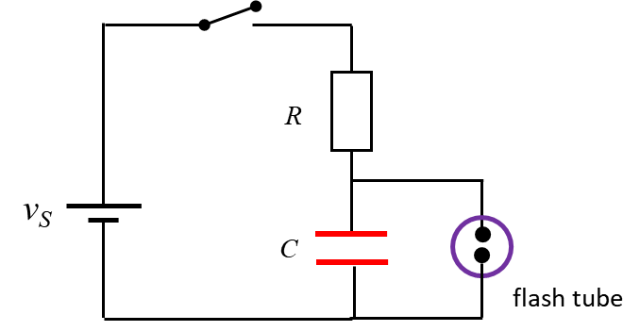

Fig. 19. RC circuit model with the script **CNRL.m**

**Circuit Parameters**

capacitance *C* = 666 μF

resistance *R* = 9000 Ω

Tube breakdown voltage *VB* = 600 V

Tube sustaining voltage *Vtube* = 50 V

**Finite difference Method**

It is a simple algorithm to calculate the voltages and current for the RC circuit used to model the circuit required for our flashing strobe light.

Step 1: Specify values for the circuit.

Step 2: Specify the time scales and set initial values.

Step 3: Implement finite difference algorithm

|  |
| --- |
| % Finite difference algorithm ---------------------------  k = dt/C;  % Time Steps #2 to #N  for c = 2 : N  vC(c) = vC(c-1) + k*iS(c-1);  vR(c) = vS(c) - vC(c);  iS(c) = vR(c)/R;  if vC(c) > VB; vC(c) = Vtube; end  end |

Step 4: Calculate period for the flashes and flash rate

|  |
| --- |
| % Calculate flash rate ----------------------------------  [iS_Peaks, t_Peaks] = findpeaks(real(vC));  nPeaks = length(t_Peaks)-1;  T_Peaks = (t(t_Peaks(end)) - t(t_Peaks(end-nPeaks)))/(nPeaks);  f_Peaks = 1 / T_Peaks; |

Step 5: Plot voltages as functions of time.

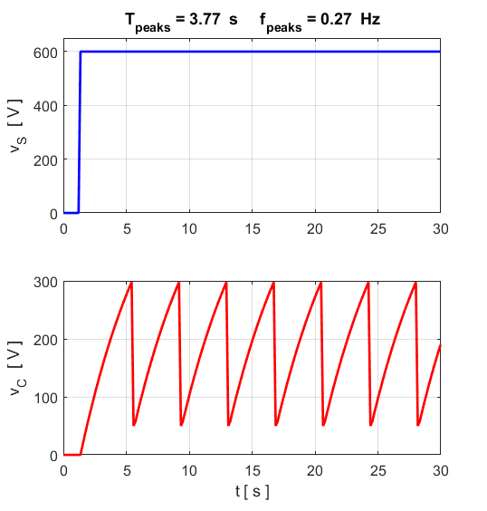

Fig. 20. The time evolution of the source emf and the voltage across the capacitor. When the voltage across the capacitor peaks at 300 V, the flash tube fires and the voltage drops back to 50 V. Then the capacitor charges again. The period of the flashes is 3.77 s and the flash rate is 0.27 Hz.

**SQUARE WAVE EXCITATION**

The response of a simple RC circuit (figure 1) can be calculated for a square wave source emf using the finite difference method to approximate the voltage across the capacitor as a function of time.

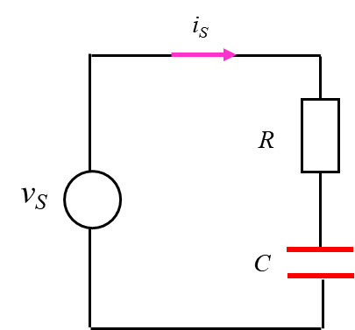

Fig. 21. RC circuit model with the script **CN05.m**

**Finite Difference Method**

It is a simple algorithm to calculate the voltages and current for the RC circuit used to model the circuit for the square wave source emf.

Step 1: Specify values for the circuit.

Step 2: Specify the time scales and set initial values.

|  |
| --- |
| % resistor [1e4]  R = 1e4;  % Capacitor [100e-6]  C = 100e-6;    % Square wave values VH (high) [10] VL (low) [-10]  VH = 10;  VL = -10;  % Number of calculations (check dt << tau) [5000]  N = 5000;  % Max time interval [100]  tMax = 100;  % Period of square wave function [20]  T = 20; |

Step 3: Specify the square wave source emf.

|  |
| --- |
| % Specify source emf  for c = 1 : N  y = sin(2*pi*t(c)/T);  if y >= 0  vS(c) = VH;  elseif y < 0  vS(c) = VL;  end  end |

Step 4: Implement finite difference algorithm

|  |
| --- |
| % Finite difference algorithm ---------------------------  k = dt/C;  % Time Steps #2 to #N  for c = 2 : N  vC(c) = vC(c-1) + k*iS(c-1);  vR(c) = vS(c) - vC(c);  iS(c) = vR(c)/R;  end |

Step 5: Plot voltages as functions of time.

**Graphical outputs for difference Capacitance values**

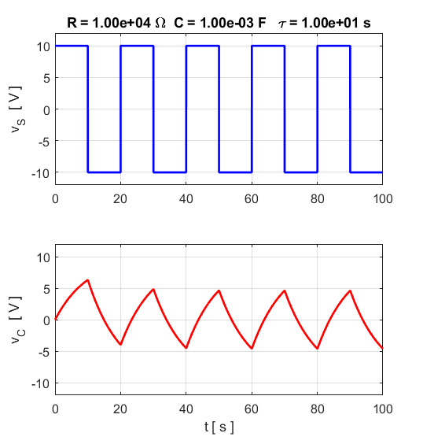

Fig. 22.

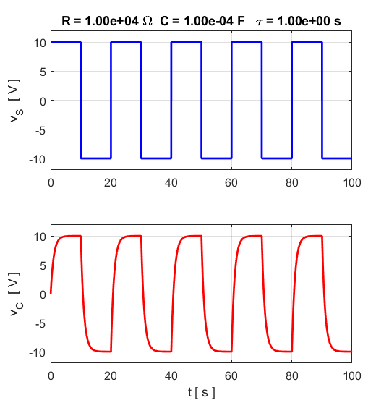

Fig. 23.

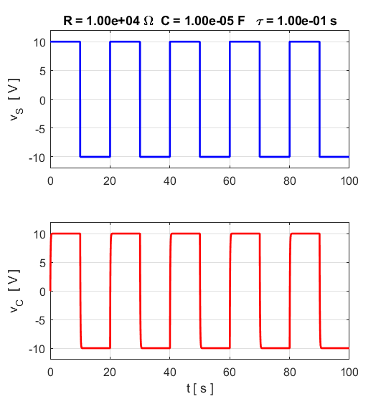

Fig. 24.