**[DOING PHYSICS WITH MATLAB](https://d-arora.github.io/Doing-Physics-With-Matlab/)**

**FINITE DIFFERENCE METHOD:**

**NUMERICAL ANAYSIS OF RL CIRCUITS**

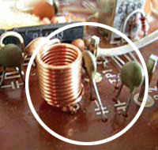

Ian Cooper

Please email any corrections, comments, suggestions or additions: matlabvisualphysics@gmail.com

[Matlab Download Directory](https://drive.google.com/drive/u/3/folders/1j09aAhfrVYpiMavajrgSvUMc89ksF9Jb)

**CNRL.m**

Modelling RL circuits using the finite difference method to approximate the current through an inductor in a series RL circuit. Many different input signals can be used to calculate the response of the circuit. Circuit parameters in set in the INPUT section of the script. The variable flagV is used to select the input signal voltage using the switch/case commands. The input signal and time scales are changed within the switch/case statements.

It may be necessary to change the axis limits of a graph to improve its appearance using

set(gca,'xLim',[0 1e3*max(t)]);

set(gca,'yTick',-10:5:10);

set(gca,'yLim',[-VS-0.2 VS+0.2]);

**Finite Difference Method and RL Circuits**

Using the finite difference method, RL circuits can be investigated in much more detail than could be done by the traditional analytical methods most often employed. The response of RL circuits can be model for a wide range of input signals with just one Matlab script. The script **CNRL.m** models a series RL circuit as shown in figure 1.

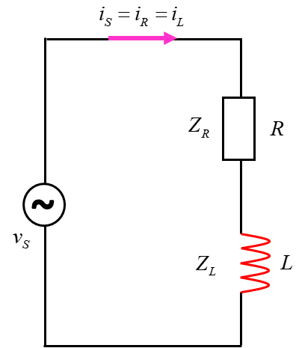

Fig. 1. RC circuit model with the script **CNRL.m**

The response of the circuit to an input signal is calculated using Kirchhoff’s Voltage and Current Laws and using the finite difference approximation for the voltage across the inductor



The finite difference method to analyse the RL circuit is done in the following sequence of steps.

Step 1: Specify the input source voltage  as a function of time. This is done within the switch/case statements using the variable flagV. FlagV = 4 gives a sinusoidal source emf expressed as a complex function. Using complex functions makes it possible to calculate the magnitude, real part, imaginary part and phase of a complex variable.

|  |
| --- |
| % Source emf: flagV = 1 step function off/on  % flagV = 2 step function on/off  % flagV = 3 pulses (square wave)  % flagV = 4 sinusoidal emf  % flagV = 5 rectified sinusoidal emf  % flagV = 6 superposition of sinusoidal emfs  flagV = 4; |

Step 2: Set all the initial values for the voltage and current variables.

Step 3: Evaluate the voltages and currents at the first time step.

|  |
| --- |
| k = dt/L;  % Initialise values  vR = zeros(1,N);  vL = zeros(1,N);  iS = zeros(1,N);    % Time Step #1  if flagV == 2  iS(1) = vS(1)/R;  vR(1) = vS(1);  end |

Step 4: Calculate the voltages and currents all time steps.

|  |
| --- |
| % Time Steps #2 to #N  for c = 2 : N  iS(c) = iS(c-1) + k*vL(c-1);  vR(c) = iS(c) * R;  vL(c) = vS(c) - vR(c);  end |

You will notice that the code is very simple in implementing the finite difference method. There are no differential equations to solve and no complex algebraic expressions.

Step 5: Calculate the power and energies absorbed or supplied to the circuit. The power  for an element is calculated from the relationship



and the energies  at time step *c* from the relationship



|  |
| --- |
| % Powers and energy  pS = real(vS) .* real(iS);  pR = real(vR) .* real(iS);  pL = real(vL) .* real(iS);    uS = zeros(1,N); uR = zeros(1,N); uL = zeros(1,N);  for c = 2 : N  uS(c) = uS(c-1) + pS(c)*dt;  uR(c) = uR(c-1) + pR(c)*dt;  uL(c) = uL(c-1) + pL(c)*dt;  end |

Step 6: Calculate phases of the source, resistor and inductor voltages and the phase of the current at a specified time step.

For the sinusoidal source emf, the impedances and their phases are calculated.

|  |
| --- |
| % Phases [degrees]  % INPUT time to calculate phasors  tP = 0.75*tMax;    nP = find(t > tP,1);  phi_vS = rad2deg(angle(vS(nP)));  phi_vR = rad2deg(angle(vR(nP)));  phi_vL = rad2deg(angle(vL(nP)));  theta_iS = rad2deg(angle(iS(nP)));    if flagV == 4  [iS_Peaks, t_Peaks] = findpeaks(real(iS));  nPeaks = length(t_Peaks)-1;  T_Peaks = (t(t_Peaks(end)) - t(t_Peaks(end-nPeaks)))/(nPeaks);  f_Peaks = 1 / T_Peaks;    ZR = R;  ZL = 1j * w*L;  Z = ZR + ZL;  Zmag = abs(Z);  phi_ZR = rad2deg(angle(ZR));  phi_ZL = rad2deg(angle(ZL));  phi_Z = rad2deg(angle(Z));  end |

For accurate results the time increment  should be chosen so that

  where is the time constant

The time step is set to  in the script **CNRL.m**.

|  |
| --- |
| % Time constant and time step  tau = L/R;  dt = tau/1000; |

The inductor and resistor are in series and so must have the same current through them at any instant



The Kirchhoff’s Voltage Law must be satisfied at any instant, since it represents a statement about conservation of energy



Note: the addition of voltages is a “vector” addition where the phase also needs to be considered.

**Transient Response of RL Circuits:**

We can investigate the response of the circuit to three step function emfs.

An inductor resists changes in current  through it. When the current  becomes constant, there is no potential difference across the inductor. An inductor has an effect only while the current is changing.

When an emf is switched on in the series RL circuit, the current in the circuit *iL* increases from zero to a constant *IL* value as given by equation 1

(1) 

The term  is called the **time constant** and has units of time. After a time interval  the current is within 1% of its final constant value *IL*. In a time of one time constant , the current rises to .

When there is constant current and then the switch in the circuit is open, the current falls exponentially with time as given by equation 2

(2) 

In a time of one time constant , the current drops to  and after a time interval of , the current is less than 1% of its initial value.

**Simulation 1 Source emf: step function (OFF/ON)**

The response of a series RL circuit to closing a switch to connect the series resistor and inductor to the emf source is modelled in Simulation 1.

Figure 2 shows the time variation of the voltage source and the voltages across the resistor and inductor. At any instant .

Figure 3 shows the time variation in the current. After a time interval of 5 a steady current flows through the circuit.



There is excellent agreement between the analytical predictions and the results of the numerical modelling of the circuit.

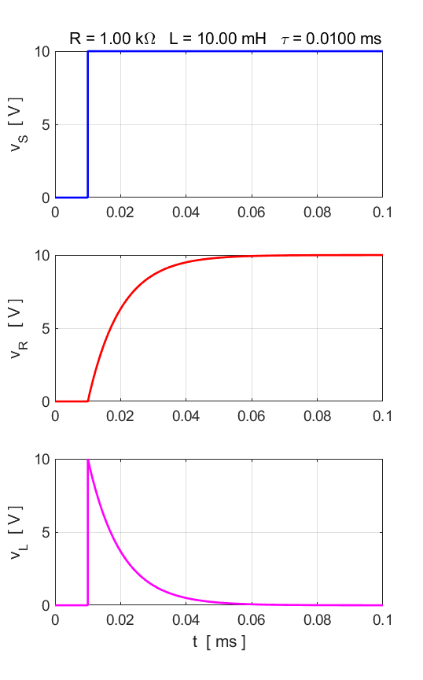

Fig. 2. The time evolution of the source emf, voltage across the resistor and the voltage across the inductor.

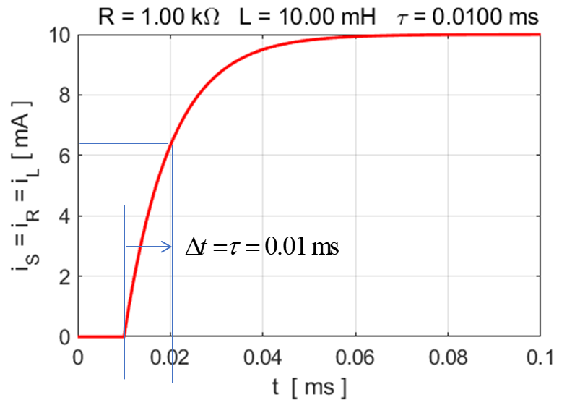

Fig. 3. The current verses time in the series LR circuit. The plot clearly shows how the inductor resists changes in the current it, because it requires a time  for the current to change by .

The values of *R* and *L* can be easily changed in the script **CNRL.m** to show the dependence of the transient response to the time constant . The Matlab Data Cursor tool can be used to measure the time constant  in the voltage and current plots.

Energy must be conserved in the circuit response to a source emf (figures 4 and 5). The source provides energy to the circuit. A current through a resistance results in energy being dissipated as thermal energy which results in an increase in temperature. For the inductor, energy is stored in the magnetic field surrounding the inductor. Hence,

 

At time *t* = 0.020 ms



There is an initial peak in the power curve for the inductor. This occurs because 

So, when the switch is closed  is a maximum and , then *vL* decreases to zero while *iL* increases to *IL.*

At time *t* = 0.080 ms



The magnetic energy stored by an inductor is



At time *t* = 0.080 ms,  and the magnetic energy is  which agrees with the numerical prediction.

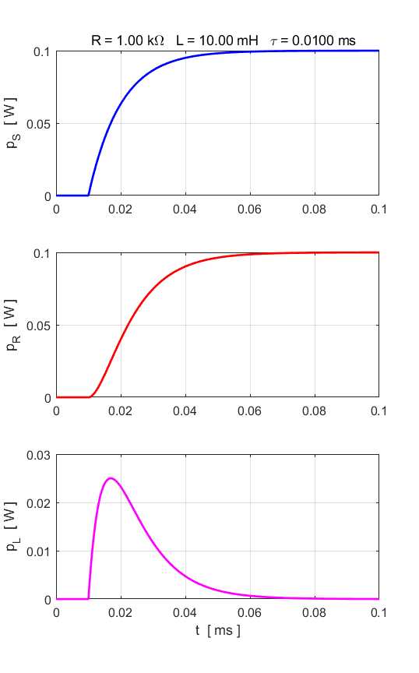

Fig. 4. Power changes in the series RL circuit. Note: difference Y scales for *pL.*

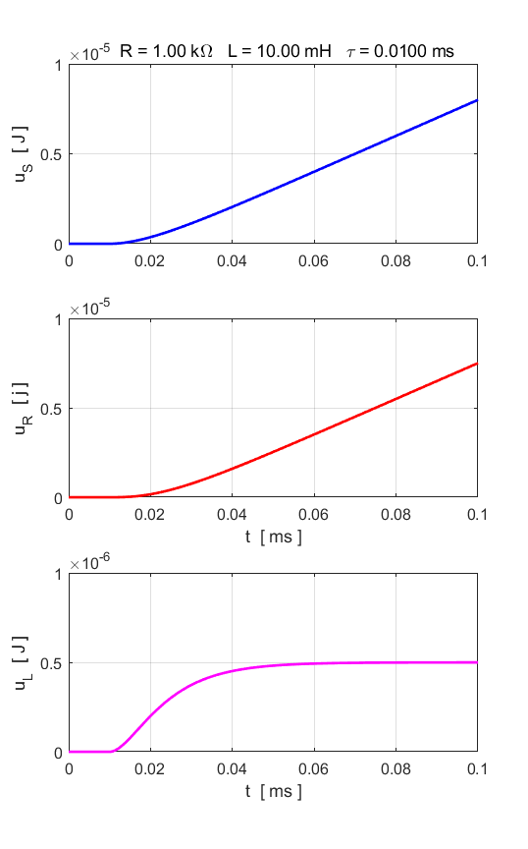

Fig. 5. Energy changes in the series RL circuit. Note: difference Y scales for *uL.*

**Simulation 2 Source emf: step function (ON/OFF)**

The source emf is a step function ON/OFF.

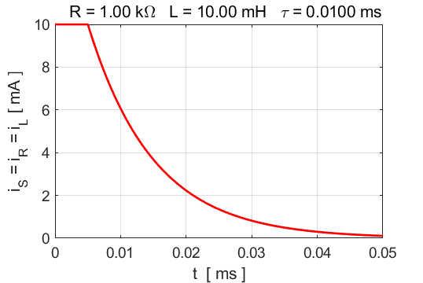

Fig. 6. The current in the circuit decreases exponentially when the source emf is switched off. The time constant is .

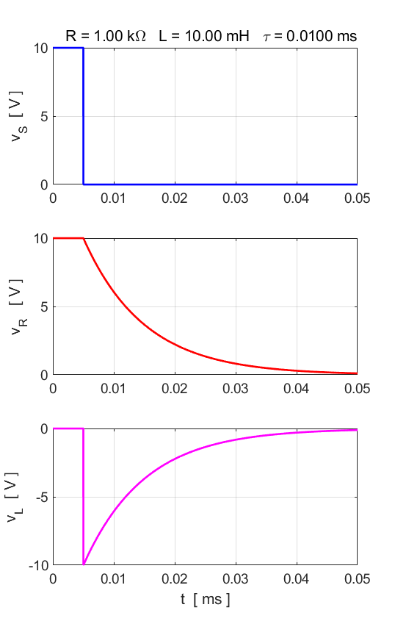

Fig. 7. The time evolution of the source emf, voltage across the resistor and the voltage across the inductor.

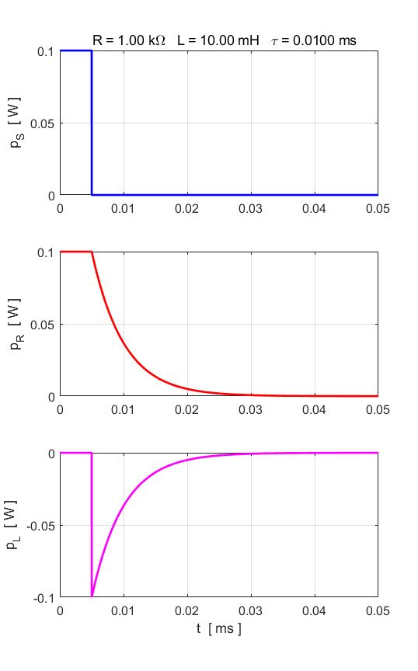

Fig. 8. Power changes in the series RL circuit. Note: difference Y scales for *pL.*

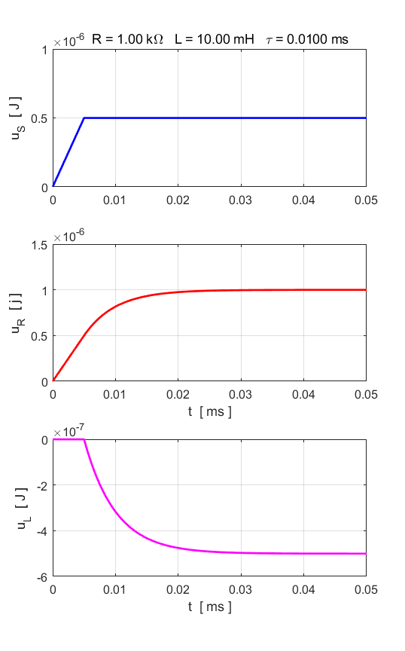

Fig. 9. Energy changes in the series RL circuit. Note: difference Y scales for *uL.*

When the source emf is switched on, the current in the circuit is constant and energy is stored in the magnetic field of the coil of the inductor. When the source emf is switched off, the current drops to zero and energy is dissipated in the resistance. The energy dissipated in the resistance is equal to the energy supplied by the source emf and the energy returned to the circuit from the energy that was stored in the magnetic field (figure 9).



Analytically, the energy stored in the magnetic field is



which agrees with the prediction from our model using the finite difference method.

**Simulation 3 Source emf: square wave function**

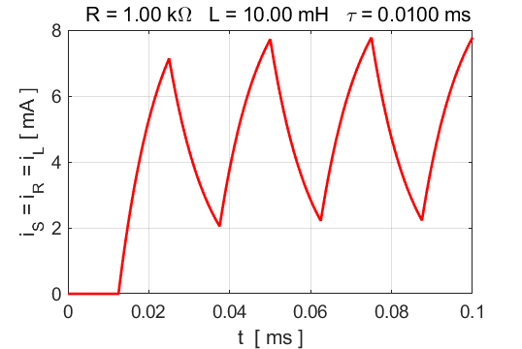

Fig. 10. The current as a function of time for a square wave source emf as shown in figure 11.

The square wave function is periodic. The voltage across the inductor has its largest change when the voltage suddenly increases or decreases. When the voltage of the square wave switches from 0 to +10 V or from +10 V to 0 V, the current is forced to “try” to prevent it from changing as the inductor opposes this change (Lenz’s Law. When the source emf is switch on – the induced voltage across the inductor increases in a positive sense to reduce the current. When the source emf is switch off – the induced voltage across the inductor increases in a negative sense to increase the current (figure 11).

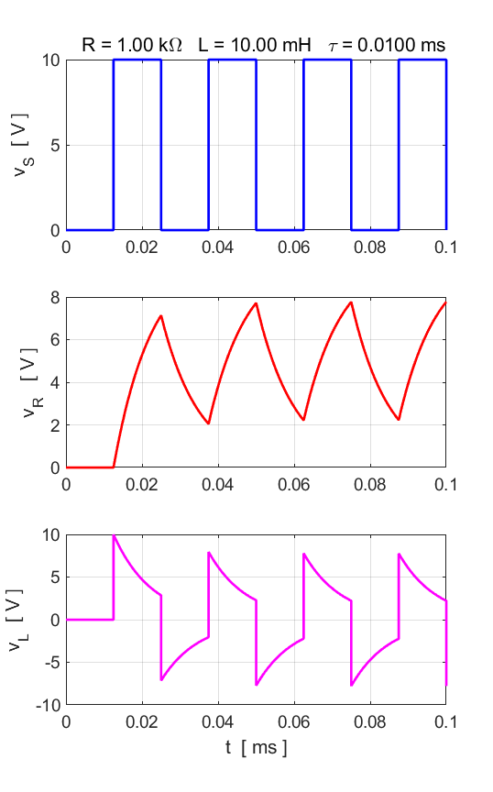

Fig. 11. The time evolution of the source emf, voltage across the resistor and the voltage across the inductor.

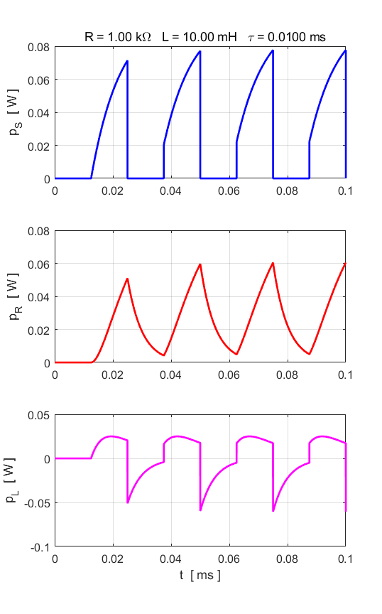

Fig. 12. The time evolution of the powers for the source emf, the resistor and the inductor.

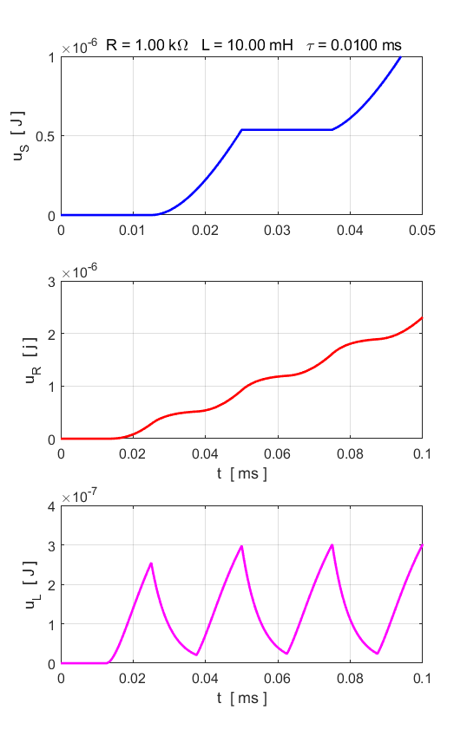

Fig. 13. The time evolution of the energies for the source emf, the resistor and the inductor.

**Simulation 4 Source emf: Sinusoidal Function**

We can model the RL circuit by calculating the response of the circuit to a sinusoidal source (input) voltage. In the switch/case statements, FlagV = 4 gives the calculation for the sinusoidal source emf. The frequency of the source is set within this segment of the code.

|  |
| --- |
| case 4 % sinusoidal input  fS = 10e3;  w = 2*pi*fS;  T = 1/fS;  nT = 8;  tMax = nT*T;  t = 0:dt:tMax;  N = length(t);  vS = VS .* exp(1j*(w*t - pi/2)); |

The complex sinusoidal function used for the source emf is

vS = VS .* exp(1j*(w*t - pi/2));

It is better to use complex functions for some of the variable, because the complex function contains information of both the magnitude and phase of the variable. The real part of a complex function gives its actual value. The actual emf that is used is a sine function .

This is an example of a driven oscillator. The voltages and current will oscillate at the driving frequency of the source.

A summary of the circuit parameters and calculations are displayed in a Figure Window.

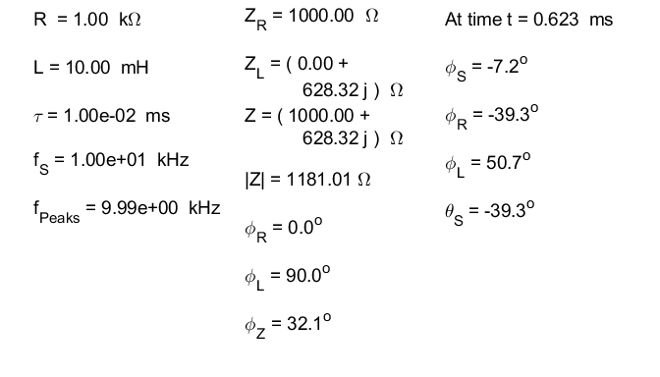

The phase of the voltages and current can be calculated from the impedances as shown in the above Table. The voltage across the resistor and the current are in phase . The voltage across the inductor leads the current by 90o . The source emf leads the current - the current reaches its peak value a later time than the voltage . The phase predictions are confirmed using the numerical calculations where the phase is calculated using the Matlab complex function **angle** as shown in the Table. Study figures 14 and 15 and you will see why the source voltage leads the current. Also, at any time you will observed

 “vector” like addition

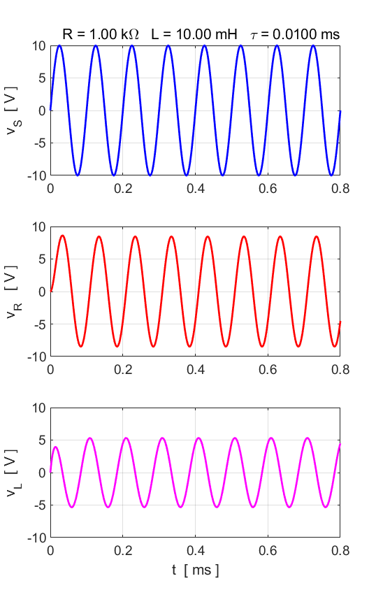

Fig. 14. The time evolution of the voltages. The frequency of the voltages across the resistor and inductor are the same as the driving frequency.

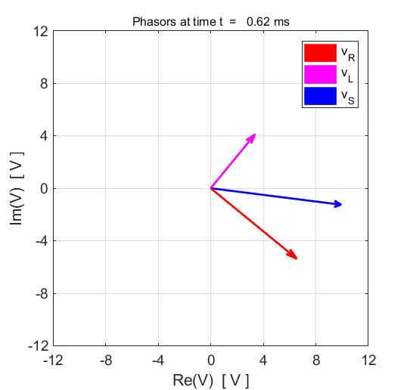

Fig. 15. Plot of the real and imaginary parts of the source emf, the resistor voltage and the inductor voltage. The plot implies . The phase of the inductor voltage leads the current by 90o and the source emf leads the current by 32o.

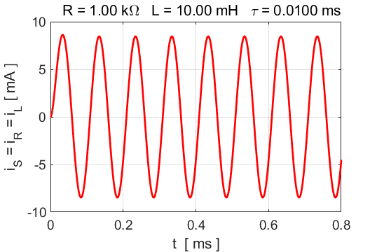

Fig. 16. The circuit current as a function of time.

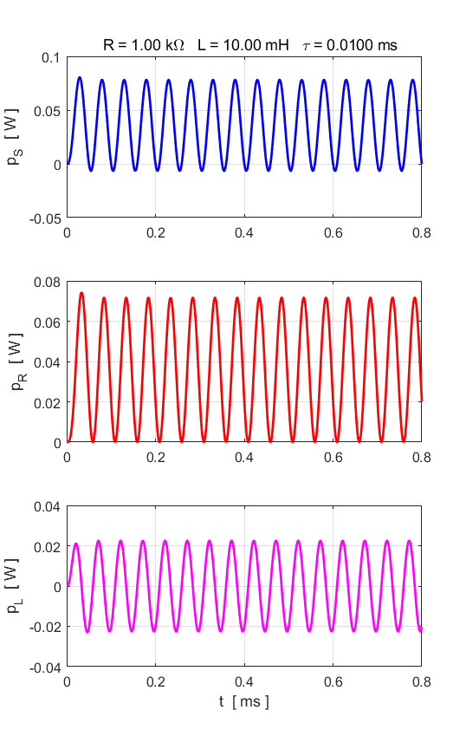

Fig. 17. The powers as a function of time. For the sinusoidal source emf, the average power for the inductor is zero.

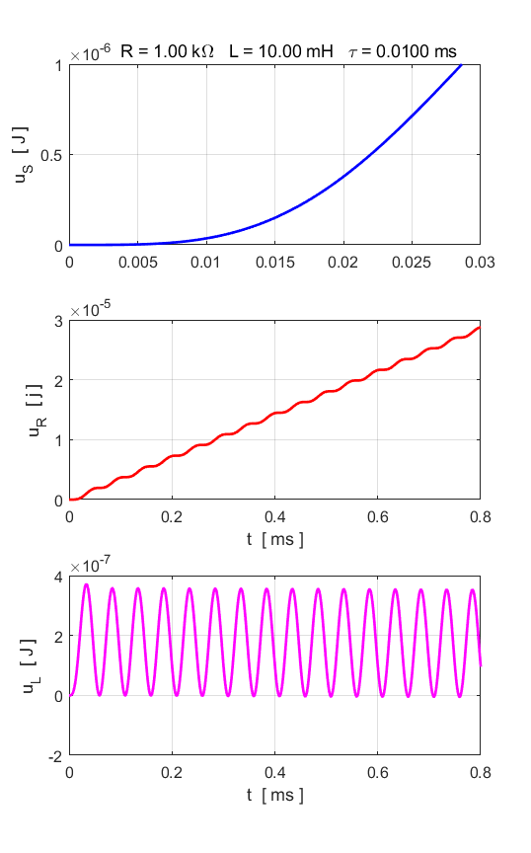

Fig. 18. The energies as a function of time.

**Simulation 5 RL Filters**

**Source emf: sinusoidal function**

The series RL voltage divider circuit can act as a filter circuit. For a low frequency source emf, the voltage across the inductor is small since the impedance of the inductor is small. Hence, the larger voltage will be across the resistor. On the other hand, for high frequencies, the impedance of the inductor is large and the higher voltage will be across the resistor.

Impedances 

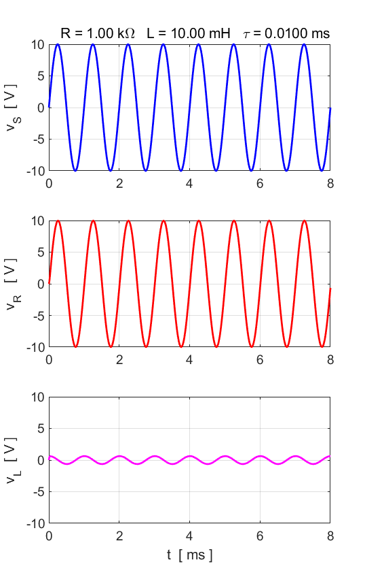

Fig. 19. The source emf frequency is 1.00 kHz. There is a low voltage across the inductor (low pass filter) and a high voltage across the resistor (high pass filter).

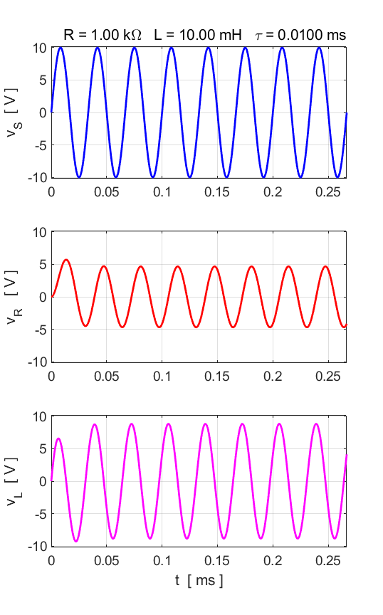

Fig. 19. The source emf frequency is 30.00 kHz. There is a high voltage across the inductor (high pass filter) and a low voltage across the resistor (low pass filter).

**Simulation 6**

**Source emf: superposition of sinusoidal functions**

vS = VS .* sin(w*t) + (0.5*VS) .* sin(10*w*t);

The source emf is composed of a lower frequency sinusoidal signal and a higher frequency sinusoidal signal. The inductor opposes the changes in the current. Hence, the higher frequency component is more heavily attenuated than the lower frequency component. This has a smoothing effect on the current. So, the rapid fluctuations in the voltage across the resistor are reduced (figure 20).

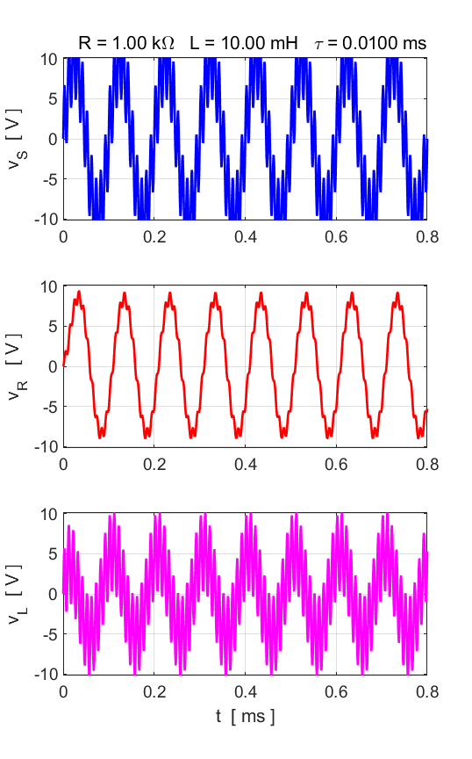

Fig. 20. The inductor opposes changes in the current. The higher frequency component is more attenuated which results in a reduction in the rapid fluctuations in the voltage across the resistor.