**[DOING PHYSICS WITH MATLAB](https://d-arora.github.io/Doing-Physics-With-Matlab/)**

**THE FINITE DIFFERENCE METHOD FOR THE NUMERICAL ANALYSIS OF PARALLEL RCL CIRCUITS**

Ian Cooper

Please email any corrections, comments, suggestions or additions: matlabvisualphysics@gmail.com

[Matlab Download Directory](https://drive.google.com/drive/u/3/folders/1j09aAhfrVYpiMavajrgSvUMc89ksF9Jb)

**arrow.m**

Used to draw arrows in a Figure Window

**CNpRCL.m**

Computation of voltages, current, and powers for a parallel RCL voltage divider circuit using the finite difference method. A Figure Window is used to draw and label the RCL voltage divider circuit. A summary of the circuit parameters is also displayed in a Figure Window rather in the Command Window.

A parallel tuned circuit is widely used in radios, television receivers and mobile devises. Most textbooks do not give an adequate explanation of such LC parallel tuned circuits. However, using a numerical procedure rather than analytical methods, a much richer study of RCL circuits can be done.

It is easy to investigate the response of RCL circuits to difference input (source) emfs that vary with time. One can change any of the circuit parameters and immediately see how the circuit responses graphically and numerically. The interrelationships between more variables can be studied than could be done using analytical methods. Topics not previously studied at an introductory level but which relate more to the “real” world can be explored.

The circuit can be drawn using Matlab plot commands and displayed in a Figure Window (figure 1). By modifying the script, you can display the numerical values for the circuit elements as well.

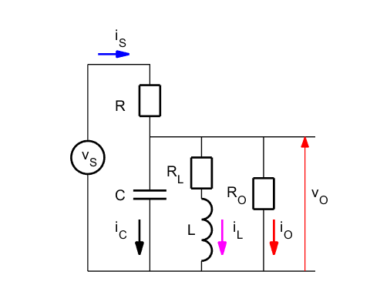

Fig. 1. The RCL parallel tuned circuit drawn using Matlab graphics commands and the drawing displayed in a Figure Window.

The input section is used to specify the values for the circuit elements, the source emf and time scales. Two emf sources are used in the script. The emf is selected using the variable flagV.

flagV = 1 Step function (OFF/ON)

flagV = 2 A complex sinusoidal function

The complex sinusoidal function used for the source emf is

(1) vS = VS .* exp(1j*(w*t - pi/2));

It is better to use complex functions for some of the variable, because the complex function contains information of both the magnitude and phase of the variable. The real part of a complex function gives its actual value. The actual emf that is used is a sine function because we assume the capacitor is initially uncharged

(2) 

The behaviour of the circuit is like an object at the end of a spring - **it may oscillate**. There is a continual exchange of energy between the energy source and the energies stored in the capacitor and inductor. In a mechanical system, an object oscillates back and forth around an equilibrium position. In the electrical circuit, it is the charge that oscillates. The oscillating charge produces an alternating current and alternating voltage drops across the resistor, capacitor and inductor. The frequency of the oscillation depends upon the values of the capacitance *C* and inductance *L.* This **natural frequency** *f*0(**resonance frequency**) is given by

(3) 

The response of the circuit shown in figure 1 is calculated using Kirchhoff’s Voltage and Current Laws and the finite difference approximations for the voltage across the capacitor and the inductor current.



The script **CNpRCL.m** is used to model the parallel RCL tuned circuit. In the script, the first letter of a variable that is a function of time or a complex variable is a lowercase letter. A variable that start with an uppercase letter is independent of time or a real quantity. For example, **vS** is the variable for the input emf and is calculated at each time step, whereas the variable **VS** is the peak value of the source emf.

To start the computational procedure, the initial conditions must be specified at time step #1.

|  |
| --- |
| % Time Step #1  vR(1) = vS(1);  iS(1) = vR(1) / R;  iC(1) = iS(1); |

The values of the voltage and current parameters are calculated at later time steps by implementing the finite difference method.

|  |
| --- |
| % Time Steps #2 to #N  for c = 2 : N  vC(c) = vC(c-1) + iC(c-1) * dt/C;  vR(c) = vS(c) - vC(c);  iS(c) = vR(c) / R;  iO(c) = vC(c) / RO;  vRL(c) = (iL(c-1) + vL(c-1)*dt/L)*RL;  vL(c) = vC(c) - vRL(c);  iL(c) = vRL(c)/RL;  iC(c) = iS(c) - iO(c) - iL(c);  end |

For accurate results, the time interval *dt* should be chosen so that it is much smaller the period of the natural oscillation

(3) 

|  |
| --- |
| % Resonance Frequency f0, period T and time step dt  f0 = 1/(2*pi*sqrt(L*C));  T0 = 1/f0;  dt = T0 /1000; |

Note: The value of the inductor resistor *RL* cannot be set to zero. The lowest used in the script for the inductor resistance is .

From the values of *R,* *C* and *L,* the impedances *Z* of the circuit elements for the sinusoidal source emf are calculated as shown in the Table.

|  |
| --- |
| % Impedance calculations  XC = 1/(w*C); ZC = -1j*XC;  XL = w*L; ZL = 1j*XL;  ZR = R;  % Total circuit impedance at time step nP  Z = (vS(nP)/iS(nP)); |

Energy is dissipated by a current through a resistor and energy is stored in the electric field between the capacitor plates, and stored in the magnetic field surrounding the coil of the inductor. The power  as a function of time *t* can easily be computed. *pS* corresponds to the power supplied by the source and *pO* is the power dissipated by the output (load) resistor.

|  |
| --- |
| % Powers  pS = real(vS) .* real(iS);  pO = real(vO) .* real(iO); |

Our parallel RCL tuned circuit is complicated. We can not simply add the voltages across the resistor, capacitor and inductor because of the phase differences between these voltages. However, in the modelling, we use a complex exponential function to simulate a real sine function source voltage. The computed values for the circuit current and voltages are all computed as complex functions. So, these complex functions contain information of the magnitudes and phases.

The script below shows the calculation of the phases at a time step given by the variable **nP**. By changing the value of **nP**, you can see the phases at different times.

|  |
| --- |
| % Phases voltage: phi and current theta at time step nP [degrees]  % INPUT value for nP  nP = N-500;    phi_vS = rad2deg(angle(vS(nP)));  phi_vO = rad2deg(angle(vO(nP)));  theta_iS = rad2deg(angle(iS(nP)));  theta_iO = rad2deg(angle(iO(nP)));  theta_iC = rad2deg(angle(iC(nP)));  theta_iL = rad2deg(angle(iL(nP))); |

When the response of the circuit results in oscillations, the period *TPeaks* of the oscillation can be approximated by finding the time intervals between peaks using the Matlab function **findpeaks** as shown in the code in the Table.

|  |
| --- |
| % Find peaks in vS and corresponding times  % Calculate period of oscillations  % May need to change number of peaks for  estimate of period: nPeaks  [iS_Peaks, t_Peaks] = findpeaks(real(iS));  nPeaks = 3;  T_Peaks = (t(t_Peaks(end))- t(t_Peaks(end-nPeaks)))/(nPeaks);  f_Peaks = 1 / T_Peaks; |

**RESPONSE TO A STEP FUNCTION OFF / ON**

When the step-function emf is switched on, the circuit responds like a heavily damped oscillator. The damping maybe so large that no oscillations are generated.

**Simulation 1** 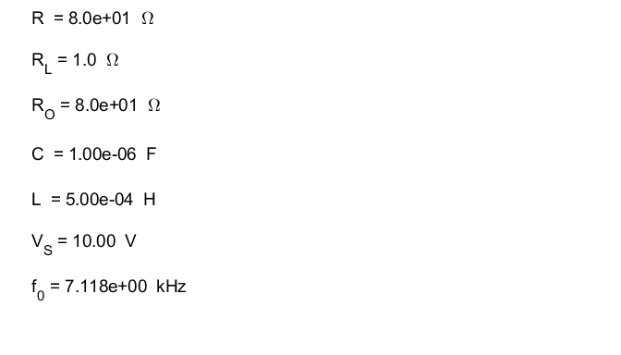

Table 1: Circuit parameters are displayed in a Figure Window.

Figure 1 shows the variation with time of the source emf *vS* and the output voltage *vO.* The frequency of the oscillations of the output voltage is equal to the resonance frequency (equation 3) and the oscillations are heavily damped.

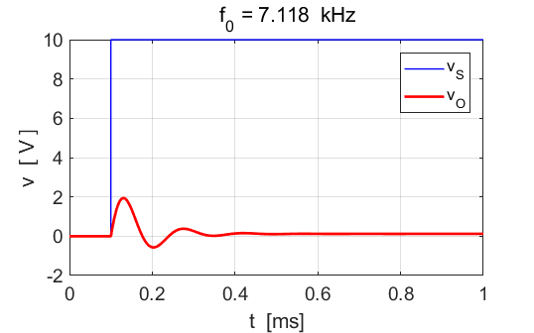

Fig.2. The circuit response to a step function input emf. The output voltage is heavy damped. The frequency of the oscillations of the output voltage is equal to the resonance frequency.

Figure 3 shows the current response of each branch of the circuit to the step-function input emf. When the emf is switched on, the capacitor charges very rapidly, then after a few oscillations the capacitor becomes fully charged and the capacitor current drops to zero. When the oscillations have fully ceased, the voltage across the capacitor is constant and equal to the constant output voltage as shown in figure 4.

The inductor opposes the changes in the current through it. After the oscillations cease, the inductor coil acts as a short circuit, and the current in the inductor branch is only determined by the resistance *RL* of the inductor branch and the inductor voltage is *vL* = 0 (figure 4).

After the oscillations cease, the impedance *Z* of the circuit is only resistive, the reactance of the circuit can be regarded as zero. The circuit behaves as if the resistor *R* is in series with the parallel combination of the resistors *RL* and *R­.*



For , the circuit impedance Z is . Therefore, the peak output voltage is



which agrees with the voltage measured across the capacitor in figure 4.

The constant source current *IS* is

 (agrees with value measured in figure 3).

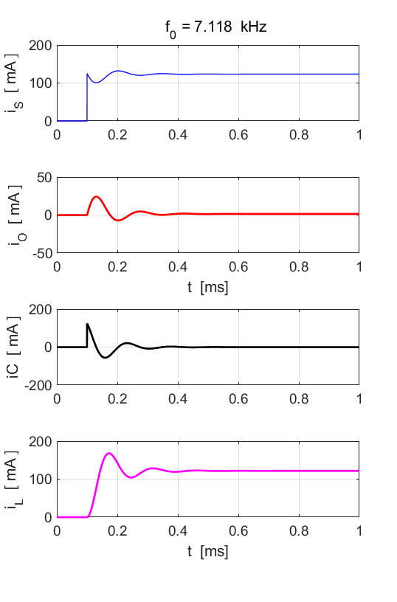

Fig. 3. The currents in the parallel tuned RCL circuit.

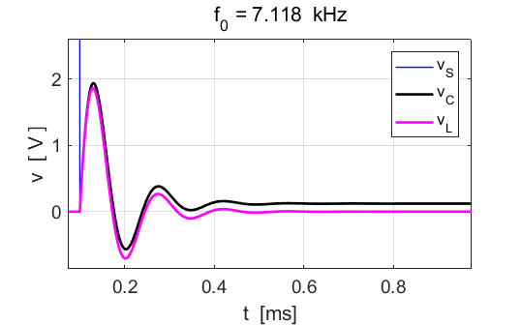

Fig.4. An expanded view of the voltages across the inductor and capacitor.

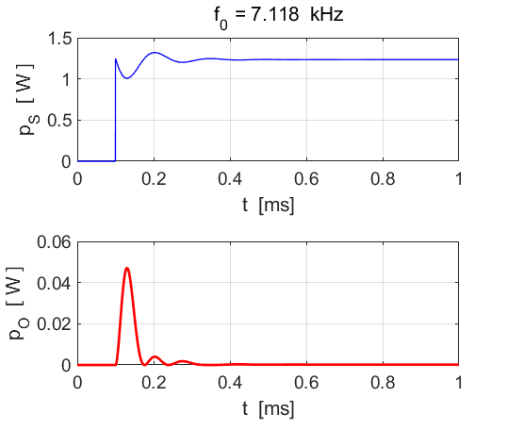

Fig. 5. The power curves for the step-function source emf.

**Simulation 2**

When the resistor *R* is set to a lower value, no oscillations in the response of the circuit to the step-function source emf occur.

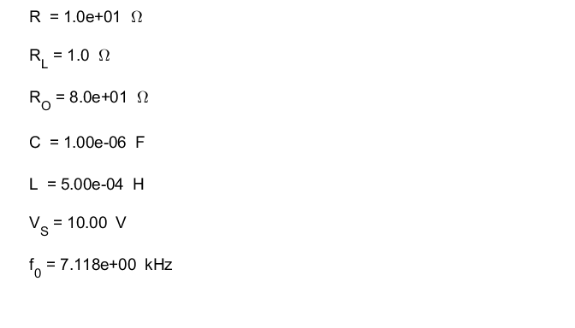

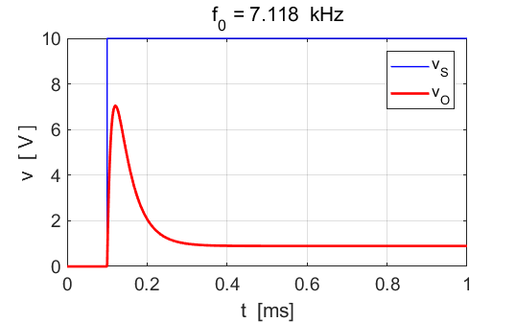

Fig. 6. The source emf and output voltage as functions of time.

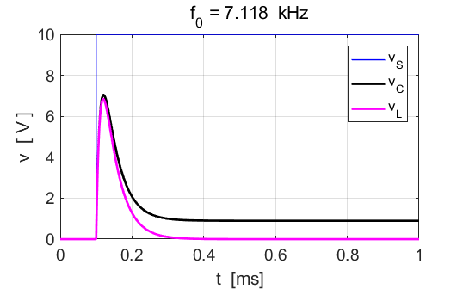

Fig. 6. The capacitor and inductor voltages as functions of time.

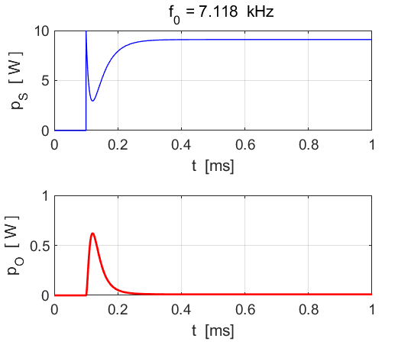

Fig. 7. The powers curves for the source and output as functions of time.

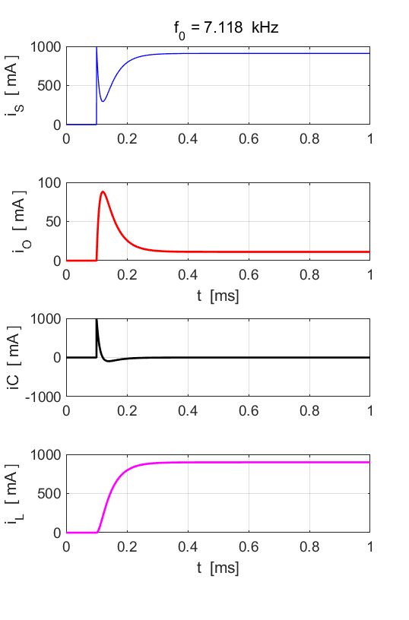

Fig. 7. Current curves as a function of time.

**RESPONSE TO A SINUSOIDAL SOURCE VOLTAGE**

A mechanical oscillator will vibrate at the driving frequency. As the driving frequency approaches the natural frequency of vibration of the system, the amplitude of the oscillation can be become very large. This phenomenon is called **resonance**. Resonance occurs in a parallel RCL circuit. The current in the circuit oscillates at the same frequency as the sinusoidal source emf. When the source emf frequency matches the natural frequency as given by equation 3 , the source current amplitude is a maximum for a given amplitude of the source emf and the circuit impedance is a minimum.

**Simulation 3 Driving frequency equals resonance frequency**

**Negligible resistance for inductor**

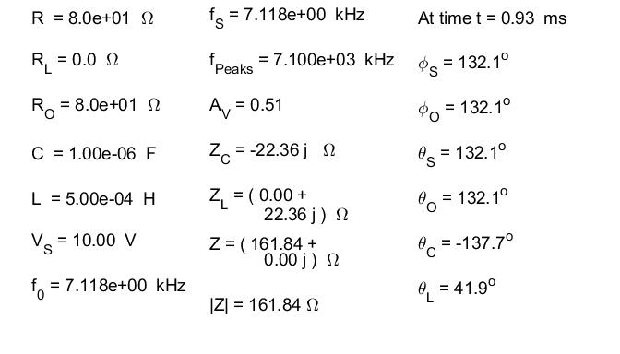

The measured frequency of oscillation using the **findpeaks** command agrees with the resonance frequency as predicted by equation 3.

At the resonance frequency, the total circuit impedance is purely resistive, the impedances of the capacitor and inductor cancel each other



The impedance is equal to the ratio of the voltage to the current. The total circuit impedance can be calculated at any time step

|  |
| --- |
| % Total circuit impedance  Z = (vS(nP)/iS(nP)); |

The difference in phase between the current in the capacitor branch and current in the inductor branch is 180o



The voltage gain is



The phase of the source emf  is equal to the phase of the output voltage  and is in phase with the output current 



Figures 8, 9, 10 and 11 show the response of the circuit when the driving frequency matches the natural frequency and the resistance in the inductor branch is essentially zero.

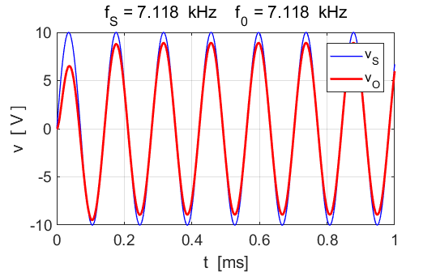

Fig. 8. Source emf and output voltage as functions of time.

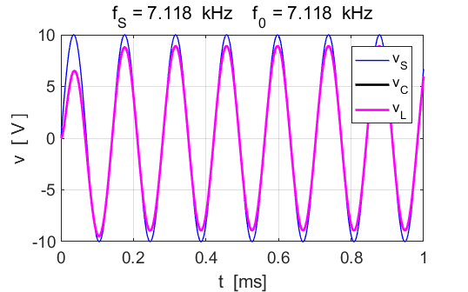

Fig. 9. Source emf and voltage across capacitor and inductor as functions of time. The variation in the capacitor voltage and inductor voltage are almost identical.

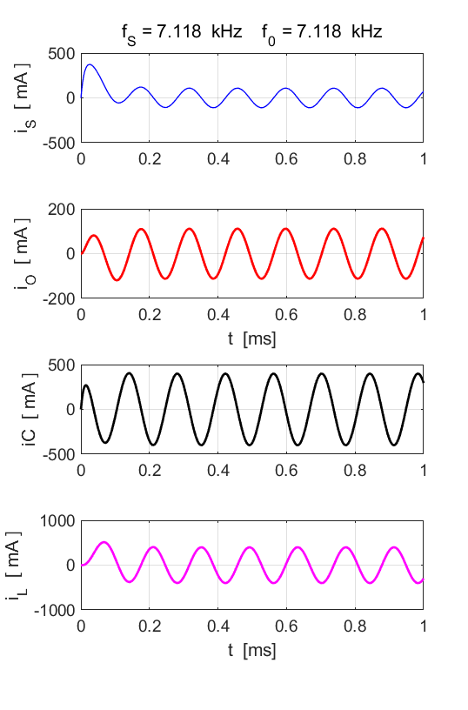

Fig. 10. Circuit currents as functions of time.

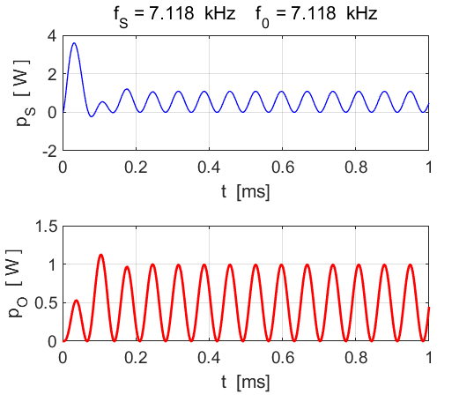

Fig. 11. Power supplied by source and power dissipated in the output resistance.

**Simulation 4 Driving frequency equals resonance frequency**

**Non-negligible resistance for inductor**

We can very easily change any of the circuit parameters and immediately see how the response of the circuit changes. When the resistance in the inductor branch is increased to 30 Ω the effects of the capacitor and inductor no longer cancel each other. You can view the graphical outputs for Simulations 3 and 4 to compare/contrast the responses of the circuit.

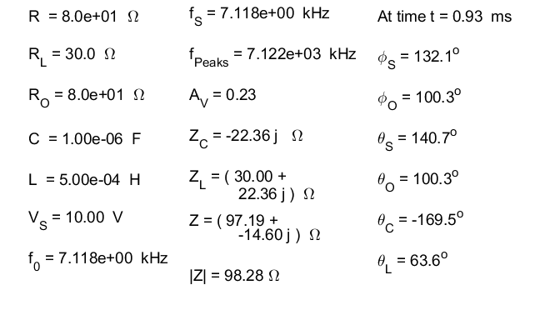

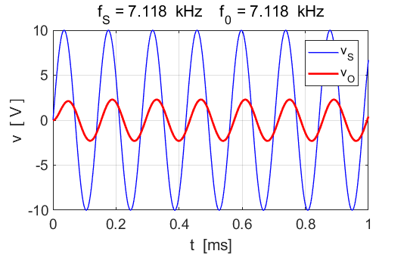

Fig. 12. Source emf and output voltage as functions of time.

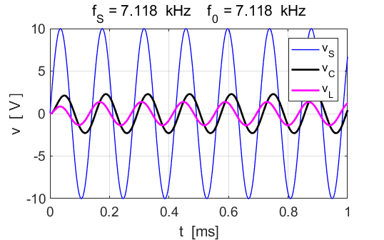

Fig. 13. Source emf and voltage across capacitor and inductor as functions of time.

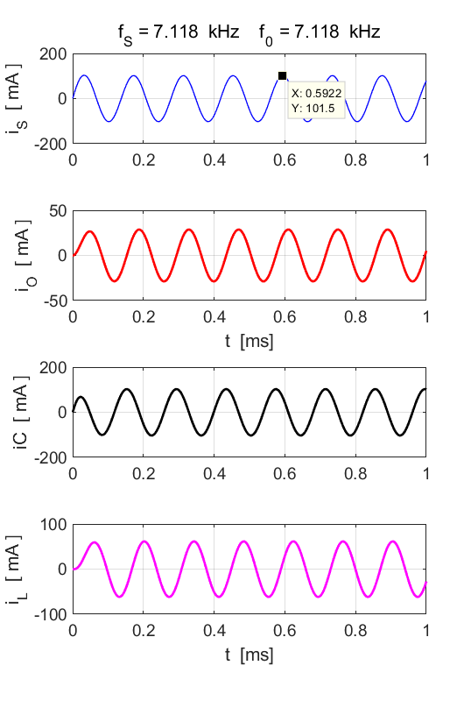

Fig. 14. Circuit currents as functions of time.

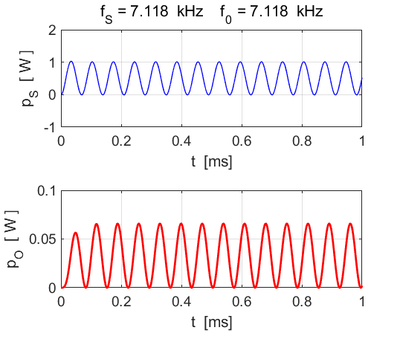

Fig. 15. Power supplied by source and power dissipated in the output resistance.

**Simulation 5**

**Driving frequency not equal to resonance**

**frequency and a non-negligible resistance for inductor**

We can very easily change any of the circuit parameters and immediately how the response of the circuit changes. Consider the driving frequency (source frequency) to be lower than the natural frequency and with non-negligible resistance in the inductor branch. You can view the graphical outputs for Simulations 3, 4 and 5 to compare/contrast the responses of the circuit.

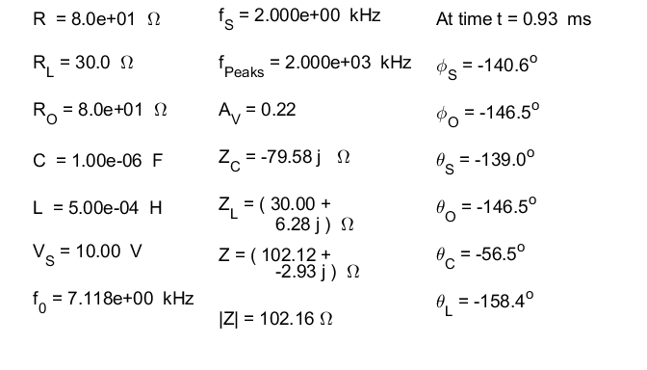

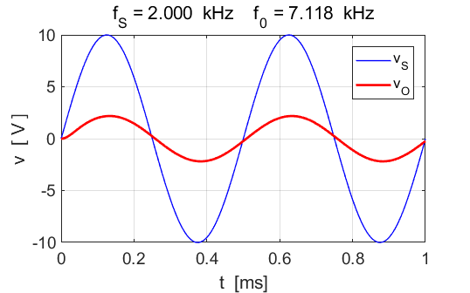

Fig. 16. Source emf and output voltage as functions of time.



Fig. 17. Source emf and voltage across capacitor and inductor as functions of time.

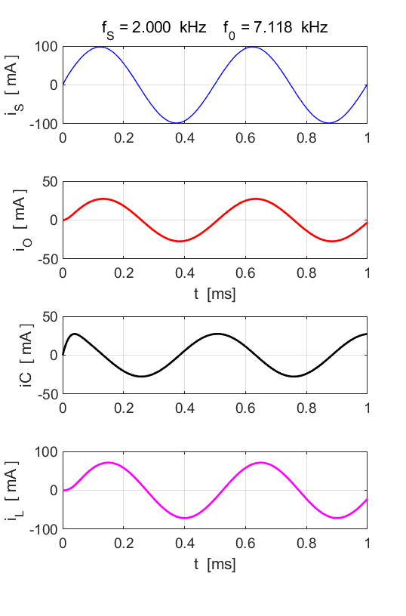

Fig. 18. Circuit currents as functions of time.

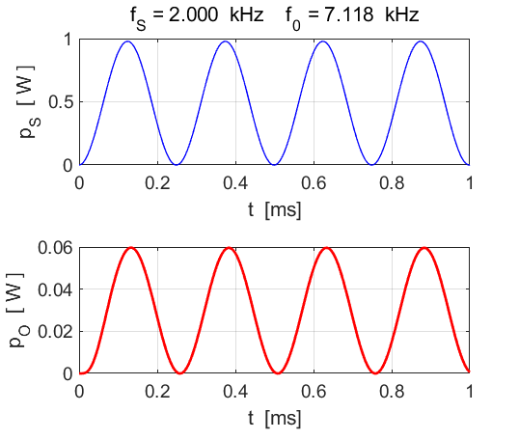

Fig. 19. Power supplied by source and power dissipated in the output resistance.

**By changing the parameters, it easy to verify:**

* The source current *iS* is minimum at the resonance frequency  as the individual branch currents *iC* and *IL* cancel and the total circuit impedance |*Z|* is a maximum.
* The source current *iS* is in phase with the source emf *vS.*