**[DOING PHYSICS WITH MATLAB](https://d-arora.github.io/Doing-Physics-With-Matlab/)**

**CIRCUIT ANALYSIS**

**DC CIRCUITS**

Ian Cooper

Please email any corrections, comments, suggestions or additions: matlabvisualphysics@gmail.com

[Matlab Download Directory](https://drive.google.com/drive/u/3/folders/1j09aAhfrVYpiMavajrgSvUMc89ksF9Jb)

**CR001.m CR002.m CWR.m CWBT.m**

DC circuits can be analysed in more detail and without doing lots of algebra using Matlab as a tool. This is done by using mesh grid equation method (Maxwell’s method).

**Mesh Equation Method or Maxwell’s Method**

1. Pick closed loops called mesh (or loop) currents.
2. Apply Kirchhoff’s Voltage Law to each loop, being careful with your sign convention to derive a set of simultaneous equations.
3. Use Matlab to solve the simultaneous equations to find the find loop currents and then the current through each component, the potential difference across each component and the power dissipated by each component.

**Voltage Divider Circuit**

One of the most important simple circuits is the voltage divider circuit. Voltage dividers find wide application in electric meter circuits, where specific combinations of series resistors are used to “divide” a voltage into precise proportions as part of a voltage measurement device. Also, voltage dividers are found in timing and amplifier circuits.

We will consider a simple voltage divider circuit with resistive components in which energy is transferred from a source to a load as shown in figure 1.

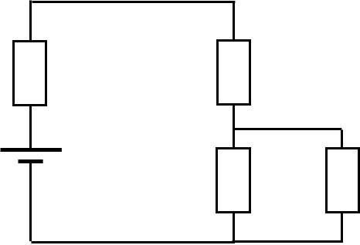

Fig. 1. Voltage divider circuit.

Each resistor is numbered 1, 2, 3 and 4. Resistor  corresponds to the internal resistance () of the source with emf  which has a constant value. The load the resistance  corresponds to the resistor .

The current though each resistor, the potential difference across each resistor and the power dissipated by each resistor are given by  respectively. The loop currents are  and  as shown in figure 2.

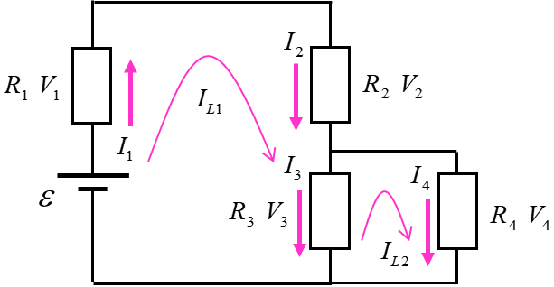

Fig. 2. Labelled voltage divider circuit.

Applying Kirchhoff’s voltage Law to loops (1) and (2), we can derive the two simultaneous equations

(1) 

which can be solved using Matlab. Equation 1 can be written in matrix form



where the matrices are





In terms of Matlab variables, the loop current matrix can be found using the following command

Im = Rm \ Vm;

The other unknown parameters are computed using the Matlab statements

IR(1) = Im(1);

IR(2) = Im(1);

IR(3) = Im(1)- Im(2);

IR(4) = Im(2);

V = IR .* R;

P = IR.^2 .* R;

The script **CR001.m** can be used in modelling the voltage divider circuit. The emf and resistor values are set within the script and the results of the computation are displayed in a table in the Command window.

Table 1. Simulation results 

emf = 10.00 V

R [ohms] IR [mA] V [V] P [mW]

0 42.86 0.000 0.00

100 42.86 4.286 183.67

200 28.57 5.714 163.27

400 14.29 5.714 81.63

So, once you have the script, you only need to change the input parameters to model all simple voltage divider circuits. For example, Table 2 shows displays the results when the internal resistance of the source is 20  .

Table 2. Simulation results 

emf = 10.00 V

R [ohms] IR [mA] V [V] P [mW]

20 39.47 0.789 31.16

100 39.47 3.947 155.82

200 26.32 5.263 138.50

400 13.16 5.263 69.25

Comparing Tables 1 and 2, you notice the terminal voltage (potential difference across circuit) drops by 0.789 V and the power delivered to the load drops by 12.38 mW.

**Voltage divider circuit: Maximum power delivered to load**

Consider a voltage divider circuit with a variable load resistance. An important thing to know is the value of the load resistance for maximum energy to be transferred from the source to the load. Achieving this goal of maximum energy transferred to as **impedance matching**.

We will model the voltage divider circuit shown in figure 3 to find the value of the load resistance to achieve maximum energy transfer from source to load.

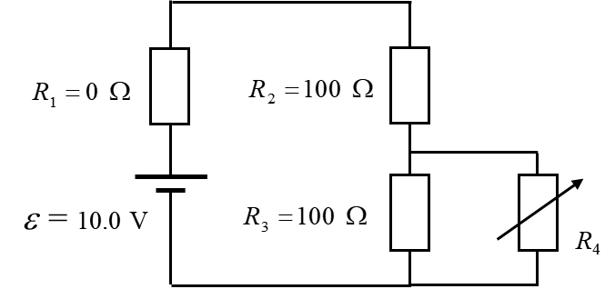

Fig. 3. Voltage divider circuit with a variable load.

The script **CR002.m** can be used to model a voltage divider circuit to find the maximum load. The input parameters are changed within the script.

% INPUTS =================================

% source emf

emf = 10;

% Resistance values R1 R2 R3 R4

R = [0 100 200 400];

% Load resistance R4 = Rload

RLmin = 10;

RLmax = 1000;

N = 5000;

The results for the power dissipated by the load is displayed in a Figure Window (figure 4). 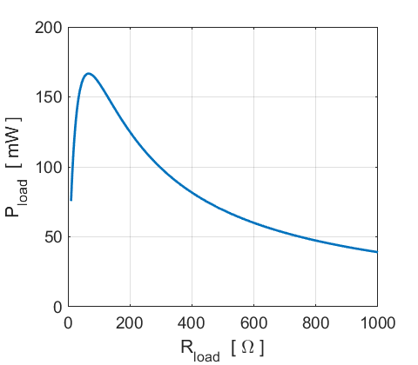

Fig. 4. Power dissipated by a variable load resistance.

The maximum power and the corresponding load resistance is displayed in the Command Window, as well as, the theoretical value of the load resistance for maximum energy transfer.

PLmax = 0.1667

RLmax = 66.6393

RLtheory = 66.6667

The value of the load resistance for maximum power transfer is found without doing lots of algebraic manipulations to find the results.

<https://en.wikipedia.org/wiki/Maximum_power_transfer_theorem>

The Matlab statements for the calculations are:

PLmax = max(PLoad)

RLmax = RLoad(PLoad == PLmax)

RLtheory = R(2)*R(3)/(R(2)+R(3)

The plot for the load power can be zoom-in and the data cursor used to find the maximum power and the corresponding load resistance as shown in figure 5.

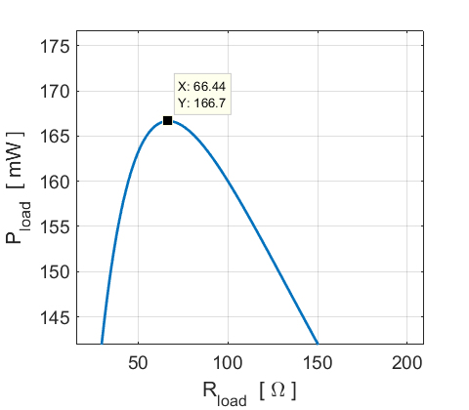

Fig. 5. Power dissipated by a variable load resistance with the expanded view of the peak.

**The Wheatstone Bridge**

The Wheatstone Bridge was originally developed by Charles Wheatstone to measure unknown resistance values and as a means of calibrating measuring instruments, voltmeters, ammeters, etc, by the use of a long resistive slide wire. Although today, digital multimeters provide the simplest way to measure a resistance. The Wheatstone Bridge can still be used to measure very low values of resistances down in the milli-ohms range.

The Wheatstone bridge (or resistance bridge) circuit can be used in a number of applications and today, with modern operational amplifiers we can use the Wheatstone Bridge circuit to interface various transducers and sensors to these amplifier circuits.

The Wheatstone Bridge circuit is nothing more than two simple series-parallel arrangements of resistances connected between a voltage supply terminal and ground producing zero voltage difference between the two parallel branches when balanced. A Wheatstone bridge circuit has two input terminals and two output terminals consisting of four resistors configured in a diamond-like arrangement as shown in figure 6. Figure 6 shows the labels for the resistors and the loop currents. The resistance  could of the resistance of a galvanometer or a voltmeter connected between the arms of the bridge.

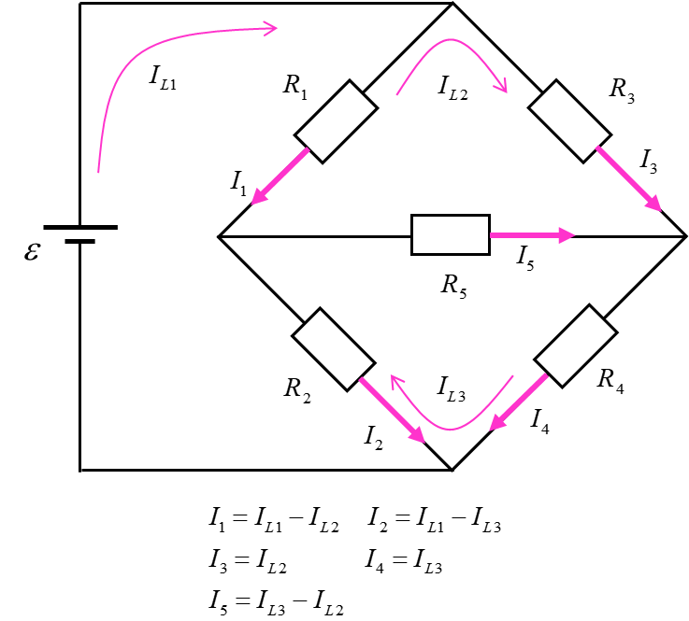

Fig. 6. Wheatstone Bridge circuit drawn as a diamond which shows the loop currents and currents through each resistor.

There are two basic modes of bridge operation. In one mode, the bridge can be used to determine the value of an unknown resistance to a high degree of accuracy by comparing it with an accurately known resistance. The value of the unknown resistance is measured by varying the resistance of one of three other resistors in the bridge circuit to obtain a balanced condition in which the bridge has zero output voltage, that is, a voltage “null”. In the other mode, the bridge is in an unbalanced state and the value of an unknown resistance is determined from the value of the bridge output voltage. This is sometimes referred to an “off-null” operation. If a resistance type transducer, for example a thermistor, light dependent resistor or a strain gauge is used as the unknown resistance, then the bridge output will depend on the transducer resistance. The output voltage can be calibrated directly in terms of the measured variable (temperature, light, expansion, …).

One of the key components of a weighing system is an instrument called a **strain gauge** which is often used to measure small amounts of deformation. It consists of a series of parallel, high resistance wire or foil elements and is mounted on a smooth surface. This strain gauge is then mounted on a metal beam that has a bucket hanging from it and it forms one of the arms of a Wheatstone bridge.

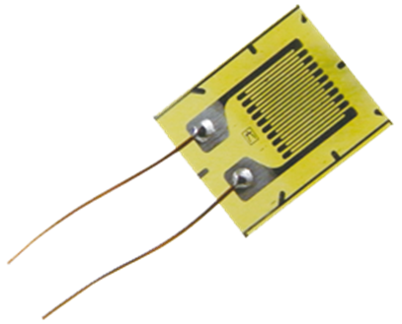

From figure 6, it is an easy task to applying Kirchhoff’s Voltage Law to loops (1), (2) and (3) and derive three simultaneous equations

(2) 

which can be solved using Matlab. Equation 2 can be written in matrix form



where the matrices are





The other unknown parameters are computed using the Matlab statements

IR(1) = Im(1) - Im(2);

IR(2) = Im(1) - Im(3);

IR(3) = Im(2);

IR(4) = Im(3);

IR(5) = Im(3) - Im(2);

V = IR .* R;

P = IR.^2 .* R;

The text University Physics by Young and Freedman has a problem on the Wheatstone Bridge. The values of three resistors and emf were given as



A galvanometer was placed across the bridge, so .

The problem was to find the value of  so that the galvanometer current is zero. The script **CWB.m** can be used for the Wheatstone Bridge calculations given the emf and resistor values.

The value of  can be adjusted by a trial error basis to find its value when . The required value is  for zero galvanometer current.

Command Window display for the results of the calculation:

emf = 13.00 V

IL1 [mA] IL2 [mA] IL3 [mA]

21.763 6.734 6.734

R [ohms] IR [mA] V [V] P [mW]

15 15.029 0.225 3.39

850 15.029 12.775 191.99

33 6.734 0.225 1.52

**1897**  6.734 12.775 86.02

0 **-0.000** -0.000 0.00

T

he Wheatstone bride is a very sensitive. For example,



The Young and Freedman text has a worked example on the Wheatstone Bridge. The task is to find the current through each resistor and the equivalent resistance of the network of the five resistors given



Using the script **CWB.m** it is an easy task to calculate all the required values.

emf = 13.00 V

IL1 [mA] IL2 [mA] IL3 [mA]

11000.000 5000.000 4000.000

R [ohms] IR [mA] V [V] P [mW]

1 6000.000 6.000 36000.00

1 7000.000 7.000 49000.00

1 5000.000 5.000 25000.00

2 4000.000 8.000 32000.00

1 1000.000 1.000 1000.00

The total current through the network is the loop current  and the potential drop across the network is 13 V. Hence, the equivalent resistance of the network is



We can model the operation of a transducer that was placed in the arm of the Wheatstone Bridge corresponding to  and a voltmeter connected across the bridge, so  (a voltmeter has a large internal resistance). The values of the fixed resistor are set to 100  and the emf is .



The script **CWBT.m** was used to model the output voltage for a transducer with variable resistance placed in one arm of the Wheatstone Bridge. The output in shown in a Figure Window (figure 7).

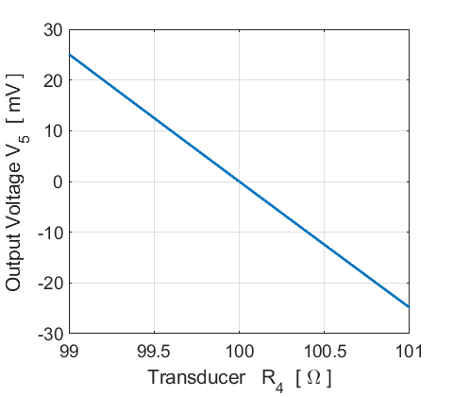

Fig. 7. The output voltage of a transducer as a function of the transducer resistance. The transducer has a linear response. The Wheatstone Bridge is balanced when the transducer resistance is 100 , as expected.

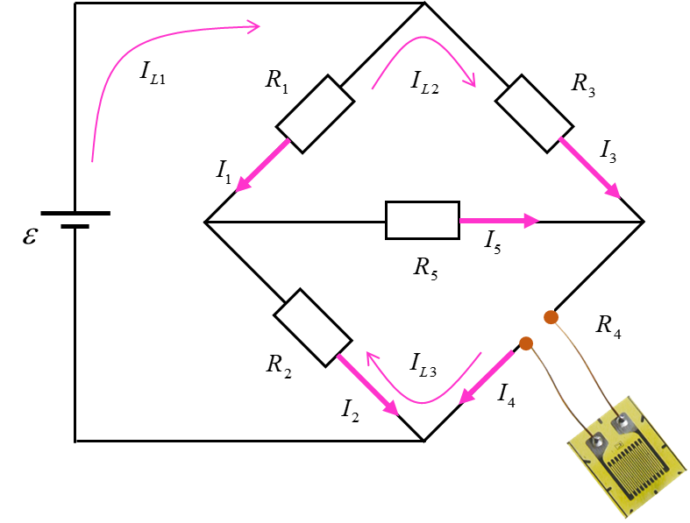

Fig. 7. A transducer connected to one arm of a Wheatstone Bridge.