**[DOING PHYSICS WITH MATLAB](https://d-arora.github.io/Doing-Physics-With-Matlab/)**

**RESONANCE CIRCUITS**

**RLC PARALLEL VOLTAGE DIVIDER**

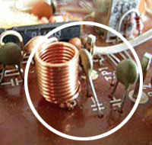

Ian Cooper

Please email any corrections, comments, suggestions or additions: matlabvisualphysics@gmail.com

[Matlab Download Directory](https://drive.google.com/drive/u/3/folders/1j09aAhfrVYpiMavajrgSvUMc89ksF9Jb)

**CRLCp1.m CRLCp2.m**

When you change channels on your television set, an RLC circuit is used to select the required frequency. To watch only one channel, the circuit must respond only to a narrow frequency range (or frequency band) centred around the desired one. Many combinations of resistors, capacitors and inductors can achieve this. We will consider a RLC voltage divider circuit shown in figure 1. The circuit shown in figure 1 can also be used as a narrow band pass filter or an oscillator circuit.

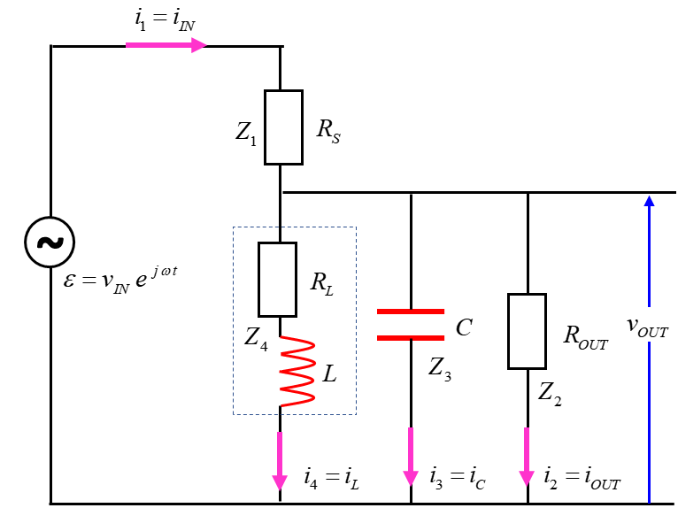

Fig. 1. RLC resonance circuit: a parallel combination of an inductor *L* and a capacitor *C* used in voltage divider circuit.

The sinusoidal input voltage is



The impedances of the circuits components are

 series resistance

 output or load resistance

 capacitor

 inductor

We simplify the circuit by combining circuit elements that are in series and parallel.

 parallel combination

 series combination: total impedance

The current through each component and the potential difference across each component is computed from



in the following sequence of calculations



Computing all the numerical values is easy using the complex number commands in Matlab. Complex circuits can be analysed and in more in-depth graphically than the traditional algebraic approach.

The code below shows the main calculations that needed for the simulations.

f = linspace(fMin,fMax, N);

w = (2*pi).*f;

% impedances

Z1 = RS; % series resistance

Z2 = ROUT; % output or load resistance

Z3 = -1i ./ (w .*C); % capacitive impedance

Z4 = RL + 1i .* w .* L; % inductive impedance

(resistance + reactance)

Z5 = 1./ (1./Z2 + 1./Z3 + 1./Z4); % parallel combination

Z6 = Z1 + Z5; % total circuit

impedance

% currents [A] and voltages [V]

I1 = V_IN ./ Z6;

V1 = I1 .* Z1;

V_OUT = V_IN - V1;

I2 = V_OUT ./ Z2;

I3 = V_OUT ./ Z3;

I4 = V_OUT ./ Z4;

I_sum = abs(I1 - I2 - I3 - I4);

% phases

phi_OUT = angle(V_OUT);

phi_1 = angle(V1);

theta_1 = angle(I1);

theta_2 = angle(I2);

theta_3 = angle(I3);

theta_4 = angle(I4);

% Resonance frequencies and Bandwidth calculations

f0 = 1/(2*pi*sqrt(L*C));

G_V = abs(V_OUT ./ V_IN); % voltage gain

Vpeak = max(G_V); % max voltage gain

VG3dB = Vpeak/sqrt(2); % 3 dB points

k = find(G_V == Vpeak); % index for peak voltage gain

f_peak = f(k); % frequency at peak

kB = find(G_V > VG3dB); % indices for 3dB peak

k1 = min(kB); f1 = f(k1);

k2 = max(kB); f2 = f(k2);

df = f2-f1; % bandwidth

Q = f0 / df; % quality factor

P_OUT = V_OUT .* I2; % power delivered to load

We will consider the following example that was done as an experiment and as a computer simulation.

Values for circuit parameters:

amplitude of input emf 

series resistance 

capacitance 

inductance 

inductance resistance estimated from simulation

output (load) resistance  (output to CRO)

**Simulation**  **script CRLCp1.m**

% INPUTS default values [ ]

% series resistance Z1 [1e4 ohms]

RS = 1e4;

% OUTPUT (LOAD) resistance Z2 [1e6 ohms]

ROUT = 1e6;

% inductance and inductor resistance Z4 [10.3e-3 H 0 ohms]

L = 10.3e-3;

RL = 0;

% capacitance Z2 [10.4e-9 F]

C = 10.4e-9;

% input voltage emf [10 V]

V_IN = 10;

% frequency range [1000 to 30e3 Hz 5000]

fMin = 1000; fMax = 30e3;

N = 5000;

Figure 2 shows the plots of the absolute values for the impedance of the capacitor , inductor  and output impedance for the parallel combination .

At low frequencies, the inductor acts like a “short circuit”



At high frequencies, the capacitor acts like a “short circuit”



At resonance 



resonance frequency 

The output impedance  has a sharp peak at the resonance frequency .

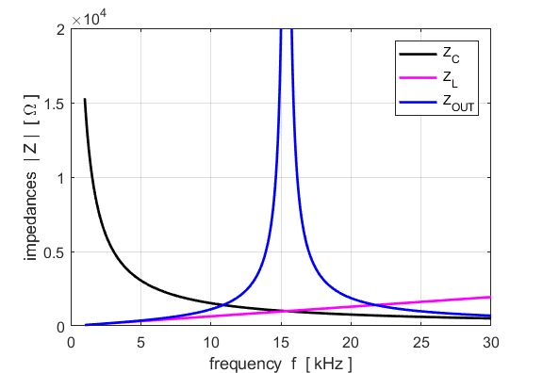

Fig. 2. The magnitude of the impedances for the capacitor, inductor and parallel combination as functions of frequency of the source. A sharp peak occurs at the resonance frequency for the impedance of the parallel combination.

Since the total circuit impedance has a maximum value at the resonance, the current from the source must be a minimum at the resonance frequency (figure 3). At resonance, the source voltage and the source current are in-phase with each other and the current through the series resistance is the same as the current through the output resistance.

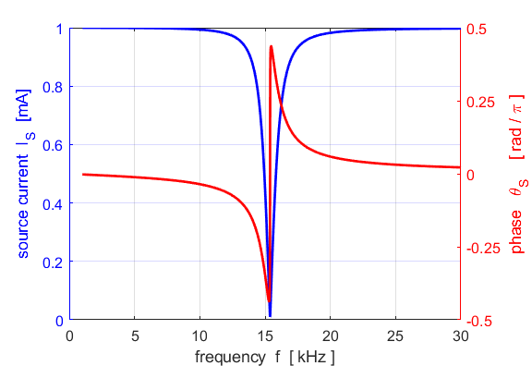

Fig. 3. The source current has a minimum at the resonance frequency. At resonance, the source voltage and source current are in-phase with each other.

The output voltage from the parallel combination is



We define the voltage gain  of the circuit as



The  is a complex quantity which is specified by its magnitude and phase. Figure 4, shows the magnitude of the voltage gain  and its phase . The voltage gain  has a peak at the resonance frequency and the output voltage  is in phase with the source voltage  since .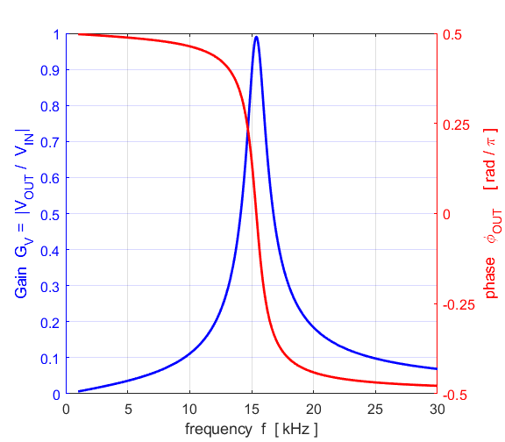

Fig. 4. The voltage gain of the parallel voltage divider resonance circuit.

For the case when , the **resonance frequency** of the circuit is



The **quality factor** *Q* is a measure of the width of the voltage gain plot. The power drops by half (-3 dB) at the half power frequencies  and  where . These two frequencies determine the **bandwidth** of the voltage gain peak



It can be shown that the quality factor *Q* is



The higher the *Q* value of a resonance circuit, the narrow the bandwidth and hence the better the selectivity of the tuning.

Figure 5 shows the voltage gain plot indicating the resonance frequency, half power frequencies and the bandwidth.

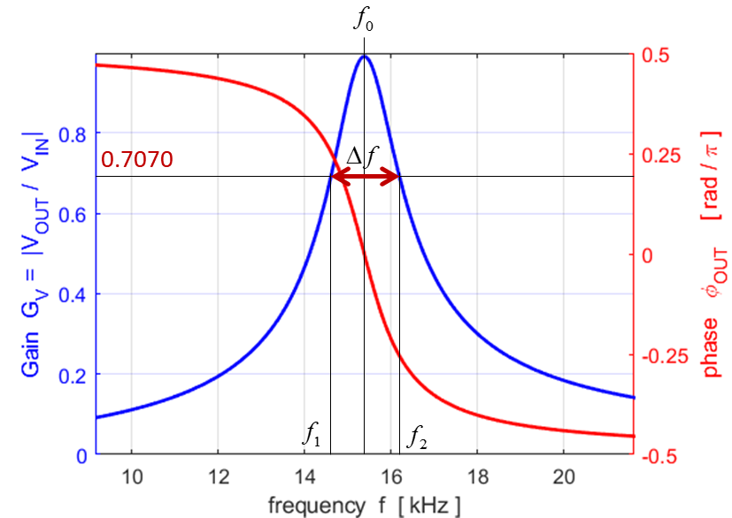

Fig. 5. The voltage gain plot indicating the resonance frequency, half power frequencies and the bandwidth.

A summary of the calculations is displayed in the Command Window

Resonance frequency 

Peak frequency 

Half power frequencies 

Quality factor 

% OUTPUTS IN COMMAND WINDOW

fprintf('theoretical resonance frequency f0 = %3.0f Hz \n',f0);

fprintf('peak frequency f_peak = %3.0f Hz \n',f_peak);

fprintf('half power frequencies f1 = %3.0f Hz %3.0f Hz \n',f1,f2);

fprintf('bandwidth df = %3.0f Hz \n',df);

fprintf('quality factor Q = %3.2f \n',Q);

fprintf('current at junction I_sum = %3.2f mA \n',max(1e3*I_sum))

Figure 6 shows the magnitudes of the currents through the capacitor and inductor branches of the parallel combination and the corresponding phases.

For frequencies less than the resonance frequency, current through the inductive branch is greater than through the capacitive branch. At resonance, the two currents are equal. Above the resonance frequency, there is more current in the capacitive branch than the inductive branch.

The two currents are always  rad out of phase. The capacitive current leads by  while the inductive current lags by , compared with the reference angle of the source emf.

At resonance,  and the two currents have the same magnitudes. Therefore, the effects of the capacitance and inductance cancel each other, resulting in a pure resistive impedance with the source voltage and current in phase.

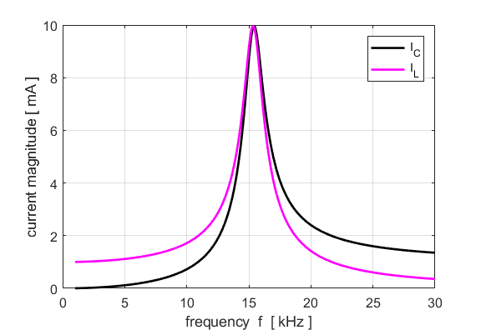

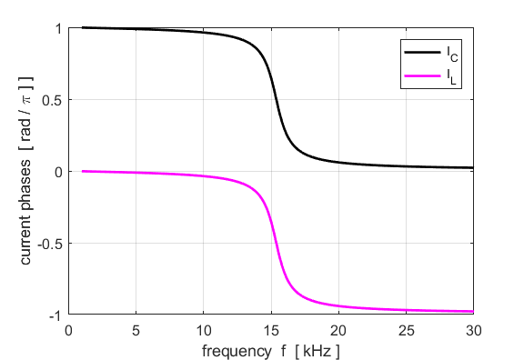

Fig. 6. Magnitudes and phases for the inductor current and inductor current.

Kirchhoff’s current law states that the sum of the currents at a junction add to zero. For ac circuits, it is not so straight forward to sum the currents because you must account for the phases of each current. At the junction of the series resistance and the parallel combination, the simulation gives the result

  need to account for phase

script: I_sum = abs(I1 - I2 - I3 - I4);

output: current at junction I_sum = 0.00 mA

Maximum power  is delivered from the source to the load only at the resonance frequency as shown in figure 7.

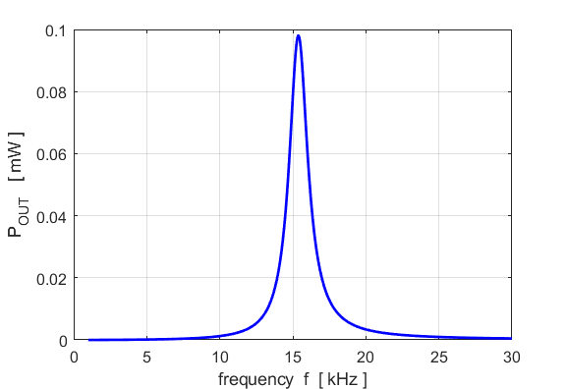

Fig. 7. Power delivered from source to load.

We can also look at the behaviour of the circuit in the **time domain** and gain a better understanding of how complex numbers give us information about magnitudes and phases. The time domain equation for the currents and voltages are



Each of the above relationship are plotted at a selected frequency which is set within the script. The graphs below are for the resonance frequency and the half-power frequencies.

% TIME DOMAIN select source frequency

fs = f_peak; kk = k;

% fs = f1; kk = k1;

% fs = f2; kk = k2;

Ns = 500;

ws = 2*pi*fs;

Ts = 1/fs;

tMin = 0;

tMax = 3*Ts;

t = linspace(tMin,tMax,Ns);

emf = real(V_IN .* exp(1j*ws*t));

v_OUT = real(abs(V_OUT(kk)) .* exp(1j*(ws*t + phi_OUT(kk))));

v1 = real(abs(V1(kk)) .* exp(1j*(ws*t + phi_1(kk))));

i1 = real(abs(I1(kk)) .* exp(1j*(ws*t + theta_1(kk))));

i2 = real(abs(I2(kk)) .* exp(1j*(ws*t + theta_2(kk))));

i3 = real(abs(I3(kk)) .* exp(1j*(ws*t + theta_3(kk))));

i4 = real(abs(I4(kk)) .* exp(1j*(ws*t + theta_4(kk))));

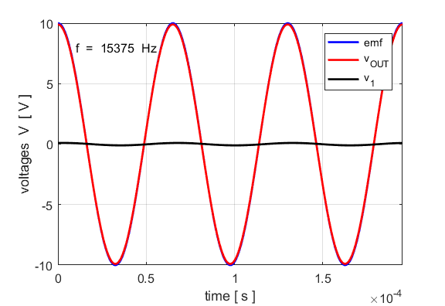

Fig. 8. The voltages at the resonance frequency. The source voltage and output voltage are in-phase. The output voltage is almost equal in magnitude to the source emf.

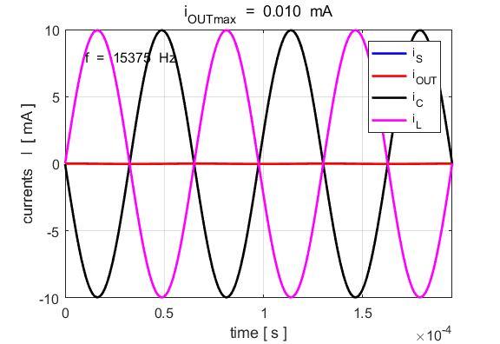

Fig. 9. The currents through the capacitor and inductor cancel at resonance. The currents through the capacitor and the inductor are rad out-of-phase and have equal amplitudes. The impedance of the circuit is purely resistive at the resonance frequency. The output current varies sinusoidally but has a very small amplitude.

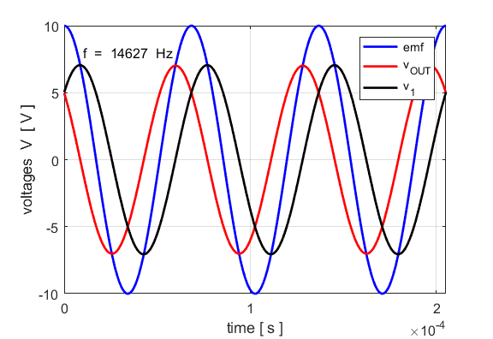

Fig. 10. The voltages at the half-power frequency. The source voltage and output voltage are out-of-phase. At each instant

.

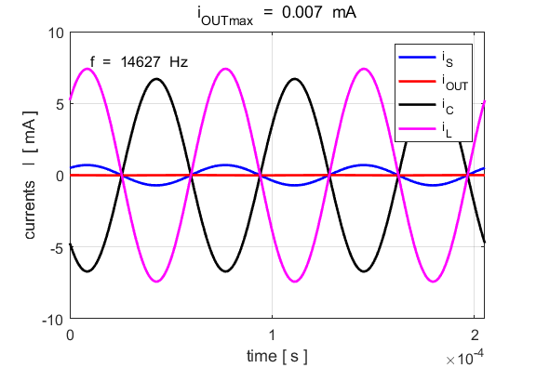

Fig. 11. The currents at the half-power frequency. The currents through the capacitor and the inductor are rad out-of-phase. The amplitude of the inductor current is greater than the amplitude of the capacitor current. The output current varies sinusoidally but has a very small amplitude. At each instant 

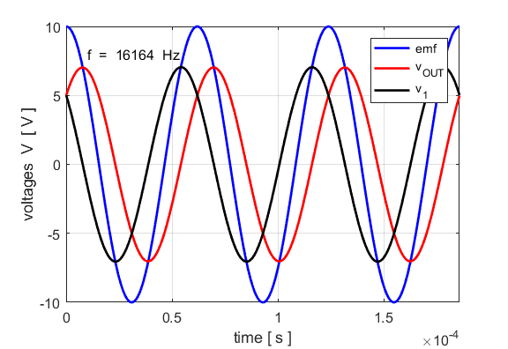

Fig. 12. The voltages at the half-power frequency. The source voltage and output voltage are out-of-phase. At each instant .

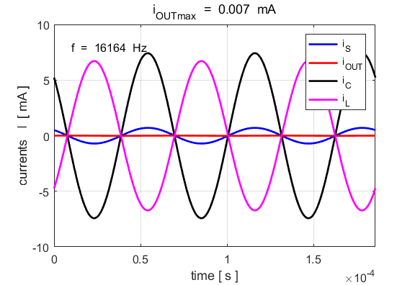

Fig. 13. The currents at the half-power frequency. The currents through the capacitor and the inductor are rad out-of-phase. The amplitude of the inductor current is less than the amplitude of the capacitor current. The output current varies sinusoidally but has a very small amplitude. At each instant 

The above simulation has for a large impedance load connected to the output of the circuit . We can examine the effect when a much smaller load resistance is connected to the circuit while keeping all other parameters unchanged.



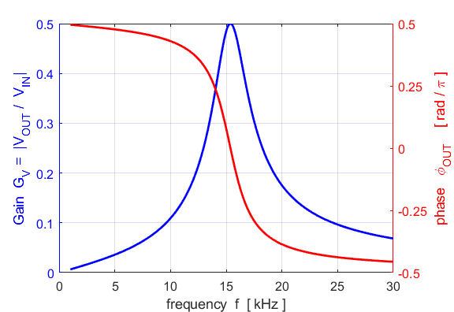

Fig. 14. The voltage gain is much reduced and the bandwidth increased giving a smaller quality factor *Q.* The larger bandwidth and smaller *Q* means that the selectivity is of the resonance circuit is reduced.

|  |  |
| --- | --- |
|  |  |

Fig. 15. Left  Right 

Since the output resistance is reduced, a much greater output current results and more power is delivered from the source to the load as shown in figure 16. With  the maximum power at resonance is 0.1 mW, whereas when , the maximum power at resonance 2.5 mW.

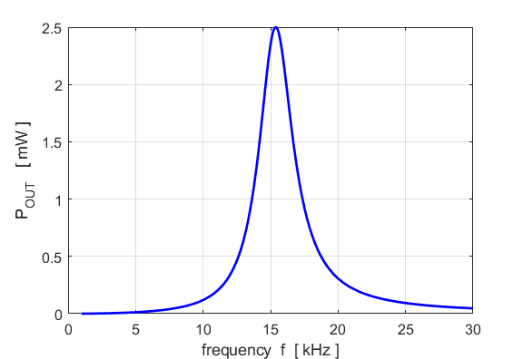

Fig. 16. The power delivered to the load is increased as the output resistance is decreased.

**Modelling Experimental Data**

Data was measured for the circuit shown in figure 1. An audio oscillator was used for the source and the output was connected to digital storage oscilloscope (DSO). The component values used were (nominal values shown in brackets):

series resistance 

capacitance 

inductance 

assume DSO resistance  (output to CRO)

**The measurements are given in the script CRLCp2.m**

Figure 17 shows a plot of the experimental data.

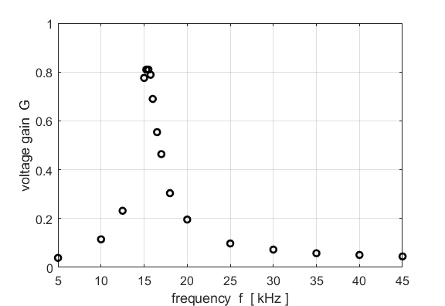

Fig. 17. Plot of the experimental measurements.

We can use our simulation **CRLCp2.m** to fit theoretical curves to the measurements and estimate the resistance of the inductor as shown in figures 18 and 19. The value of the inductive resistance  is changed to obtain the best fit between the model and the measurements.

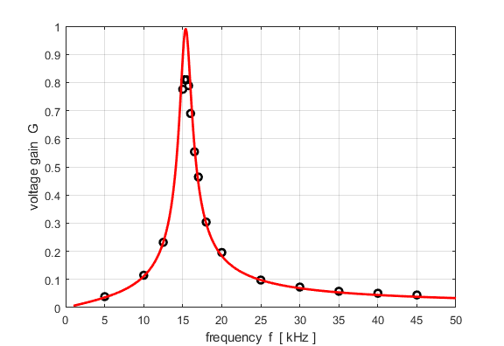

Fig. 18. The fit of the model to the measurements with .



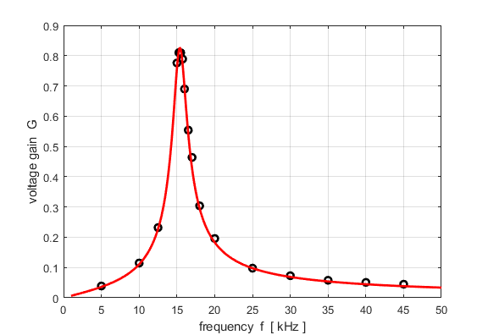

Fig. 19. The fit of the model to the measurements with .



The model with  gives an excellent fit to the measurements. The DC resistance measurement of the coil resistance measured with a multimeter was 12.5 .

The resonance frequency is slightly higher than predicted from the relationship



The bandwidth is increased and the *Q* of the resonance circuit is lower.

If you consider the simplicity of the code in the Matlab script to model resonance circuits, this computational approach has many advantages compared with the traditional algebraic approach.