**[DOING PHYSICS WITH MATLAB](https://d-arora.github.io/Doing-Physics-With-Matlab/)**

**RESONANCE CIRCUITS**

**SERIES RLC CIRCUITS**

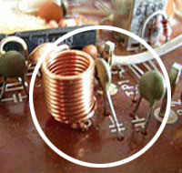

Ian Cooper

Please email any corrections, comments, suggestions or additions: matlabvisualphysics@gmail.com

[Matlab Download Directory](https://drive.google.com/drive/u/3/folders/1j09aAhfrVYpiMavajrgSvUMc89ksF9Jb)

**CRLCs1.m** Graphical analysis of a series RLC resonance circuit

**CRLCs2.m** Fitting a theoretical curve to experimental data

When you change channels on your television set, an RLC circuit is used to select the required frequency. To watch only one channel, the circuit must respond only to a narrow frequency range (or frequency band) centred around the desired one. Many combinations of resistors, capacitors and inductors can achieve this. Consider the circuit shown in figure 1 for a sinusoidal input voltage  applied to a circuit composed of three passive circuit elements: resistor *R,* inductance *L* and capacitance *C.*

The effect upon the RLC series circuit performance with a load resistance  connected across the one of the passive elements will also be consider.

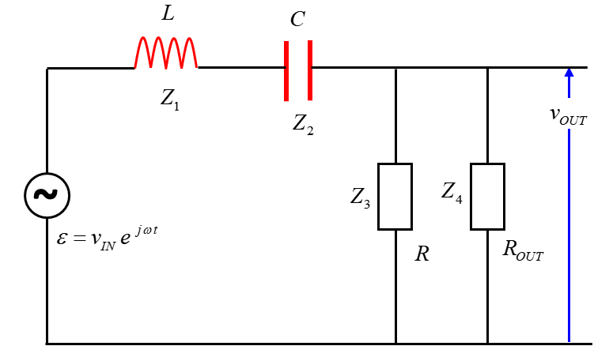

Fig. 1. RLC resonance circuit: a series combination of an inductor *L*, capacitor *C* and a resistor *R.* A load resistance  is added to the circuit.

The sinusoidal input voltage is



The impedances of the circuits components are

 inductor

 capacitor

 series resistance

 output or load resistance

We simplify the circuit by combining circuit elements that are in series and parallel.

Parallel combination of series resistance and load resistance



Series combination: total impedance



The current through each component and the potential difference across each component is computed from



in the following sequence of calculations (figure 2)



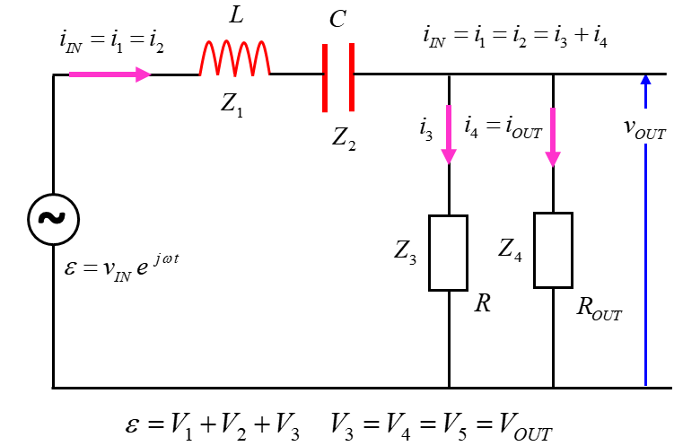

Fig. 2. RLC resonance circuit: a series combination of an inductor *L*, capacitor *C* and a resistor *R.* A load resistance  is added to the circuit. Kirchhoff’s Law are used to find the relationships between the currents and the relationships the voltages.

Computing all the numerical values is easy using the complex number commands in Matlab. Complex circuits can be analysed in more depth graphically than the traditional algebraic approach.

The code below shows the main calculations that needed for the simulations.

f = linspace(fMin,fMax, N);

w = (2*pi).*f;

% impedances

Z1 = 1i .* w .* L; % inductive impedance (reactance)

Z2 = -1i ./ (w .*C); % capacitive impedance (reactance)

Z3 = R; % series resistance

Z4 = ROUT; % output or load resistance

Z5 = 1./ (1./Z3 + 1./Z4); % parallel combination

Z6 = Z1 + Z2 + Z5; % total circuit impedance

% currents [A] and voltages [V]

I1 = V_IN ./ Z6;

I2 = I1;

V1 = I1 .* Z1;

V2 = I2 .* Z2;

V_OUT = V_IN - V1 - V2;

V3 = V_OUT; V4 = V_OUT;

I3 = V_OUT ./ Z3;

I4 = V_OUT ./ Z4;

% phases

phi_OUT = angle(V_OUT);

phi_1 = angle(V1);

phi_2 = angle(V2);

theta_1 = angle(I1);

theta_2 = angle(I2);

theta_3 = angle(I3);

theta_4 = angle(I4);

We will consider a circuit with the following parameters:

amplitude of input emf 

inductance 

capacitance 

series resistance 

output (load) resistance  (output to CRO)

**Smulation**  **script CRLCs1.m**

% ========================================================

% INPUTS default values [ ]

% ========================================================

% inductance Z1 [10e-3 H]

L = 10e-3;

% capacitance Z2 [1.0e-8 F]

C = 1.0e-8;

% series resistance Z3 [ 1e2 ohms]

R = 1e2;

% OUTPUT (LOAD) resistance Z4 [1e6 ohms]

ROUT = 1e6;

% input voltage emf [10 V]

V_IN = 10;

% frequency range [2000 to 50e3 Hz 5000]

fMin = 2000; fMax = 50e3; N = 5000;

Figure 3 shows the plots of the absolute values for the impedance of the inductor , capacitor , and total circuit impedance .

The inductive reactance increases linearly with frequency. At low frequencies, the inductor acts like a “short circuit”



The capacitive reactance is inversely proportional to the frequency. At high frequencies, the capacitor acts like a “short circuit”



At a certain frequency for an RLC circuit, the inductive reactance equals the capacitive reactance. The circuit is said to be **resonant** at this frequency. At resonance 

resonance frequency 

At the resonance frequency



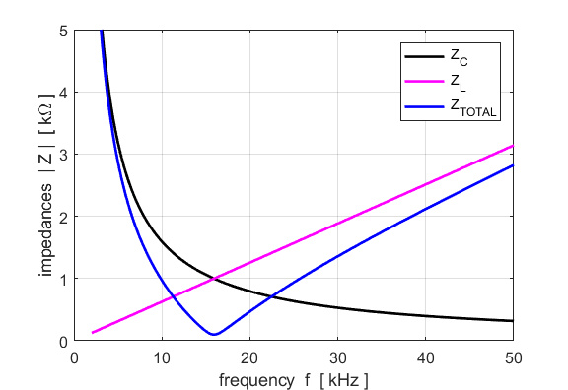

Fig. 3. The magnitude of the impedances for the capacitor, inductor and parallel combination as functions of frequency of the source. A sharp peak occurs at the resonance frequency for the impedance of the parallel combination.

Since the total circuit impedance has a minimum value at resonance, the current from the source must be a maximum (figure 4). At resonance, the source voltage and the source current are in-phase. Only at the resonance frequency, is maximum power delivered to the load (figure 5).

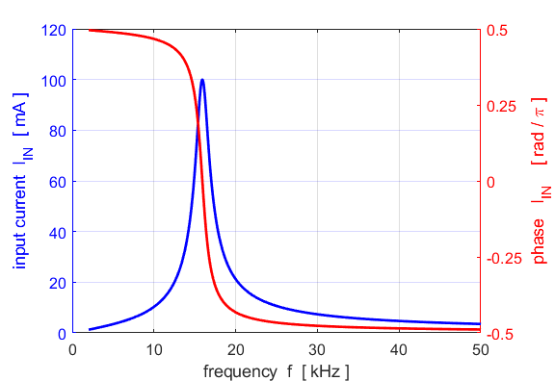

Fig. 4. The source current has a maximum at the resonance frequency. At resonance, the source voltage and source current are in-phase with each other. 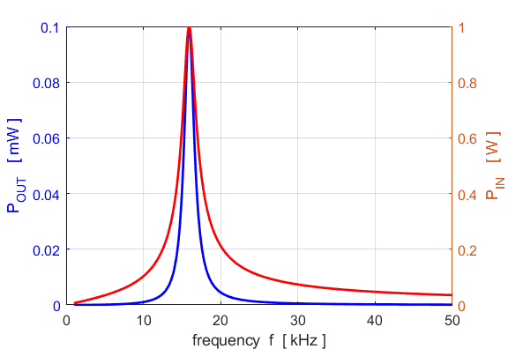

Fig. 5. Maximum power is delivered to the load at the resonance frequency.

The **resonance frequency** of the circuit is



The **quality factor** *Q* is a measure of the width of the current against frequency plot. The power drops by half (-3 dB) at the half power frequencies  and  where . These two frequencies determine the **bandwidth** of the current.



It can be shown that the quality factor *Q* is



The higher the *Q* value of a resonance circuit, the narrow the bandwidth and hence the better the selectivity of the tuning.

The code for determination of the bandwidth:

% Resonance frequencies and Bandwidth calculations

f0 = 1/(2*pi*sqrt(L*C));

Ipeak = max(abs(I1)); % max input current

k = find(abs(I1) == Ipeak); % index for peak voltage gain

f_peak = f(k); % frequency at peak

I3dB = Ipeak/sqrt(2); % 3 dB points

kB = find(abs(I1) > I3dB); % indices for 3dB peak

k1 = min(kB); f1 = f(k1);

k2 = max(kB); f2 = f(k2);

df = f2-f1; % bandwidth

Q = f0 / df; % quality factor

Figure 6 shows the current plot indicating the resonance frequency, half power frequencies and the bandwidth.

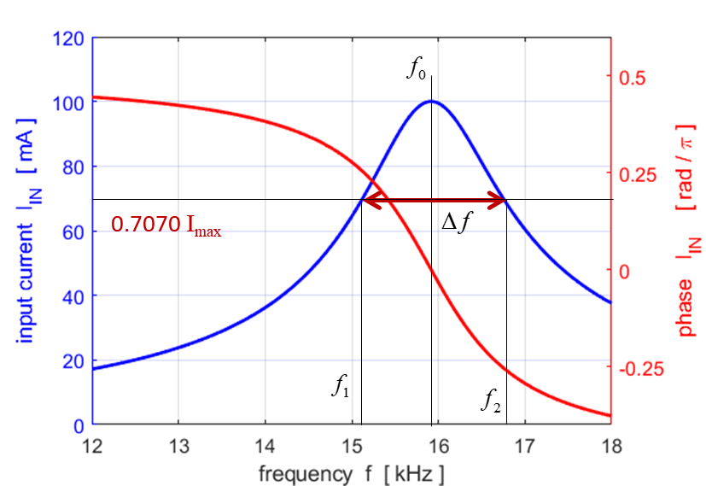

Fig. 6. The current plot indicating the resonance frequency, half power frequencies and the bandwidth.

A summary of the calculations is displayed in the Command Window

theoretical resonance frequency f0 = 15915 Hz

peak frequency f_peak = 15915 Hz

half power frequencies f1 = 15140 Hz 16730 Hz

bandwidth df = 1590 Hz

quality factor Q = 10.01

fprintf('theoretical resonance frequency f0 = %3.0f Hz \n',f0);

fprintf('peak frequency f_peak = %3.0f Hz \n',f_peak);

fprintf('half power frequencies f1 = %3.0f Hz %3.0f Hz \n',f1,f2);

fprintf('bandwidth df = %3.0f Hz \n',df);

fprintf('quality factor Q = %3.2f \n',Q);

The voltage across various elements is shown in figure 7. At the resonance frequency, the magnitude of the voltage across the inductor and capacitor are equal and are have maximum values. However, the phase difference between these two voltages is rad (figure 8). So, the voltage across both the inductor and capacitor is zero at the resonance frequency .

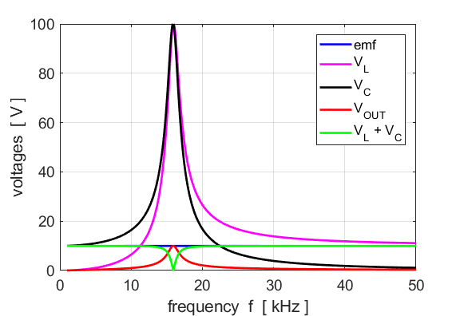

Fig. 7. Voltage across different circuit elements. At resonance, the effects of the capacitor and inductor cancel each other. Note for this RLC circuit, the voltages across the capacitor and inductor are much larger that the source voltage. The reason for this is that the voltages act like vectors and no not add algebraically. You need to consider the phases of the voltages and their magnitudes. The voltages must be added like vectors.

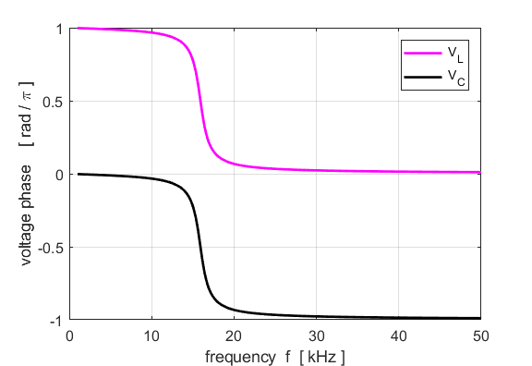

Fig. 8. At resonance,  and the two voltages have the same magnitudes. Therefore, the effects of the capacitance and inductance cancel each other, resulting in a pure resistive impedance with the source voltage and current in phase.

Kirchhoff’s Voltage Law states that the sum of the voltage drops around the circuit is equal to the input emf to the circuit. For ac circuits, it is not so straight forward to sum the voltages. You must account for the phases of each current.

  need to account for phase

abs(V1+V2+V3)

The emf is  and at each frequency .

Consider the case when *ROUT* is large and its effects on the circuit can be ignored. At resonance:

The impedance is a minimum and is purely resistive (figure 3).

The current is a maximum and in phase with the source voltage (figure 4).



The voltage across the inductor is



We can define the quality factor *Q* as



Hence, the voltage of the inductor is



The voltage across the capacitor is



*Q* measured from the bandwidth: *Q* = 10.0.

Calculated in the Command Window from the above relations, *Q* = 10.0.

We can also look at the behaviour of the circuit in the **time domain** and gain a better understanding of how complex numbers give us information about magnitudes and phases. The time domain equation for the currents and voltages are



Each of the above relationships are plotted at a selected frequency which is set within the script. The graphs below are for the resonance frequency and the half-power frequencies.

c = 1;

% c = 1 fs = f_peak;

% c = 2 fs = f1;

% c = 3 fs = f2

if c == 1; kk = k; fs = f_peak; kk = k; end

if c == 2; kk = k1; fs = f1; end

if c == 3; kk = k2; fs = f2; end

Ns = 500;

ws = 2*pi*fs;

Ts = 1/fs;

tMin = 0;

tMax = 3*Ts;

t = linspace(tMin,tMax,Ns);

emf = real(V_IN .* exp(1j*ws*t));

v1 = real(abs(V1(kk)) .* exp(1j*(ws*t + phi_1(kk))));

v2 = real(abs(V2(kk)) .* exp(1j*(ws*t + phi_2(kk))));

v3 = real(abs(V3(kk)) .* exp(1j*(ws*t + phi_3(kk))));

i1 = real(abs(I1(kk)) .* exp(1j*(ws*t + theta_1(kk))));

i3 = real(abs(I3(kk)) .* exp(1j*(ws*t + theta_3(kk))));

i4 = real(abs(I4(kk)) .* exp(1j*(ws*t + theta_4(kk))));

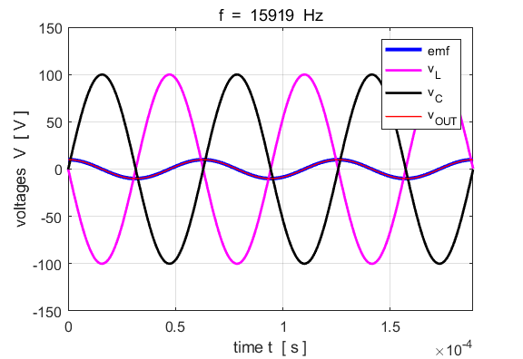

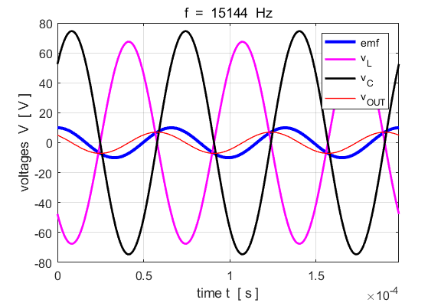

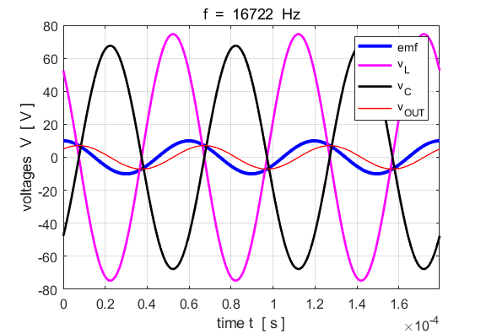

Fig. 9. The voltages at the resonance frequency and half-power frequencies.

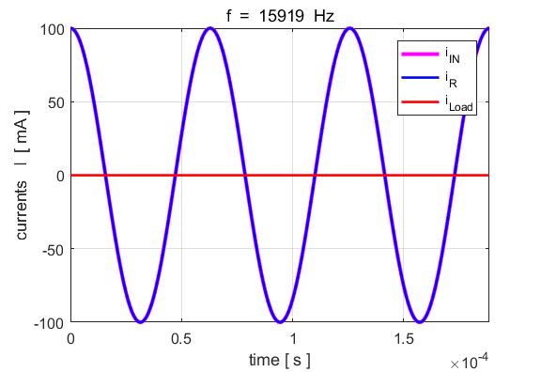

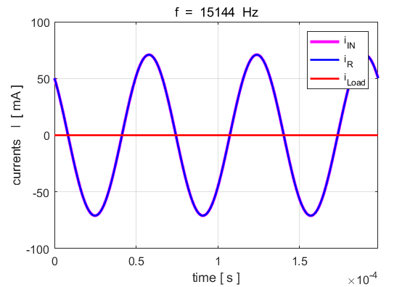

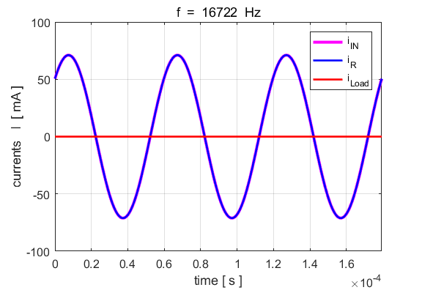

Fig. 10. The currents at the resonance frequency and half-power frequencies.

**Investigating the response of the RLC series circuit with changes in parameters**

You can simply change the input parameters and immediately see the changes in the response of the circuit.

* Changing the value of the series resistance *R* does not change the resonance frequency . However, it does change the sharpness of the current peak. As *R* is increased, the bandwidth increases and the *Q* factor decreases. Also, the current in the circuit decreases (figures 11 and 12).

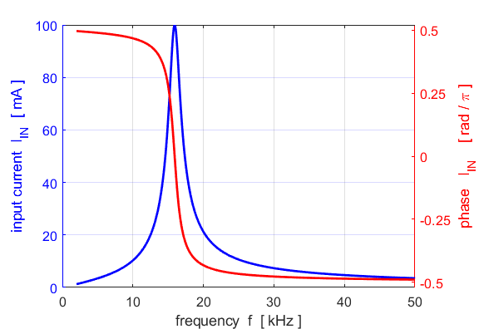

Fig. 11. 

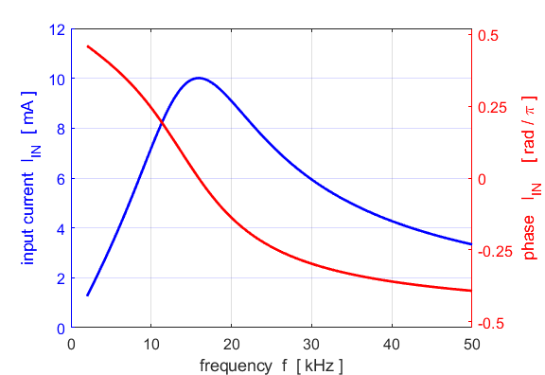

Fig. 12. 

* Decreasing the output resistance (load) *ROUT* slightly decreases the bandwidth and increases the *Q v*alue, while the current and power delivered to the load is increased (figures 13 and 14).

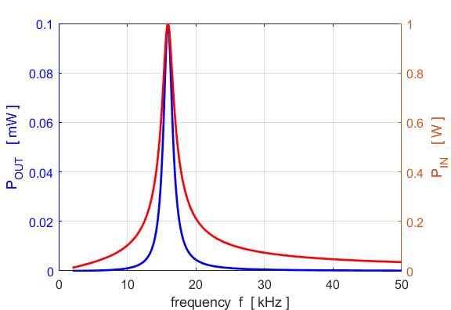

Fig. 13. 

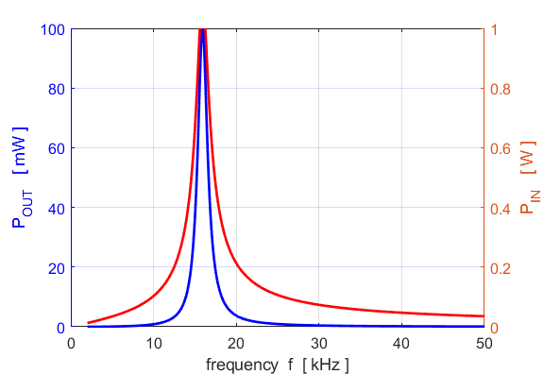

Fig. 14. 

* Textbook examples: Many textbook style problems on ac circuits can be done using the complex number functions in Matlab rather than doing lots of tedious algebra

**Sample Problem**

Find the magnitude and phase of the current in the RLC series circuit with parameters:

*emf* = 20 V *f* = 1590 Hz, *R* = 30 , *L* = 14 mH, C = 1 F

Run the script with the above parameters and set the range of frequencies as

fMin = 1590; fMax =52e3

The first element of each array corresponds to the frequency of the source emf. The answers to the problem can be found by entering commands in the Command Window

>> abs(I1(1)) ans = 0.4015

>> angle(I1(1)) ans = -0.9245

>> rad2deg(angle(I1(1))) ans = -52.9696

The magnitude of the current is 400 mA and the current lags the source *emf* by 53o.

Using Matlab it is easy to show the phase relationship between the source emf and current graphically (figure 15). Also, you can show the resonance peak for the current (figure 16).

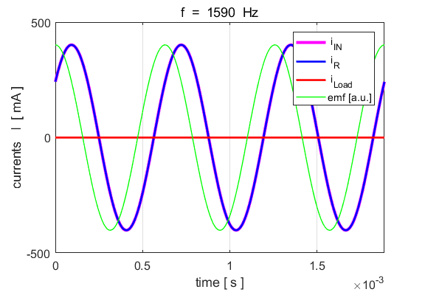

Fig 15. The time variation in the currents at the frequency of 1590 Hz. The green curve is the scaled applied emf curve. The plots illustrate the lag in phase of 53o of the current with respect to the source emf.

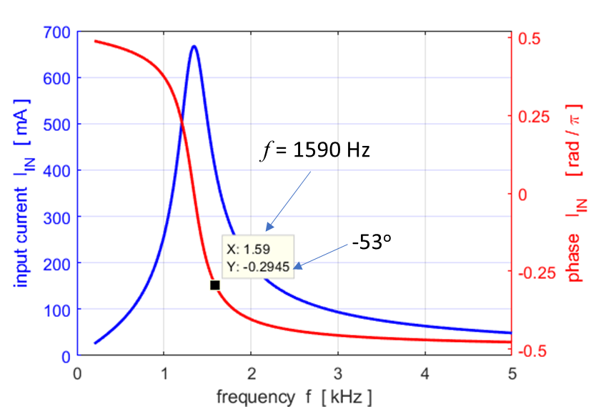

Fig. 16. Resonance response of the RLC series circuit .

**Modeling Experimental Data**

Data was measured for the circuit shown in figure 1. An audio oscillator was used for the source and the output was connected to digital storage oscilloscope (DSO). The component values used were:

series resistance 

capacitance 

inductance 

assume DSO resistance  (output to CRO)

**The measurements are given in the script CRLCs2.m**

Figure 11 shows a plot of the experimental data.

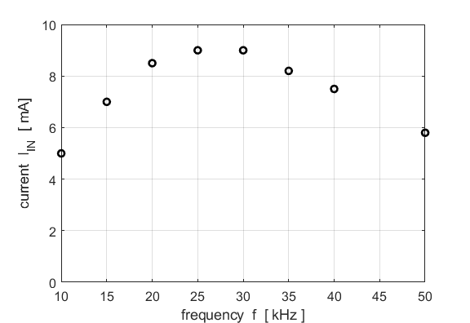

Fig. 11. Plot of the experimental measurements.

We can use the simulation **CRLCs2.m** to fit theoretical curves to the measurements by adjusting the input values for the inductance, capacitance and resistance to try and get the best fit (figure 12).

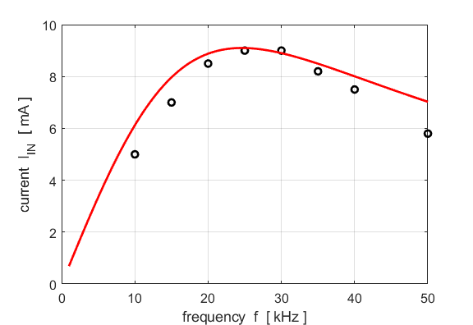

Fig. 12. The best-fit of the model to the measurements.



If you consider the simplicity of the code in the Matlab script to model resonance circuits, this computational approach has many advantages compared with the traditional algebraic approach.