[DOING PHYSICS WITH MATLAB](https://d-arora.github.io/Doing-Physics-With-Matlab/)

FILTER CIRCUITS

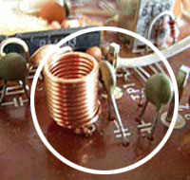

Ian Cooper

Please email any corrections, comments, suggestions or additions: matlabvisualphysics@gmail.com

[Matlab Download Directory](https://drive.google.com/drive/u/3/folders/1j09aAhfrVYpiMavajrgSvUMc89ksF9Jb)

CacFilters1.m

Modelling a simple RC low pass filter or RC high pass filter using complex functions to represent circuit parameters for sinusoidal signals. All results are shown graphically. The RC circuit can be fully analysed without the need for extensive algebraic manipulations. The circuit parameters are set in the INPUT section of the script.

Low pass filter: flagF = 1 High pass filter: flagF = 2

The parameter fs sets the frequency for the voltages as functions of time t.

CacFilters2.m

Modelling a bandpass filter: combination of a low and high pass filter.

The operation of many electronic instruments requires the amplification of a selected range of frequencies while suppressing others. The behaviour of an amplifier for a given frequency can be controlled by adding reactive elements - capacitors and inductors. Such circuits are usually called filters because they “filter” out frequencies except those lying in a selected range. The response of any electronic circuit depends to some degree on the frequency of operation. In an amplifier, for example, the gain will be constant over some range but fall off outside this range of frequencies. The frequency behaviour is called its frequency response characteristic and is usually displayed graphically. The ratio of output voltage to input voltage as it varies over a given frequency range is known as the circuit’s transfer function.

We will consider a simple ac voltage divider circuit that can act as a low pass filter or a high pass filter depending upon the circuit elements as shown in figure 1. The Matlab complex functions are used to calculate circuit impedances, currents, voltages and voltage gain for a sinusoidal input voltage without all the “messy” algebra.

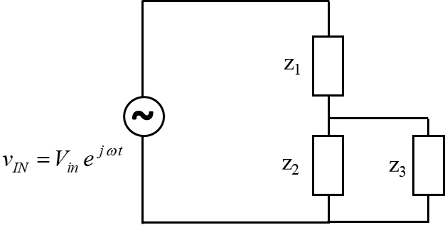

Fig. 1. ac voltage divider circuit. Complex parameters are expressed with the first letter being lowercase and peak values have an Uppercase first letter. This convention is used in the Matlab scripts.

We will only consider sinusoidal voltage inputs where the source emf is given by



where *f* is the frequency, *T* the period and  the angular frequency.

The actual voltage is found by taking the real part of the complex function



The impedance *Z* of a circuit element is



where *R* is the resistance and *X* is the reactance.

The reactance of a capacitor  is



The reactance of an inductor is



Our goal is to calculate the output voltage across the load *Z*3*,* the current *IOUT* through the load *Z3* and the power *POUT* absorbed by the load *Z*3*.*

The ratio of the output voltage to the input voltage is called the voltage gain 



The above quantities are calculated as described in the following sequence.

The impedance *Z*4of the parallel combination is



The total impedance *Z*5of the circuit is



The currents and potential differences are











The power absorbed by an element is given by



LOW PASS FILTER

A simple low pass filter is shown in figure 2 where the output voltage is measured across the capacitor.

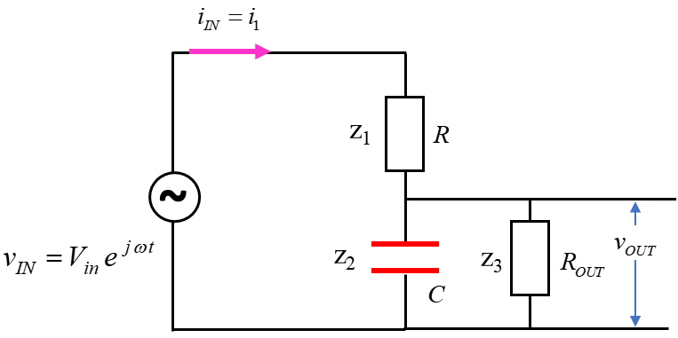

Fig. 2. Simple RC low pass filter.

It is an easy task to calculate the circuit currents and voltages using Matlab complex functions.

The input parameters used in modelling the circuit shown in figure 2 are shown in the Table below.

|  |
| --- |
| % =====================================================  % INPUTS default values [ ]  % =====================================================  % set flagF: flagF = 1 low pass filter / flagF = 2 high pass filter  flagF = 1;  % series resistance Z1 [ 1e3 ohms]  R = 1000;  % capacitance Z2 [1.0e-6 F]  C = 1e-6;  % output resistance Z3 [ 1e3 ohms]  R_OUT = 1e3;  % input peak voltage for apllied emf [10 V]  V_IN = 10;  % frequency range {N = 1000 fMIn = 10 Hz fMAx = 5e3 Hz]  N = 1000;  fMin = 10;  fMax = 10e3;  % input signal frequency fs for time domain graph [319.6897] Hz  fs = 319.6897; |

The code to calculate the currents (magnitude and phase), voltages (magnitude and phase) and powers is shown in the Table below. Logical functions are used to find the frequency *fC* at which the power drops by 50% (-3dB point). The frequency *fC* is known as the cut-off frequency. The voltage gain  expressed as a ratio and in dB is defined as



|  |
| --- |
| % ======================================================  % CALCULATIONS  % ======================================================  f = linspace(fMin,fMax, N);  w = (2*pi).*f;    % impedances  % low pass filter  Z1 = R; % series resistance  Z2 = -1i ./ (w .*C); % capacitive impedance (reactance)    % high pass filter  if flagF == 2  Z1 = -1i ./ (w .*C);  Z2 = R;  end    Z3 = R_OUT; % output or load resistance    Z4 = 1 ./ (1./Z2 + 1./Z3); % parallel combination  Z5 = Z1 + Z4; % total circuit impedance    % currents [A] and voltages [V]  i1 = V_IN ./ Z5; i_IN = i1;  v1 = i1 .* Z1;  v2 = V_IN - v1; v3 = v2; v_OUT = v2;  i2 = v2 ./ Z2;  i3 = v3 ./ Z3; i_OUT = i3;    % Magnitudes: currents [mA] and voltages [V]  V1 = abs(v1);  V2 = abs(v2);  V3 = V2;  V_OUT = V2;  I1 = 1e3.*abs(i1); I_IN = I1;  I2 = 1e3.*abs(i2);  I3 = 1e3.*abs(i3);  I_OUT = I3;    % Phases [rad /pi]  phi_1 = angle(v1)./pi;  phi_2 = angle(v2)./pi;  phi_3 = angle(v3)./pi;  phi_OUT = phi_3;    theta_1 = angle(i1)./pi;  theta_2 = angle(i2)./pi;  theta_3 = angle(i3)./pi;    % Powers [mW]  P1 = V1.*I1;  P2 = V2.*I2;  P3 = V3.*I3; P_OUT = P3;  P_IN = V_IN .* I_IN;    % Voltage gain Av and -3dB point  Av = V_OUT ./ V_IN;  AvdB = real(20*log10(Av));    AvdB_max = max(AvdB);  AvdB_3 = AvdB_max-3;  K = find(AvdB < AvdB_3,1);  if flagF == 2  K = find(AvdB > AvdB_3,1);  end  fC = f(K);  AvdB_C = AvdB(K); |

The results of the calculations are displayed in a series of graphs as shown in figures 3 to 6.

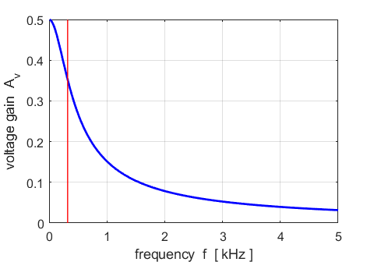

Fig. 3. The voltage gain across the capacitor as a function of input frequency. The red line indicates the cut-off frequency.

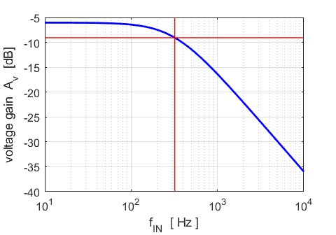

Fig. 4. The voltage gain (dB scale) as a function of frequency. The red lines show the -3dB point and the cut-off frequency.

The 3 dB point gives the frequency at which the voltage gain has fallen by 3 dB (figure 4). At this point, the power is ½ of the maximum power. For frequencies less than the cut-off frequency, the voltage gain is essentially constant and independent of frequency. Above the cut-off frequency, the voltage gain falls with a slope of –20 when the voltage gain *A*v (dB) is plotted against log10 ( *f* ).

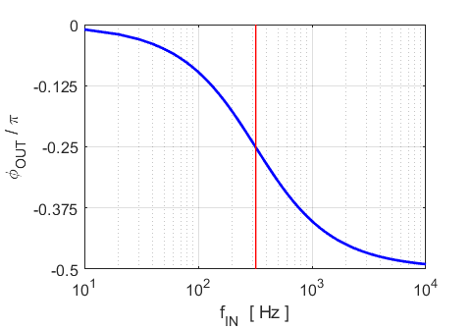

Fig. 5. The phase difference between the output voltage and the input voltage of the source.

At very low frequencies, the capacitance has a very high impedance  and acts like an open circuit. So, the output and in voltages are essentially in phase. However, at very high frequencies, the impedance of the capacitor is very small and acts like a shorty circuit which results in the output voltage lagging the input voltage by  rad. At the cut-off frequency, the phase difference is .

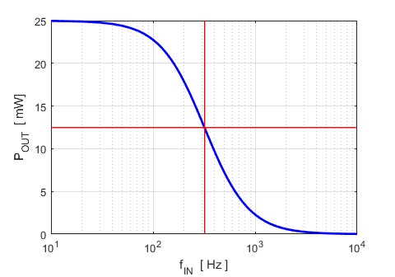

Fig. 6. The power delivered to the load (output) resistance as a function of source frequency. The red lines indicate the cut-off frequency, the frequency at which the maximum power drops by 50%.

From figures 3 to 6, it is easy to see why this circuit is called a low pass filter. It passes low frequency signals with less attenuation than high frequency signals. For very low frequencies, the capacitive reactance is so large compared to the resistance values that it is essentially an open circuit. Thus, the circuit behaves as if the capacitor was removed. A passive RC circuit such as this one does not have a sharp cut-off above a certain frequency, rather, the attenuation gradually falls as the impedance of the capacitor decreases with increasing frequency. For very high frequencies, the capacitive reactance is much smaller than the load resistance, thus shorting it out. Therefore, the load resistance has little effect on the circuit and the circuit again acts as a simple voltage divider.

We can also look at the voltages in the time domain at a fixed frequency *fs* (figure 7).

The source voltage is given by



The actual voltage is real and given by the real part of the complex voltage function



The complex function for the output voltage is



The actual output voltage is



|  |
| --- |
| KK = find(f > fs,1);  Ns = 1000;  ws = 2*pi*fs;  Ts = 1/fs;  tMin = 0;  tMax = 3*Ts;  t = linspace(tMin,tMax,Ns);  % input signal emf  emf = real(V_IN .* exp(1j*ws*t));  % output or load voltage  vLoad = real(abs(V3(KK)) .* exp(1j*(ws*t + pi*phi_3(KK)))); |

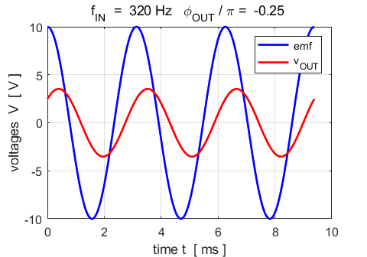

Fig. 7. The input and output voltages as functions of time . When the source frequency is set to the cut-off frequency, the output voltage lags the source voltage by  rad.

HIGH PASS FILTER

A simple high pass filter is shown in figure 7 where the output voltage is measured across the resistor.

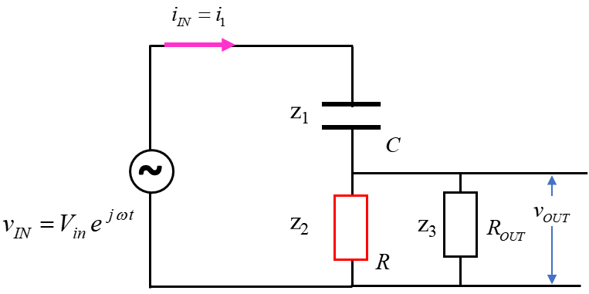

Fig. 8. Simple RC high pass filter.

Low pass filter



High pass filter



The input parameters used in modelling the circuit shown in figure 2 are shown in the Table below.

|  |
| --- |
| % =====================================================  % INPUTS default values [ ]  % =====================================================  % set flagF: flagF = 1 low pass filter / flagF = 2 high pass filter  flagF = 2;  % series resistance Z1 [ 1e3 ohms]  R = 1000;  % capacitance Z2 [1.0e-6 F]  C = 1e-6;  % output resistance Z3 [ 1e3 ohms]  R_OUT = 1e3;  % input peak voltage for apllied emf [10 V]  V_IN = 10;  % frequency range {N = 1000 fMIn = 10 Hz fMAx = 5e3 Hz]  N = 1000;  fMin = 10;  fMax = 10e3;  % input signal frequency fs for time domain graph [319.6897] Hz  fs = 319.6897; |

The results of the calculations are displayed in a series of graphs as shown in figures 9 to 12.

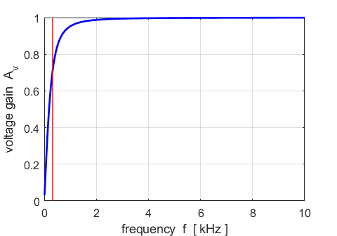

Fig. 9. The voltage gain across the resistor *R* as a function of input frequency. The red line indicates the cut-off frequency.

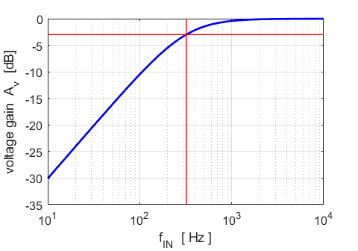

Fig. 10. The voltage gain (dB scale) as a function of frequency. The red lines show the -3dB point and the cut-off frequency.

The 3 dB point gives the frequency at which the voltage gain has fallen by 3 dB (figure 10). At this point, the power is ½ of the maximum power. For frequencies greater than the cut-off frequency, the voltage gain is essentially constant and independent of frequency. Below the cut-off frequency, the voltage gain falls with a slope of +20 when the voltage gain *A*v (dB) is plotted against log10 ( *f* ).

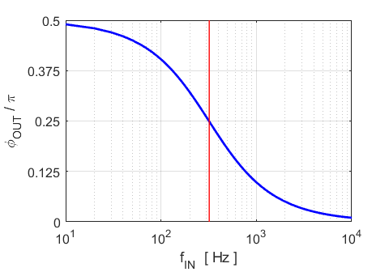

Fig. 11. The phase difference between the output voltage and the input voltage of the source.

At very high frequencies, the capacitance has a very high impedance  and acts like an open circuit. So, the output and in voltages are essentially in phase. However, at very low frequencies, the impedance of the capacitor is very small and acts like a short circuit which results in the output voltage leading the input voltage by  rad. At the cut-off frequency, the phase difference is .

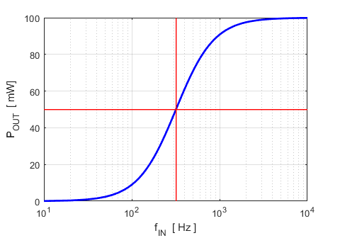

Fig. 12. The power delivered to the load (output) resistance as a function of source frequency. The red lines indicate the cut-off frequency, the frequency at which the maximum power drops by 50%.

From figures 9 to 12, it is easy to see why this circuit is called a high pass filter. It passes high frequency signals with less attenuation than low frequency signals. A passive RC circuit such as this one does not have a sharp cut-off below a certain frequency, rather, the attenuation gradually rises as the impedance of the capacitor decreases with increasing frequency.

We can also look at the voltages in the time domain at a fixed frequency *fs* (figure 13).

The source voltage is given by



The actual voltage is real by the real part of the complex voltage function



The complex function for the output voltage is



The actual output voltage is



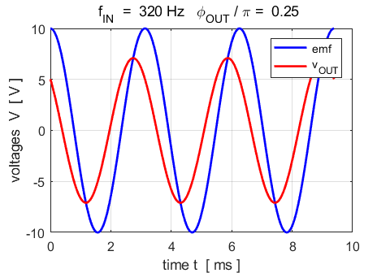

Fig. 13. The input and output voltages as functions of time. . When the source frequency is set to the cut-off frequency, the output voltage leads the source voltage by  rad.

Changing circuit parameters

It is easy to change any of the input parameters and immediately view the changes in the response of the circuit. For example, if the capacitance *C* is halved , the cut-off frequency *fC* is doubled (figure 14). This is because, with a lower capacitance, the capacitive reactance decreases more slowly with frequency.

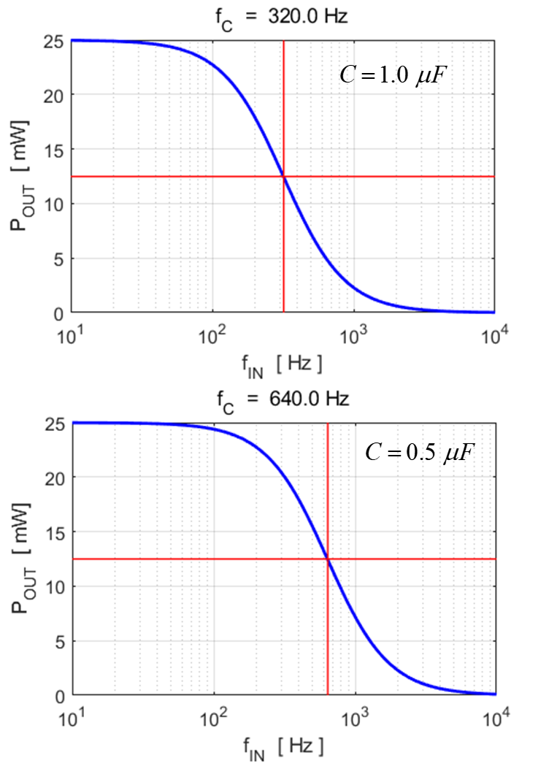

Fig. 14. Change in the response of the circuit when the value of the capacitance *C* is halved.

BANDPASS FILTER CacFilters2.m

We can analyse more complicated circuits using the same approach as for low and high pass filters. For example, the output of a low pass filter becomes the input signal for a high pass filter. This creates a band pass filter. The lower and higher frequencies are more attenuated then the central frequencies. Figure 15 shows the circuit used for the band pass filter.

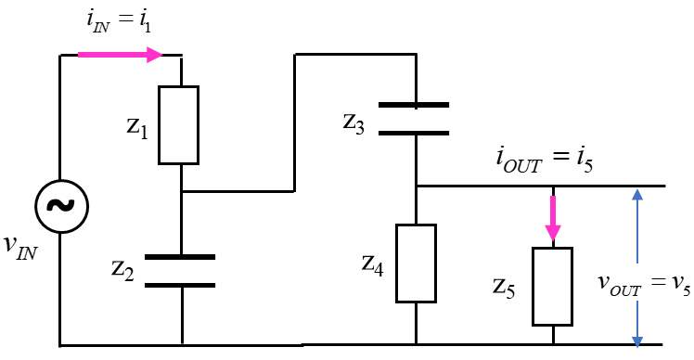

Fig. 15. Bandpass filter circuit: The output from the low pass filter becomes the input signal for the high pass filter.

Our goal is simply to calculate the power output *POUT* absorbed by the load (*Z*5) as a function of frequency *f.* To do the calculations, we simply apply Kirchhoff’s Voltage and Currents Laws and combine impedances that are in parallel and series as shown in figure 16.

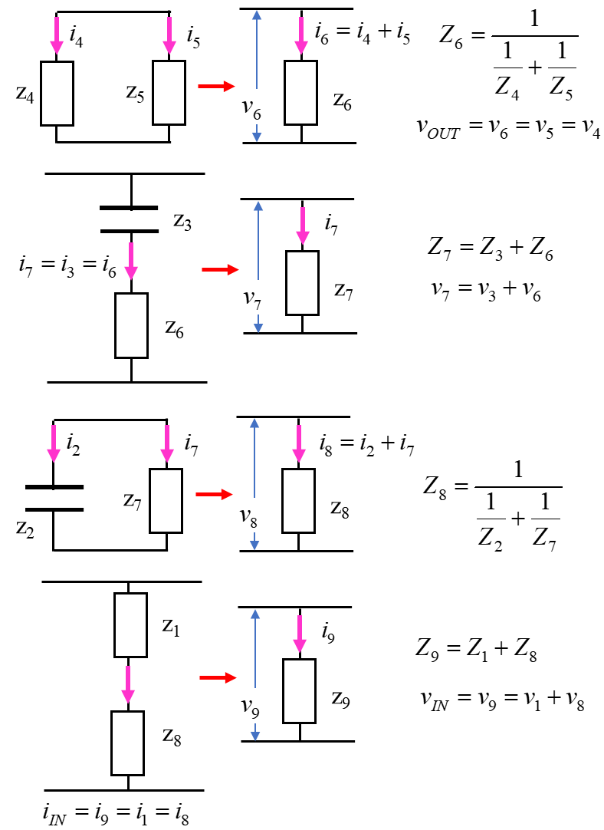

Fig. 16. Equivalent circuits for the bandpass filter of figure 15.

The sequence of calculations to determine the output power absorbed by the load in given by the code shown in the Table below with the script CacFilters2.m

|  |
| --- |
| % impedances  Z1 = R1;  Z2 = -1i ./ (w .*C2);  Z3 = -1i ./ (w .*C3);  Z4 = R4;  Z5 = R5;  Z6 = 1./(1./Z4 + 1./Z5);  Z7 = Z3 + Z6;  Z8 = 1./(1./Z2 + 1./Z7);  Z9 = Z1 + Z8;    % currents [A] and voltages [V]  i1 = V_IN ./ Z9; i_IN = i1;  v1 = i1 .* Z1;  v2 = V_IN - v1;  i3 = v2./Z3;  i7 = i1 - i3;  v6 = i7 .* Z6;  i5 = v6./Z5;  i_OUT = i5;  I_OUT = abs(i_OUT);  v_OUT = v6;  V_OUT = abs(v_OUT);  P_OUT = V_OUT .* I_OUT; |

Simulation with the following input parameters:

|  |
| --- |
| % ====================================================  % INPUTS default values [ ]  % ====================================================    % series resistance Z1 [ 1e3 ohms]  R1 = 1e3;  % capacitance Z2 [1.0e-6 F]  C2 = 1e-6;  % capacitance Z3 [1.0e-6 F]  C3 = 1e-6;  % resistance Z4 [ 1e3 ohms]  R4 = 1e3;  % output resistance Z5 [ 1e3 ohms]  R5 = 1e3; R_OUT = R5;  % input peak voltage for apllied emf [10 V]  V_IN = 10;  % frequency range {N = 1000 fMIn = 10 Hz fMAx = 5e3 Hz]  N = 5000;  fMin = 10;  fMax =10e3; |

The graphical output from the script CacFilters2.m is shown in figure 17.

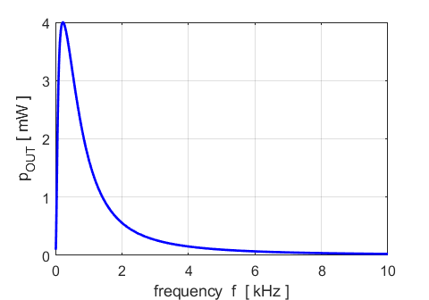

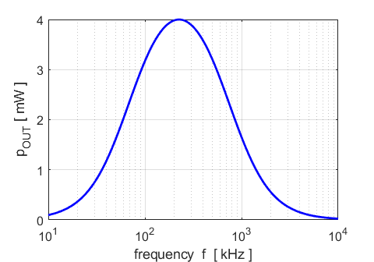

Fig. 17. Bandpass filter. The power absorbed by the load as a function of frequency of the source.