[**DOING PHYSICS WITH MATLAB**](https://d-arora.github.io/Doing-Physics-With-Matlab/)

**ELECTROMAGNETISM USING THE FDTD METHOD**

**[1D] Propagation of Electromagnetic Waves**

Ian Cooper

Please email any corrections, comments, suggestions or additions

matlabvisualphysics@gmail.com

[Matlab Download Directory](https://drive.google.com/drive/u/3/folders/1j09aAhfrVYpiMavajrgSvUMc89ksF9Jb)

**ft_03.m ft_sources.m**

Download and run the script **ft_03.m**. Carefully inspect the script to see how the FDTD method is implemented. Many variables can be changed throughout the script, for example, type of excitation signal, boundary conditions, time scales, properties of the medium.

The script **ft_03.m** is a very versatile program to investigate many aspects of the propagation of electromagnetic waves through dielectric media. You can investigate: free space propagation; propagation in different dielectric media; propagation in lossy dielectric media; reflection and refraction (transmission at an interface); interference effects; resonance.

The **Finite-Difference Time-Domain Method** (**FDTD**) is one of the most popular techniques used in solving problems in electromagnetism because it is very easy to write the computer code even for three-dimensional problems. The method was first proposed by K. Yee in the early 1970s. In this document, solutions to Maxwell’s equation will be given for the one-dimensional propagation of electromagnetic waves generated from a point source.

**MAXWELL’S EQUATIONS and the FDTD Method**

The theory on which the FDTD is simple. To solve problems in electromagnetism, you simply discretise in both space and time the Maxwell’s curl equations with a central difference approximation.

Maxwell’s equations predict the existence of electromagnetic waves that propagate through free space at the speed of light *c*0. The electric field and the magnetic field are time dependent and influence each other - a time varying magnetic field induces a time varying electric field and the time varying electric field induces a time varying magnetic field and the process just continues.

The time-dependent Maxwell’s curl equations in a non-magnetic lossy dielectric material with a dielectric constant  and the losses determined by the medium’s conductivity  are

(1a) 

(1b) 

where the current density  is .

For the one-dimensional case where a plane electromagnetic wave propagates in the Z direction due to a time varying electric field component  and a magnetic field component , Maxwell’s curl equations reduce to

(2a) 

(2b) 

This mode of propagation is called a **TEM wave** (electric field polarized in X direction with  and ).

The values of  and  differ by several orders of magnitude and hence and  will also differ by several orders of magnitude when and  are measured in S.I. units. This problem can be overcome by making a change of variable where  is replaced by a scaled value  for the electric field



(3) 

which gives

(4a) 

(4b) 

We can approximate both the spatial and temporal partial derivatives using the **central difference method**

(5a) 

To find the latest value for the electric field, equation 5a is rearranged to give

(5b)

and equation (4b) becomes

(5c)



We can simulate an electromagnetic wave propagating from one medium to another by making both the relative dielectric  and conductivity  functions of z. To simply the coding, we can define a series of functions

(6a) 

(6b) 

(6c) 

(6d) 

(6e) 

For stability of the iterative method is often given by the **Courant Condition**

(7) 

where *D* is the dimension of the simulation and we will take the equality sign for the stability condition. Thus, a given cell size or grid spacing  determines the time step  in a simulation or vice-versa

(8) 

The default value used in the simulation is ***D* = 4**giving

(9) 

Substituting equations 6 into equations 5b and 5c gives

(10a)



(10b) 

Equations 10a and 10b are interleaved, the new value of  at position  is calculated from the previous value of  at position  and the most recent pair values of at  and . is calculated at  from its previous value at  and the most recent values of  at and .



This **interleaving** is at the heart of the FDTD method, that is, the equations are solved in a **leap-frog** manner where the electric field is solved at a given instant in time, then the magnetic field is solved at the next instant in time, and the process is repeated over and over again.

To write the mscript to solve iteratively equations 10a and 10b, we need to assign indices for time  and position , where





For the electric field 

Time: 

Position: 

For the magnetic field 

Time: 

Position:



Equations 10a and 10b can now be expressed in a format that is now straight forward to write the computer code

(11a) 

(11b)



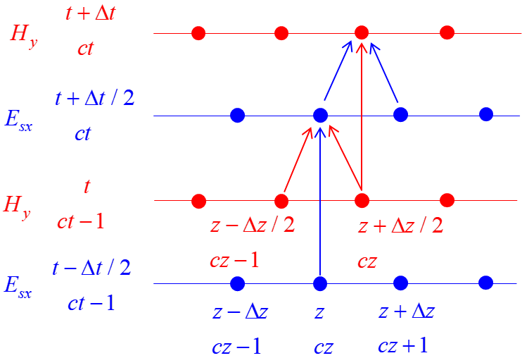

Fig. 1. Interleaving of the  and  fields in space and time in the FDTD method.

**BOUNDARY CONDITIONS**

A fundamental assumption in the FDTD method is that in calculation the *E* and *H* fields, we need to know the surrounding *H* and *E* field values, but at the edges of the Z space we do not have values for *E* and *H.* So, it is important that the boundary values for *E* and *H* are specified at each time step.

The boundary condition where *E* = 0 is called a **perfect electric conductor boundary** (PEC). A **perfect magnetic conductor** **boundary** (PMC) is when *H* = 0 is set as the boundary condition. This means that when a pulse arrives at the ends of the Z space, the boundary conditions that are imposed on the solution results in the reflection of both the electric and magnetic fields.

**Absorbing boundary conditions**

We can stop the reflections at the boundary by applying absorbing boundary conditions. We can solve this problem by assuming that there are no sources outside the Z space and that the wave propagates outward across the boundary. From the stability condition given by equation 9 with *D =* 4

(9) 

it takes two time steps for the wave to propagate that from one grid position to the next in free space. Hence, to apply absorbing boundary conditions at the ends of the Z space, the values of the fields at the boundaries of the Z space are set to the values of the adjacent z position two time steps earlier. In terms of the space *cz* and time *ct* indices, the absorbing boundary conditions are:

(13) 

These boundary conditions are easy to code. We need to simply store the values for the fields adjacent to the end points of the Z space for the previous two time steps.

**Excitation of the propagating *E* and *H* fields**

A variety of functions at any grid point can be used as the source of the propagating electromagnetic wave. The mscript **fd_sources.m** was used to create the plots of the source functions shown in figures 2, 3 and 4.

**Gaussian pulse**

A Gaussian pulse in the electric field at a grid point produces an electromagnetic wave pulse that propagates away in both directions from a fixed source point.

The values of *Esx* and *Hy* are calculated by separate loops due to the interleaving of the *Esx* and *Hy* values. After *Esx* has been calculated, the *Esx* value at the source point is over-written by the value calculated from the Gaussian source function when its value is greater than some threshold value. This is referred to as a **hard source** because a specific value is imposed on *Esx* on the FDTD grid. In wave impinging upon the hard source will lead to reflections.

The Gaussian pulse is given by equation 14

(14) 

where *zS* is the index specifying the location of the point source, *A* is the maximum height of the pulse, *t0* determines the time step index for the peak value of the pulse, *s* is the spread of the pulse and *ct* is the index for the time step.

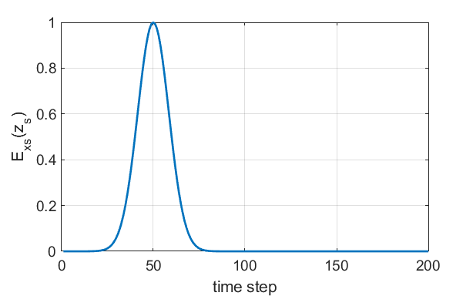

Fig. 2. Hard source: Gaussian time variation in *Esx* at source point. (*A* = 1, *s* = 12, *t0 =* 40).

**Sinusoidal Excitation**

A continuous sinusoidal source (equation 16) can act to excite the propagation of the electromagnetic wave along the Z axis.

(16) 

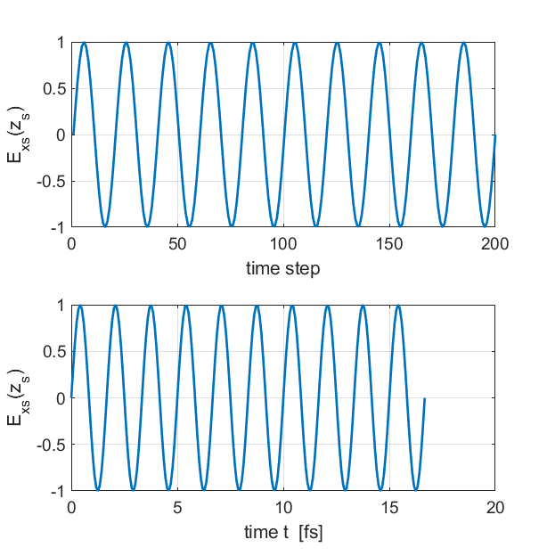

Fig. 3. Sinusoidal excitation signal.

**Modulated Gaussian pulse**

A modulated Gaussian pulse given by equation 15 act as a source at the point *zs*.

(15) 

The frequency of the modulation signal is *fs.*

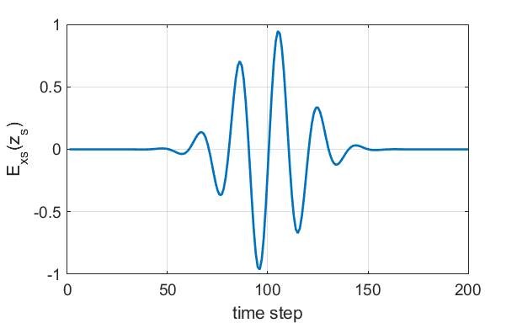

Fig. 4. Modulated Gaussian pulse.

|  |
| --- |
| **fd_sources.m**  % INPUTS ==================================================  % Number of time steps  nt = 200;  % Amplitude of source signal  A = 1;  % Width of source signal  s = 12;  % Signal frequency  fS = 3e8/500e9;  % Time for peak signal  ct0 = 100;  % wavelength  wL0 = 500e-9;  % CALCULATIONS ============================================  % speed of light / frequency / period  c0 = 3e8;  f0 = c0/wL0;  T0 = 1/f0;  tMax = 10*T0;  t = linspace(0,tMax,nt);  dt = t(2)-t(1);  ct = 1:nt;    % GAUSSIAN PULSE  EG = A.*exp(-(0.5.*(ct0 - ct)./s).^2);  % SINE FUNCTION  ES = sin(2*pi*f0*t);  % MODULATED GAUSSIAN SIGNAL  EMG = EG .* ES; |

**MATLAB script ft_03.m**

The finite difference time domain (FDTD) uses a centre-difference representation of the continuous partial differential equations to create iterative numerical models of electromagnetic wave propagation by solving Maxwell’s equations in the time domain. Maxwell’s equations are discretized in time and space and a leap-frog algorithm is used to find the Ex-field and Hy-field as functions of time and space.

The number of time steps Nt is varied to change the simulation time.

The number of spatial grid points is specified by the variable Nz. Generally Nz is fixed at the default value Nz = 400.

Time and position are **not** independent quantities as shown by equation 7.

(7) 

To specify the Z axis, the wavelength associated with a sinusoidal wave is given by the variable lambda.

In the simulations using the script, a point source is used to excite an electromagnetic wave that propagates along the Z axis. You can select the source excitation by setting the value of the variable flagS.

flagS = 1 Gaussian pulse excitation

flagS = 2 Sinusoidal excitation

flagS = 3 Modulated sinusoidal excitation with a Gaussian

envelope

The source is specified by the inputs: zS (Z index for location of excitation point); A (amplitude); width (width of the Gaussian pulse in time steps); centre (centre of pulse in time steps).

The properties of the media are specified by the relative permittivity (dielectric constant) eR and the conductivity S. The default for the program is to have a uniform medium or two uniform media where the boundary occurs at the grid position given by M2. You can specify the electrical properties of the Z space by specifying the relativity permittivity and conductivity for a range of grid points. This is not done in the INPUT section of the script.

|  |
| --- |
| % ELECTRICAL PROPERTIES OF MEDIA  eR = ones(1,Nz).* eR1; % Relative permittivity  indexR = round(200:200+12.5/8);  eR(indexR) = eR2; |

We can monitor the time evolution of the E-field and H-field at five Probe positions along the Z axis which is specified by the variable cP. You can easily change the positions of the Probes.

The variables limE and limH are used to change the Y limits for the plots of the E-field and H-field as functions of time in figure 1.

The boundary conditions are specified by the variable flagBC.

|  |
| --- |
| % BOUNDARY CONITIONS -----------------------------------------------------  % flagBC = 1 absorbing  % flagBC = 2 Perfect electric conductor PEC at end  boundary only  % flagBC = 3 Perfect magnetic conductor PMC at end  boundary only  % flagBC = 4 Perfect electric conductor PEC at both  boundaries  flagBC = 1; |

An animation of figure can be saved as a gif file using the variable f_gif = 1.

The results of the modelling are shown in Figure Windows.

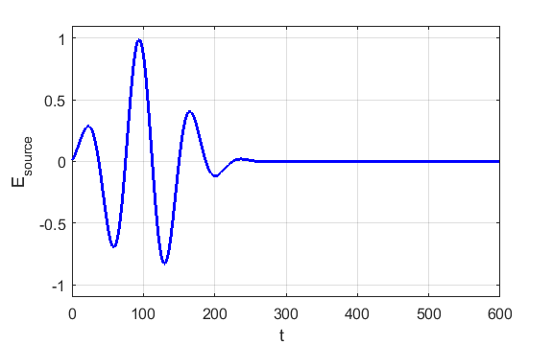

Fig. 5. Plot of the source function (Modulate Gaussian Pulse:

width = 50 and centre = 100)

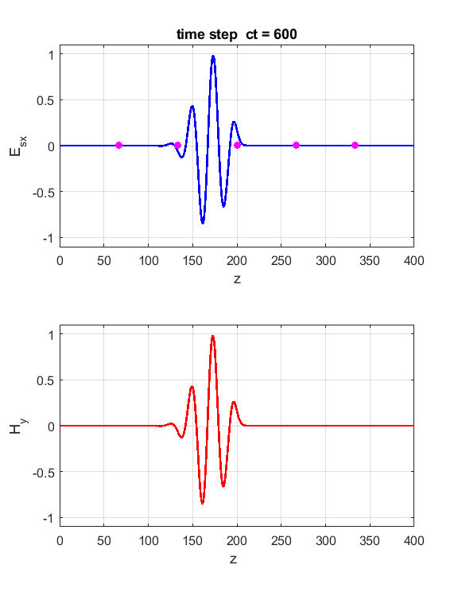

Fig. 6. The E-field and H-field after 600 time steps. The magenta dots show the positions of the 5 Probes.

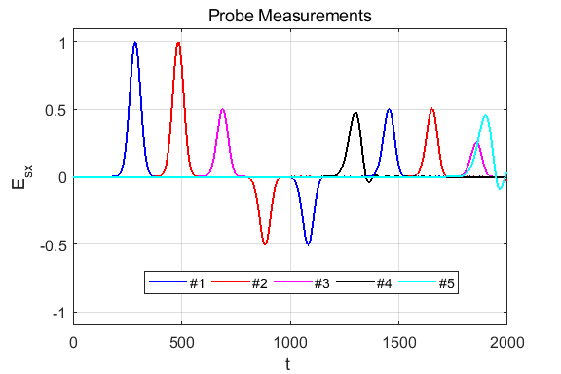

Fig. 7. EM pulse hitting a medium with a different dielectric constant. Pulse: width = 25 and centre = 100. Medium 1 is free space and Medium 2 has a dielectric constant of 9.

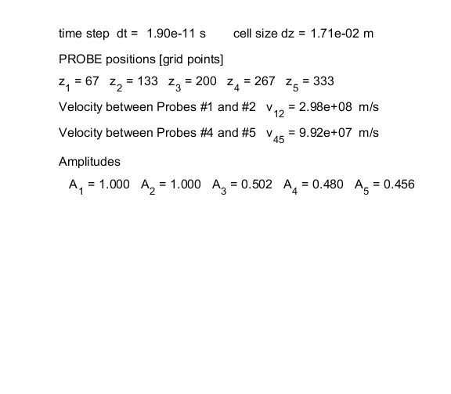

Fig. 8. Summary of the results for EM pulse shown in figure 7

the hitting the boundary. The pulse travels at a speed of *c*0/3 in Medium 2 which has a dielectric constant of 9.

**Reference**

Dennis M Sullivan, *Electromagnetic Simulation Using the FDTD Method*. IEEE Press.