**SOLVING ORDINARY DIFFERENTIAL EQUATIONS WITH THE LAPLACE TRANSFORM USING MATLAB**

**Ian Cooper**

matlabphysics@gmail.com

**Doing Physics with Matlab**

https://d-arora.github.io/Doing-Physics-With-Matlab/

**Download Scripts**

https://drive.google.com/drive/u/3/folders/1j09aAhfrVYpiMavajrgSvUMc89ksF9Jb

**Laplace07.m**

The Laplace transform is used to solve the ODE for the cases where the System is driven via the **mass**.

**Laplace08.m**

The Laplace transform is used to solve the ODE for the cases where the System is driven via the **mass** by a sinusoidal driving force.

**Laplace09.m**

The Laplace transform is used to solve the ODE for the cases where the System is driven via the **dashpot** by a sinusoidal driving force.

**Laplace11.m**

The Laplace transform is used to solve the ODE for the cases where the System is driven via the **spring** by a sinusoidal driving force.

**Laplace12.m**

The Laplace transform is used to solve the ODE for the cases where the System is driven via the **dashpot** and **spring** by a sinusoidal

driving force.

**INTRODUCTION**

Starting from a linear ordinary differential equation in *x* with constant coefficients, the Laplace transform *X* produces an algebraic equation that can be solved for *X*. The solution *x* is then found by taking the inverse Laplace transform of *X*. The Laplace transform method is most compatible with initial value problems.

Many physical systems can be modelled by ordinary differential equations (ODEs) with time independent coefficients. In this paper we will consider solving ODEs of the form

(1) 

where *m*, *b* and *k* are constants and *x* is the displacement of the system from its equilibrium position (*x* = 0). The initial conditions are specified by the displacement *x*(0) and velocity *v*(0). The time dependent function *f*(*t*) is called the input signal or forcing function or driving force. The solution *x*(*t*) is called the output signal.

Equation (1) is used to model a mass *m*, spring *k*, and dashpot - damping *b* System as shown in figure 1 for different input signals.

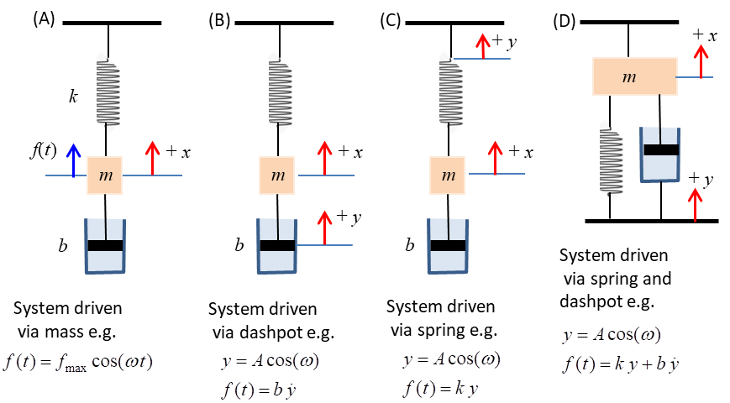

Fig. 1. Mass / spring / dashpot System.

**LAPLACE TRANSFORM**

The Laplace transform and its inverse can be used to find the solution of initial value problems for ordinary differential equations.

Suppose that the function  is defined for all . Then its Laplace transform is the function  as given by

(2) 

where is the symbol used for the Laplace transform operator and *s* is a complex variable such that

(3)  dimensions  [1/time]

An important property of the Laplace transform is that it turns a derivative into an algebraic operation. For example,

(4) 

The Laplace transform of a function can be easily computed in Matlab (Symbolic Maths and Signal Processing toolboxes required) as shown by the following examples. The function *f* and variables *t* and *s* are all declared as **symbolic** variables

syms f t s

f = 2; laplace(f,t,s)  2/s

f = sin(4*t); laplace(f,t,s)  4/(s2+16)

f = 10*sin(4*t); laplace(f,t,s)  40/(s2+16)

f = 5*cos(2*t); laplace(f,t,s)  5s/(s2+4)

f = x^5; laplace(f,t,s)  120/s6

f = exp(-2*t); laplace(f,t,s)  1/(s+2)

f = 3*exp(4*t); laplace(f,t,s)  3/(s-4)

Table 1 lists a few of the most frequently used Laplace transforms.

Table 1. Laplace transforms.

|  |  |
| --- | --- |
| *f*(*t*) | *F*(*s*) |
| *a* | *a / s* |
| *A* sin(*b t*) | *A b /* (*s*2*+b*2) |
| *A* cos(b t) | *A s /* (*s*2*+b*2) |
| *xn* | *n*! / *sn*+1 |
| *A*e- *a t* | *A* / (*s*+*a*) |

You can also do the reverse by finding the function *f*(*t*) from its Laplace transform *F*(*s*) using the inverse Laplace transform. For example



ilaplace(3/((s-1)^2+6)) (6^(1/2)*exp(t)*sin(6^(1/2)*t))/2

**LAPLACE TRANSFORM AND ORDINARY DIFFERENTIAL EQUATIONS**

Initial value ordinary differential equation problems can be solved using the Laplace transform method. We want to solve ODE given by equation (1) with the initial the conditions given by the displacement *x*(0) and velocity *v*(0) . Our goal is to find the output signal for a given input signal.We will denote the Laplace transform of the input as *F*(*s*) and the output as *X*(*s*). Taking the Laplace transform of both sides of equation (1) and using equation (4), we find

(5) 

This algebraic equation can be solved to find *X*(*s*). We than take the inverse Laplace transform of *X*(*s*) to find the output signal *x*(*t*).

We can also find dependence of both the velocity *v* and acceleration *a* of the mass by from the Laplace transform of the output signal *X*(*s*)

Velocity *v* and its Laplace transform *V*(*s*)



Acceleration *a* and its Laplace transform *A*(*s*)



**A1 System driven through via the mass Laplace07.m**

Four plots are used to display the output in a Figure Window: (1) displacement *x* vs time *t*; velocity *v* vs *t*; acceleration *a* vs *t*; phase plot *v* vs *t*; function *f* vs *t*. The labelling shows the System parameters *m*, *b* and *k*; the natural frequency of oscillation and the natural period of oscillation  and the period estimated from the *x* vs *t* graph using the Matlab function findpeaks. The symbolic results are displayed in the Command Window, for example,

Sol_x = s/(s^2 + 4)

sol_x = cos(2*t) cos(2 t)

Sol_v = s^2/(s^2 + 4) - 1

sol_v =-2*sin(2*t) -sin(2 t) 2

Sol_a = s^3/(s^2 + 4) - s

sol_a = -4*cos(2*t) -cos(2 t) 4

**A1.1 Simple harmonic motion**



 

 

 

**Poles of the Laplace transform Solx**



Hence, the natural frequency of oscillation is  and the solution of the displacement is of the form



**A1.2 Damped harmonic motion**















**Poles of the Laplace transform Solx**

The solution of the displacement is of the form





**A1.3 Exponential impulsive force**





Sol_x = 1/(s^3 + s^2 + 4*s + 4)

sol_x = exp(-t)/5 - cos(2*t)/5 + sin(2*t)/10

Sol_v = s/(s^3 + s^2 + 4*s + 4)

sol_v = cos(2*t)/5 - exp(-t)/5 + (2*sin(2*t))/5

Sol_a = s^2/(s^3 + s^2 + 4*s + 4)

sol_a = (4*cos(2*t))/5 + exp(-t)/5 - (2*sin(2*t))/5

**Poles of the Laplace transform Solx**



The roots of the polynomial are computed using the Command Window

>> p = [1 1 4 4] p = 1 1 4 4

>> roots(p)

0.0000 + 2.0000i

0.0000 - 2.0000i

-1.0000 + 0.0000i

After the initial disturbance the System oscillates at its natural frequency indefinitely since the damping is zero.

**A2 System driven through via the mass by sinusoidal functions**

**Laplace08.m**

We next consider the system driven via the mass by a sinusoidal driving force. This example allows you to study the phenomena of **resonance**. The ODE to be solved is



given the initial displacement and velocity of the mass. The ODE equation can be also expressed as



where the output *z* is assumed to be a sinusoidal function of the form



where *G* is the complex function



After a bit of algebra, you can derive the following relationships:





Resonance frequency 

Natural frequency 

Phase 

**A2.1 System driven at its natural frequency of vibration with no damping.**



The System vibrates at the driving frequency. When the System is driven at its natural frequency, then the oscillations continually grow with time .

Sol_x = s/(s^2 + 4)^2



sol_x = (t*sin(2*t))/4

Sol_v = s^2/(s^2 + 4)^2 sol_v = sin(2*t)/4 + (t*cos(2*t))/2

Sol_a = s^3/(s^2 + 4)^2 sol_a = cos(2*t) - t*sin(2*t)



The oscillations of the input and output are in phase.

**A2.2 System driven at its natural frequency of vibration with damping.**



Sol_x = s/((s^2 + 4)*(s^2 + s/2 + 4))

In the Command Window

>> p=[1 0.5 4] p = 1.0000 0.5000 4.0000

>> roots(p) ans = -0.2500 + 1.9843i -0.2500 - 1.9843i



sol_x = sin(2*t) - (8*7^(1/2)*exp(-t/4)*sin((3*7^(1/2)*t)/4))/21

The System’s resonance frequency is .

Since the System is driven at a frequency very close to its resonance frequency, large amplitude oscillations result with the output leading the input by 90o.



When the System is driven at a frequency which is away from the resonance frequency, the System will vibrate at the driving frequency with small amplitude oscillations after the initial transient oscillations die away exponentially.



Sol_x = s/((s^2 + 9)*(s^2 + s/2 + 4))

sol_x = (6*sin(**3**\*t))/109 - (20*cos(**3**\*t))/109 +

(20\***exp(-t/4)**\*(cos((3*7^(1/2)*t)/4) –

(13*7^(1/2)*sin((3*7^(1/2)*t)/4))/105))/109



**B System driven through the dashpot Laplace09.m**

To illustrate the Laplace transform method to solve ODEs, we will consider the example of the mass / spring / dashpot System excited by a sinusoidal displacement of the piston in the dashpot. The ODE for this system is



The output and input functions can be expressed in exponential form as



where *G* is the **transfer function**. By substitution, we can find the expressions for the transfer function *G*, its magnitude *g* and argument .

(8) 

The maximum gain is *g* = 1 when .  is the natural frequency of the System. At the natural frequency of excitation, the input and output oscillations are in phase . For the System driven through the damper, the natural frequency  and maximum gain are both independent upon the damping parameter *b*. If  then the phase lag is negative and the response runs behind the input (lags). If  then the phase lag is positive and the response runs ahead of the input (leads).

**B.1 Example** 



Sol_x = (s - 4/(5*(s^2 + 1)) + 1)/(s^2 + (4*s)/5 + 4)

sol_x = (16*cos(t))/241 - (60*sin(t))/241 +

(225*exp(-(2*t)/5)*(cos((4*6^(1/2)*t)/5) +

(991*6^(1/2)*sin((4*6^(1/2)*t)/5))/5400))/241

The Laplace transform *X*(*s*) gives us information directly about the nature of the oscillation when it has the largest magnitude and this occurs when each denominator approaches zero

The first term



describes the sinusoidal oscillations with frequency 

For the second term, we can find the values of *s* from the poles of the solution for *x* in the Command Window

>> p = [1 0.8 4] p = 1.0000 0.8000 4.0000

>> roots(p) ans = -0.4000 + 1.9596i -0.4000 - 1.9596i

>> 4*sqrt(6)/5 ans = 1.9596

This terms describes the decaying oscillations with a frequency of



and decay constan*t* 

Initially there are transient oscillation which quickly decay exponentially, leaving the mass oscillating at the same frequency as the input signal .

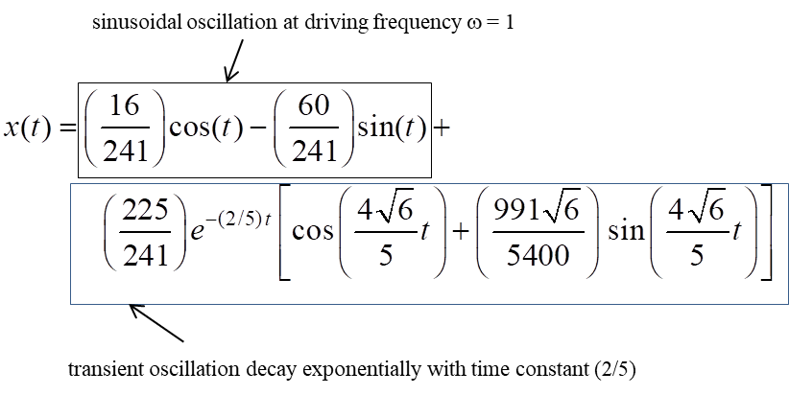



The **Bode** and **Nyguist** plots for the response of the System as functions of the driving frequency .

The **Bode plot** gives graphs of the frequency response of a system, one displaying the magnitude of the response and other graph, the phase lag of the output signal to the input signal. Once the transient oscillations have died away, the output signal oscillates at the driving frequency.

A **Nyquist plot** is a parametric plot of the frequency response where the imaginary part of the transfer function *G* is plotted against the real part. In our example, as the frequency increases from zero, a circular contour with the centre at (0.5,0) is swept out in a clockwise sense. The green dot is for the initial point where . to The red dot on the contour gives the real and imaginary parts at the driving frequency. The length of the line from zero to this point is the magnitude of the transfer function *G* and the angle  gives the phase shift between the output and the input.

**B.2 Example** 



Sol_x = (s - 16/(5*(s^2 + 4)) + 1)/(s^2 + (4*s)/5 + 4)

sol_x = cos(**2**\*t) + (6^(1/2)\***exp(-(2*t)/5)**\*sin((4*6^(1/2)*t)/5))/24

The transient effects die away exponentially and then the System vibrates with maximum amplitude at its natural frequency.

The solutions for the velocity and acceleration are:

Sol_v = (s*(s - 16/(5*(s^2 + 4)) + 1))/(s^2 + (4*s)/5 + 4) – 1

sol_v = (exp(-(2*t)/5)*(cos((4*6^(1/2)*t)/5) –

(6^(1/2)*sin((4*6^(1/2)*t)/5))/12))/5 - 2*sin(2*t)

Sol_a = (s^2*(s - 16/(5*(s^2 + 4)) + 1))/(s^2 + (4*s)/5 + 4) - s - 1/5

sol_a = - 4*cos(2*t) - (4*exp(-(2*t)/5)*(cos((4*6^(1/2)*t)/5) +

(23*6^(1/2)*sin((4*6^(1/2)*t)/5))/24))/25

The Bode and Nyquist plots are:



When the System is driven via the dashpot at resonance, then the amplitude of the oscillation is a maximum and the System vibrates in phase with the input signal.

**C System driven through the spring Laplace11.m**

The equation of motion for the System driven by a sinusoidal input signal via the spring is



Assume exponential input and output function of the form

Input 

Output 

where *G* is the transfer function.

After a bit of algebra you can derive the following



The gain function *G* approaches a maximum when the denominator *D* approaches a minimum



Hence, the resonant frequency is



The phase lag is



If there is zero damping *b* = 0, then the System will oscillate in phase with maximum amplitude when excited at the natural frequency.

**C.1 Example **



Sol_x = -(s/2 - (4*s)/(s^2 + 1) + 1/2)/(s^2 + s + 4)

sol_x = (6*cos(t))/5 + (2*sin(t))/5 - (17*exp(-t/2)*(cos((15^(1/2)*t)/2)

+ (5*15^(1/2)*sin((15^(1/2)*t)/2))/51))/10



**C.2 Example **



Sol_x = -(s/2 - (4*s)/(s^2 + 4) + 1/2)/(s^2 + s + 4)

sol_x = 2*sin(2*t) - (exp(-t/2)*(cos((15^(1/2)*t)/2) +

(17*15^(1/2)*sin((15^(1/2)*t)/2))/15))/2



**D System driven through the spring and dashpot Laplace12.m**

The equation of motion for the System driven by a sinusoidal input signal via the **dashpot** and **spring** is



Assuming the input and output can be expressed as exponential functions







**D.1 Example **



