**[DOING PHYSICS WITH MATLAB](https://d-arora.github.io/Doing-Physics-With-Matlab/)**

# 

**1st ORDER NONLINEAR ODEs**

**slope (direction) fields, nullclines, isoclines, solution (integral) curves**

**Ian Cooper**

matlabvisualphysics@gmail.com

**DOWNLOAD DIRECTORIES FOR MATLAB SCRIPTS**

# <https://github.com/D-Arora/Doing-Physics-With-Matlab/tree/master/mpScripts>

<https://drive.google.com/drive/u/3/folders/1j09aAhfrVYpiMavajrgSvUMc89ksF9Jb>

**ODE_004.m**



**TIME DEVELOPMENT: 1st  order nonlinear ODEs**

The Script **ODE_004.m** can be used to explore many aspects of the time development of a solution of 1st order nonlinear ODEs.

1st order nonlinear equations can be written in the standard form as



Nonlinear ODEs usually have to be solved using numerical methods. The Script **ODE_004.m** uses a simple Euler method to solve a number of nonlinear ODEs. The ODE to be solved is selected using the variable **z**.

% ODE FUNCTIONS

z = 1;

% z = 1 S = y^3 - 3y - t

% z = 2 S = y^2 - 2t

% z = 3 S = 1 + t - y

% z = 4 S = 2y/t

% z = 5 S = -y / ((t^2 + y^2)

% z = 6 S = t - 2y

% z = 7 S = y(1 - y) AUTONOMOUS EQUATION

% Z = 8 s = 3Y - Y^2 AUTONOMOUS EQUATION

It is easy to add other functions. The default domain for time is from -4 to +4 and -4 to +4 for y.

Using the concept of **slope field** or **direction field** one can view the solution of an ODE geometrically.

A slope (direction) field is a diagram which includes at each point  a **short line element** (or line segment) whose slope is the value .

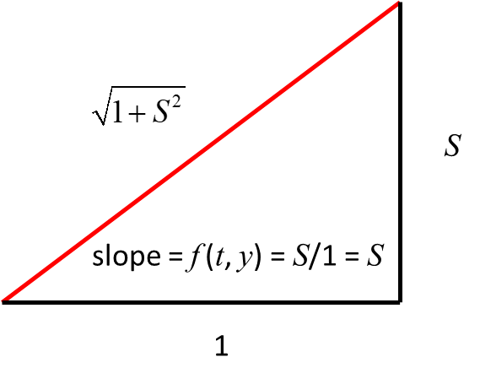

Short line element with slope *S*

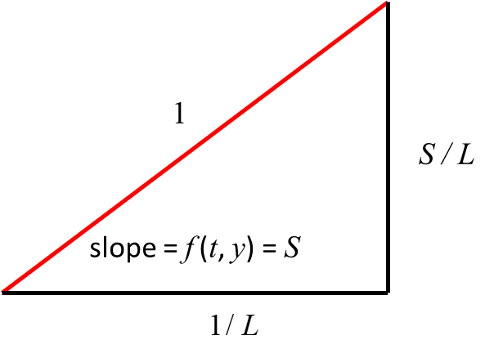

Normalized short line element with slope *S*

The **quiver function** is used to plot the slope (direction) field.

% Slope (direction) Field

q = quiver(tt,yy,1./L,S./L,0.6,'b');

q. AutoScaleFactor = 1.2;

The graph of a solution  to the DE in the  - plane is called a **solution curve** or an **integral curve**

.

An integral curve must be tangent to the slope field at every point. In the Figure Window, the integral (solution) curve is the **black curve** with the **green dot** showing the initial conditions .

Why draw a slope field? The ODE is telling us that the slope of the solution curve at each point is the value of , so the short segment is, to first approximation, a little piece of the solution curve. To get an entire solution curve, follow the segments!

For a number *C* the ***C*-isocline** is the set of points in the  - plane such that the solution curve through that point has slope *C*. (isocline means “same incline", or “same slope"). The equation for the *C*-isocline is . An isocline is shown as a **pink curve** in the Figure Window plot.

When ***C* = 0**, the isocline is called the **nullcline** where



and is shown as the **red curve**. The **critical points** are of all solutions to the DE that lie on the nullcline.

For any point  if  and  are continuous near  then there is a **unique solution** to the first order DE through the point . As a consequence of uniqueness, we have the following two geometric features:

1. Solutions curves cannot cross.
2. Solutions curves cannot become tangent to one another; that is, they cannot touch.

However, there may be certain points where **existence** and **uniqueness** may fail.



.

Weird behaviour happens along the Y axis  where  is not even defined. Through any point  on the Y axis, there is no solution curve. The existence theorem does not apply. Geometrically, the parabolas become tangent at the origin. This would be ruled out by uniqueness if the uniqueness theorem applied. Both existence and uniqueness apply to every point outside the Y axis. The rest of the plane (outside the Y axis) is covered with good solution curves, one through each point, none touching or crossing the others.

An **autonomous** ODE is a differential equation that does not explicitly depend on the independent variable. If time is the independent variable, this means that the ODE is time-invariant. The standard form for a first order autonomous equation is



where the right hand side does not depend on *t*.





Two consequences of the time invariance of an autonomous equation:

1. Each isocline consists of one or more horizontal lines.
2. Solution curves are horizontal translations of one another. That is, if  is a solution, then so is for any *a*.

The values of  at  which  are called the **critical points** or **equilibria** of the autonomous equation.

If  is a critical point of an autonomous equation, then  is a constant (or horizontal, or equilibrium) solution, because the derivative of a constant function is zero. The nullcline of an autonomous equation consists of all the constant solutions.

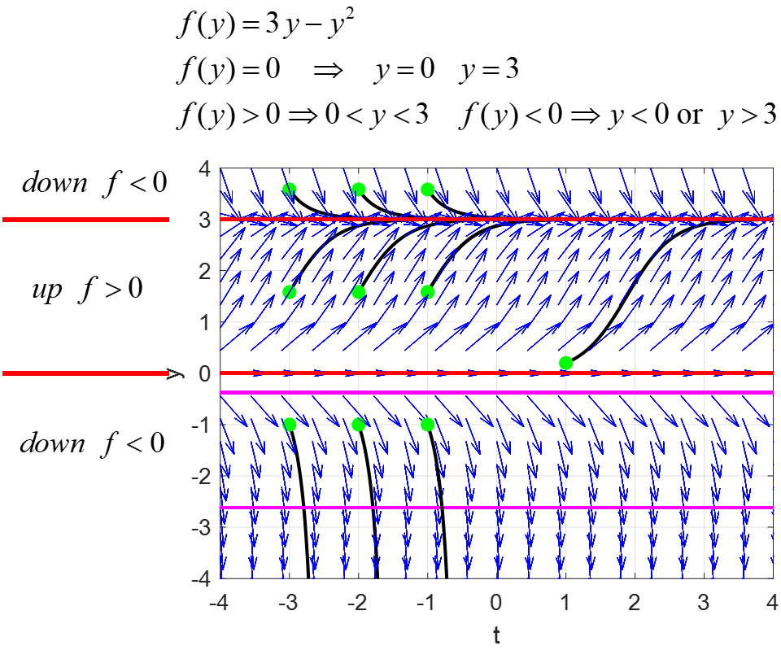The constant solutions *y* = 0 and *y* = 3 are the critical points that divide *t-y* plane into "up" and "down" regions.

The solution curve *y* = 0 corresponds to **unstable equilibrium** points, whereas the solution curve *y* = 3 are points which are **stable equilibrium** points.

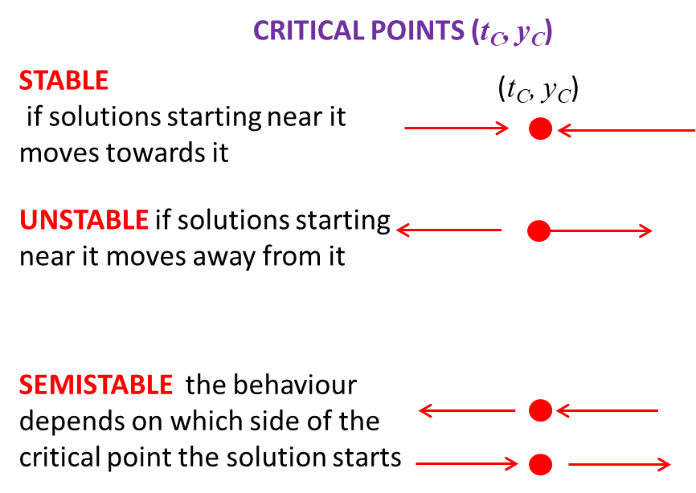

Another way of looking at the stability of critical points is to view a phase plot of .

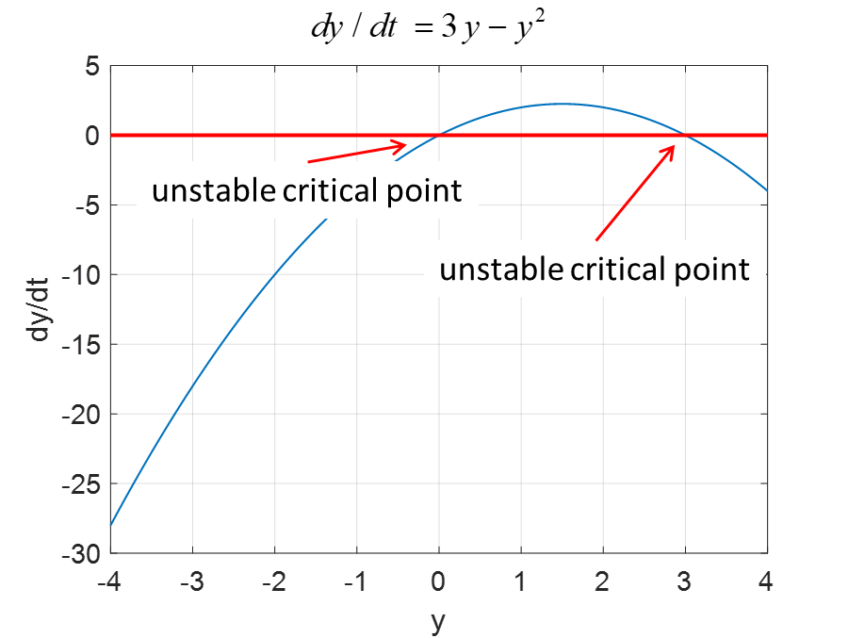

The solution of a DE can be very sensitive to the initial conditions are shown in the plot below.

