**[DOING PHYSICS WITH MATLAB](https://d-arora.github.io/Doing-Physics-With-Matlab/)**

**APP DESIGNER**

# GUI SIMULATIONS

# 

**OSCILLATIONS: MASS – SPRING SYSTEM**

**FREE, DAMPED, FORCED MOTION AND RESONANCE**

**Ian Cooper**

matlabvisualphysics@gmail.com

**DOWNLOAD DIRECTORY FOR MATLAB SCRIPTS**

# <https://github.com/D-Arora/Doing-Physics-With-Matlab/tree/master/mpScripts>

<https://drive.google.com/drive/u/3/folders/1j09aAhfrVYpiMavajrgSvUMc89ksF9Jb>

**ad_001.mlapp**

App Designer GUI to simulation the motion of a mass – spring system. You can investigate the free motion, damped motion and forced motion of the system. Explore the concepts of energy conservation, natural frequency of oscillation and resonance and view the Fourier Transfer (psd: power spectral density) of the displacement-time function. Inputs (S.I. units): mass m, spring constant k, damping constant b, amplitude of driving force, and frequency fD of the sinusoidal driving force.

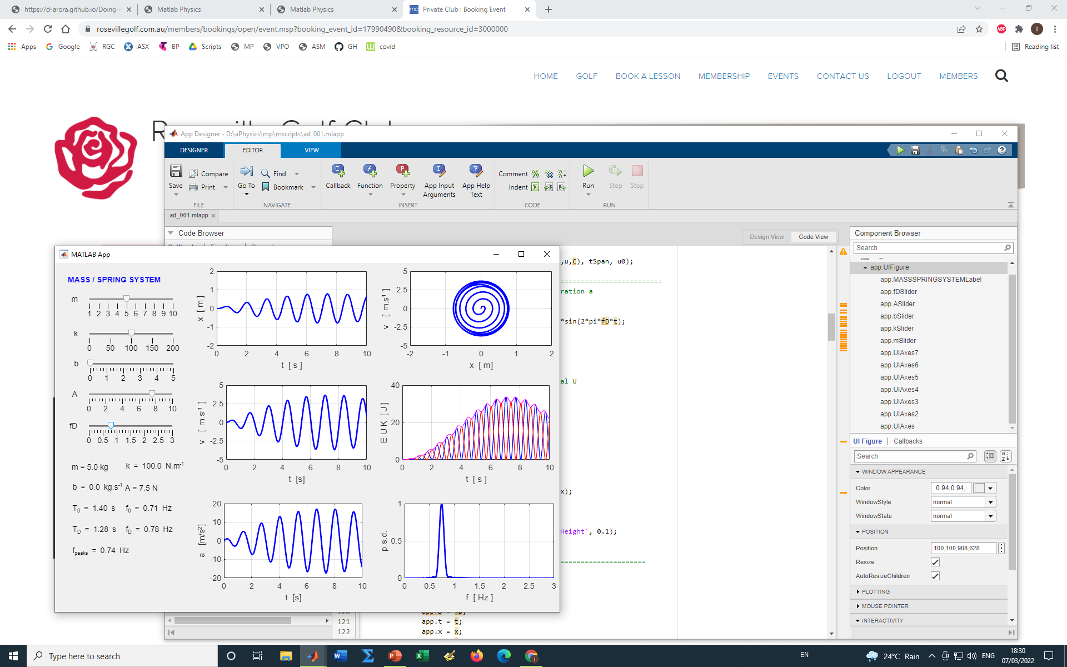

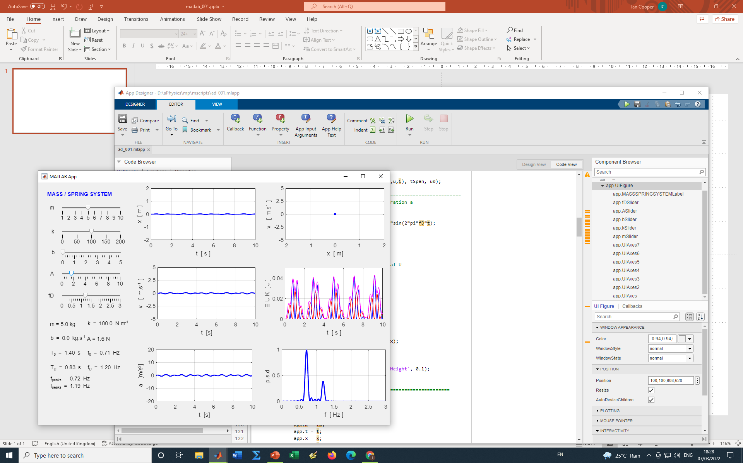

The equation of motion of the mass – spring system



Is solved using the Matlab function **ode45**.

The Fourier Transform of the displacement x(t) is computed by the direct integration of the [Fourier integral](https://d-arora.github.io/Doing-Physics-With-Matlab/mpDocs/maths_ft01.pdf). Note: the power spectral density function shows that the motion is a superposition of the natural frequency and driving frequency.

For a detailed discussion on the equation of motion for the mass – spring system, you can access the following two links:

[Documentation 1](https://d-arora.github.io/Doing-Physics-With-Matlab/mpDocs/osc_harmonic01.pdf)

[Documentation 2](https://d-arora.github.io/Doing-Physics-With-Matlab/mpDocs/math_ODE_A.htm)