[**DOING PHYSICS WITH MATLAB**](https://d-arora.github.io/Doing-Physics-With-Matlab/)

**APP DESIGNER**

# GUI SIMULATIONS

# 

**QUANTUM MECHANICS**

**SQUARE / SLOPING POTENTIAL WELL**

**EIGENVALUES, EIGENFUNCTIONS, EXPECTATION VALUES**

**Ian Cooper**

matlabvisualphysics@gmail.com

**DOWNLOAD DIRECTORY FOR MATLAB SCRIPTS**

# <https://github.com/D-Arora/Doing-Physics-With-Matlab/tree/master/mpScripts>

<https://drive.google.com/drive/u/3/folders/1j09aAhfrVYpiMavajrgSvUMc89ksF9Jb>

**ad_002.mlapp**

App Designer GUI to simulate an electron bound within either a square well or a well with a sloping base. The Schrodinger equation is solved using a matrix method to find the eigenvalues and eigenfunctions for the allowed bound states. Expectation values are calculated for a number of physical quantities. In the GUI you can select values for the width of the well and the well depth at the two boundaries of the well. You can explore the solution of the Schrodinger equation for two quantum numbers qn1 and qn2. To start a simulation, press the **UPDATE** button. Different plots are shown by using the PLOT scroll bar.

**Plot 1**

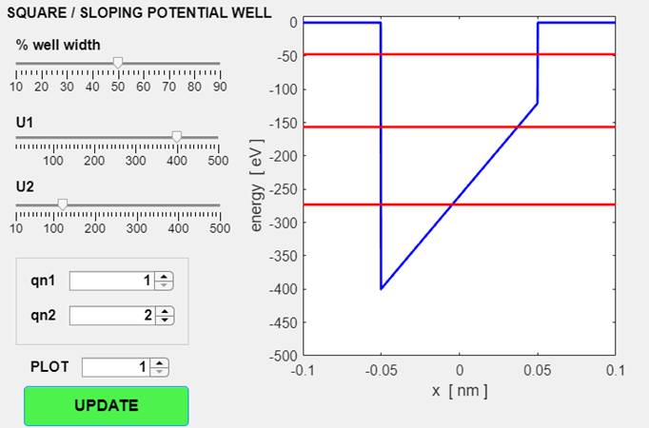

**Plot 2**

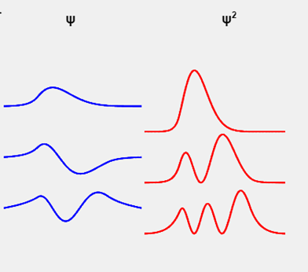

**Plot 3**

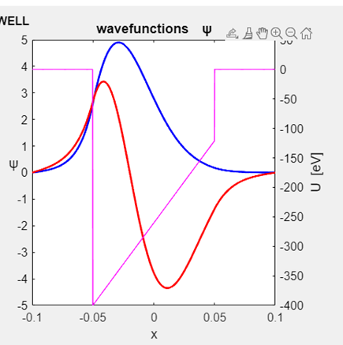

**Plot 4**

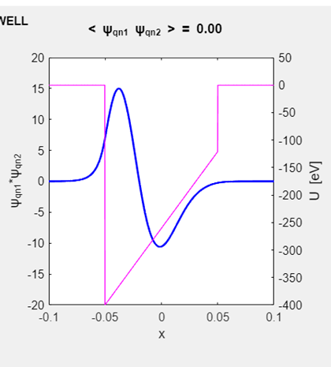

**Plot 5**

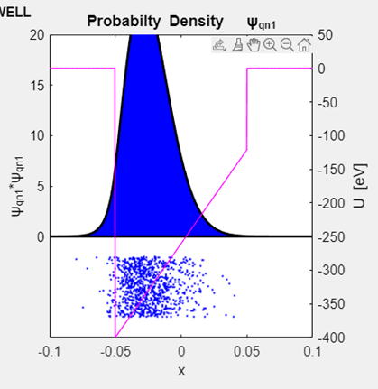

**Plot 6**

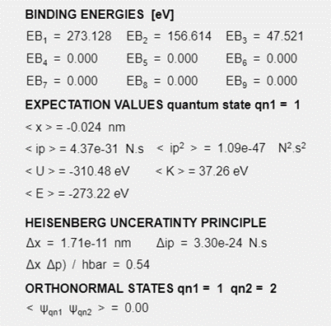

For more details on bound states, view the following link

[Documentation](https://d-arora.github.io/Doing-Physics-With-Matlab/mpDocs/qp_se_matrix.pdf)