**[DOING PHYSICS WITH MATLAB](https://d-arora.github.io/Doing-Physics-With-Matlab/)**

**APP DESIGNER**

# GUI SIMULATIONS

# 

**SINUSOIDAL FUNCTIONS**

**Ian Cooper**

matlabvisualphysics@gmail.com

**DOWNLOAD DIRECTORY FOR MATLAB SCRIPTS**

# <https://github.com/D-Arora/Doing-Physics-With-Matlab/tree/master/mpScripts>

<https://drive.google.com/drive/u/3/folders/1j09aAhfrVYpiMavajrgSvUMc89ksF9Jb>

**ad_002B.mlapp**

You can explore the relationship between the two equations



and



**ad_002C.mlapp**

You can explore the relationship between the two equations



and



**Part 1 ad_002B.mlapp**

Graphs of sinusoidal functions can be either expressed in terms of sine functions or cosine functions. The parameters of sinusoidal functions are:

*A* amplitude

*T* period [s]

*f* frequency [Hz]

 angular frequency [rad.s-1]



 phase [rad]

 initial phase angle (phase at *t* = 0) or

Phase shift [rad]

 time shift [s]

Consider two sinusoidal functions which have the same amplitude *A* and angular frequency  but with a phase difference .





The **phase shift**  can be used to describe the relationship between these two sine functions using the terms “**leading**” and “**lagging**”. Because of the phase difference, the functions reach their maximum at different times. We will take the sine function *y*1 as a reference and ask whether the sine function *y*2 is lagging or leading the reference sine function *y*1.



 occurs **before**  then *y*2 **leads** *y*1



 occurs **after**  then *y*2 **lags** *y*1



the two maxima occur at the same time,

then *y*1 and *y*2 are said to be **in-phase**

**The time interval between the first two maxima is called** the **time shift** . If the function *y*2 reaches its maximum first then the time shift is known as a **time lead**, if the *y*2 maximum occurs after the maximum of *y*1, then time shift is known as the time **lead**.

Increasing the value of  or  shifts the sine function *y*2 to the left (lower values of *t*) and decreasing the values of  or , shifts the curve to the right (higher values of *t*)

From the two expressions for , the relationship between the initial phase angle  and the time shift  is



since 

A sinusoidal signal can be represented by a vector in the complex plane called a **phasor**. A phasor is simply a shorthand way of representing a signal that is sinusoidal in time. The complex representation of a sinusoidal function is





The **phasor diagram** is constructed like drawing a vector and its components: the length of the phasor is the amplitude of the signal; the real part (X component) and imaginary part (Y component. Figure 1 shows a phasor diagram at the instant when *t* = 0.

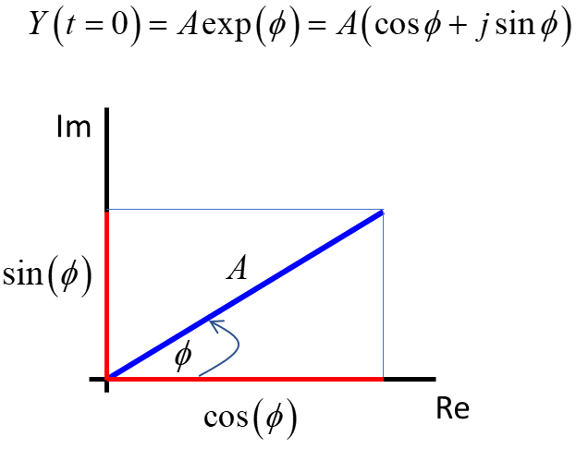

Fig. 1 Phasor diagram of a sinusoidal function at time *t* = 0.

As time advances, the phasor rotates in an anticlockwise direction with the angle of the phasor being . The speed at which the phasor rotates is equal to the angular frequency (angular speed rad.s-1) .

Using the app **ad_002B.mlapp**, you can explore many aspects of sinusoidal functions. The GUI graphically displays the two equations



where *A*1 = 6.00, *T*1 = 20.0, *f*1 = 0.050, 1 = 0.314,  = 0

and



where the values of  are set by the three sliders. The units for the phase slider are rad.

To make the most of the app as a learning tool it is a good idea to use the **Predict Observe Explain** (**POE**) method. Before any input values are changed using the sliders, **predict** the output response – all plots and numerical results. **Observe** the output response and compare with your predictions. **Explain** any discrepancies.

Figure 2 shows the GUI: Plots of the two functions, a summary of all numerical values and the phasor diagram (the two circles have radii equal to *A*1 and *A*2. Zero phase  corresponds to the **blue** horizontal line and the **red** radius line is for the phasor for the phase shift .

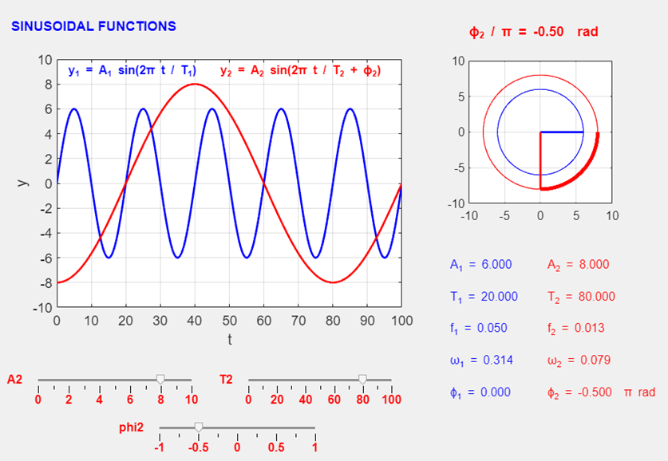

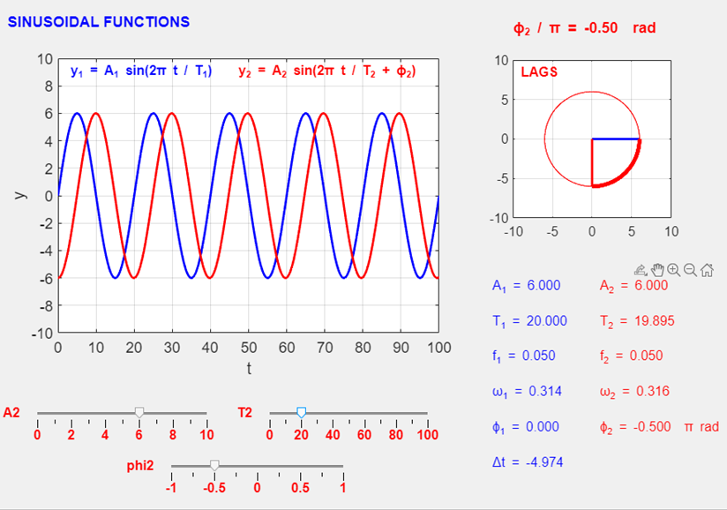

Fig. 2 GUI for **ad_002B.mlapp**.

**Part 2 ad_002C.m**

Consider the four sinusoidal functions



You can use the app **ad_002C.m** to investigate these four sinusoidal functions. There are four input sliders:



The period of each sinusoidal function is fixed



The GUI is shown in figure 3.

Implement the **POE** strategy before changing any input values.

You can now play a game.

Select the values of 

Then find the values of the coefficients 

such that





Then set the values of  and find the values for 

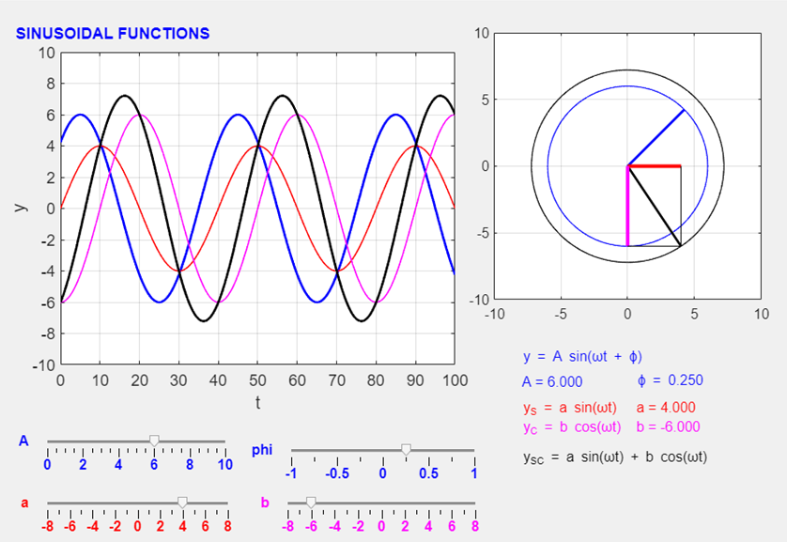

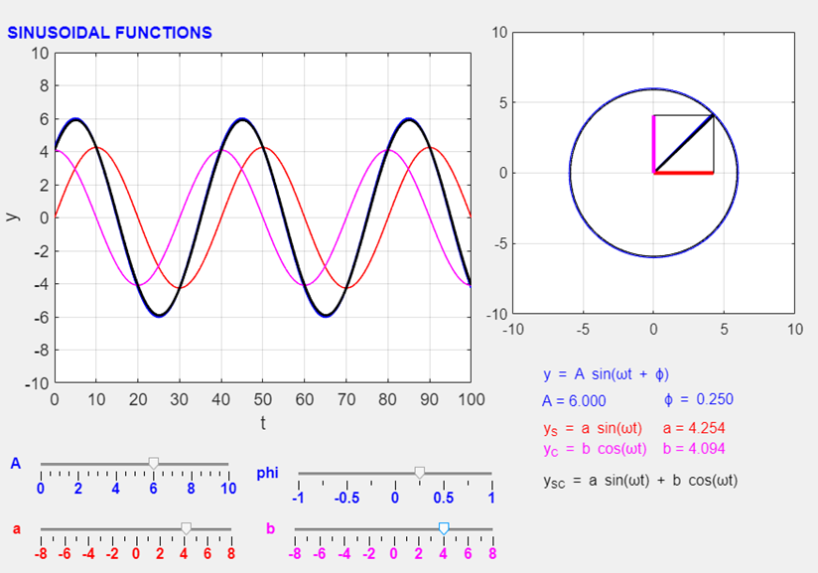

Fig. 3 GUI for **ad_002C.mlapp**

For more details of simple harmonic motion and the sine function click the documentation link

[Documentation](https://d-arora.github.io/Doing-Physics-With-Matlab/mpDocs/wav_shm_sine.pdf)

An excellent web site on phasor diagrams can be viewed at

[Link](https://lpsa.swarthmore.edu/BackGround/phasor/phasor.html)