[**DOING PHYSICS WITH MATLAB**](http://www.physics.usyd.edu.au/teach_res/mp/home.htm)

**BIOPHYSICS**

**HODGKIN-HUXLEY MODEL: MEMBRANE CURRENT**

Ian Cooper

School of Physics, University of Sydney

ian.cooper@sydney.edu.au

[**MATLAB SCRIPTS**](http://www.physics.usyd.edu.au/teach_res/mp/mscripts/) **(download files)**

|  |
| --- |
| **alpha.m**  Function: calculates the rate constants *αx* (equations 18, 19) |
| **beta.m**  Function: calculates the rate constants *βx* (equations 18, 19) |
| **alpha_beta_plot.m**  m-script: plot of rate constants as a function of membrane voltage (figure 4) |
| **N_0.m**  Function: calculations *n*(0), *m*(0), *h*(0) (equation 13) |
| **N_inf.m**  Function: calculations *n*(∞), *m*(∞), *h*(∞) (equation 13) |
| **tau.m**  Function: calculations of time constants *τn*­, *τm*, *τh* (equation 15) |
| **tau_nmh_inf_plot.m**  m-script: plots of *n*(∞), *m*(∞), *h*(∞) and *τn*­, *τm*, *τh* (figure 5) |
| **bp_neuron_02.m**  m-script: plot of rate constants *αx* , *βx* and gate variables gK, gNa (figure 7) for a voltage clamp |
| **bp_neuron_01.m**  m-script: plots of membrane voltage and conductances for an external current stimulus |
| **bp_neuron_01a.m**  m-script: plots of membrane voltage and conductances for an external current stimulus of multiple pulses |
| **bp_neuron_01b.m**  m-script: plots of membrane voltage and conductances for an external current stimulus |
| **bp_neuron_01bb.m**  m-script: plot of firing frequency vs magnitude of current stimulus (figure 16) |
| **bp_neuron_01c.m**  m-script: different external current stimuli (can include noise) and plot of interval distribution for repetitive firing |

**Physical Quantities: Symbols, Units, Typical values**

|  |  |  |
| --- | --- | --- |
| *t* | ~ ms | time |
| *a* | 5x10-6 m | Radius of axon |
| *b* | 6x10-9 m | Membrane thickness |
| *Ri* | Ω | Longitudinal resistance of axon |
| *rin* | 6.4x109 Ω.m-1 | Longitudinal resistance / length  axoplasm resistance / length |
| *V*(*t,*x)  *V*m(t,x) | ~ - 70 mV to + 40 mV | instantaneous potential difference across membrane (membrane potential) |
| *V*in(t,*x*) | ~ - 70 mV to + 40 mV | potential inside cell  Vin = V (membrane potential) |
| *Vout* | 0 | potential outside cell: consider as ground potential |
| *VR* | -65 mV | Resting membrane potential |
| *C* | F | membrane capacitance |
| *cm* | 1.0x10-6 F/cm2 | Capacitance / area |
| *Q*(*t*,*x*) | C | instantaneous charge on capacitor plates |
| *I*C(*t*,*x*) | A | instantaneous capacitive current |
| *Iion*(*t*,*x*) =  *Im*(*t*,*x*) | A | ion current or membrane current |
| *INa*(*t*,*x*) | A | Na+ current |
| *IK*(*t*,*x*) | A | K+ current |
| *IL*(*t*,*x*) | A | leakage current – small, mainly Cl- |
| *Iin(t,x)* | A | Longitudinal current – current along inside of axon |
| *Jext*(*t*,*x*) | A.cm-2 | Instantaneous external stimulus current density |
| *Jion*(*t*,*x*) = *Jm*(*t*,*x*) | A.cm-2 | ion current or membrane current density |
| *JNa*(*t*,*x*) | A.cm-2 | Na+ current density |
| *JK*(*t*,*x*) | A.cm-2 | K+ current density |
| *JL*(*t*,*x*) | A.cm-2 | leakage current density – small, mainly Cl- |
| *Jext*(*t*,*x*) | A.cm-2 | external stimulus current density |
| *GNa*(*t*,*x*) | Ω-1 | Na+ conductance |
| *GK*(*t*,*x*) | Ω-1 | K+ conductance |
| *GL*(*t*,*x*) | Ω-1 | leakage conductance |
| *gNa*(*t*,*x*) | = 120x10-3  Ω-1.cm-2 | Na+ conductance / area  maximum value |
| *gK*(*t*,*x*) | = 36x10-3  Ω-1.cm-2 | K+ conductance / area  maximum value |
| *gL*(*t*,*x*) | = 0.3x10-3  Ω-1.cm-2 | leakage conductance / area  maximum value |
| *ENa* | + 50 mV | reversal potential for Na+ |
| *EK* | - 77 mV | reversal potential for K+ |
| *EL* | - 75.6 mV | reversal potential for leakage |

|  |  |  |
| --- | --- | --- |
| *k* | 1.38x10-23 J.K-1 | Boltzmann’s constant |
| *e* | 1.60x10-19 C | Charge on an electron |
| *z* |  | Valency of an ion |
| *T* | K or oC | Temperature |

**INTRODUCTION**

The core mathematical framework for modern biophysically based neural modelling was developed around 1950 by Alan Hodgkin and Andrew Huxley. They carried out a series of elegant electrophysiological experiments on the squid giant which has an extraordinarily large diameter ~ 0.5 mm.

Hodgkin and Huxley systematically demonstrated how the macroscopic ionic currents in the squid giant axon could be understood in terms of changes in Na+ and K+ conductances in the axon membrane. Based on a series of voltage-clamp experiments, they developed a detailed mathematical model of the voltage-dependent and time-dependent properties of the Na+ and K+ conductances. Their model accurately reproduces the key biophysical properties of the action potential. For this outstanding achievement, Hodgkin and Huxley were awarded the 1963 Nobel Prize in Physiology and Medicine.

In biophysically based neural modelling, the electrical properties of a neuron are represented in terms of an electrical equivalent circuit. Capacitors are used to model the charge storage capacity of the cell membrane, resistors are used to model the various types of ion channels embedded in membrane, and batteries are used to represent the electrochemical potentials established by differing intracellular and extracellular ion concentrations. Figure 1 shows the equivalent circuit used by Hodgkin and Huxley in modelling a segment of squid giant axon. The current across the membrane has two major components, one associated with the membrane capacitance and one associated with the flow of ions through resistive membrane channels.



Fig.1. Electrical equivalent circuit for a short segment of squid giant axon. Capacitor (capacitance *C* of the cell membrane); Variable resistors (voltage-dependent Na+ and K+  conductances *GNa*, *GK* ); fixed resistor (voltage-independent leakage conductance *GL*); Batteries (reversal potentials Na+, K+ , leakage - *ENa*, *EK*, *EL*); Membrane potential *V* = *Vin* – *Vout*; External stimulus *Iext*; Current direction (arrows: *Iext* outside → inside,  *INa*, *IK* and *IL* inside → outside.

Conductance *G*, resistance *R* → *G* = 1 / *R*.

**MATHEMATICAL ANALYSIS**

A mathematical analysis of the equivalent RC circuit for the neuron as shown in figure 1 is outlined by the following equations.

(1) *Vm* = *Vin* – *Vout* membrane potential difference measured w.r.t. *Vout= 0*

(2)  capacitive current (displacement current): rate of change of charge *Q* at the membrane surface

(3)   charge stored on surface of membrane

(4)  differentiating *Q* w.r.t. *t* at a fixed position *x*0

(5)  membrane current due to movement of ions

(6)  Kirchhoff’s current law (conservation of charge)

Fundamental differential equation (D.E.) relating the change in membrane potential to the currents across the membrane for a small segment of the membrane:

(7)  at a fixed position *x*0





Fig.2. Longitudinal currents inside cell, membrane currents and capacitive current for a segment of an axon.

We also need to consider the current along the axon as shown in figure 2 to make equation (7) more general.

(8) Kirchhoff’s current law

(9)  currents change the charge on the membrane

If we consider a small segment (see figure 2), then



The membrane current crosses an area , using ,and using a finite difference approximation for the second derivative of a function, we can derive a differential equation relating the membrane voltage to the currents:



(10) 

Equation (10) is a very general equation starting from Kirchhoff’s laws for a segment of the axon. The only assumptions are that the currents depend only on time *t* and position *x* along the axon and changes on the outside of the axon can be neglected (*Vout* = 0 for all *t* and *x*).



The membrane current density depends upon “driving voltages” and the conductances of the membrane. But this becomes very complicated because the conductances depend upon the membrane voltage *V*. Solutions to equation (10) are only possible by matching solutions with experimental results to determine values of parameters and the variation in conductances with membrane voltage. We will consider a few special examples in giving solutions to equation (10) that give predictions in good agreement with experimental results.

**REVERSAL POTENTIALS**



**MEMBRANE CURRENT *Jm***

Voltage Δ*V*, current *I*, resistance *R* and conductance *G* are related by the equations



In applying these relationships to ion channels, the equilibrium (reversal) potential for each ion type also needs to be taken into account. This is the potential at which the net ionic current flowing across the membrane would be zero for a given ion species. The reversal potentials are represented by the batteries in figure 1. Hence,

(11) 

These relationships are complicated because *J* and *V* are function of *t* and *x*, but also *g* is a function of *V* which is a function of *t* and *x*. We will develop a model to give a functional relationship for each *g*. However, the conductance for the leakage is assumed to be constant (independent of *V*, *t* or *x*  ).



Fig. 3. Sign convention for currents. A positive external current *Iext* (outside to inside)will tend to depolarize the cell (i.e., make *Vm* more positive) while a positive ionic current *Iion* will tend to hyperpolarize the cell (i.e., make V = *Vm* more negative).

In a simple model, the Na+ and K+ ions are considered to flow through ion channels where a series of gates determine the conductance of the ion channel. The macroscopic conductances of the Hodgkin & Huxley model arise from the combined effects of a large number of microscopic ion channels embedded in the membrane. Each individual ion channel can be thought of as containing one or more physical gates that regulate the flow of ions through the channel. The variation in *g* values is determined by the set of gate variables *n*, *m* and *h*.



The value of the conductance depends upon the membrane voltage *V* because the values of *n*, *m* and *h* depend on time, their previous value at an earlier time and the membrane voltage. The rates of change of the gate variables are

(12) 

where the the ***α*** ’s and **β**’s are **rate constants**

α → rate of closed gates opening β → rate of open gates closing

 → fraction of gates opening per second 

 → fraction of gates closing per second

If the membrane voltage is clamped at some fixed value *V*, then values of the gate variables *n*, *m* and *h* will reach a steady state value *n*∞, *m*∞ and *h*∞

 where *x* ≡ *n* or *m* or *h*

and the steady state (equilibrium) value is given by

(13) 

If at time *t* = 0, *x*(0) = *x*0, then a solution of equation (12) is

(14) 

where the time *τx* constant for the evolution of x is

(15) 

The K+ channel is controlled by 4*n* activation gates

(16) 

The Na+ channel is controlled by 3*m* **activation gates** and 1*h* **inactivation gate**

(17) 

An **activation gate** → conductance increases with depolarization (*V* increases)

An **inactivation gate** → conductance decreases with depolarization (*V* increases)

Expressions for the rate constants *α* and *β* were formulated by Hodgkin and Huxley in their series of voltage clamp experiments of giant axon nerve cells.

(18)  

(19a)  

(19b)  

(19c)  

The rate constants *α* and *β* can be calculated as functions of membrane voltage V and temperature *T* using the Matlab functions **alpha.m** and **beta.m**. The variables *V* (in millivolts, mV) and the temperature *T* (in oC) are passed onto the functions. The functions return the rate constants *α* and *β* (in /milliseconds, ms-1). The resting potential *Vr* must be set to a global variable. The default value is *Vr* = -65 V.

**Matlab code for the two functions**

|  |
| --- |
| function [ An Am Ah ] = alpha(V,T)  % Returns rate constant in units per ms (millisecond)  % Inputs: V in [mV] and temperature in [deg C]  global Vr  dV = (V - Vr);  phi = 3^((T-6.3)/10);  An = phi * (eps + 0.10 - 0.01 .* dV) ./ (eps + exp(1 - 0.1 .* dV) - 1);  Am = phi * (eps + 2.5 - 0.1 .* dV) ./ (eps + exp(2.5 - 0.1 .* dV) - 1);  Ah = phi * 0.07 .* exp(-dV ./ 20);  end |

|  |
| --- |
| function [ Bn Bm Bh ] = beta(V,T)  % Returns rate constant in units per ms (millisecond)  % Inputs: V in [mV] and temperature in [deg C]  global Vr  dV = (V - Vr);  phi = 3^((T-6.3)/10);  Bn = phi * 0.125 .* exp(-dV ./ 80);  Bm = phi * 4 .* exp(-dV/18);  Bh = phi * 1 ./ (exp(3.0 - 0.1 .* dV) + 1);  end |

The m-script **alpha_beta_plot.m** can be used to plot the rate constants *α* and *β* as functions of membrane potential *V* at a fixed temperature *T* as sown in figure 4.

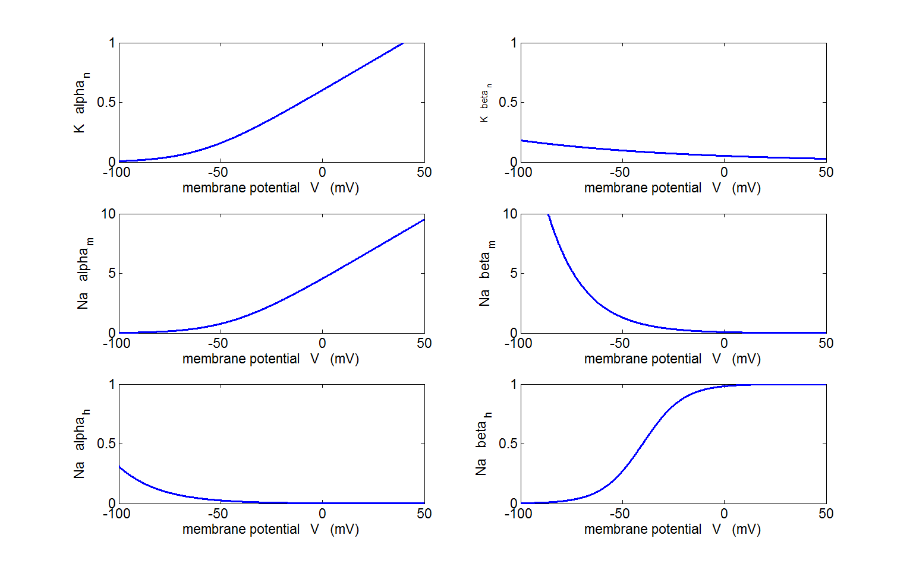

Fig.4. Plots of the rate constants *α* and *β* as functions of *V* at *T* = 6.3 oC.

**alpha_beta_plot.m**

The steady values of (*n*∞, *m*∞, *h*∞), the steady values of (*n*0, *m*0, *h*0) when *V* = *Vr* and the time constants (*τn*, *τm*, *τh*) are calculated using the Matlab functions **N_inf.m**, **N_0.m** and **tau.m**. The result of the calculations are shown in figure 5 which was created using the Matlab m-script **tau_nmh_inf_plot.m**

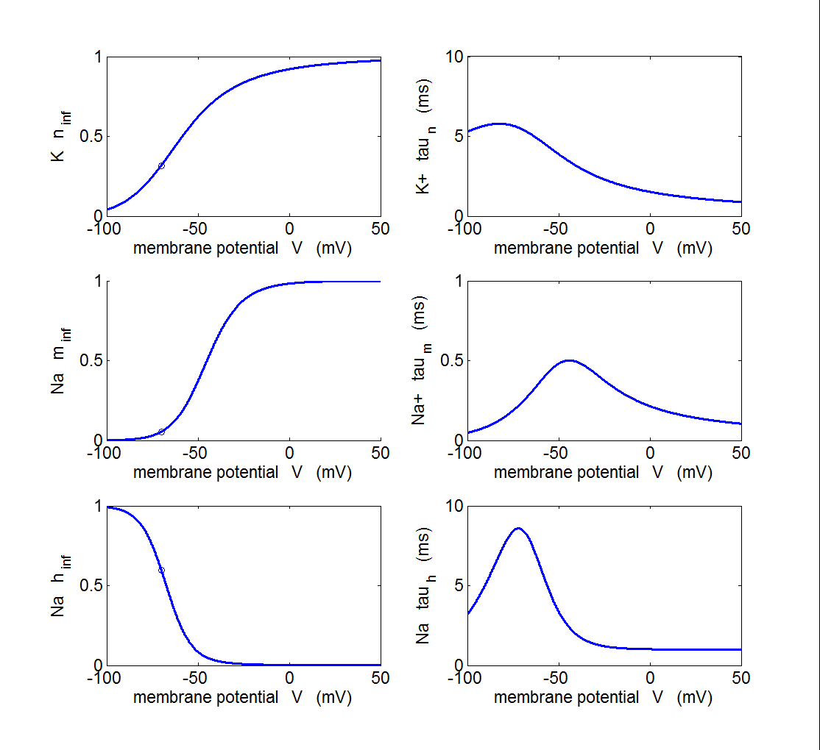

Fig. 5. *n*∞, *m*∞, *h*∞, and *τn*, *τm*, *τ*h as functions of membrane potential *V*.

*τm* << *τn* or *τh* *m* → *m*∞ very quickly. *n* and *m* are activating gate variables (increase in values as *V* increases). *h* is an inactivating gate variable (*h* decrease as *V* increases). The blue circle gives the value of *n*0, *m*0 and *h*0. *T* = 6.3 oC

**tau_nmh_inf_plot.m**

**VOLTAGE-CLAMP SIMULATIONS**

In many of the experiments performed by Hodgkin and Huxley, they held the membrane at a fixed voltage by inserting an electrode into the axon of a squid.



Fig. 6. Voltage-clamp of a squid axon.

The Matlab m-script **bp_neuron_02.m** can be used to calculate and display the voltage-clamp, the current densities (*Jm*, *JL*, *JK* and *JNa*), the gate variables (*m*, *m*3, h and *n*, *n*4) and the conductances (*gNa*, *g*K). Sample graphical outputs are shown in figure 7 for voltage clamps of +20 mV and +80 mV.

**Outline the m-script bp_neuron_02.m structure**

* Default resting potential *Vr* = -65 mV
* Voltage clamp is given as a long pulse
* Rate constants *α* and *β* are calculated using the functions **alpha.m** and **beta.m**
* As the time variable is incremented, the gates variables (*n*, *m*, *h*) then the conductances (*gNa* and *gK*) then the current densities (*JNA*, *JNa* and *JM*) are calculated for each time step. The gate variables are calculated from equation (12) by using **the finite difference method** to approximate the first derivative:

|  |
| --- |
| nt(c+1) = nt(c) + dt * (An(c) *(1-nt(c)) - Bn(c) * nt(c));  mt(c+1) = mt(c) + dt * (Am(c) *(1-mt(c)) - Bm(c) * mt(c));  ht(c+1) = ht(c) + dt * (Ah(c) *(1-ht(c)) - Bh(c) * ht(c)); |

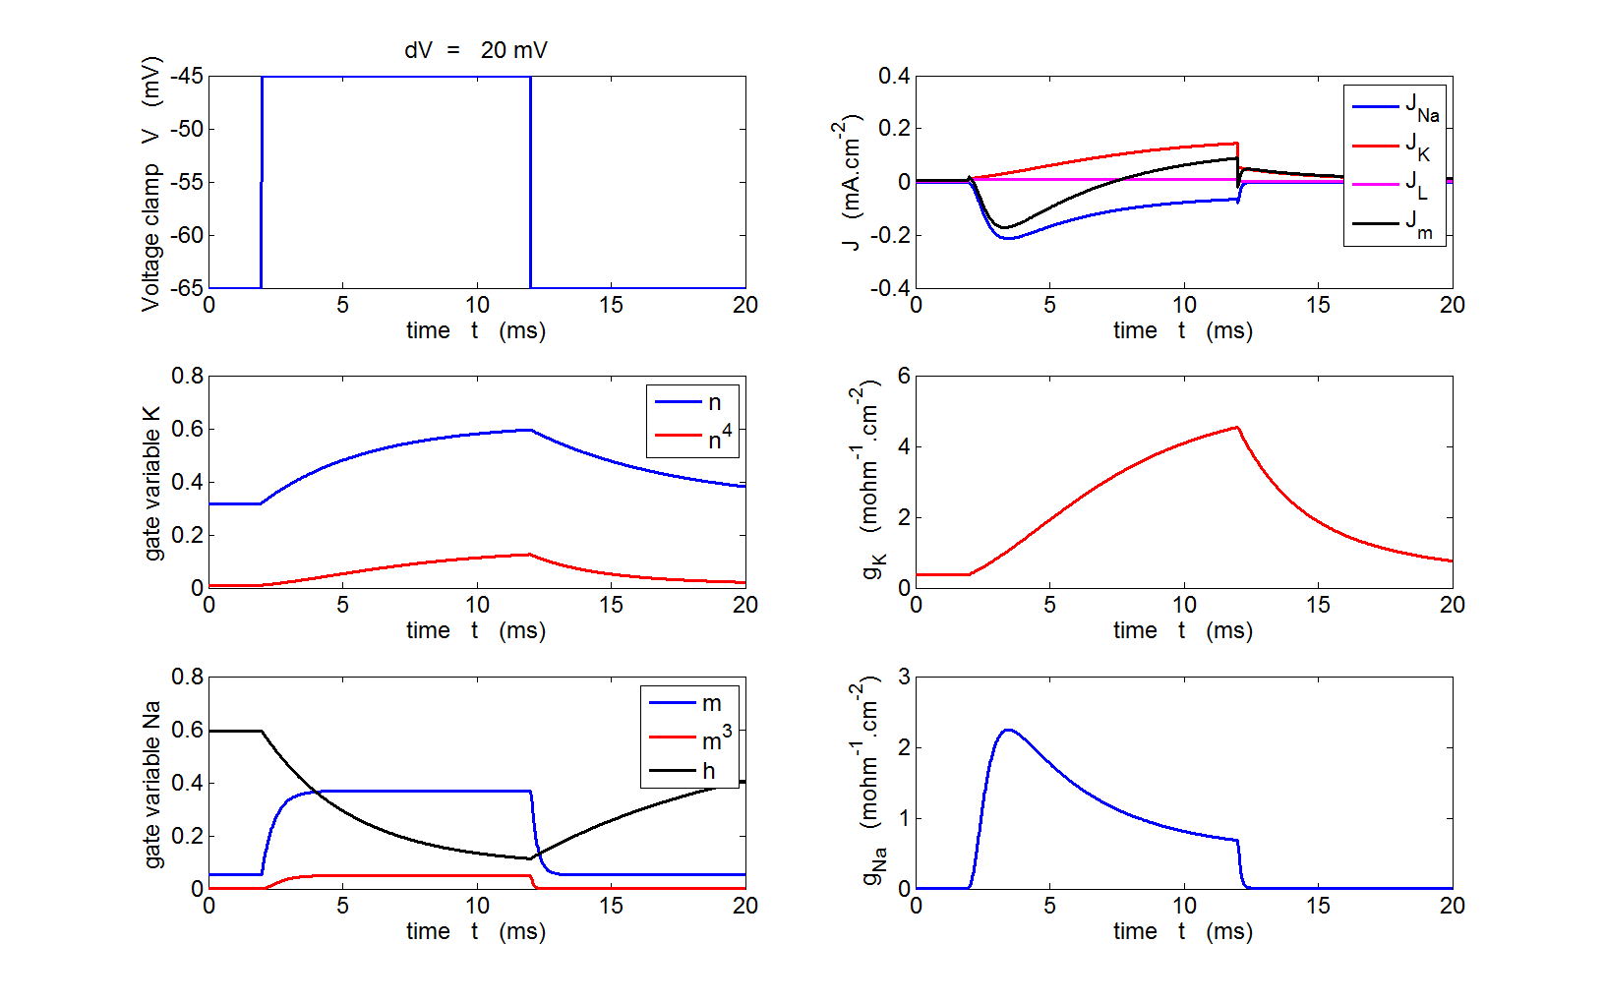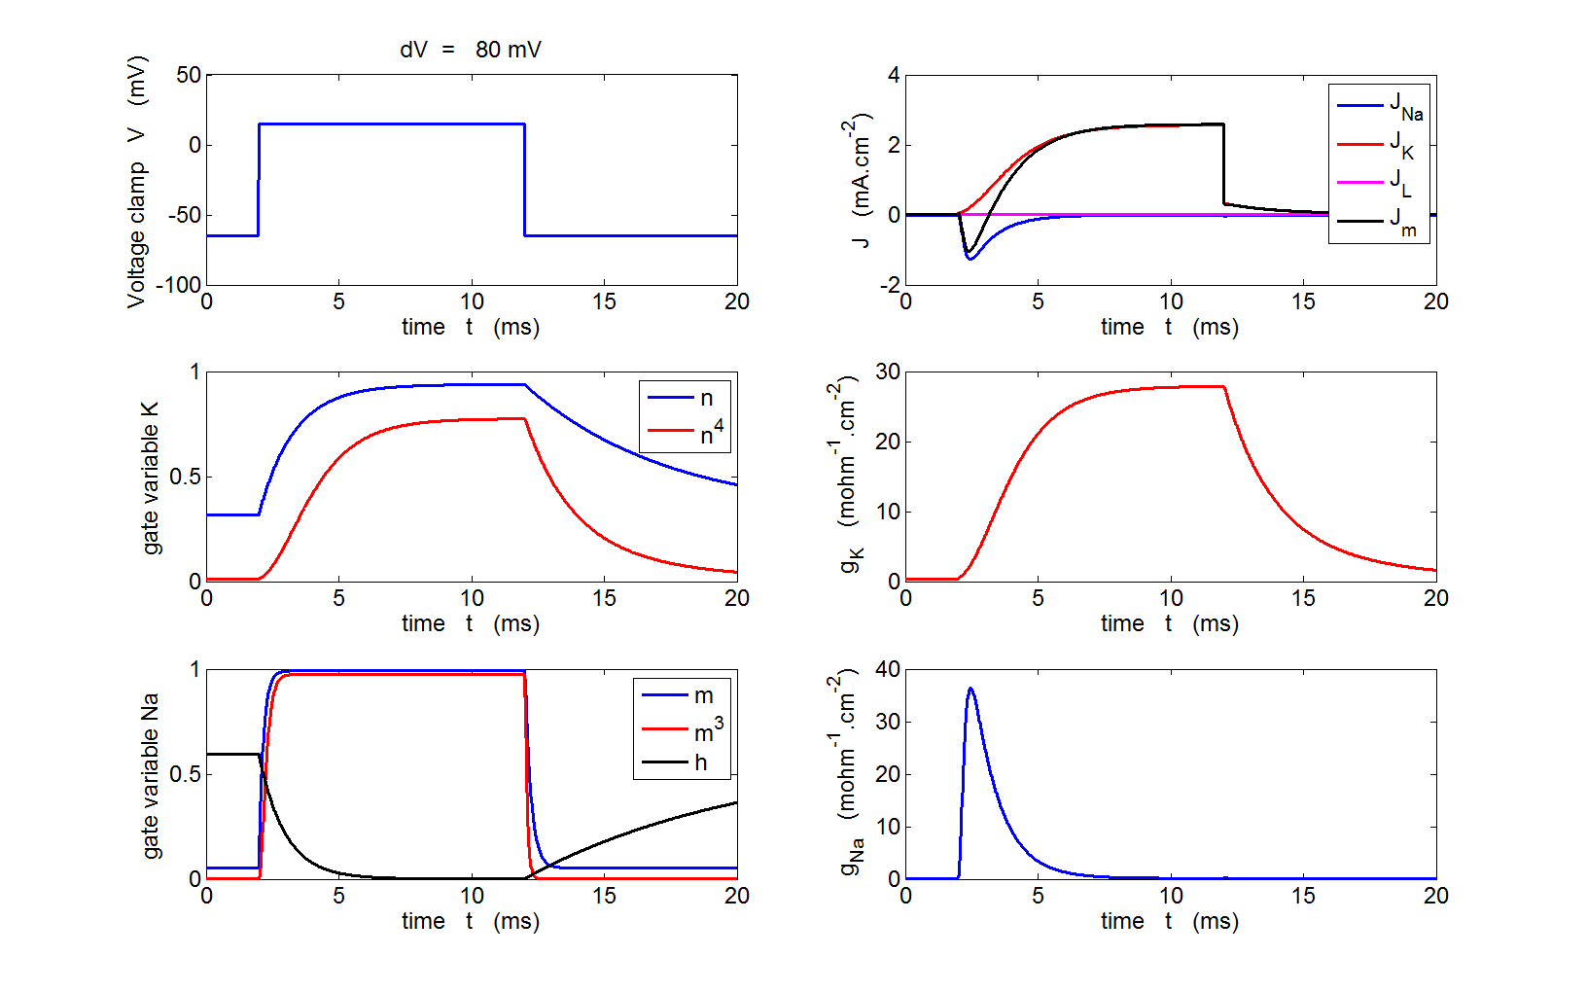

Fig. 7. Variation in the gate variables, conductances and current densities for a voltage-clamp applied to the axon. The depolarization produced by the clamp causes a transient increase in Na+ into the cell. The rise in the K+ current from the cell occurs more slowly and is maintained as long as the membrane is depolarized. The rate of rise of the Na+ and K+ currents increases with increasing size of the voltage clamp and the peak values of Na+ and K+ currents are significantly increased as the clamp voltage is increased, the peak values are over 100 times the magnitudes in the resting membrane.

**bp_neuron_02.m**

**ACTION POTENTIAL SIMULATION**

The equations listed below constitute the complete set of equations to describe the membrane current in a squid axon and membrane voltage.

(10) 

(11)  

(16) 

(17)  

(13)   

(18)  

(19a)  

(19b)  

(19c)  

We will consider an axially clamped axon where the interior potential does not depend upon the location *x* along its length: *V*(*t*,*x*) = *V*(*t*). Since the membrane voltage *V* does not depend upon *x* the second derivative in equation (10) is zero

(20) 

Hence equation (10) simplifies to

(21) 

If there is no external stimulus *Jext* = 0 and *V* = *Vr* (resting potential) then *Jm* = 0 and *V* does not change with time *t* as *dV*/*dt* = 0. It is necessary to introduce a stimulus to create a pulse.

Equation (21) can be solved numerically by using the finite difference method to approximate the derivatives in equations 21, 16 and 17. An outline of the Matlab code to solve equation (21) is shown below.

|  |
| --- |
| for cc = 1 : num-1    [ An Am Ah ] = alpha(V(cc)*1000, T);  [ Bn Bm Bh ] = beta(V(cc)*1000, T);  An = sf * An; Am = sf * Am; Ah = sf * Ah;  Bn = sf * Bn; Bm = sf * Bm; Bh = sf * Bh;    n(cc+1) = n(cc) + dt * (An *(1-n(cc)) - Bn * n(cc));  m(cc+1) = m(cc) + dt * (Am *(1-m(cc)) - Bm * m(cc));  h(cc+1) = h(cc) + dt * (Ah *(1-h(cc)) - Bh * h(cc));    gK(cc+1) = n(cc+1)^4 * gKmax;  gNa(cc+1) = m(cc+1)^3 * h(cc+1) * gNamax;    JK(cc+1) = gK(cc+1) * (V(cc) - VK);  JNa(cc+1) = gNa(cc+1) * (V(cc) - VNa);  JL(cc+1) = gL(cc+1) * (V(cc) - VR - 10.6e-3);  Jm(cc+1) = JNa(cc+1) + JK(cc+1) + JL(cc+1);    V(cc+1) = V(cc) + (dt/Cm)*(-JK(cc+1) - JNa(cc+1) - JL(cc+1) + Jext(cc+1));    end |

**Single current pulse**

The results for current pulse stimuli using the m-script **bp_neuron_01.m** are shown in the following figures.



Fig. 8. The current densities for the stimulated axon at 18.5 oC. Only a very small current pulse is required to dramatically change the conductances of the membrane to produce large K+ and Na+ currents. The potassium current is positive as the K+ ions move from inside to the outside of the cell whereas the sodium current is negative as Na+ ions move into the cell across the membrane. The Na+ and K+ currents are nearly balanced throughout most of the pulse which lasts about 2 ms. The *JNa* curve has an extra wiggle around *t* = 1.3 ms caused by the rapidly changing voltage while the conductance *gNa* varies smoothly.

**bp_neuron_01.m**

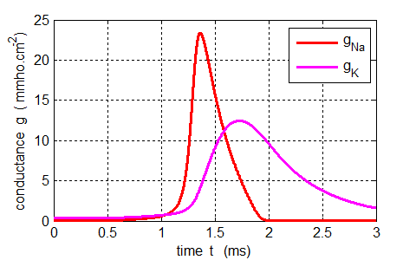

Fig. 9. The conductance for potassium and sodium for the stimulated axon at 18.5 oC. Both the conductances vary smoothly. The rise in the sodium conductance occurs more rapidly than for the potassium. **bp_neuron_01.m**



Fig. 10. Action potential produced by an external current pulse (*Jext* = 1.0x10-4 A.cm-2 and duration 0.10 ms) at a temperature of 18.5 oC. If the pulse height is halved and the pulse width is doubled ( *Jext* = 0.50x10-4 A.cm-2 and duration 0.20 ms: amount of charge transferred is constant Δ*q* = *I* Δ*t* = constant), the variation of membrane potential with time is almost unchanged. **bp_neuron_01.m**



Fig. 11. Membrane voltage responses to three different external stimuli at 18.5 oC and duration 0.10 ms. (a) *Jext* = 0.6 mA.cm-2, no action potential pulse is produced, only a small rise in the membrane voltage and then a slow decay back to the resting potential. There is a threshold, when the the external stimulus exceeds some critical value an action potential is produced. (b) *Jext* = 1.0 mA.cm-2, an action potential pulse is produced. (c) *Jext* = 2.0 mA.cm-2, an action potential pulse is which rises more rapidly and to a higher peak value than the 1.0 mA.cm-2 stimulus. **bp_neuron_01.m**

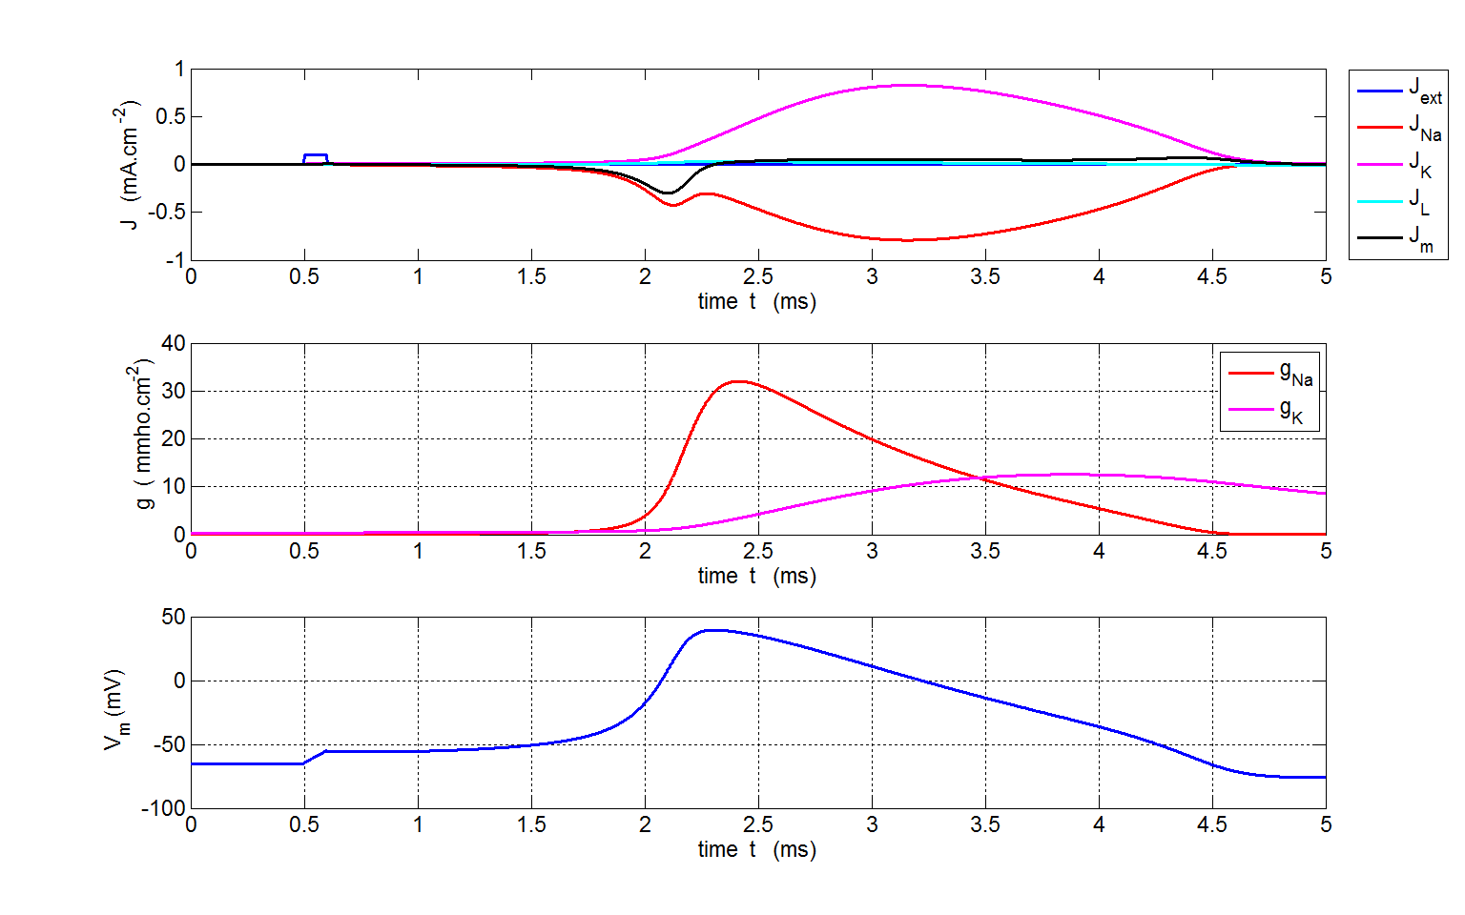

Fig. 12. Plots for the computation of an action potential generated by a 0.010 mA.cm-2 external stimulus in a voltage clamp squid axon at 6.3 oC. The time scale is different for the stimulus at 18.5 oC where the pulse is much of a shorter duration. **bp_neuron_01.m**

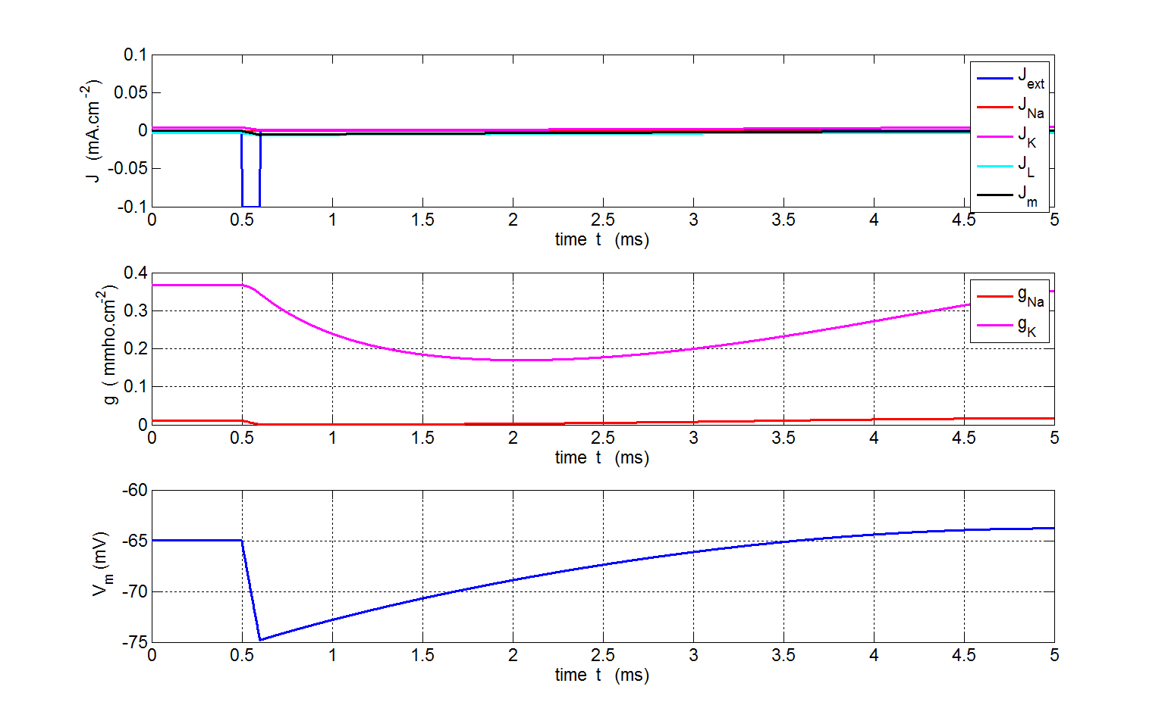

Fig. 13. Plots for the computation for a negative current pulse at 18.5 oC. The conductances of the membrane decreases and the membrane potential becomes more polarized before slowly returning to its resting value. **bp_neuron_01.m**

**Multiple current pulses**



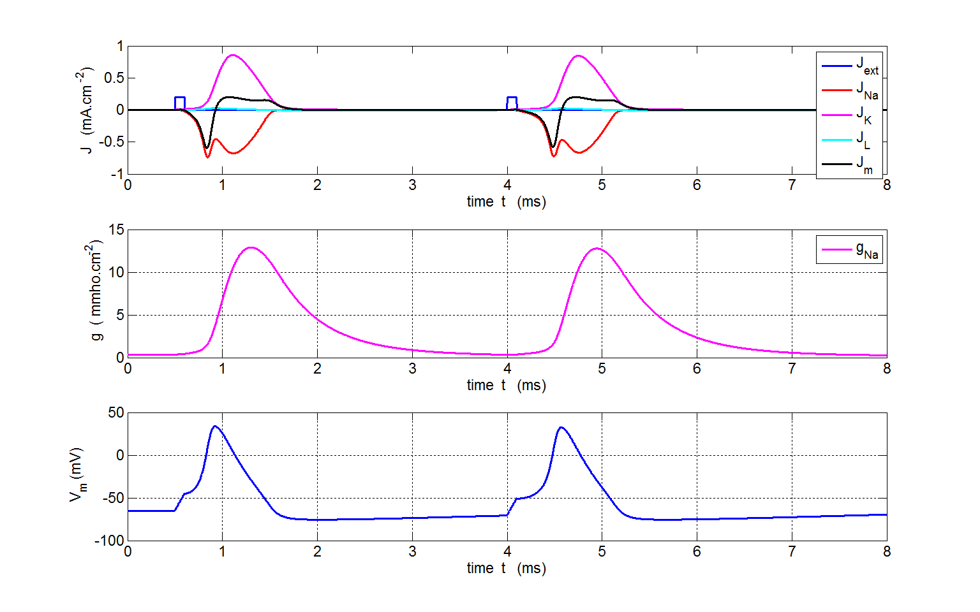

Fig. 14. Double stimulus. A second action potential is only produced when sufficient time has passed for the membrane voltage to return to nearly the resting potential. The refractory time is about 2.6 ms. If pulses occur in a time less than 2.6 ms, no action potential is generated.

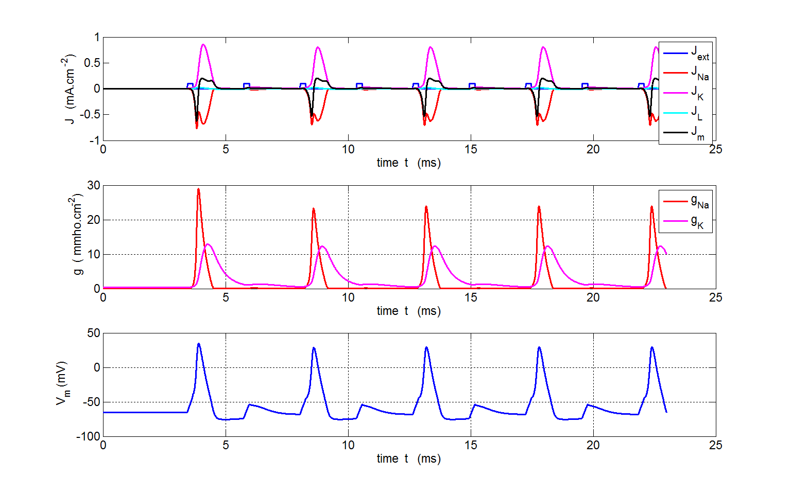Fig. 15. A series of current pulses can be injected into the neuron. If the repetition rate is too high for the pulses, then, not every pulse will result is an action potential being created.

**bp_neuron1a.m**

**Step input current**

|  |  |
| --- | --- |
|  |  |
|  |  |
|  |  |
|  |  |
|  |  |

Fig. 16. The external stimuli are step inputs for the currents densites (constant current injection). The stimuli are switched on at time *t* = 5.0 ms. If the size of the step is less than 0.007 mA.cm-2 then an action potential is not produced. As the size of the step is increased, the frequency of the repetitive firing increases but the the degree of depolarization decreases.

**bp_neutron_01b.m**.

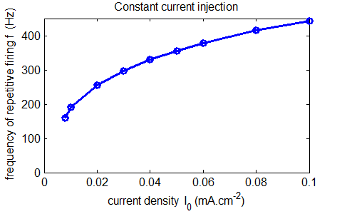

Fig.17. The frequency *f* of the repetitive firing was determined for each value of *I0*. This was done by using the Matlab command **ginput** to measure the period of the repetitive firing of the neuron in the figure window for the variation in membrane voltage as a function of time. **bp_neuron_01bb.m**

**External Stimuli with noise**

Noise was added to the external stimulus using the random numbers to generate white noise. The Matlab code for the one type of noise that was used to produce the plots shown in figure 18 is:

|  |
| --- |
| num1 = 81; num = 80000;  Jext_max = 0.2e-4; % max current density for ext stimulus (A.cm^-2)  Jext(num1:num) = Jext_max; % external stimulus current  rng('shuffle');  Jext = Jext./2 + (Jext_max./2) .* (2.*rand(num,1)-1); |

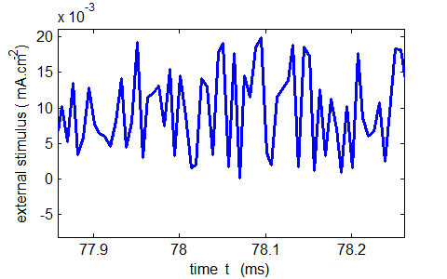

Fig. 18. A noisy external stimulus used to excited the neuron showing a portion of the external signal for a short time interval. **bp_neuron_01c.m**

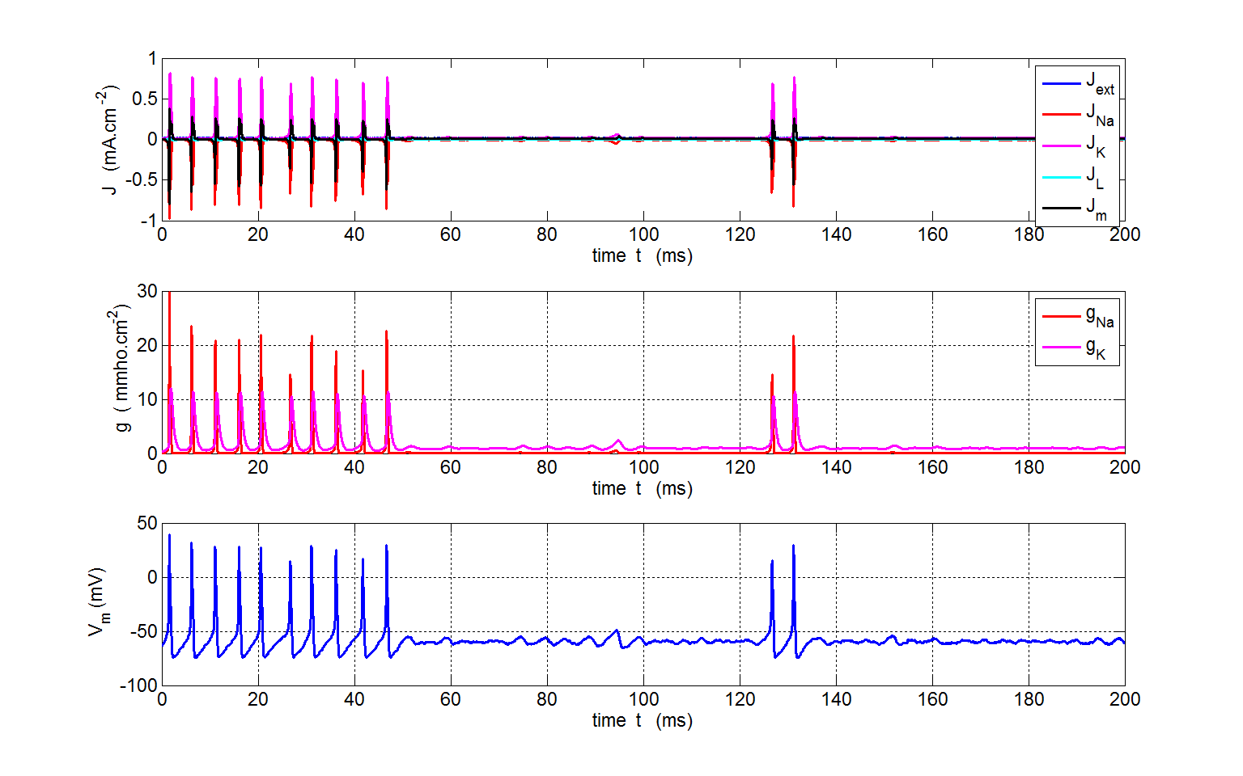

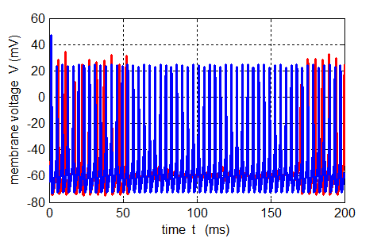

Fig. 19. External stimuli for a random input current density variation between 0 and 0.02 mA.cm-2. The input simulates noise. Spike trains are produced spasmodically. The spike trains have a slightly larger time interval between adjacent spikes than for a constant current density signal of 0.02 mA.cm-2 as shown in the lower plot.

**Interval Spike Distribution**

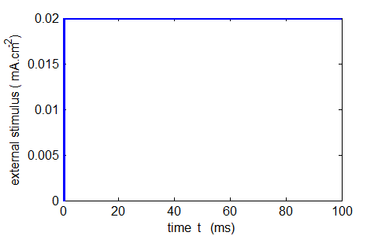

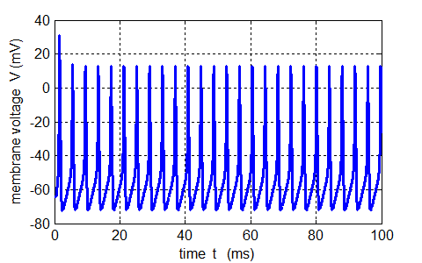

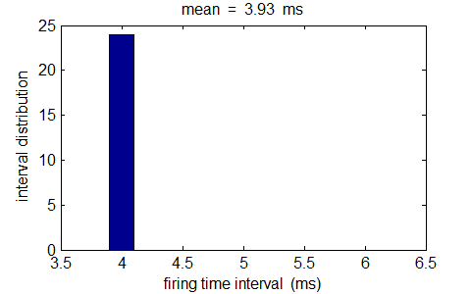

Fig. 20. A step input for the current density (*I*0 = 0.02 mA.cm-2) produces a spike train with action potentials produced at regular intervals (period *T* = 3.93 ms and frequency *f* = 254 Hz. **bp_neuron_01c.m**

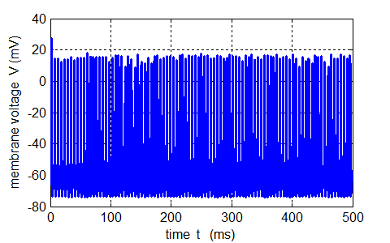

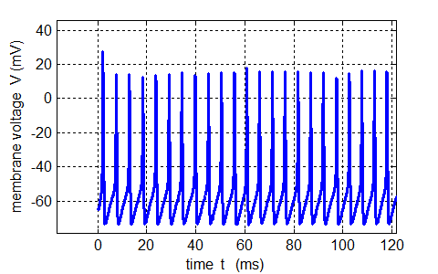

Fig. 21. The membrane voltage variation due to the noisy external stimulus shown in figure 19. **bp_neuron_01c.m**

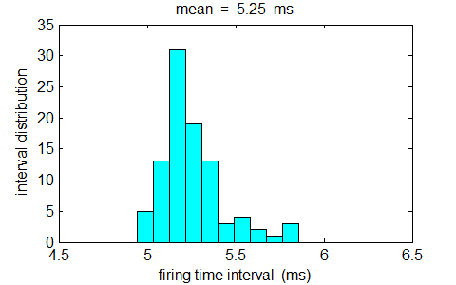

Fig. 22. The interspike interval distribution for the spike train shown in figure 20. The spike frequency is about 191 Hz which is lower than that for the constant input shown in figure 18. **bp_neuron_01c.m**

**Strong stimulus and noise**

A neuron receives signals from thousands of other neurons creating a noisy input resulting in small random fluctuations of the membrane potential around its resting value. A strong external stimulus pulse added to the noise creates a depolarization of the membrane producing a spike or a short spike train.

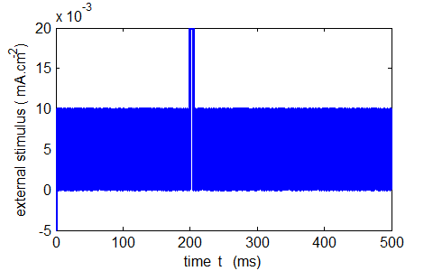

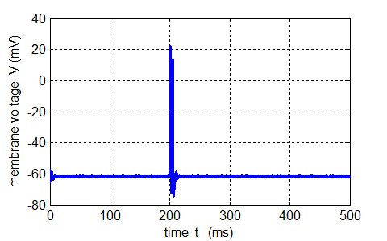

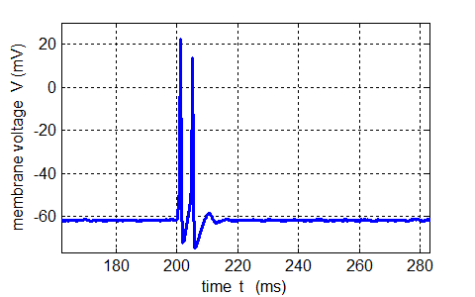

Fig. 23. A small amplitude noisy external stimulus and a strong short pulse added to the noise. The short pulse results in a firing of the neuron to produce a short spike train.

**bp_neuron_01c.m**

**Sinusoidal external stimulus**

The excitation of nerve cells by sinusoidal alternating current waveforms is very dependent upon the frequency of the stimulus because of the necessity to transfer a specific amount of charge to produce the excitation.

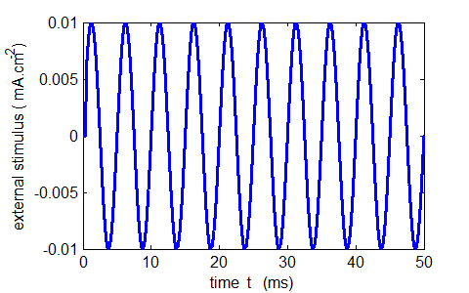

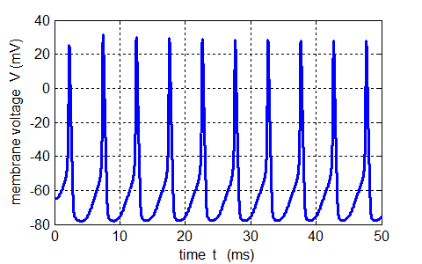

Fig. 24 . A sinusoidal external current stimulus (period 5.0 ms and frequency 200 Hz) produces a spike train with a frequency that matches the external stimulus. There is enough time for the membrane of the nerve cell to depolarize as sufficient electric charge can be applied to the membrane within the positive half cycle of the stimulus (charge transferred equals area under current vs time curve ). **bp_neuron_01c.m**

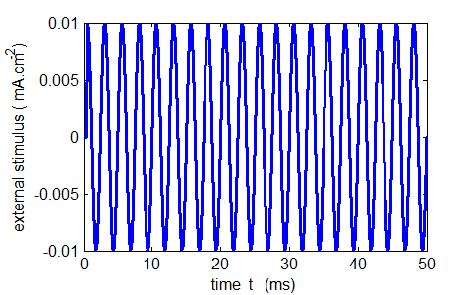

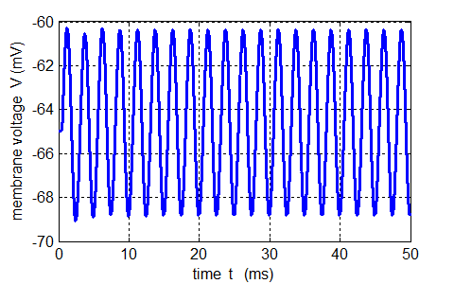

Fig. 25. A sinusoidal external current stimulus (period 2.5 ms and frequency 400 Hz) does not produce a spike train. The membrane potential oscillates with small amplitude around the resting membrane potential (*V*rest = - 65 mV) with a frequency that is close to the frequency of the external stimulus. With this higher frequency of external stimulus there is not sufficient electric charge to depolarize the membrane before the current polarity reverses which then acts to repolarize the membrane. From a circuit analysis point of view, there is not sufficient time for the capacitor to charge and hence only a small voltage drop across it can develop. At higher frequency, the impedance of the capacitor is low thus the voltage across it is also low. **bp_neuron_01c.m**

ap/mp/images/circuits_01.pptx