[**DOING PHYSICS WITH MATLAB**](http://www.physics.usyd.edu.au/teach_res/mp/home.htm)

**CIRCUITS BIOPHYSICS**

**TRANSIENT RESPONSES IN RC CIRCUITS**

Ian Cooper

School of Physics, University of Sydney

ian.cooper@sydney.edu.au

[**MATLAB SCRIPTS**](http://www.physics.usyd.edu.au/teach_res/mp/mscripts/) **(download files)**

simpson1d.m (function: integration using Simpson’s rule)

RC01.m (RC circuit: charging a capacitor)

RC02.m (RC circuit: discharging a capacitor)

RC03.m (RC circuit: step or pulse current input)

**INTRODUCTION**

Many electronic circuits use combinations of resistors and capacitors for controlling the timing of events. For example, the flash unit in a camera: typically there is a delay before taking a flash picture because of the time required to charge the capacitor. In a nerve cell called a **neuron**, currents can pass through the cell membrane from inside to out or from outside to in. Inside and outside the neuron is an electrolytic fluid which is a good conductor and the membrane acts as a dielectric (insulator) separating the two electrolytes. Thus, the simplest model of a segment of the neuron membrane is a capacitor and resistor connecting the outside to the inside of the cell.



Fig. 1. The membrane of a neuron can be modelled as a combination of a resistor and a capacitor.

To understand the transient effects in RC circuits and to start thinking about how signals are propagated along nerve cells, models of RC circuits will be developed using Matlab to generate graphically predictions of these models.

**CHARGING A CAPACITOR (RC01.m)**

Let a capacitor *C* and resistor *R* be connected in series to a battery of emf *E* via a switch. At time *t* = 0, the switch is closed and initially the capacitor is uncharged. The circuit diagram created in Matlab (RC01.m) is shown in figure 2.

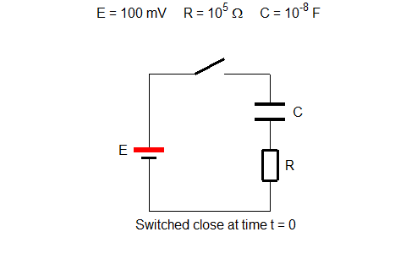

Fig. 2. *RC* circuit diagram used to charge the capacitor.

**Variables and default values**

*E* = 100 mV battery emf

*R* = 103 Ω resistance (typical neuron membrane resistance value)

*C* = 10-6 F capacitance (typical neuron membrane capacitance)

τ = RC = 10-3 s = 1.00 ms time constant (tau). For nerves: time constants ~ ms

*VC* potential across capacitor [V]

*VR* potential across resistor [V]

*Q*  charge on plates of capacitor [C]

*I* = *IR* = *IC* current [A]

*PE* power supplied by battery [W]

*PC* power stored by capacitor [W]

*PR* power dissipated by resistor [W]

*WE* energy supplied by battery [J]

*WC* energy stored by capacitor [J]

*WR* energy dissipated by resistor [J]

**Derivations**

From Kirchhoff’s voltage law, we can write the differential equation for *VC* and solve it to find all the parameters that describe the RC circuit.

 Kirchhoff’s voltage law

 Voltage and charge stored by capacitor

 Current (series circuit)



 D.E. to solve (from Kirchhoff’s voltage law)

 Solution of D.E. with initial conditions *t* = 0 and *VC* = 0

 From the solution *VC*

 Current

 Charge

 Power

 Energy (integration by Simpson’s rule)

The D.E. for *VC* can also be solved using the **finite difference method**.

 D.E. to be solved

 finite differences approximate the derivative ()

 solve starting with *t* = 0 and *VC*(0) = 0

**Graphical Predictions** (Matlab script RC01.m)

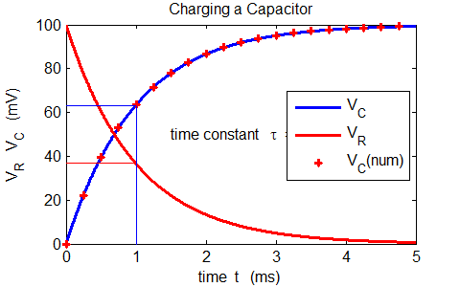

Fig. 3. When the switch is closed, **exponential** changes occur in the potential across the capacitor *C* and the resistor *R*. The applied potential difference *E* at all times is the sum of the potential difference across the capacitor *VC* and resistor *VR* (*E* = *VC* + *VR*). As soon as the switch is closed: *VC* = 0 and *VR* = *E*. In a time of one time constant *τ* = *RC* the capacitor potential VC increases by 63% of its final value and the potential across the resistor *VR* drops by 63% to 37% of its initial value.

If a membrane is suddenly allowed to charge passively to a new membrane potential, the time course of the voltage is exponential and undergoes 63% of the total change in about 1 ms.

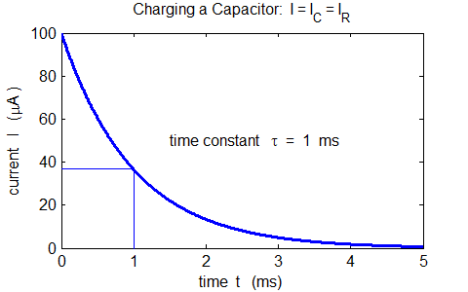

Fig. 4. When the switch is closed, the current decreases **exponentially**. In a time of one time constant *τ* = *RC* the current (*I* = *IC* = *IR*) in the circuit drops by 63% to 37% of its initial value.

Once fully charged, a capacitor in a DC circuit acts like an open switch in the branch in which it is placed. This property is used in many electronic circuits to remove a DC voltage component from a signal.

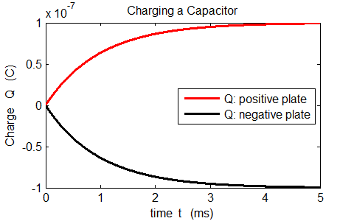

Fig. 4. When the switch is closed, the capacitor is charged as the charged stored on the two plates increases as an exponential function. The curve for the charge is identical in shape to the potential difference across the capacitor as *Q* ∝ *VC*. For *t* > 5*τ*, the capacitor can be considered fully charged.

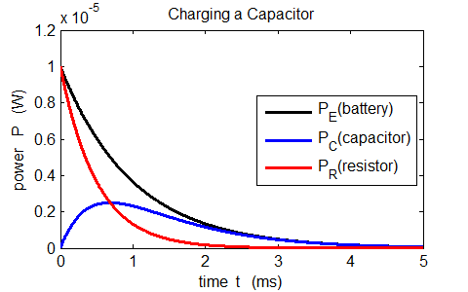

Fig. 5. The battery supplies the energy in the circuit. Some of this energy is stored by the capacitor and the remainder of the energy is dissipated as internal energy by the resistor’s current (Ohmic losses).

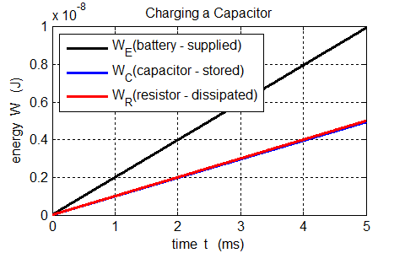

Fig. 6. The battery supplies the energy in the circuit. Some of this energy is stored by the capacitor and the remainder of the energy is dissipated as internal energy by the resistor’s current (Ohmic losses). The energy stored by the capacitor at all times in equal to half the energy dissipated by the resistor

(*WC* = *WR*).

The energy stored by the capacitor is given by



which agrees with the prediction of our model.

**DISCHARGING A CAPACITOR (RC02.m)**

Let a capacitor *C* and resistor *R* be connected in parallel to each other and with no connection to a source of emf. At time *t* = 0, the switch is closed and initially the capacitor is fully charged. The circuit diagram created in Matlab (RC01.m) is shown in figure 7.

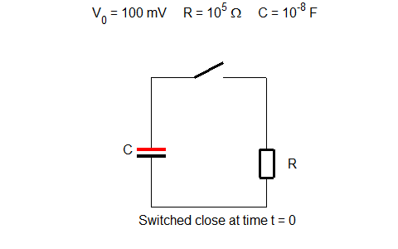

Fig. 7. *RC* circuit diagram used to discharge the capacitor.

**Derivations**

From Kirchhoff’s voltage law, we can write the differential equation for *VC* and solve it to find all the parameters that describe the RC circuit.

 Kirchhoff’s voltage law

 Voltage and charge stored by capacitor

 Initial values *t* = 0 *V*0 = 100 mV

 Current (series circuit)



 D.E. to solve (from Kirchhoff’s voltage law)

 Solution of D.E. with initial conditions *t* = 0 and *Q*0 = *VC*0

 From the solution *Q*

 Current

 Power

 Energy (integration by Simpson’s rule)

**Graphical Predictions** (Matlab script RC02.m)

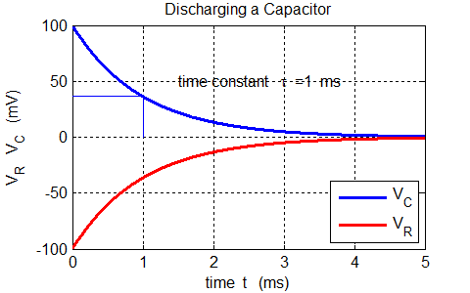

Fig. 8. When the switch is closed, **exponential** changes occur in the potential across the capacitor *C* and the resistor *R*. At all times is the sum of the potential difference across the capacitor *VC* and resistor *VR* is zero (*VC* + *VR* = 0). As soon as the switch is closed: *VC* = +100 V and the voltage drop across the resistor is *VR* = -100 mV. In a time of one time constant *τ* = *RC* the capacitor potential VC and resistor potential *VR* magnitudes decreases by 63% of their final values to a value of 37% of their initial values.

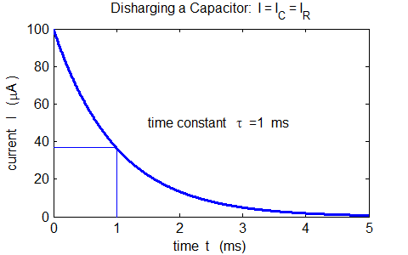

Fig. 9. When the switch is closed, the current decreases **exponentially**. In a time of one time constant *τ* = *RC* the current (*I* = *IC* = *IR*) in the circuit drops by 63% to 37% of its initial value.

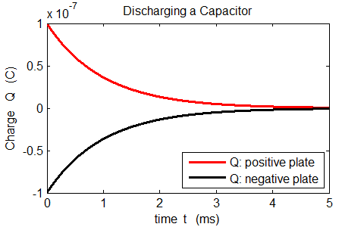

Fig. 10. When the switch is closed, the capacitor is fully charged as the charged stored on the two plates then decreases as an exponential function. The curve for the charge is identical in shape to the potential difference across the capacitor as *Q* ∝ *VC*. For *t* > 5*τ*, the capacitor can be considered fully discharged.

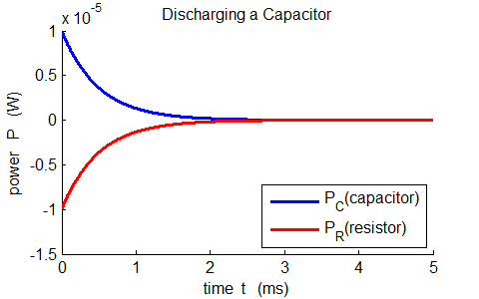

Fig. 11. The energy initially stored by the capacitor is dissipated as internal energy by the resistor’s current (Ohmic losses).

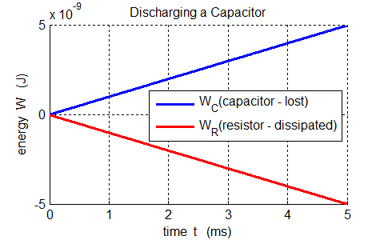

Fig. 12. The energy is stored by the capacitor is lost as internal energy by the current in the resistor.

which agrees with the prediction of our model.

**TRANSIENT RESPONSE: STEP or PULSE CURRENT INPUT**

**(RC03.m)**

The capacitor *C* and resistor *R* are connected in parallel and a current is injected into the circuit as shown in figure 13 (figure created in Matlab script RC03.m).

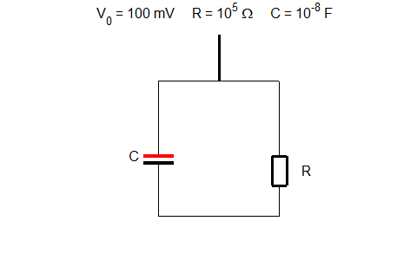

Fig. 13. *RC* circuit diagram for current injection.

**Derivations**

 capacitor and resistor connected in parallel

 Kirchhoff’s current law: *I* is the injected current

 conservation of charge

 currents

 D.E. to be solved for *V*

The easiest way to solve this D.E. is to use the **finite difference method** where the derivative is replaced by a difference equation

 good approximation provided *dt* << *τ* = *RC*

 can find successive values of *V* in time steps Δ*t*

 charge at time *t*

 currents at time *t*

**Graphical Predictions** (Matlab script RC03.m)

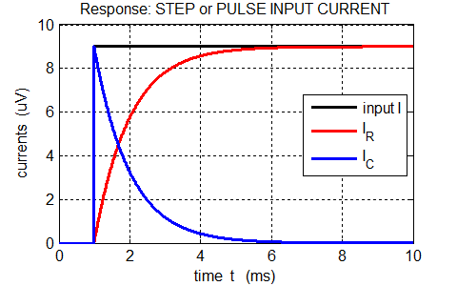

Fig. 14. Variation in the currents as functions of time. *I* is the external current injected into the circuit. The resistive current *IR* and capacitive current *IC* vary exponentially with a characteristic time constant *τ* = *RC* = 1 ms. When the input current *I* jumps, the capacitor charges almost immediately then discharges through the resistor *R*, while the capacitive current *IC* decreasing exponentially. The resistive current increases exponentially to a maximum level after a time interval of about 5τ.

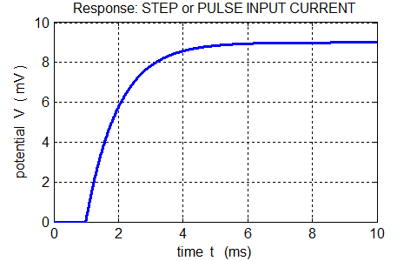

Fig. 15. The voltage across the parallel combination of *R* and *C* increases exponentially to a maximum level with a characteristic time constant

*τ* = *RC* = 1 ms.

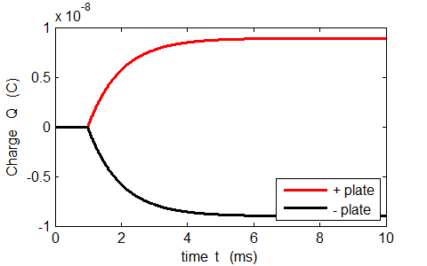

Fig. 16. The charge *Q* on the plates of the capacitor *C* increases exponentially to a maximum level with a characteristic time constant *τ* = *RC* = 1 ms. The shape of the curve is the same as the variation in voltage since .

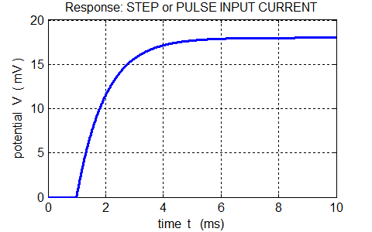

Fig. 17. When the magnitude of the step current increases by a factor of 2, then the change in the maximum potential difference also doubles.

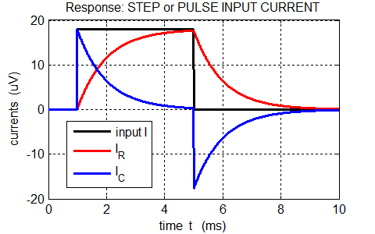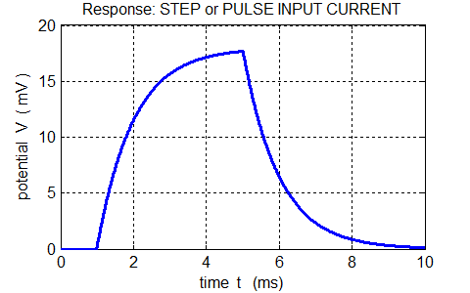

Fig. 18. Response for a pulse input. The capacitor charges then discharges. The potential difference *V* curve is the same shape as the curve for the resistive current *IR* since *IR* ∝ *V*.

For a neuron, at any instant, the total current *I*(*t*) is equal to the sum of the currents through the membrane: *I*(*t*) = *IC*(*t*) + *IR*(*t*) where *IR*(*t*) is a **conducting current** and *IC*(*t*) is known as a **displacement current**. The current thus depends upon the voltage and the rate of change of the voltage and this parallel combination offers minimum opposition to current for rapidly changing voltages since there is not enough time for the capacitance to charge significantly.

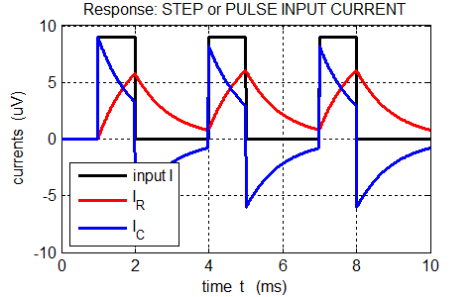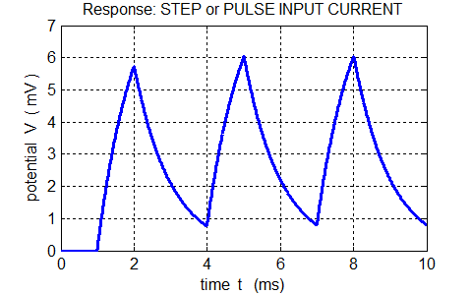

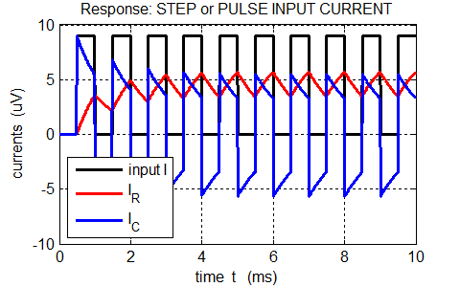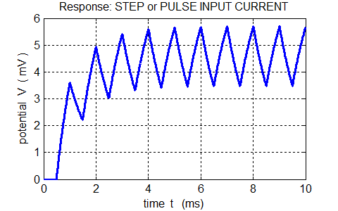

Fig. 19. Response for a series of pulses. For a rapid series of pulses the conductive current *I­R* has small fluctuations about an average value. The result of many pulses arriving at a neuron is that the voltage across the membrane can grow as the capacitor charges and discharging. This can result is a sufficient voltage across the membrane to produce an action potential (large voltage spike) then can initiate the propagation of a signal along the axon.