

[**DOING PHYSICS WITH MATLAB**](http://www.physics.usyd.edu.au/teach_res/mp/mphome.htm)

**VECTOR ANANYSIS**

Ian Cooper

School of Physics, University of Sydney

ian.cooper@sydney.edu.au

[**DOWNLOAD DIRECTORY FOR MATLAB SCRIPTS**](http://www.physics.usyd.edu.au/teach_res/mp/mscripts)

**cemVectorsA.m**

Inputs: Cartesian components of the vector V

Outputs: cylindrical and spherical components and [3D] plot of vector

**cemVectorsB.m**

Inputs: Cartesian components of the vectors A B C

Outputs: dot products, cross products and triple products

**cemVectorsC.m**

Rotation of XY axes around Z axis to give new of reference X’Y’Z’.

Inputs: rotation angle and vector (Cartesian components) in XYZ frame

Outputs: Cartesian components of vector in X’Y’Z’ frame

mscript can be modified to calculate the rotation matrix for a [3D] rotation and give the Cartesian components of the vector in the X’Y’Z’ frame of reference.

**SPECIFYING a [3D] VECTOR**

A **scalar** is completely characterised by its magnitude, and has no associated direction (mass, time, direction, work). A scalar is given by a simple number.

A **vector** has both a magnitude and direction (force, electric field, magnetic field). A vector can be specified in terms of its Cartesian or cylindrical (polar in [2D]) or spherical coordinates.

Cartesian coordinate system (XYZ right-handed rectangular: if we curl our fingers on the right hand so they rotate from the X axis to the Y axis then the Z axis is in the direction of the thumb).

A vector in specified in terms of its X, Y and Z Cartesian components



where  are unit vectors parallel to the X, Y and Z axes respectively.

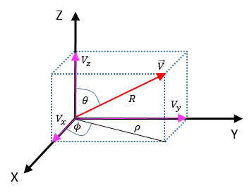

Fig. 1. Specifying a vector in an orthogonal coordinate system.

The **polar angle**  is the angle down from the Z axis to the vector .

The **azimuthal angle**  is the angle around from the X axis.

Polar angle 

Azimuthal angle  or 

Angles can be measured in radians or in degrees where 

You can use the Matlab functions **rad2deg** and **deg2rad** for the conversions between radians and degrees

deg2rad(30) 🡪 30o = 0.5236 rad

rad2deg(pi) 🡪  = 180o

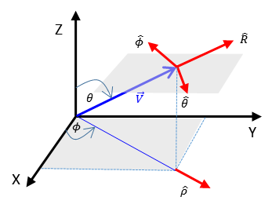

Fig. 2. The unit vectors  pointing in the direction of an increase in the corresponding coordinate.

Cartesian components 

Cylindrical components 

Spherical components 

**Magnitudes**





Relationship between coordinates from figure 2







**Spherical coordinates**



**Cylindrical coordinates**



**Matlab**

Vector 

row vector V = [3 5 -6]

column vector V = [3; 5; -6]

magnitudes R = norm(V) rho = sqrt(V(1)^2+V(2)^2)

azimuthal angle 

phi = atan2(V(2),V(1));

if phi < 0, phi = phi + 2*pi; end

polar angle theta = acos(V(3)/R);

thetaD = acosd(V(3)/R);

**Matlab: changing orthogonal systems**

You can also use MATLAB functions to make the conversion between Cartesian, polar, cylindrical, and spherical coordinate systems easy.

Cartesian components  Vx Vy Vz

Cylindrical components  Vrho Vphi Vz

Spherical components  VR Vphi Vtheta

where the angles Vphi and Vtheta are in radians

[2D] [Vphi Vrho] = cart2pol(Vx,Vy)

[Vx Vy] = pol2cart(Vphi, Vrho)

[3D] [Vphi Vrho Vz] = cart2pol(Vx, Vy, Vz)

[Vx Vy Vz] = pol2cart(Vphi, Vrho, Vz)

[Vtheta Vphi VR] = cart2sph(Vx, Vy, Vz)

[Vx Vy Vz] = sph2cart(Vtheta, Vphi, VR)

[Vphi Vrho Vz] = sph2pol(Vtheta, Vphi, VR)

[Vtheta Vphi VR] = pol2sph(Vphi, Vrho, Vz)

**Sample results**

|  |  |  |  |  |  |  |
| --- | --- | --- | --- | --- | --- | --- |
|  |  |  |  |  |  |  |
| 3 | 5 | -6 | 5.831 | 8.367 | 1.03 rad  59.04o | 0.80 rad  -45.82o |
| 1.2247 | 0.7071 | 1.4142 | 1.4142 | 2.0000 | 0.52 rad  30.00o | 0.79 rad  45.00o |
| 1.2247 | -  -0.7071 | -  -1.4142 | 1.4142 | 2.0000 | -0.52 rad  -30.00o | 0.79 rad  -45.00o |

Figure (1) gives a [3D] plot of a vector plus a summary of the input values for the Cartesian components and the calculated spherical and cylindrical components of the vector using the **mscript cemVectorsA.m**.

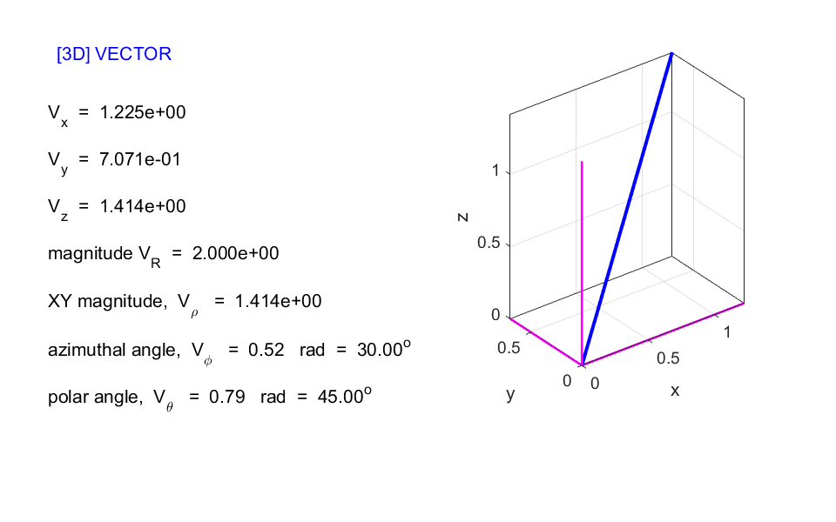

Fig. 1. Figure Window for a vector with inputs as the Cartesian components. **cemVectorsA.m**

**VECTOR ALGEBRA**

**Addition / Subtraction / Scalar multiplication**

To add or subtract vectors, you add or subtract the components. For multiplication of a vector by a scalar, simply multiply each component by the number for the scalar.

For example: consider the vectors in Cartesian coordinates



**Matlab Command Window**

A = [1 2 3]

B = [-1 -3 -5]

C = [2 4 -3]

V = 3*A+B-2*C 🡪 V = [ -2 -5 10]

**Dot product (scalar product) of two vectors**



where  is the angle between the two vectors when they are placed tail to tail

 scalar

 commutative

 distributive

Geometrically  is the product of  times the projection of  along or the product of  times the projection of along****

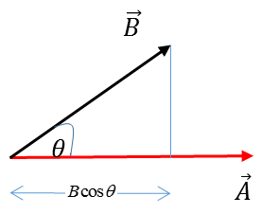

Angle between the two vectors 

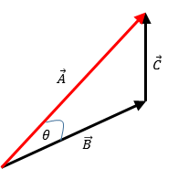 Law of cosines



Matlab function **dot(A,B)** where A and B are row vectors of the same length.

**Cross product or vector product of two vectors**

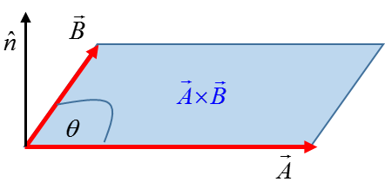



where  is the angle between the two vectors placed tail to tail and  is a unit vector that is normal to the plane defined by the two vectors and whose direction is determined by the right-hand rule (fingers curl from  to  then extended thumb points in direction of ).

 non-commutative

 distributive



The cross product is the vector area of the parallelogram having  and  on adjacent sides.

Determinant form 

Matlab function **cross(A,B)** returns the cross product of the vectors A and B. A and B must be 3 element vectors.

**Triple Products**

Examples of triple products of three vectors









Calculations of triple products are given in the following examples. You should compare the numerical outputs with the above relationships.

**Results of running the mscript**  **cemVectorsB.m**

Inputs vectors

A = [1 0 1] B = [0 1 1] C = [2 4 5]

Outputs

Magnitudes of vectors Amag = norm(A)

Amag = 1.4142 Bmag = 1.4142 Cmag = 6.7082

Dot products AdotB = dot(A,B)

AdotB = 1 BdotA = 1 BdotC = 9 CdotA = 7

Cross products AB = cross(A,B)

AB = [-1 -1 1] BA = [1 1 -1] BC = [1 2 -2] CA = [4 3 -4]

Cross products: magnitudes ABmag = norm(AB)

ABmag = 1.7321 BAmag = 1.7321 BCmag = 3 CAmag = 6.4031

Angles between vectors ABangle = asin(norm(AB) /(Amag * Bmag))

ABangle_deg = rad2deg(ABangle)

ABangle = 1.0472 rad = 60.0000 deg

BAangle = 1.0472 rad = 60.0000 deg

BCangle = 0.3218 rad = 18.4349 deg

CAangle = 0.7409 rad = 42.4502 deg

Triple products (cross product of vectors A and B written as AB)

AdotBC = -1 AdotBC = dot(A,cross(B,C))

BdotCA = -1

CdotAB = -1

AdotCB = 1

BdotAC = 1

CdotBA = 1

AcrossBC1 = [-2 3 2] cross(A,cross(B,C))

AcrossBC2 = [-2 3 2] B .* dot(A,C) - C .* dot(A,B)

AcrossBC = [-2 3 2] AcrossBC = cross(A,cross(B,C))

ABcrossC = [-9 7 -2] ABcrossC = cross(cross(A,B),C)

**Example** Find the angle between the face diagonals of a cube

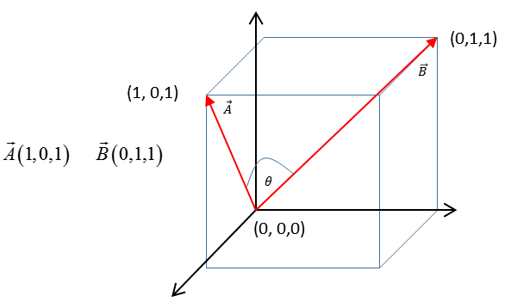

**⇒**

The angle between the two vectors can be found from the cross product of the two vectors



Run the mscript **cemVectorsB.m**

A = [1 0 1] B = [0 1 1]

angle is *θ* = 1.0472 rad = 60.0000 deg

**⇐**

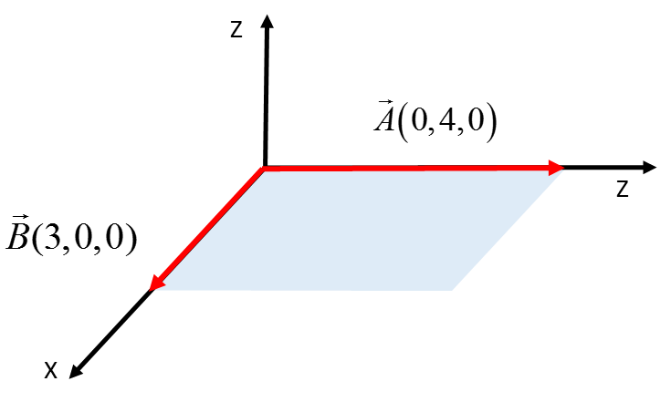**Example** Find the components of the unit vector  perpendicular to the shaded regions formed by the vectors  and 



**Example** Find the components of the unit vector  perpendicular to the shaded regions formed by the points R, P, Q.

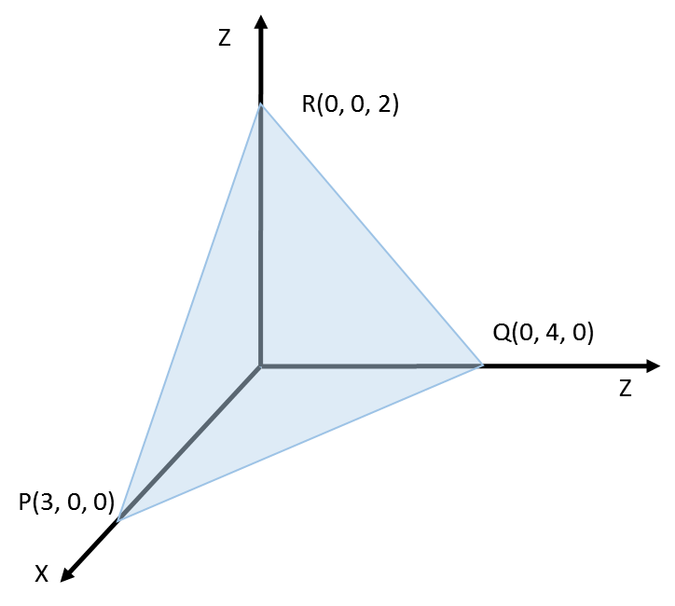

Let  be the vector pointing from R to P and  be the vector pointing from R to Q. Then the vectors are  and .

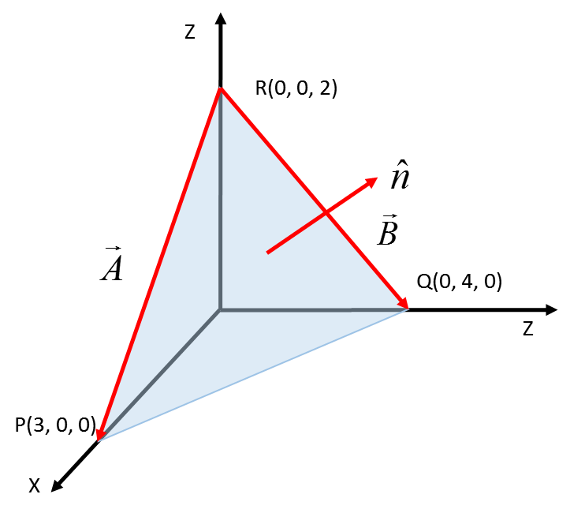 

**Matlab Command Window**

A = [3 0 -2] B = [0 4 -2]

C = cross(A,B) C = [8 6 12]

Cmag = norm(C) Cmag = 15.6205

n = C./Cmag

n = [0.5121 0.3841 0.7682]

The Cartesian components of the vector  are (0.5121, 0.3841, 0.7682)

**TRANSFORMATION OF COORDINATES DUE TO ROTATION**

What is the change in the components of a vector due to a rotation of the coordinate system from X Y Zto X ’Y ’Z’*?*

The transformation matrix due to a rotation uses the following notation



 is the angle between axes  and 

 is the angle between axes  and 

 where 

 in the XYZ coordinate system

 in the X’Y’Z’ coordinate system

 where 

The mscript **cemVectorsC.m** can be modified to calculate the rotation matrix and the components of the vector in the X’Y’Z’ frame of reference.

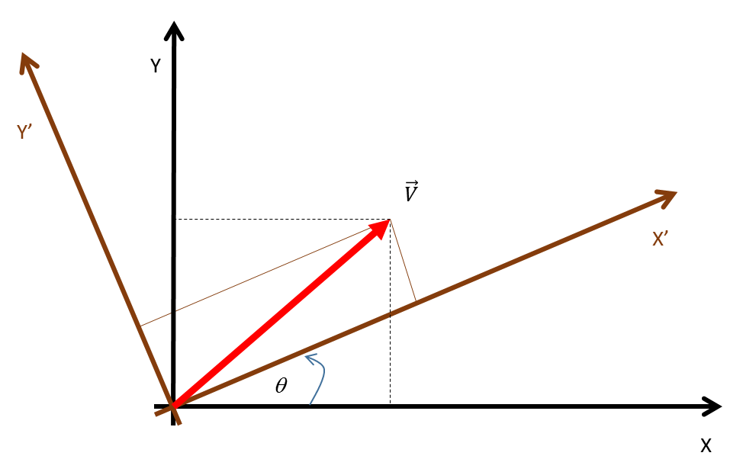**Rotation of the XY axes around the Z axis**

Consider the vector  in the unprimed frame of reference.

What will be its components in the primed frame of reference that is rotated by an angle  in an anticlockwise direction in the XY plane?

Angles between the axes XYZ and X’Y’Z’



Transformation of vector components



**Example**

V(2, 3, 0) in XYZ frame of reference

XYZ rotated by 30o anticlockwise in XY plane to give the X’Y’Z’ frame

What are the components of V in the X’Y’Z’ frame?

**⇒**

Run the mscript **cemVectorsC.m**

Inputs: V = [2 3 0] theta = 30

Output displayed in Command Window: Vdash = [3.2321 1.5981 0]

**⇐**