

[**DOING PHYSICS WITH MATLAB**](http://www.physics.usyd.edu.au/teach_res/mp/mphome.htm)

**ELECTROMAGNETIC INDUCTION**

**FARADAY’S LAW**

**MUTUAL & SELF INDUCTANCE**

Ian Cooper

School of Physics, University of Sydney

ian.cooper@sydney.edu.au

[**DOWNLOAD DIRECTORY FOR MATLAB SCRIPTS**](http://www.physics.usyd.edu.au/teach_res/mp/mscripts)

Download and inspect the mscripts and make sure you can follow the structure of the programs.

**cemB01.m**

Calculations of the induced emfs and current in a square shaped coil due to the changing magnetic flux through the surface of the coil produced by a time varying current in a long straight wire.

**cemB02.m**

Calculations of the induced emfs and current in a square shaped coil due to the sinusoidal magnetic flux through the surface of the coil produced by a sinusoidal time varying current in a long straight wire.

**simpson1d.m simpson2d.m**

Computation of [1D] and [2D] integrals using Simpson’s rule. The functions to be integrated must have an **ODD** number of the elements.

Faraday’s law is applied to a system of a long straight wire (1) and a square shaped conducting coil (2). A time dependent current  in the wire produces a time varying magnetic field *B* surrounding it. The coil is coupled to the wire by the **mutual inductance** *M* of the system of wire and coil. The changing magnetic flux  through the coil induces emf  around the coil which opposes the change in magnetic flux through it. The coil has a **self-inductance** *L* and the current in the coil produces its own emf  to oppose the emf .

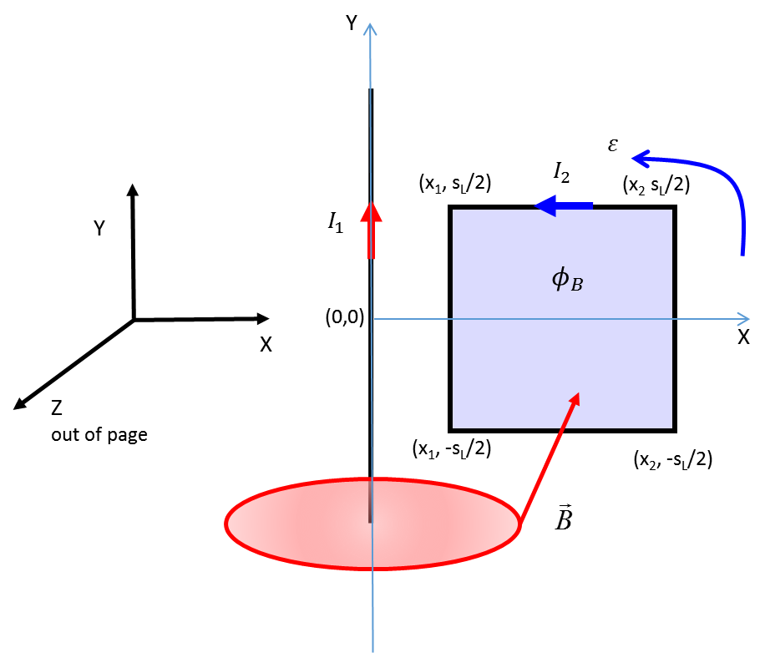

Fig. 1. System of long straight wire conductor aligned along the Y axis and conducting square shaped coil aligned in the XY plane and centred on the X axis. The current in the wire is  and the induced current in the coil is . The side length of the square coil is  and the radius of the coil wire is *a.* The closest side of the coil to the wire is the distance  and the opposite of the side of the coil is at a distance . The conductivity of the of the coil is (resistivity ) and the resistance of the coil is *R.* The magnetic field  through the coil is parallel to the Z axis and the magnetic flux through the coil is .

The magnitude of the magnetic field *B* at a distance *x* from the wire is

(1) 

If the wire current  is in the +Y direction, the magnetic field is in the –Z direction through the coil and in the +Z direction if the wire current  is the –Y direction (right hand screw rule).

The magnetic flux  through the square coil is

(2) 

**Faraday’s law** can we expressed as

(3) 

Normally we think of fields created by charges. However, when a magnetic flux through some surface changes with time, then there is also an electric field created to give an emf around the boundary of the surface.

A steady current  in the wire produces a constant magnetic flux through the coil and the induced emf is zero. Only when the wire current  changes with time that the magnetic flux  changes and a net emf created around the coil (the coil forms the boundary of the surface through which the magnetic flux changes). The induced emf drives a current  through the conductive coil. The direction of the induced current in the coil is determined by **Lenz’s law**. The induced current ** gives a magnetic flux that opposes the change in magnetic flux  produced by the wire current . Hence, the direction of the induced current  can be determined by using the right hand screw rule. In figure 1, if the current  is increasing the magnetic field through the coil is increasing in the –Z direction. The induced current  in the coil is in an anticlockwise sense which gives its magnetic field in the + Z direction (opposite to the *B* field from the wire).

The magnetic flux at every point within the coil is proportional to the wire current  (equation 2), therefore, we can write

(4) 

where the constant of proportionality *M* is the **mutual inductance** of the system composed of the coil and long straight wire. The S.I. unit for the mutual inductance is the henry [H].

From equations 1 and 2, the mutual inductance *M* is

(5a) 

(5b) 

(5c) 

We have three ways of computing *M.* For the surface enclosed by the coil a [2D] grid can be created. Then *M* from equation 5a can be estimated by calling the function **simpson2d.m** which evaluates the integral for the grid of NxN points where N must be an odd number. The integral in equation 5b can be evaluated by dividing the area of the coil into strips parallel to the Y axis and using the function **simpson1d.m**. M can be found analytically using equation 5c.

**Matlab cemB01.m**

Setting up the [2D] grid

% Grid for square coil xG yG

x = linspace(x1,x2,N);

y = linspace(y1,y2,N);

[xG, yG] = meshgrid(x,y);

Computing the mutual inductance

% Mutual inductance for wire and square coil M:

three ways of calculating

fn = (1./xG);

ax = x1; bx = x2; ay = y1; by = y2;

integral2D = simpson2d(fn,ax,bx,ay,by);

M1 = (mu0 / (2*pi)) * integral2D;

fn = 1./x;

integral1D = simpson1d(fn,ax,bx);

M2 = (mu0 / (2*pi)) * (by-ay) * integral1D;

M3 = (y2 - y1)* mu0/(2*pi) * log(x2/x1);

M = M1;

The three ways of computing M give the exact same result.

The current in the coil also creates a magnetic field and a magnetic flux through the coil. If this current changes with time, so does the magnetic flux and additional emf exists around the coil. This additional emf influences the current .

emf generated by current in the wire

(6) 

emf generated by current in the coil

(7) 

where *L* is the constant of proportionality called the **self-inductance** [henries H].

The self-inductance *L* for the square coil of side length *sL* and the coil wire has a circular cross-section with radius *a*, then

(8) 

where *L* is in henries, *sL* and *a* are in meters.

So, the changing current  in the wire gives the time varying magnetic flux through the coil that induces an electric field that produces an emf in the coil which drives the coil current . The emf around the coil is

(9) 

If the coil has a resistance *R,* then  and we can obtain a differential equation that can be solved to give the coil current 

(10) 

(11) 

**Analytical solution of equation 11**



(12) 

**Finite difference solution to equation 11**

A finite difference method can be used to solve equation 11. This approach is better, because you can’t always find an analytical solution.

The first derivative is approximated by the finite difference

 for time steps  and *n*

where *n* = 1, 2, 3, … , *N*  (*N* odd integer)

(13) 

Given the initial values (*n* = 1) of  and  it is easy to find the values of  at later times.

**Example 1 cemB01.m**

Wire current varies linearly with time 

= 2.0 A.s-1

constant (don’t need numerical approximation for derivative)

Square coil

side length *sL* = 1.0 m

radius *a* = 1.0x10-3 m

copper wire resistivity 1.68x10-8 Ω.m resistance R = 0.0214 Ω

distance from wire *x*1= 0.10 m

self inductance *L* = 5.1070x10-6 H

Wire and coil

mutual inductance M = 4.7958x10-7 H

Figure 2 show plots of the wire current  and the induced coil current . The current  is computed by solving equation 11 and the numerical result is identical to the analytical solution provided the time step is smaller enough. The analytical solution gives a saturation value  for the current  as 

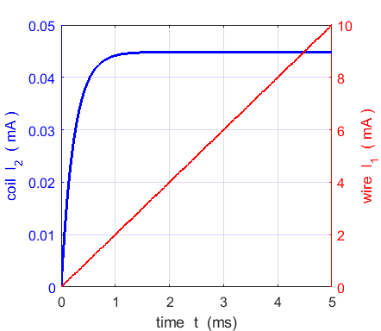 (14) 

Fig. 2. The time variation of the wire current  and induced coil current . The saturation current for the induced coil current is 4.484x10-5 A.

From the solution given by equation 12, we can define a time constant  such that



The value for the time constant  calculated numerically is the same as the analytical value for 5001 grid points and 5001 time steps (). The final steady state value  does not depend upon the self-inductance *L,* but the time the current takes to the reach steady state does.

The self-inductance tends to inhibit changes in the coil current , and the larger the value of *L,* the longer the system takes to reach steady-state.

The induced emf  in the coil is due to two components: the mutual inductance of the wire and coil and the self-inductance of the coil as described by equations 6, 7, and 9. Figure 3 shows a plot of the emf induced in the coil.

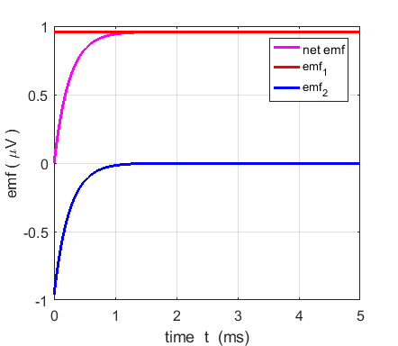

Fig. 3. net emf induced in the coil and its components  and .





Can we find the electric field induced by the time varying magnetic flux?

You may think that equation 3 can be used to find the value of 

(3) 

but this can only be done for very symmetrical cases such as when there is circular symmetry. Consider an irregular shape closed loop. An emf is induced in the loop due to an induced electric field whose direction and magnitude at points around the loop vary quite differently. Faraday’s law does not allow us to find anything more than the average magnitude of the electric field, the direction and magnitude depend on the path chosen. The induced emf around a closed path has meaning whether or not a conductor lies on the path. The electric field is not directly related to the value of *B* at points on the path taken, it only depends on the rate of change of the magnetic flux within the area enclosed by the loop.

We can find an average value for the electric field the current around the closed coil from the line integral form of Faraday’s law

(15) 

The numerical value of  for the parameters of Example 1 when a steady state situation has been reached is



We can also find the value of the average electric field  from equation 16

(16) 

where the electric field drives the current density  through a material with conductivity .



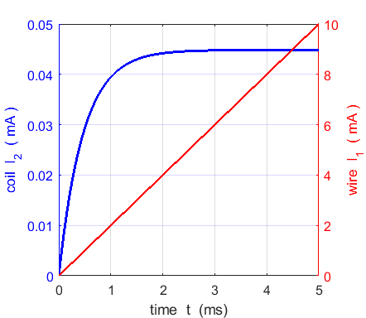**Changing input parameters**



The only change is that it takes longer to reach the steady state situation

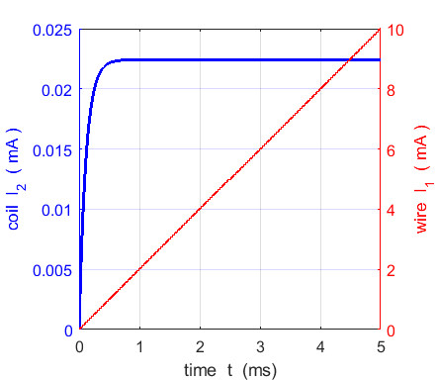





No change in emfs

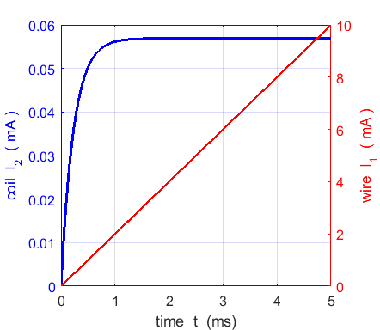







No change in time constant 

Reducing the area of the coil, reduces the magnetic flux and hence reduces the magnitude of the current induced in the coil.

**Example 2: Sinusoidal variation in magnetic flux cemB02.m**

The induced current  in the square shaped coil is produced by a time varying sinusoidal current  in the long straight wire. You can vary the frequency *f* of the sinusoidal current  in the wire to investigate how the induced current depends upon the frequency *f* of the changing magnetic flux through the coil.

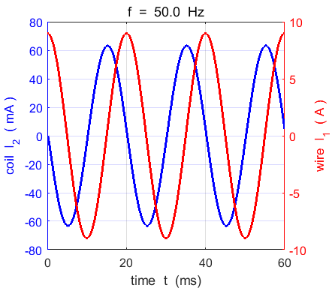

wire I1: frequency f = 50.0 Hz

coil: max current I2 = 63.22 mA

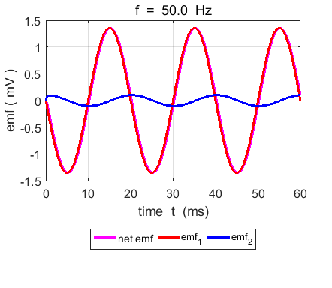

coil: max emf = 1.35 mV

coil: max emf1 = 1.36 mV

coil: max emf2 = 0.10 mV

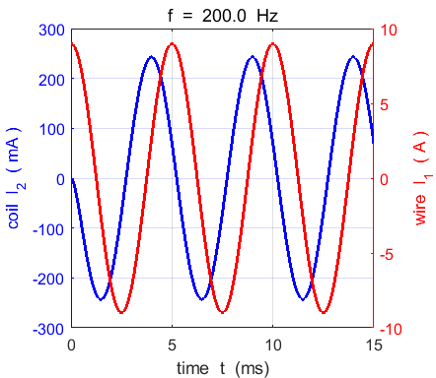

wire I1: frequency f = 200.0 Hz

coil: max current I2 = 243.00 mA

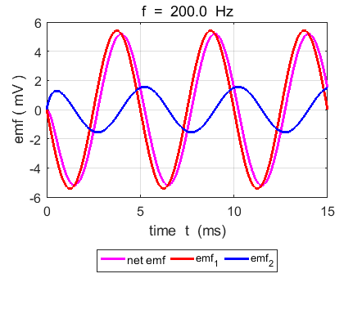

coil: max emf = 5.19 mV

coil: max emf1 = 5.42 mV

coil: max emf2 = 1.56 mV

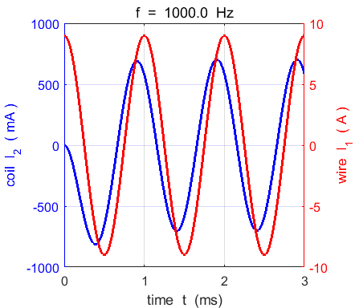

wire I1: frequency f = 1000.0 Hz

coil: max current I2 = 703.84 mA

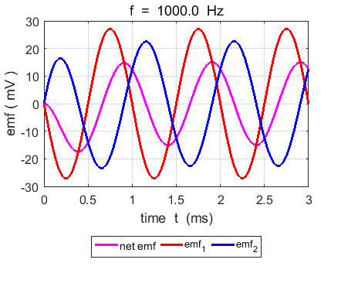

coil: max emf = 15.01 mV coil: max emf1 = 27.12 mV

coil: max emf2 = 22.58 mV

As expected, the greater the frequency (the greater the rate of change in the magnetic flux and the larger the induced currents in the copper coil.