

[**DOING PHYSICS WITH MATLAB**](http://www.physics.usyd.edu.au/teach_res/mp/mphome.htm)

**STATIC MAGNETIC FIELDS**

**BIOT-SAVART LAW**

**PARALLEL WIRES**

Ian Cooper

School of Physics, University of Sydney

ian.cooper@sydney.edu.au

[**DOWNLOAD DIRECTORY FOR MATLAB SCRIPTS**](http://www.physics.usyd.edu.au/teach_res/mp/mscripts)

Download and inspect the mscripts and make sure you can follow the structure of the programs.

**cemB03.m**

Set of 1 to 4 parallel wires aligned in the Z direction

Calculations based upon the Biot-Savart Law: magnetic field , line integral, curl  , magnetic flux  and divergence 

**simpson1d.m**

Function to calculate a [1D] integral (function must have an ODD number of elements)

**Related documents**

<http://www.physics.usyd.edu.au/teach_res/mp/doc/cemDifferentialCalculus.pdf>

**MAGNETIC FIELD SURROUNDING STRAIGHT PARALLEL CONDUCTORS**

All static magnetic fields are produced by moving electric charges.

The **Biot-Savart Law** gives the magnetic field  at a point P() arising from a current  in a small length of a conductor situated at a point 

(1) 

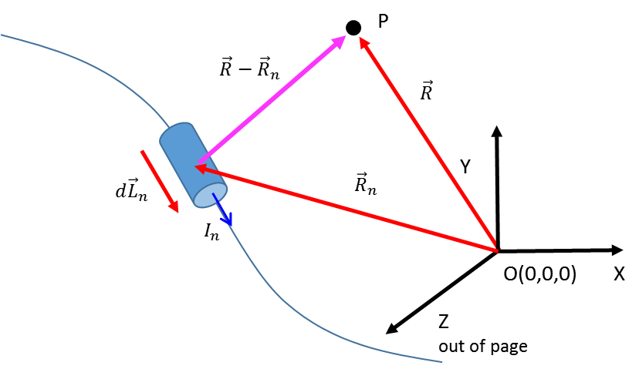

Fig. 1. Biot-Savart Law parameters.

We can calculate the magnetic field  for a current carrying conductor of finite length by integrating equation 1 over whatever length and shape of conductor we are interested in.

The magnetic field is also related to the current by the **Ampere-Maxwell Law**.

The integral form of the Ampere-Maxwell Law for static fields is

(2) 

The left side of equation 2 is called the circulation of the magnetic field around a closed path C. The right side is the source of the magnetic field - the conduction current passing through any surface bounded by the closed loop C.

Another source for magnetic fields is a changing electric field. The more general form of equation 2 is

(3) 

The term  is the electric flux. So, a changing electric flux through the surface bound by the loop C produces a circulating magnetic field around the path bounding that surface.

The differential form of the Ampere-Maxwell Law is

(4) 

 is the curl of the magnetic field – the tendency of the field lines to circulate around a point and the vector  is the current density and is the time rate of change of the electric field at that point.

A circulating magnetic field is produced by an electric current and by an electric field that changes with time.

All magnetic field lines form continuous loops such that there exists at least one location about which the path integral of the field is nonzero or the curl is nonzero. These locations are at points at which there is a current and/or a changing electric field.

A common misconception is that the curl of a vector field is nonzero whenever the field appears to curve. Consider the example of the magnetic field around an infinite straight conductor. The magnetic field lines circulate around the conductor, the direction of the magnetic field is in the  direction and decreases as 

(5) 

Taking the curl of  gives a zero result . The magnetic field curves but its curl is zero. What the Ampere-Maxwell Law tells us is that the curl of is nonzero exactly at the location of the current or where the electric field is changing with time. In the case of current carrying wire, the reduction in amplitude of the magnetic field away from the wire, exactly compensates for the curvature of the magnetic field lines, hence, the curl of is zero everywhere except at the wire itself.

The integral form of **Gauss’s Law for magnetism** can be expressed as

(6)  integral form for Gauss’s Law for magnetism

The left side of equation 6 is the magnetic flux through the closed surface A (number of magnetic field lines passing through the closed surface *A)*. The right hand side is identically equal to zero.

The total magnetic flux passing through any closed surface is zero.

Gauss’s Law for magnetic fields arises directly from the fact that in nature there are no isolated magnetic monopoles – every magnetic north pole is accompanied by a magnetic south pole.

The differential form of Gauss’s Law for magnetism is very simple because of the continuous nature of the magnetic field lines

(7)  differential form for Gauss’s Law for magnetism

The divergence of the magnetic field at any point is zero.

Since it is not possible to isolate magnetic poles, you can’t have a north pole without a south pole, hence, the “magnetic charge density” must be zero everywhere. This means that the divergence of the magnetic field must also be zero. Vector fields with zero divergence are called solenoidal fields and thus, all magnetic fields are solenoidal.

The number of calculation performed in the mscript **cemB03.m** is mainly determined by the *N* x *N* [2D] grid and the number of partitions *Nz* of the wire in the Z direction. If these values are too small, then the results are not accurate. However, increasing them too much will cause the calculation time to be too long. The default values are *N* = 4101 and *Nz* = 401 which gives an execution time ~ 30 seconds.

The mscript **cemB03.m** can be used to find the magnetic field in the XY plane (*z =* 0) at the centre of a set of 1 to 4 conductors that are aligned in the Z direction. When the distance between a measurement point P and the wire approaches zero, the magnetic field strength approaches infinity. This can cause problems in using numerical methods in calculating the magnetic field and spatial derivatives of the magnetic field.

The parameters used in the modelling are entered in the INPUT section of the code:

* XY coordinates and currents for the 4 wires.
* The [2D] grid dimensions.
* The path for the calculation of the line integral and for the calculation the magnetic flux.
* XY coordinates for the calculation of the divergence and curl at the nearest grid point.

% ======================================================================

% INPUTS

% ======================================================================

% Wires: current I / xy (x,y) coordinates / Z length / Z partitions

Nwire = 1;

I = [10,0,0,0];

xW = [0.00, 0.005, -0.005, 0.002];

yW = [0, -0.0050, 0.005, 0.008];

minZ = -5; maxZ = 5;

nZ = 4101;

radiusW = 0.001;

% Grid dimensions: Grid points / X range / y range

N = 401;

L = 0.005*2;

minX = -L; maxX = L;

minY = -L; maxY = L;

minR = 1e-3;

% Calculation of line integral and magentic flux L < maxX or maxY

L = 3e-3;

minLx = -L; maxLx = L;

minLy = -L; maxLy = L;

% Calculation of the divergence and curl at the point a grid closest

to the values xD, yD

xD = 0.05e-3;

yD = 0.05e-3;

A [2D] grid is setup using the meshgrid function to calculate the distances from each grid point from the origin. The XY positions of each wire are adjusted so that the minimum *x* or *y* distance between a grid point and the location of a wire is not less than *dx*/2 *o*r *dy*/2 where *dx* and *dy* are the grid spacings.

% constants permeability of free space

mu0 = 4*pi*1e-7;

K = I .* (mu0/(4*pi));

%Bsat = mu0 * max(I) / minR;

Bsat = 2e-3;

zW = linspace(minZ, maxZ, nZ);

dLz = zW(2)-zW(1);

dLx = 0; dLy = 0;

dL = [dLx dLy dLz];

% [2D] region

x = linspace(minX,maxX,N);

y = linspace(minY, maxY,N);

dx = x(2)-x(1); dy = y(2)-y(1);

% Grid positions

[xG, yG] = meshgrid(x,y);

dx = x(2)-x(1); dy = y(2)-y(1);

RG = sqrt(xG.^2 + yG.^2);

for n1 = 1 : Nwire

for n2 = 1 : N

if abs(x(n2) - xW(n1)) < dx/2 ; xW(n1) = x(n2) + dx/2; end

if abs(y(n2) - yW(n1)) < dy/2 ; yW(n1) = y(n2) + dy/2; end

end

end

The magnetic field components  are calculated at each grid point using the Biot-Savart Law . If the magnitude of the magnetic field is greater than a saturation value, then the magnetic field is assigned the saturation value at that grid point.

Bx = zeros(N,N); By = zeros(N,N); Bz = zeros(N,N);

for n = 1 : Nwire

for m = 1 : nZ

Rx = xG - xW(n);

Ry = yG - yW(n);

Rz = 0 - zW(m);

% Rx(Rx<minR) = minR;

% Ry(Ry<minR) = minR;

R = sqrt(Rx.^2 + Ry.^2 + Rz.^2);

% R(R<minR) = minR;

R3 = R.^3;

Bx = Bx + K(n) .* (dLy .* Rz - dLz .* Ry) ./ R3;

By = By + K(n) .* (dLz .* Rx - dLx .* Rz) ./ R3;

Bz = Bz + K(n) .* (dLx .* Ry - dLy .* Rx) ./ R3;

end

end

B = sqrt(Bx.^2 + By.^2 + Bz.^2);

The magnetic field is only calculated in a region close to and at the center of a finite wire. This gives a good approximation to a wire of infinite extent and gives the result as expected and near the centre of the wire *Bx* and *By* are independent of the Z value.

The XY circulation path is defined from the input parameters which corresponds to a rectangle so that the line integral of equation 2 is evaluated only in the X or Y directions. The numerical calculation of the circulation gives an estimate of the current enclosed by the rectangular path



and this value can be compared with the current in the wires.

% Line integral B.dL ----------------------------------------------------

% fn must have an odd number of elements

X1 = find(x>minLx,1);X2 = find(x>maxLx,1);

Y1 = find(y>minLy,1);Y2 = find(y>maxLy,1);

if mod(X2-X1,2) ~= 0; X2 = X2+1; end;

if mod(Y2-Y1,2) ~= 0; Y2 = Y2+1; end;

a = x(X1); b = x(X2); fn = Bx(Y1,X1:X2);

BdL(1) = simpson1d(fn,a,b);

a = y(Y1); b = y(Y2); fn = By(Y1:Y2,X2)';

BdL(2) = simpson1d(fn,a,b);

a = x(X1); b = x(X2); fn = -Bx(Y2,X1:X2);

BdL(3) = simpson1d(fn,a,b);

a = y(Y1); b = y(Y2); fn = By(Y1:Y2,X1)';

BdL(4) = -simpson1d(fn,a,b);

Ienclosed = sum(BdL)/mu0;

The integral is computed using the function **simpson1d.m**. In using this function, the function must have an odd number of elements.

The circulation path is used to give a closed surface of unit height in the Z direction. The total magnetic flux is calculated through this closed surface as shown in figure 2

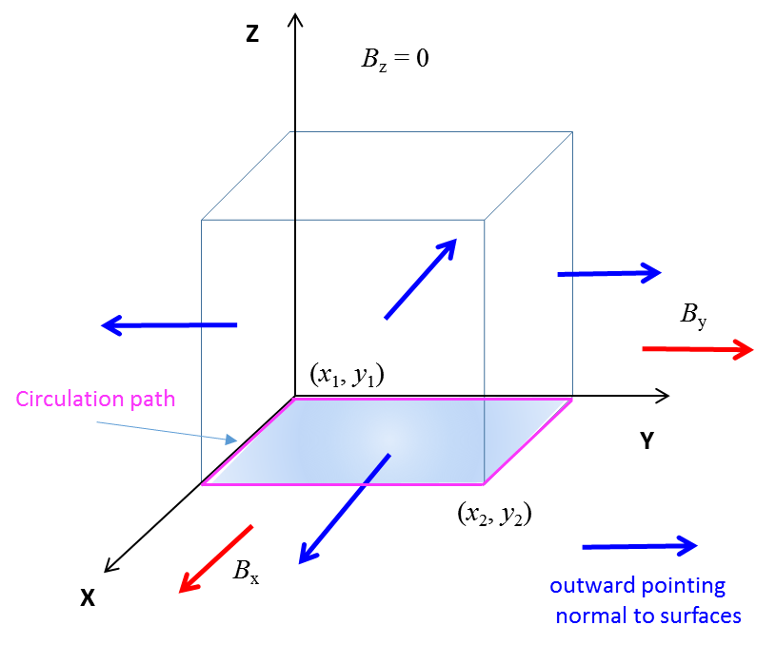

Fig.2. Closed surface for calculating the magnetic flux.

% Gauss's Law for Magentisim: Magnetic flux through a closed surface

a = y(Y1); b = y(Y2); fn = Bx(Y1:Y2,X2)';

phi(1) = simpson1d(fn,a,b);

a = y(Y1); b = y(Y2); fn = -Bx(Y1:Y2,X1)';

phi(2) = simpson1d(fn,a,b);

a = x(X1); b = x(X2); fn = By(Y2,X1:X2);

phi(3) = simpson1d(fn,a,b);

a = x(X1); b = x(X2); fn = -Bx(Y1,X1:X2);

phi(4) = simpson1d(fn,a,b);

phi_total = sum(phi);

The divergence and the curl of the magnetic field are calculated at a grid point nearest to the point specified in the input section of the code. The calculations may not be accurate for points close to the wires.

% Divergence divB and Curl curlB -------------------------------------

Nx = find(x > xD,1);

Ny = find(y > yD,1);

divB = divergence(xG,yG,Bx,By);

min_divB = min(min(divB));

max_divB = max(max(divB));

curlB = curl(xG,yG,Bx,By);

min_curlB = min(min(curlB));

max_curlB = max(max(curlB));

dBdx = (Bx(Ny,Nx+1) - Bx(Ny,Nx-1))/(x(Nx+1)-x(Nx-1));

dBdy = (By(Ny+1,Nx) - By(Ny-1,Nx))/(y(Ny+1)-y(Ny-1));

divBp = dBdx+dBdy;

% curl of B at the position of wire 1

curlB_1 = mu0*I(1)/(dx/2)^2;

**Example 1: Single wire located near the origin**

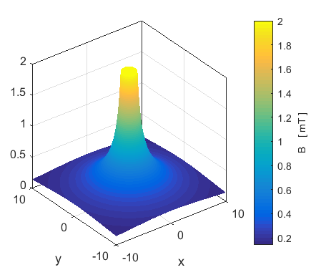

Fig. 3. Surf plot of the magnetic field .

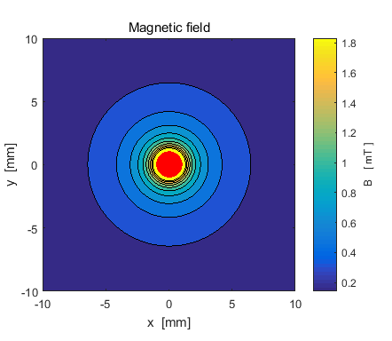

Fig. 4. Contourf plot of the magnetic field.

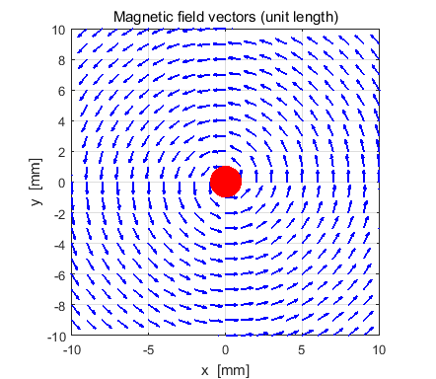

Fig. 5. Magnetic field vectors of unit length showing the direction of the magnetic field. The red dot represents the wire with a current in the + Z direction. The magnetic field lines form circular loops around the wire in a direction as given by the right hand screw rule.

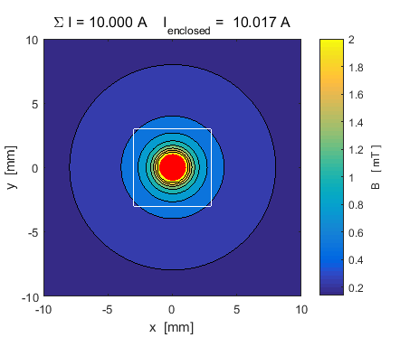

Fig. 6. Magnetic field and the path for the calculation of the circulation. The numerical results agree with the predictions of the Ampere-Maxwell Law



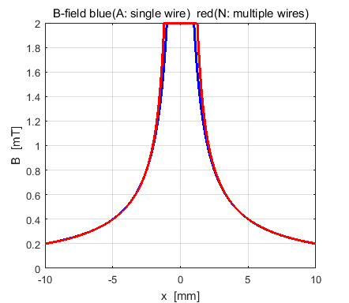

Fig. 7. Comparison of the magnetic field along the X axis (*y* = 0) through the wire. The blue curve is the magnetic field calculated from equation 5 and the red curve is from the results of the computation using the Biot-Savart Law (equation 1). Close to the wire there is some difference in the two values of the magnetic field.

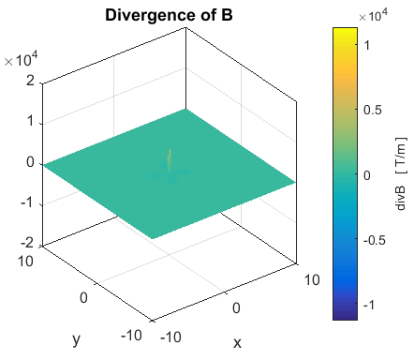

Fig. 8. The divergence of *B* in the XY plane. Everywhere the divergence is zero, . A spike at the centre is due to numerical computational difficulties near the location of the wire.

The numerical values of the divergence are displayed in the Command Window. The divergence is calculated using the Matlab function divergence and by evaluating the partial derivatives  and *.* The numerical results for the divergence at different grid point gives a zero answer.

The magnetic flux through the closed surface with one face bounded by the path of the circulation calculation is

Gauss Law for magnetism: total flux through the closed surface

phi_B = -3.147e-06 a.u.

Hence we can conclude that 

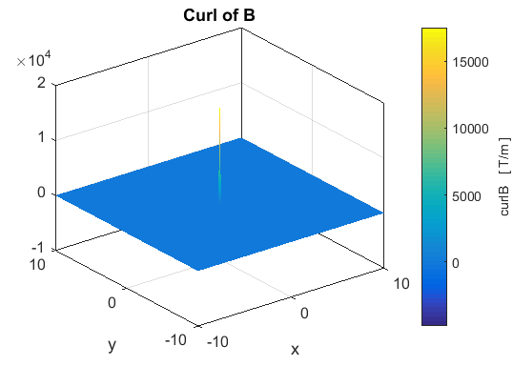

Fig. 10. The curl of the magnetic field is zero at all points except at the location of the wire. The spike at the centre of the wire representing the value of may not be accurate since the calculations are done near the location of the wire.

The curl  is zero everywhere except at the location of the wire even though the magnetic field lines form closed loops.

We can get an approximate estimate the value of the term  by assuming that  and use it to compare the left and right sides of the Ampere-Maxwell Law for static magnetic fields  . The values are displayed in the Command Window

Curl of B at (xG,yG) - an element of the array curlB

curl B = 1.75e+04 T/m

Ampere-Maxwell Law: curlB at location of wire 1

Wire 1: curlB = 2.01e+04 T/m

The agreement is not too bad since it is difficult to get accurate answers near the wire and we have to approximate the area *A* through which the current *I* passes to give the current density .

Command Window display

Number of wires = 1

x location of wires [mm]

0.02

y location of wires [mm]

0.02

Wire currents [A]

10.000

I_total = 10.000 A

Circulation path and closed surface: line integral & flux

I_enclosed = 10.02 A

Gauss Law for magnetism: total flux through the closed surface

phi_B = -3.147e-06 a.u.

Divergence and curl of B at the grid point (xG,yG)

xG = 0.050 mm

yG = 0.050 mm

Divergence of B at (xG,yG) - an element of the array divB

div B = 0.00e+00 T/m

Divergence of B at (xG,yG) - calculated from definition of divergence

div B = 0.00e+00 T/m

Curl of B at (xG,yG) - an element of the array curlB

curl B = 1.75e+04 T/m

Ampere-Maxwell Law: curlB at location of wire 1

Wire 1: curlB = 2.01e+04 T/m

To display in the Command Window the elements of the matrices

for the divergence or curl of the magnetic field B type

divB or curlB

**Example 2: Two parallel wires with currents in +Z direction**

Location in millimetres of wires carrying currents of +10 A: (-5, 0) and (+5,0).

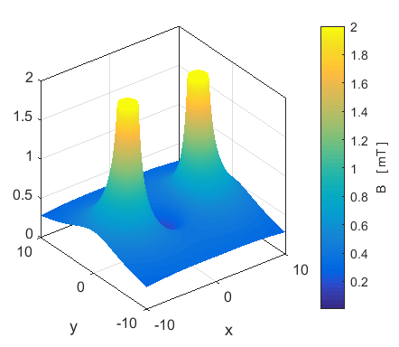

Fig. 11. Surf plot of magnetic field.

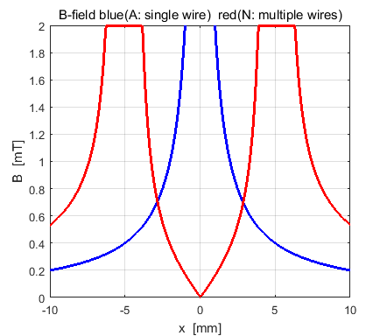

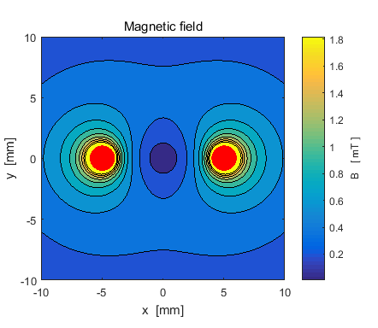

Fig. 12. Contourf plot and variation of the of the magnetic field along the X axis (red curve).

The magnetic field is dramatically reduced in the region between the wires. The force between current carrying wires is proportional to the magnitude of the magnetic field. The magnetic field is weaker in the region between the wires, hence the wires will be **attracted** to each other.

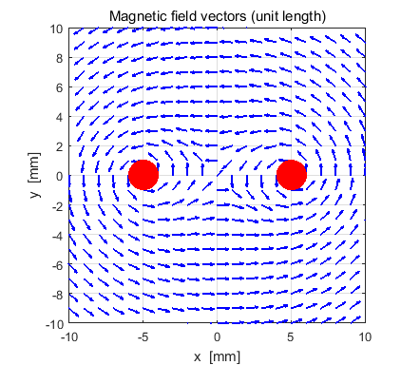

Fig.13. Unit vectors for the direction of the magnetic field.

Number of wires = 2

x location of wires [mm]

5.02 -4.98

y location of wires [mm]

0.02 0.02

Wire currents [A]

10.000

10.000

I_total = 20.000 A

Circulation path and closed surface: line integral & flux

I_enclosed = -0.12 A

Gauss Law for magnetism: total flux through the closed surface

phi_B = -2.497e-06 a.u.

Divergence and curl of B at the grid point (xG,yG)

xG = 0.050 mm

yG = 0.050 mm

Divergence of B at (xG,yG) - an element of the array divB

div B = -1.61e-08 T/m

Divergence of B at (xG,yG) - calculated from definition of divergence

div B = -1.61e-08 T/m

Curl of B at (xG,yG) - an element of the array curlB

curl B = -3.96e-05 T/m

Ampere-Maxwell Law: curlB at location of wire 1

Wire 1: curlB = 2.01e+04 T/m

**Example 3: Two parallel wires with currents in +Z and –Z direction**

Location in millimetres of wires carrying currents of +10 A: (-5, 0) and -10 A (+5,0).

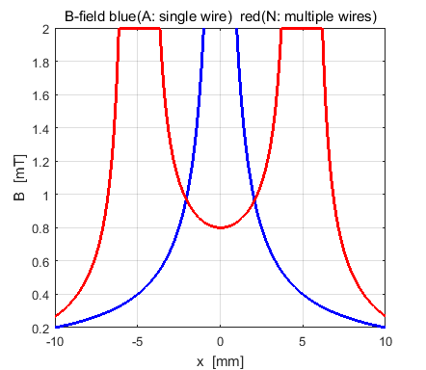

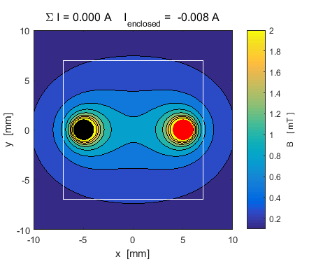

Fig. 14. Contourf plot showing the circulation path and variation of the magnetic field along the X axis (red curve).

The circulation path enclosed both wires. The total current enclosed by the path is zero. The magnetic field is increased in the region between the wires. The force between current carrying wires is proportional to the magnitude of the magnetic field. The magnetic field is stronger in the region between the wires, hence the wires will be **repel** to each other.

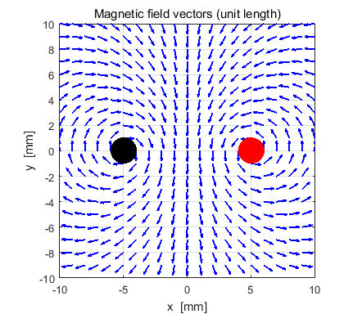

Fig.15. Unit vectors for the direction of the magnetic field.

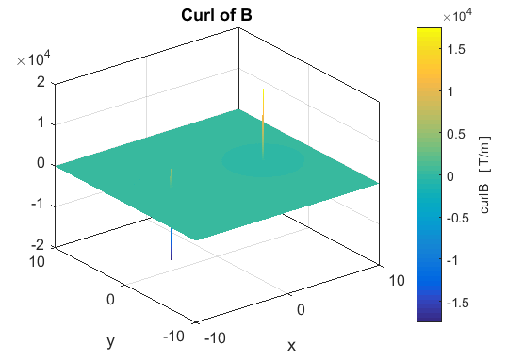

Fig. 16. The curl of the magnetic field  is zero everywhere except at the location of the wires.

Number of wires = 2

x location of wires [mm]

5.02 -4.98

y location of wires [mm]

0.02 0.02

Wire currents [A]

10.000

-10.000

I_total = 0.000 A

Circulation path and closed surface: line integral & flux

I_enclosed = -0.01 A

Gauss Law for magnetism: total flux through the closed surface

phi_B = -2.604e-06 a.u.

Divergence and curl of B at the grid point (xG,yG)

xG = 0.050 mm

yG = 0.050 mm

Divergence of B at (xG,yG) - an element of the array divB

div B = -6.41e-07 T/m

Divergence of B at (xG,yG) - calculated from definition of divergence

div B = -6.41e-07 T/m

Curl of B at (xG,yG) - an element of the array curlB

curl B = -1.89e-06 T/m

Ampere-Maxwell Law: curlB at location of wire 1

Wire 1: curlB = 2.01e+04 T/m

**Example 4: Four parallel wires**

Number of wires = 4

x location of wires [mm]

5.02 -4.98 -4.98 5.02

y location of wires [mm]

5.02 -4.98 5.02 -4.98

Wire currents [A]

10.000

-10.000

10.000

10.000

I_total = 20.000 A

Circulation path and closed surface: line integral & flux

I_enclosed = 20.22 A

Gauss Law for magnetism: total flux through the closed surface

phi_B = -9.688e-06 a.u.

Divergence and curl of B at the grid point (xG,yG)

xG = 0.050 mm

yG = 0.050 mm

Divergence of B at (xG,yG) - an element of the array divB

div B = 1.62e-15 T/m

Divergence of B at (xG,yG) - calculated from definition of divergence

div B = 1.62e-15 T/m

Curl of B at (xG,yG) - an element of the array curlB

curl B = 3.90e-06 T/m

Ampere-Maxwell Law: curlB at location of wire 1

Wire 1: curlB = 2.01e+04 T/m

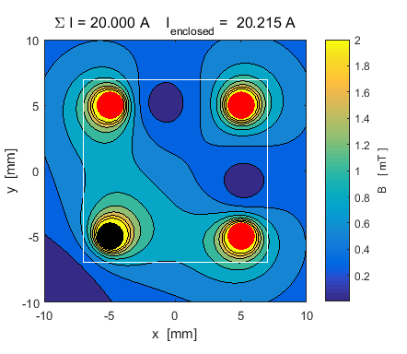

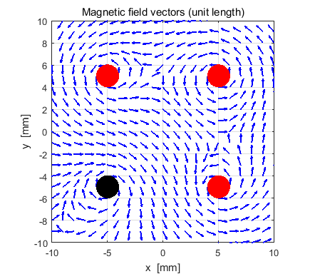

Fig.17. Magnetic field in the region of 4 parallel current carrying conductors. (Red dots: current in +Z direction, out of page and Black dots: currents in –Z direction: into page). From the contour plot it is easy to see which conductors repel or attract.