[**DOING PHYSICS WITH MATLAB**](https://d-arora.github.io/Doing-Physics-With-Matlab/)

**Ian Cooper**

**matlabvisualphysics@gmail.com**

**A COMPUTATIONAL APPROACH TO**

**ELECTROMAGNETIC THEORY**

**CHAPTER 4**

**VECTOR ANALYSIS**

**PROBLEMS AND SOLUTION USING MATLAB**

**DOWNLOAD DIRECTORIES FOR MATLAB SCRIPTS**

[**Google drive**](https://drive.google.com/drive/u/3/folders/1j09aAhfrVYpiMavajrgSvUMc89ksF9Jb)

[**GitHub**](https://github.com/D-Arora/Doing-Physics-With-Matlab/tree/master/mpScripts)

**Script**

**cemCh4Problems.m**

We no longer use slides rule or log tables. With computer and software access available to everyone, we should be approaching the solving of traditional physics problems in an “up-to-date” fashion.

|  |  |
| --- | --- |
| The Slide Rule— Extraordinary Ordinary Things • BLOG@UBIQUITY | calculations - Support for "tables of functions" - TeX - LaTeX Stack  Exchange |

More realistic and more challenging problems should be encountered. Matlab is the “perfect” tool to solve many problems in electromagnetism. This Chapter will show how many traditional problems can be solved using Matlab. Many of the problems are taken from the excellent texts

Robert H. Good *Classical Electromagnetism*

David J. Griffiths *Introduction to Electrodynamics* (3rd Edition)

**PROBLEM 1**

Given the two vectors  and 

1.1 Find the vector 

1.2 Find the dot product 

1.3 Find the angle  between the vectors  and 

1.4 Verify the law of cosines 

**SOLUTION 1**

%% PROBLEM 1

close all; clear all; clc

A = [1 1]

B = [-1 1]

Amag = norm(A) 🡪 1.4142

Bmag = norm(B) 🡪 1.4142

AdotB = dot(A,B) 🡪 0o

theta = acosd(AdotB/(Amag*Bmag)) 🡪 90o

C = A-B 🡪 [2 0)

Cmag = norm(C) 🡪 2

CdotC = dot(C,C) 🡪 4

LHS = Cmag^2 🡪 4

RHS = Amag^2 + Bmag^2 - 2*Amag*Bmag*cosd(theta) 🡪4

**PROBLEM 2**

Given the four vectors 

Is the cross product associative?



**SOLUTION 2**

A = [1 1 1]

B = [2 -1 1]

C = [-2 1 1]

D = [2 2 0]

AB_C = cross(cross(A,B),C) 🡪 [4 4 4]

A_BC = cross(A,cross(B,C)) 🡪 [4 -2 -2]

AB_D = cross(cross(A,B),D) 🡪 [6 -6 2]

A_BD = cross(A,cross(B,D)) 🡪 [4 -8 4]

The cross product is **not** associative

**PROBLEM 3**

A box has base of 4x3 and sides 3x1 and 4x1. Calculate the angle of base diagonal with the diagonals of the two side faces.

**SOLUTION 3**

A = [4 3 0] % base diagonal

B = [0 4 1] % side 1 diagonal

C = [3 0 1] % side 2 diagonal

Amag = norm(A) 🡪 5

Bmag = norm(B) 🡪 4.1231

Cmag = norm(C) 🡪 3.163

AdotB = dot(A,B) 🡪 12

AdotC = dot(A,C) 🡪 12

theta1 = acosd( AdotB/(Amag*Bmag) ) 🡪 54.4o

theta2 = acosd( AdotC/(Amag*Cmag) ) 🡪 40.6o

**PROBLEM 4**

Find the displacement vector from a source point (3,9,8) to a field point (5,7,9). What is the unit vector in the direction of the displacement vector?

**SOLUTION 4**

S = [3 9 8] F = [5 7 9]

R = F – S 🡪 [2 -2 1]

Rmag = norm(R) 🡪 3

Rhat = R./Rmag 🡪 [0.6667 -0.6667 0.3333]

**PROBLEM 5**

Find the gradient of the scalar displacement function



**SOLUTION 5**

syms r x y z drdx

r = sqrt(x^2 + y^2 + z^2) 🡪 (x^2 + y^2 + z^2)^(1/2)

drdx = diff(r,x) 🡪 x/(x^2 + y^2 + z^2)^(1/2)

drdy = diff(r,y) 🡪 y/(x^2 + y^2 + z^2)^(1/2)

drdz = diff(r,z) 🡪 z/(x^2 + y^2 + z^2)^(1/2)



This makes sense as the distance from the Origin increases rapidly in the radial direction and the maximum rate of increase is in that direction,

**PROBLEM 6**

Find the gradients of the functions 



**SOLUTION 6**

% comment the functions that are not used

syms f x y z drdx e

f = x^3 + y^4 + z^5 🡪 x^3 + y^4 + z^5

%f = x*y^2*z^3

%f = e^x*sin(y)*log(z)

drdx = diff(f,x)

drdy = diff(f,y)

drdz = diff(f,z)







**PROBLEM 7**

Consider the displacement vector 

Find  and 

**SOLUTION 7**

syms r1 r2 x y z

r2 = x^2 + y^2 + z^2 grad2_x = diff(r2,x) grad2_y = diff(r2,y)

grad2_z = diff(r2,z)

r2 = x^2 + y^2 + z^2 🡪 

grad2_x = 2*x grad2_y = 2*y grad2_z = 2*z 

r1 = 1/sqrt(r2)

grad1_x = diff(r1,x) grad1_y = diff(r1,y) grad1_z = diff(r1,z)

r1 = 1/(x^2 + y^2 + z^2)^(1/2) 🡪 

grad1_x = -x/(x^2 + y^2 + z^2)^(3/2) 🡪 

grad1_y = -y/(x^2 + y^2 + z^2)^(3/2) 🡪 

grad1_z = -z/(x^2 + y^2 + z^2)^(3/2) 🡪 



Hence, we can conclude



**PROBLEM 8**

A vector is given by



Calculate its divergence, curl and Laplacian.

Calculate the Laplacian of the scalar function



**SOLUTION 8**

syms x y z

R = [x^2*y*z^5 3*x*y^4*z^2 -2*x*z]

🡪 [x^2*y*z^5, 3*x*y^4*z^2, -2*x*z]

vars = [x y z];

divR = divergence(R,vars) 🡪 12*x*y^3*z^2 + 2*x*y*z^5 - 2*x

crossR = cross(R,vars)

🡪 [3*x*y^4*z^3 + 2*x*y*z, - y*x^2*z^6 - 2*x^2*z,

x^2*y^2*z^5 - 3*x^2*y^4*z^2]

grad2_x = diff(R(1),x,2) 🡪 2*y*z^5

grad2_y = diff(R(2),y,2) 🡪 36*x*y^2*z^2

grad2_z = diff(R(3),z,2) 🡪 0



A = -2*sin(x^2)*sin(4*y)*sin(3*z^3)

lapA = laplacian(A) 🡪

32*sin(x^2)*sin(4*y)*sin(3*z^3) - 4*cos(x^2)*sin(4*y)*sin(3*z^3) - 36*z*sin(x^2)*sin(4*y)*cos(3*z^3) + 8*x^2*sin(x^2)*sin(4*y)*sin(3*z^3) + 162*z^4*sin(x^2)*sin(4*y)*sin(3*z^3)

**PROBLEM 9**

Graph the curl of the vector 

Also calculate its divergence and curl.

**SOLUTION 9**

syms x y z

V = [-y x z]

vars = [x y z];

divV = divergence(V,vars)

crossV = cross(V,vars)

N = 201;

X = linspace(-10,10, N); Y = X; Z = X;

[xx, yy, zz] = meshgrid(X,Y,Z);

Vxx = -yy; Vyy = xx; Vzz = zz;

divV = divergence(xx, yy, zz, Vxx, Vyy, Vzz);

[curlVxx, curlVyy, curlVzz] = curl(xx, yy, zz, Vxx, Vyy, Vzz);

% GRAPHICS =============================================================

minX = -10; minY = -10; maxX = 10; maxY = 10;

dx = 1:20:N; dy = dx; dz = 1;

figure(1)

set(gcf,'units','normalized','position',[0.05 0.2 0.3 0.4]);

p1 = xx(dx,dy,dz); p2 = yy(dx,dy,dz); p3 = zz(dx,dy,dz);

p4 = Vxx(dx,dy,dz); p5 = Vyy(dx,dy,dz); p6 = Vzz(dx,dy,dz);

h = quiver3(p1, p2, p3, p4, p5, p6);

set(h,'color',[0 0 1],'linewidth', 2);

axis tight

set(gca,'xLim',[minX, maxX]);

set(gca,'yLim',[minY, maxY]);

% set(gca,'zLim',[minZ, maxZ]);

title('Vector Field V');

xlabel('x'); ylabel('y'); zlabel('z');

set(gca,'fontsize',14)

view(-40,90)

box on

axis tight

V = [-y, x, z]

divV = 1

crossV = [x*z - y*z, x*z + y*z, - x^2 - y^2]

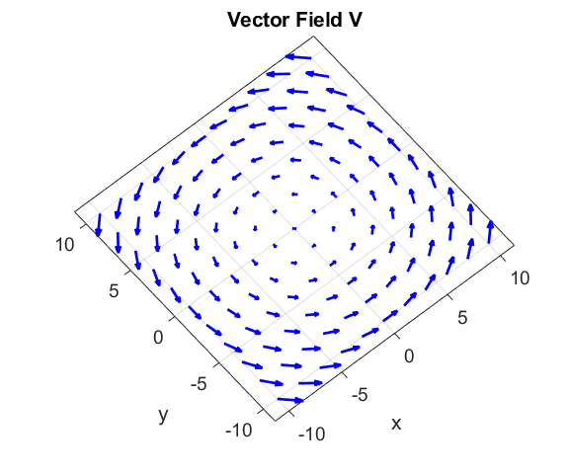

**PROBLEM 10**

Calculate the divergence of the vector function



**SOLUTION 10**

syms x y z

V = [-x*y*z (x+y)*z x^3*y^5*z^6]

vars = [x y z];

divV = divergence(V,vars)

V = [-x*y*z, z*(x + y), x^3*y^5*z^6]

divV = 6*x^3*y^5*z^5 - y*z + z

**PROBLEM 11**

A vector function is given by



Calculate its divergence and plot the divergence function. Show the vector added to the plot using the quiver function.

**SOLUTION 11**

syms x y z k

V = [cos(k*x)/k (sin(k*y))/k 0]

vars = [x y z];

divV = divergence(V,vars)

lambda = 25;

k = 2*pi/lambda; num = 101;

X = linspace(0,100,num);

Y = X; Z = X;

[xx, yy, zz] = meshgrid(X,Y,Z);

Vxx = cos(k.*xx)/k; Vyy = sin(k.*yy)/k; Vzz = zeros(num,num,num);

divV = divergence(xx, yy, zz, Vxx, Vyy, Vzz);

xP = xx(:,:,1); yP = yy(:,:,1); P = divV(:,:,1);

figure(1)

set(gcf,'units','normalized','position',[0.05 0.2 0.3 0.4]);

pcolor(xP,yP,P)

shading("interp")

colorbar; hold on

xQ = 2:17:100; yQ = 2:21:100;

[xxQ, yyQ] = meshgrid(xQ,yQ);

Vx = cos(k*xxQ)./k; Vy = sin(k*yyQ)./k;

h = quiver(xQ,yQ,Vx,Vy,'r','linewidth',2);

set(h,'AutoScale','on', 'AutoScaleFactor',0.6)

V = [cos(k*x)/k, sin(k*y)/k, 0]

divV = cos(k*y) - sin(k*x)

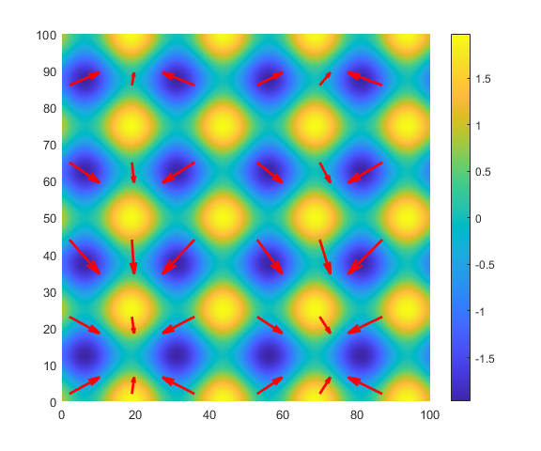

Note: the vector field spreads from areas of positive divergence (source) and is points in towards area of lower divergence values (sink).

**PROBLEM 12**

|  |  |
| --- | --- |
| Compute the line integral of    around the triangular path. |  |

**SOLUTION 12**

Line integral





Path 1 

Path 2 



Path 3 

We can use the Script **simpson1d.m** to evaluate the integral for path 2.

% Limits >>>>>

xMin = 1;

xMax = 0;

% X range

num = 999;

x = linspace(xMin,xMax,num);

% Function >>>>>

F = x.*(-2.*x + 2).^2 -x -4;

% Value of integral

S = simpson1d(F,xMin,xMax);

fprintf('Integral S = %2.4f \n',S)

Integral S = 4.1667

The line integral around the complete path is

