[**DOING PHYSICS WITH MATLAB**](https://d-arora.github.io/Doing-Physics-With-Matlab/)

**Ian Cooper**

**matlabvisualphysics@gmail.com**

**A COMPUTATIONAL APPROACH TO**

**ELECTROMAGNETIC THEORY**

**CHAPTER 5**

**ELECTROMAGNETIC FIELDS**

**THE ELECTRIC FIELD**

**DOWNLOAD DIRECTORIES FOR MATLAB SCRIPTS**

[**Google drive**](https://drive.google.com/drive/u/3/folders/1j09aAhfrVYpiMavajrgSvUMc89ksF9Jb)

[**GitHub**](https://github.com/D-Arora/Doing-Physics-With-Matlab/tree/master/mpScripts)

The following mscripts are used to plot the potential and electric field in a [2D] space for different configurations of charged circular disks. It is difficult to write one mscript to model different charge distributions, therefore, each mscript is used basically for one charge distribution. In the plotting of the electric field lines you always need to check that the number of field lines converging or diverging to a charged object is related to the size of the charge. Where possible, you should always check your code by comparing numerical values calculated from the program with theoretical calculations. Numerical values can be checked in the Command Window and by using the Data Cursor tool in a Figure Window. Download and inspect the mscripts and make sure you can follow the structure of the programs. The charge configuration is specified in the INPUT section of the mscript.

**simpson1d.m**

[1D] computation of an integral using Simpson’s rule. The function to be integrated must have an ODD number of the elements.

**cemVE01.m**

Single charge +Q or –Q at the origin of the [2D] space

Calculation of the potential between two points by the evaluation of the line integral of the electric field



**cemVE02.m** Electric dipole [2D]

**cemVE03.m** Two charges of equal magnitude and same sign

**cemVE04.m** Two charges of unequal magnitude and opposite sign

**cemVE05.m**  Two charges of unequal magnitude and same sign

**cemVE06.m** Three charges at the corners of an equilateral triangle

**cemVE07.m**

[2D] quadrupole – four charges of equal magnitude and alternating sign lying on the corners of a square

**cemVE08.m**

[1D] quadrupole of 3 charges in a straight lines -q +2q -q

**cemVE09.m** 4 equal charges at the corners of a square

**cemVE10.m** Model of a short capacitor

**INTRODUCTION**

**All of electromagnetic is contained in the Maxwell’s equations of the electric and magnetic field**.

Maxwell’s partial differential equations of electrodynamics were formula around 1870. The equations represent a fundamental unification of electric and magnetic fields and predict the existence of electromagnetic waves.

|  |  |
| --- | --- |
| Integral form | Differential form |
|  | Gauss’ Law for electric fields |
|  | Faraday’s Law of Magnetic Induction |
|  |  |
|  | Ampere’s Law plus Maxwell’s displacement current |

The situations that are described by these equations can be very complicated. How to handle them becomes much easier using Matlab as a tool.

Maxwell’s equation shows us how the fields are created:

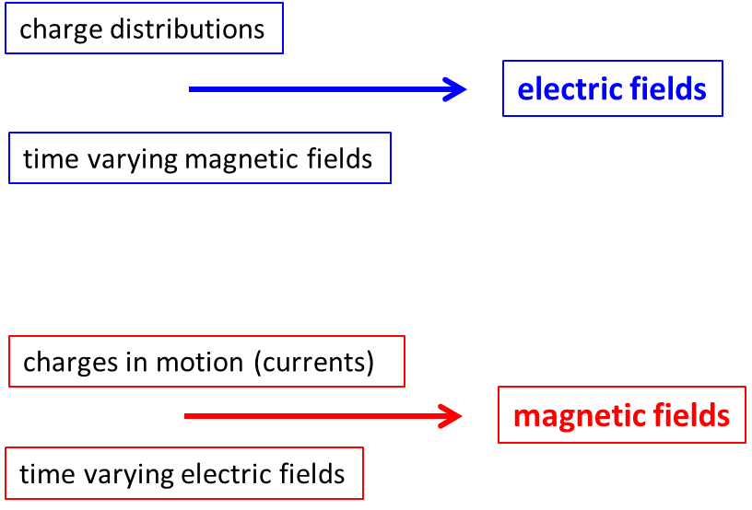

***Interactions between fields produces electromagnetic forces 🡪 “electricity”***

So, we will start with simple situations and progress to more complicated phenomena.

We can solve problems and visualize electric fields and electrical potentials due to various charge distributions very easily using Matlab.

From basic electrostatic theory, the electric field  at position  due to a charge  located at position  is given by Coulomb’s Law

(1) 

When there are many charges, the electric field is given by the vector sum of the electric field due to each individual charge. Therefore, to find the resultant electric field due to *N c*harges, it is best to add the x, y and z components of the electric field due to each charge

(2) 

The electrical potential  at position  due to the *N* charges is

(3) 

Equations 1 to 3 are also valid for spherical charged conductors. In the Matlab mscripts we will consider charges located in a [2D] plane and compute the potential and electric field only in this XY plane. The charged objects correspond to charged circular objects of radius *a*.

By inspecting equation 2 and 3 you see immediately there are problems in graphing the electric field and the potential

* 
*  same for the y and z components
* As the electric field falls rapidly with increasing distance from a charge, it is often difficult to show graphically the vector field.

To overcome the above problems, in the Matlab mscripts, the following are implemented in the code:

* The values for the electric field and potential are assigned to saturation values when  and 
* If the measurement point  is too close a point charge  the separation distance is assigned to a minimum separation distance *minR.*
* If  and  then the separation distances for the components are also set to minimum values  *minRx* and  *minRy.*

We also have another problem that must be addresses and that is in the drawing of the electric field lines. Electrostatic field lines start on a positive charge or at infinity and end on negative charge or at infinity. Plots showing electric field line patterns typically have the properties

1. Tangents to the electrostatic field lines are everywhere parallel to the electric field.
2. The density of the electric field lines is proportional to the strength of the electric field.
3. All points on an equipotential surface (or contour for [2D]) are at the same electrostatic potential.
4. The electrostatic field lines are perpendicular to equipotential surfaces (contours in [2D]) at every point: .
5. A positive test charged placed in the electric field would move along an electric field line in the direction of lower potential.

In the Matlab mscript the **streamline** command is used to draw the electric field lines by specifying the starting point for each streamline (electric field line). The streamlines are drawn from a starting point to other points that are always in the direction of the lowest potential. For example, twice as many lines must start on a +2 charge as on a +1 charge. For a negative charge, then the electric field components are reversed in the **streamline** command.

It would be difficult to write one program for many different charge distributions. So, for each different charge distribution we will use a separate mscript. The mscripts are basically the same but different coding is used for the graphics, especially the plotting of the electric field lines. Shown below are examples of the graphs of the potential and electric fields for a number of charge distributions. It is an easy task for you to create your own mscripts for other charge distributions.

**Example 1 Single charge at the origin cemVE01.m**

|  |  |
| --- | --- |
| *Q*  = 20x10-6 C | *Q*  = - 20x10-6 C |
|  |  |
|  |  |
|  |  |

**Positive charge red dot / Negative charge black dot**

|  |  |
| --- | --- |
| *Q*  = 20x10-6 C | *Q*  = - 20x10-6 C |
|  |  |
|  |  |
|  |  |

|  |  |
| --- | --- |
| *Q*  = 20x10-6 C | *Q*  = - 20x10-6 C |
| **electric field lines (white)** |  |
|  |  |

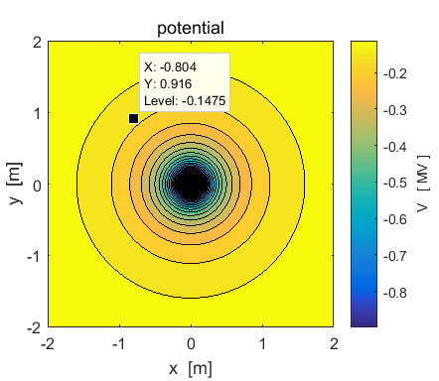

Numerical values can be determined from the Command Window or using the Data cursor in a Figure Window.

Example  m  m

x(300) 🡪 -0.8040 y(730) 🡪 0.9160

xG(730,300) 🡪 -0.8040 yG(730,300) 🡪 0.9160

V(730,300) 🡪 -1.4749x105 V

E(730,300) 🡪 1.2101x105 V.m-1

Ex(730,300) 🡪 7.9825x104 V.m-1

Ey(730,300) 🡪 -9.0945x104 V.m-1

direction E:  -48.7256o

N.B. the order of the indices in the [2D] arrays for x and y.

Calculation of the potential between two points is computed by the evaluation of the line integral of the electric field



In the evaluation of the integral, the integrand must have an **odd** number of elements. The coordinates of the two points at are determined by specifying the indices for the x and y arrays.

The numerical values for the line integral and the potential difference V2-V1 are displayed in the Command Window.

x1 = 0.200 m y1 = -1.760 m

V1 = 1.015e+05 V E1 = 5.729e+04 V/m

x2 = 1.040 m y2 = 1.160 m

V2 = 1.154e+05 V E2 = 7.406e+04 V/m

dV from calculation of potentials

V2 - V1 = 1.390e+04 V

dV from calculation of line integral E.dL

V21 = 1.390e+04 V

Section of the mscript **cemVE01.m**

% Calcuation LINE INTEGRAL Nx1 Nx2 Ny1 Ny2 must all be ODD numbers

Nx1 = 551; Nx2 = Nx1 + 210; % must add an EVEN number

Ny1 = 61; Ny2 = Ny1 + 730; % must add an EVEN number

f = Ex(Ny1,Nx1:Nx2); % f must have an ODD number of elements

sx1 = x(Nx1); sx2 = x(Nx2);

Vx = -simpson1d(f,sx1,sx2);

f = Ey(Ny1:Ny2,Nx2)';

sy1 = y(Ny1); sy2 = y(Ny2);

Vy = -simpson1d(f,sy1,sy2);

V21 = Vx + Vy;

dV = V(Ny2,Nx2) - V(Ny1,Nx1);

disp(' ');

fprintf('x1 = %2.3f m',sx1);

fprintf(' y1 = %2.3f m\n',sy1);

fprintf('V1 = %2.3e V',V(Ny1,Nx1));

fprintf(' E1 = %2.3e V/m\n',E(Ny1,Nx1));

disp(' ')

fprintf('x2 = %2.3f m',sx2);

fprintf(' y2 = %2.3f m\n',sy2);

fprintf('V2 = %2.3e V',V(Ny2,Nx2));

fprintf(' E2 = %2.3e V/m\n',E(Ny2,Nx2));

disp(' ');

disp('dV from calculation of potentials ');

fprintf(' V2 - V1 = %2.3e V\n',dV);

disp('dV from calculation of line integral E.dL ');

fprintf(' V21 = %2.3e V\n',V21);

disp(' ');

disp(' ');

**Example 2: [2D] ELECTRIC DIPOLE cemVE02.m**

An electric dipole consists of two separated charges of equal magnitude but of opposite sign. The traditional analytical approach is to assume that the separation distance of the charges is much smaller than the distance of the detection point from the dipole. In this approximation  and . However, using the superposition principle where the fields are added at the detection point, this approximation does not have to be used, and the variation in the fields with distance from the dipole can be examined from the plots using the Data Cursor or from numerical results displayed in the Command Window.

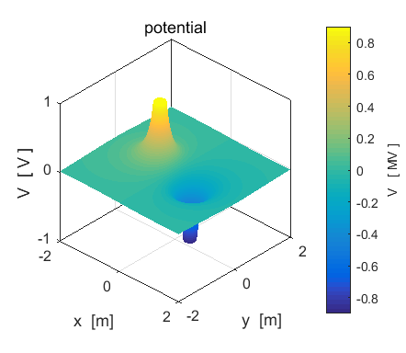

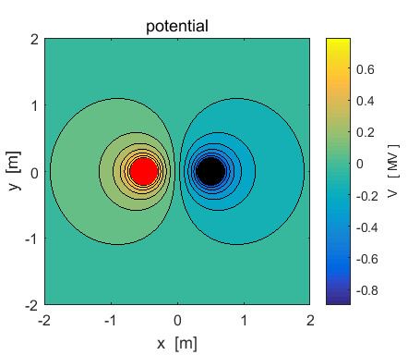

The closer the spacing of the potential contours the greater the electric field strength .

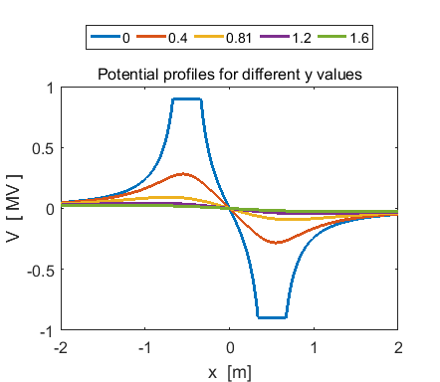

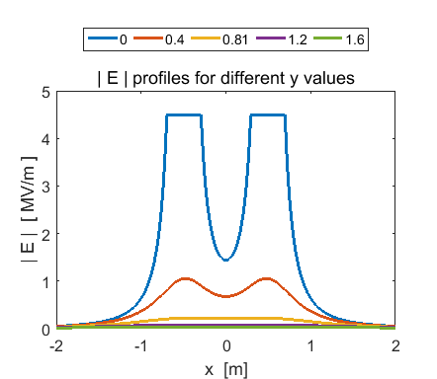

From the Command Window

y(501) 🡪 0 x(686) 🡪 0.7400 x(871) 🡪 1.48 x(871) / x(686) = 2

V(501,686) 🡪 - 6.0401x105 V(501,871) 🡪 - 9.2638x105

V(501,686) / V(501,871) 🡪 6.5

E(501,686) 🡪 3.0038x106 E(501,871) 🡪 1.4132x105

E(501,686) / E(501,871) 🡪 21.3

From the numbers, you can see that in doubling the distance from the centre of the dipole along is axis (y = 0), there is a dramatic decreasing in the potential and electric field. This is because the effects of the positive charge cancel the effects of the negative charge to some extent.

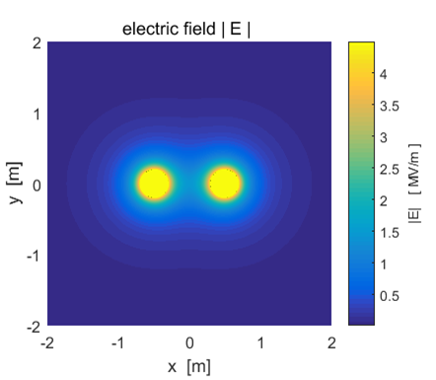

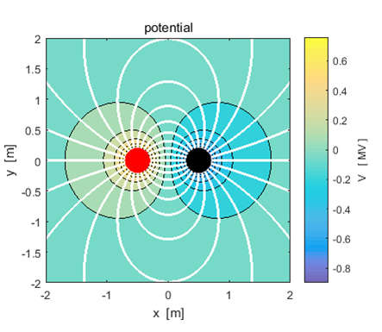

In the lower plot, the electric field lines (in white) are superimposed upon the plot of the potential. The direction of the electric field anywhere on an electric field line is from the region of higher potential to lower. It is not so easy to place an arrow on the electric field lines using the Matlab **streamline** function.

The plots below show **quiver** plots for the electric field. In left plot the arrow length is proportional to the electric field. In the plot on the right, each arrow has a unit length.

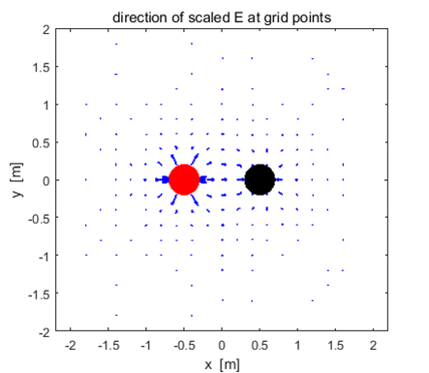

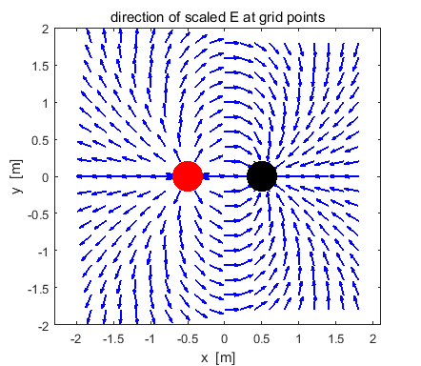

**Example 3: Two charges of equal magnitude and same sign**

**cemVE03.m**

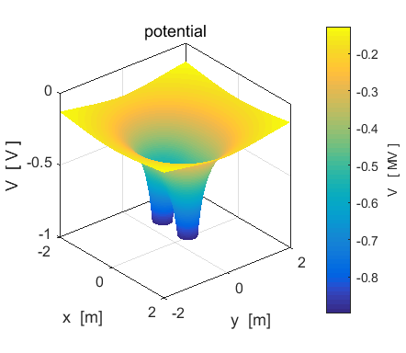

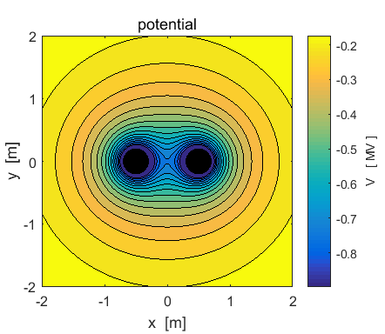

|  |  |
| --- | --- |
|  |  |

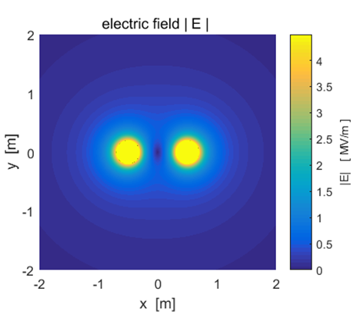

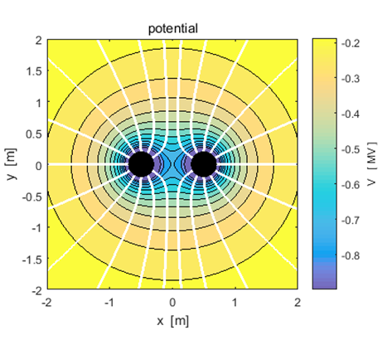

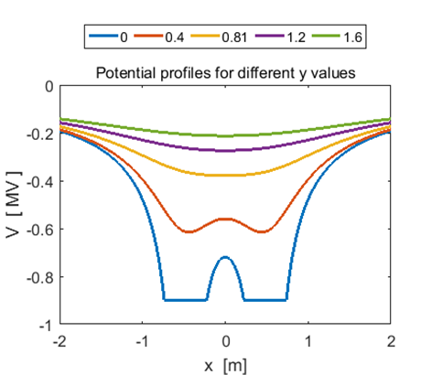

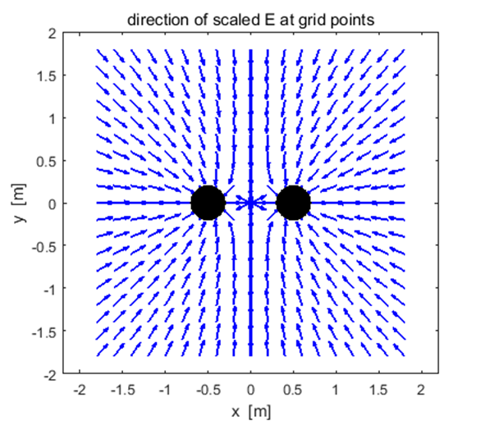

**Example 4: Two charges of unequal magnitude and opposite signs**

**cemVE04.m**

Q(1) = + 20x106  C Q(2) = - 60x106 C

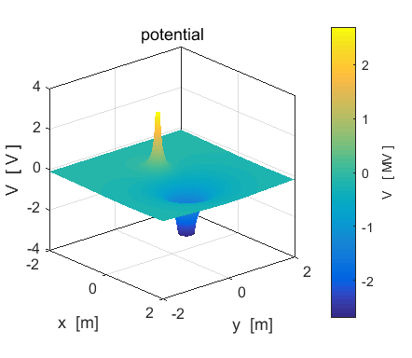

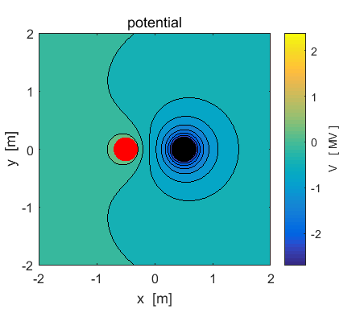

Q(1) = + 20x106  C Q(2) = - 60x106 C

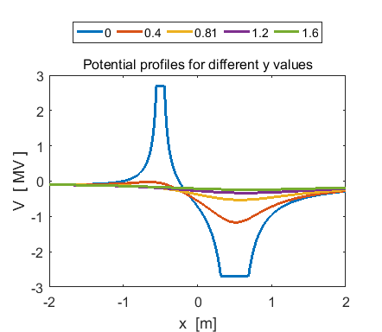

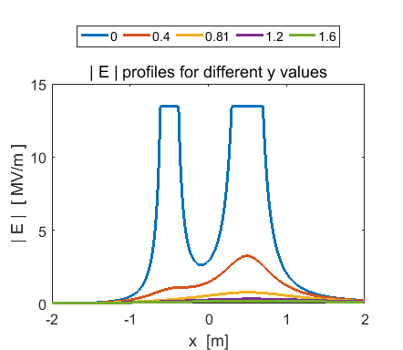

Q(1) = + 20x106  C Q(2) = - 60x106 C

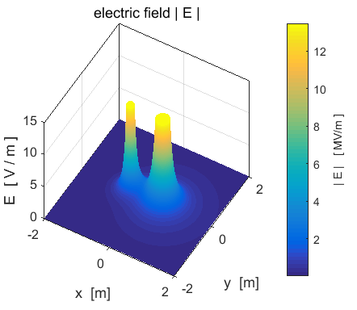

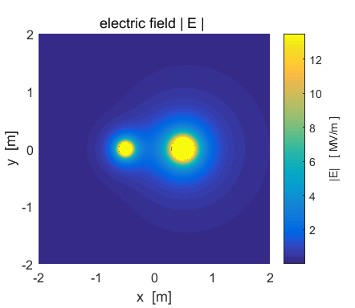

Q(1) = + 20x106  C Q(2) = - 60x106 C

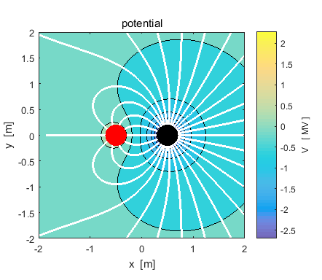

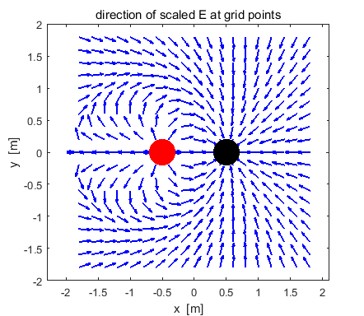

**Example 5: Two charges of unequal magnitude and same sign**

**cemVE05.m**

Q(1) = + 20x106  C Q(2) = + 60x106 C

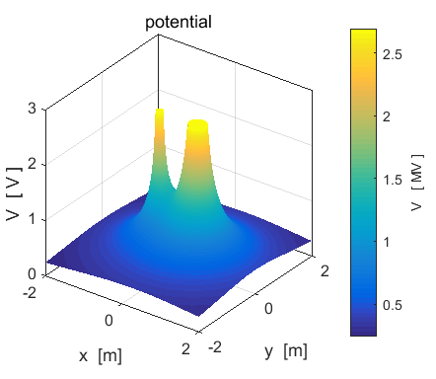

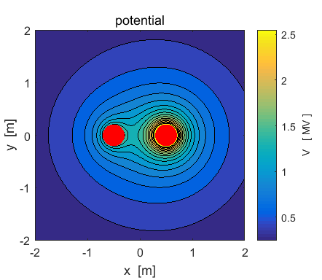

Q(1) = + 20x106  C Q(2) = + 60x106 C

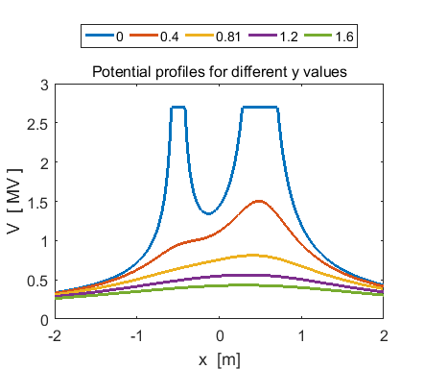

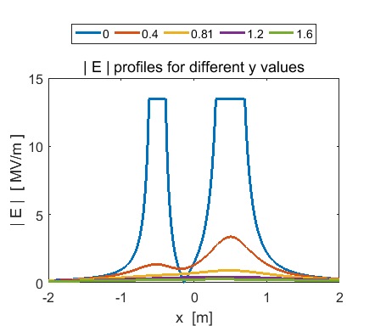

Q(1) = + 20x106  C Q(2) = + 60x106 C

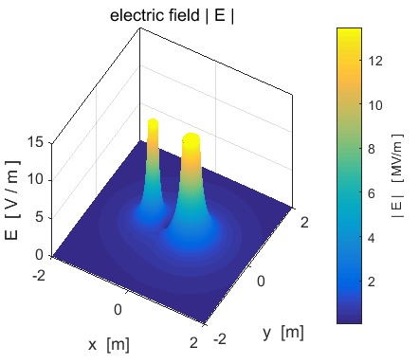

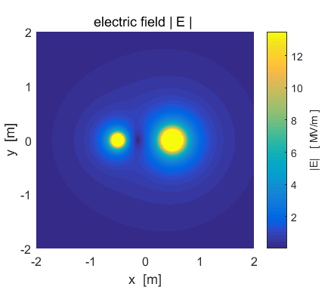

Q(1) = + 20x106  C Q(2) = + 60x106 C

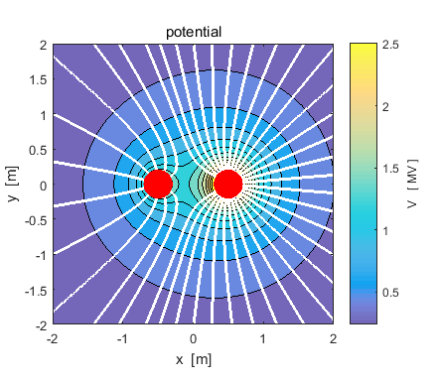

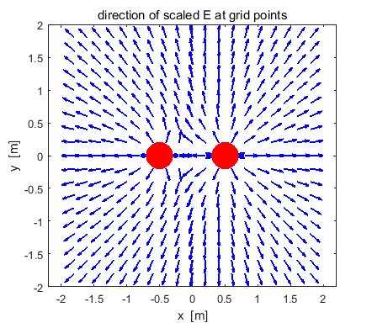

**Example 6: Three equal charges at the corners of an equilateral triangle cemVE06.m**

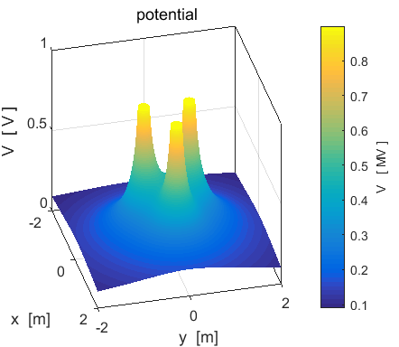

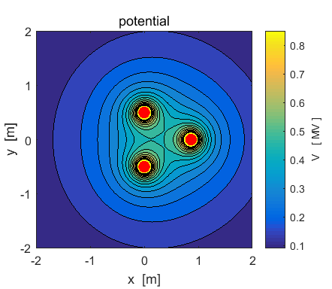

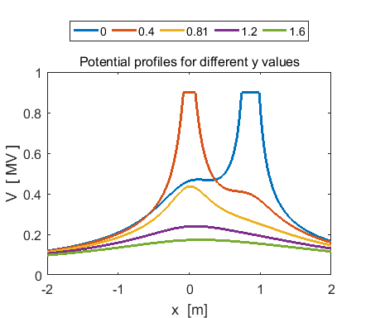

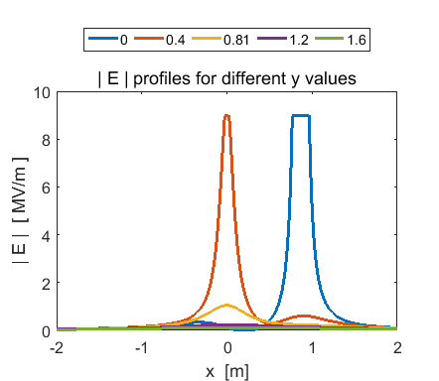

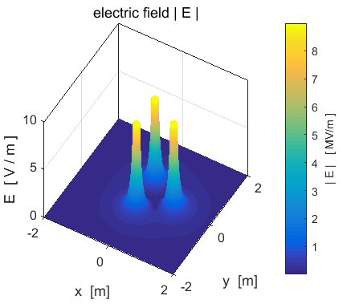

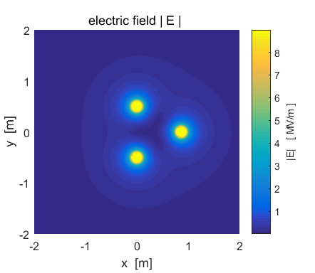

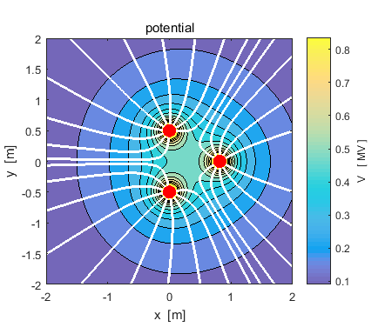

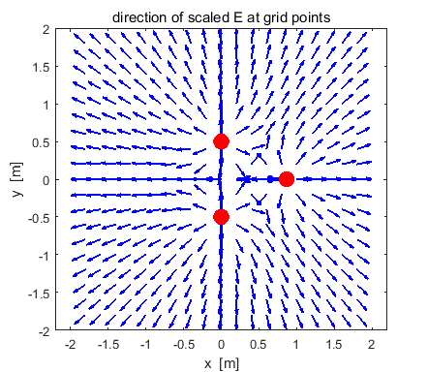

**Example 7: [2D] quadrupole – four charges of equal magnitude and alternating sign lying on the corners of a square cemVE07.m**

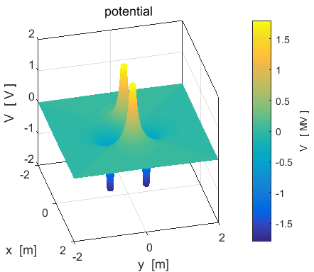

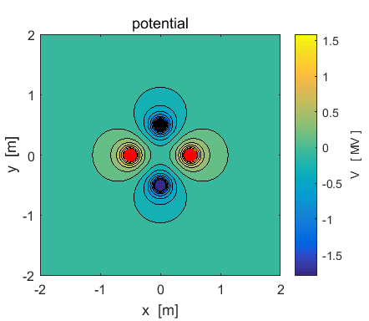

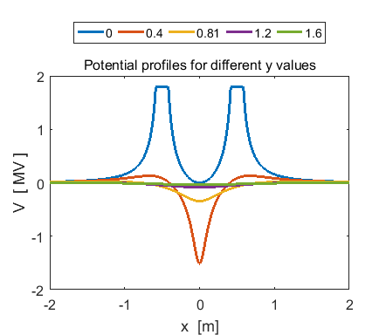

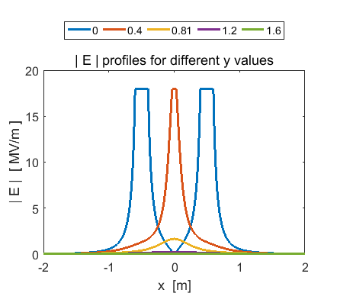

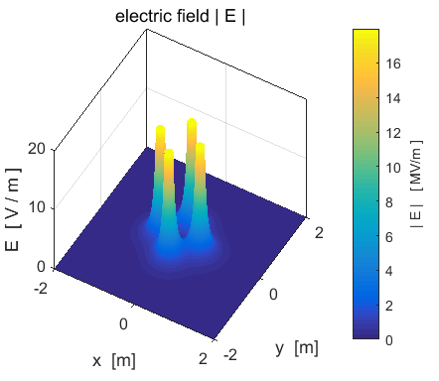

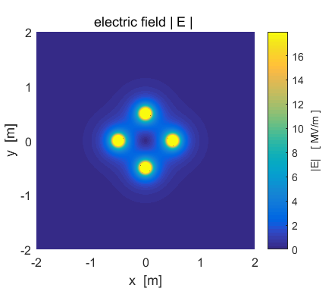

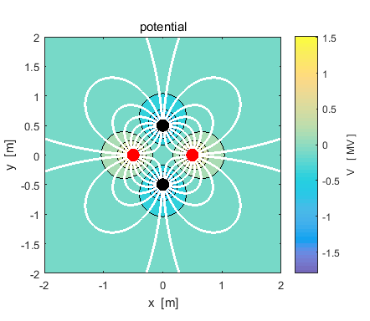

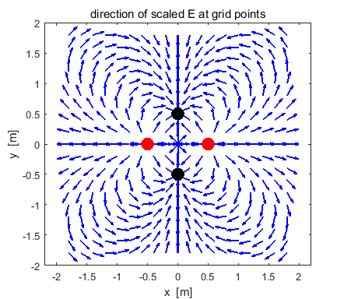

**Example 8: [1D] quadrupole of 3 charges in a straight lines -q +2q -q cemVE08.m**

Q(1) = - 10x106  C Q(2) = + 20x106 C Q(3) = - 10x106  C

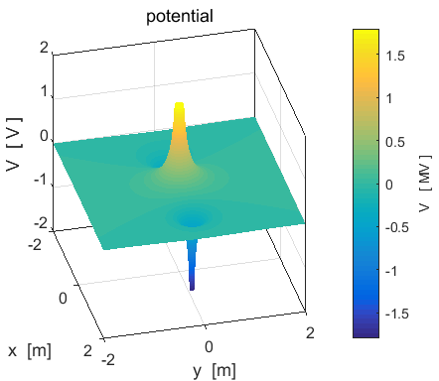

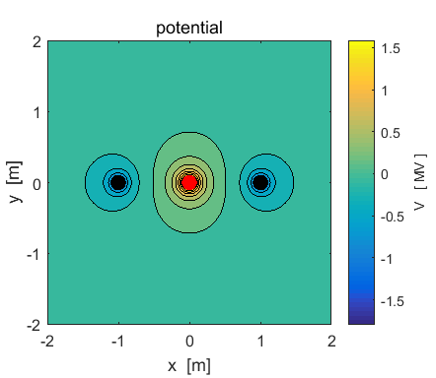

Q(1) = - 10x106  C Q(2) = + 20x106 C Q(3) = - 10x106  C

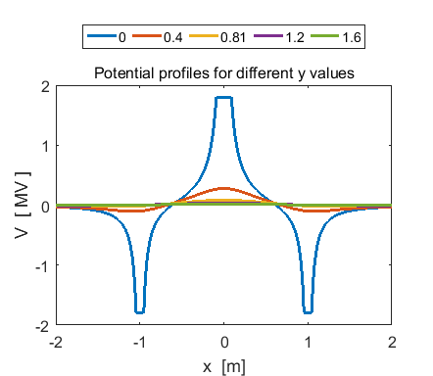

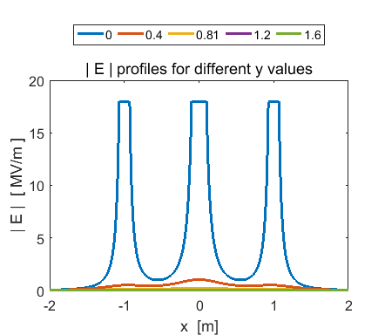

Q(1) = - 10x106  C Q(2) = + 20x106 C Q(3) = - 10x106  C

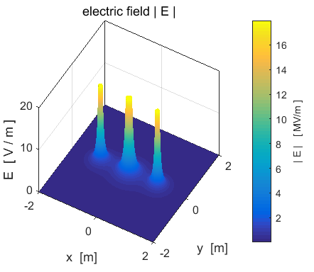

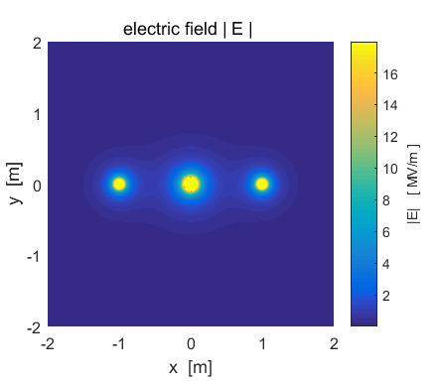

Q(1) = - 10x106  C Q(2) = + 20x106 C Q(3) = - 10x106  C

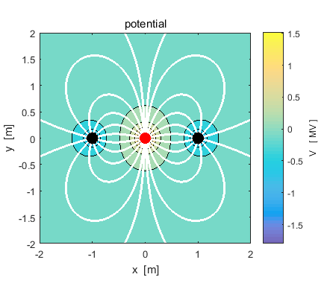

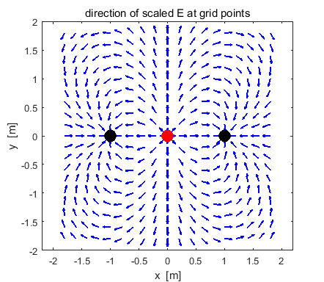

**Example 9: Four equal charges at the corners of a square cemVE09.m**

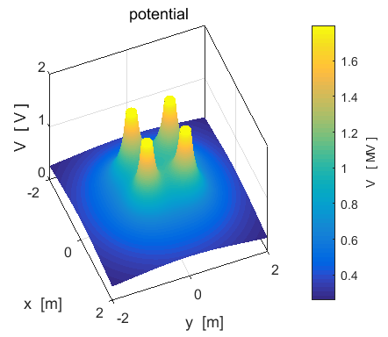

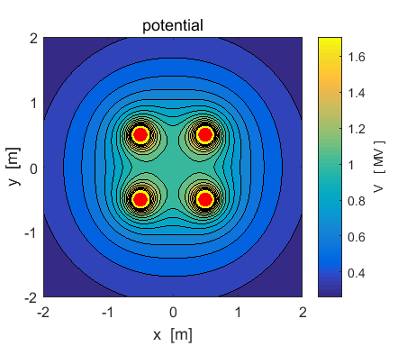

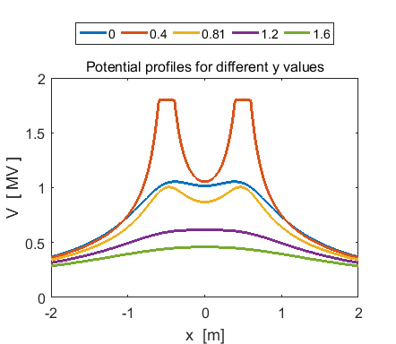

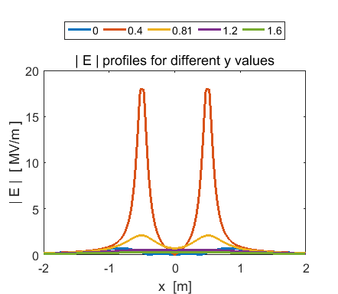

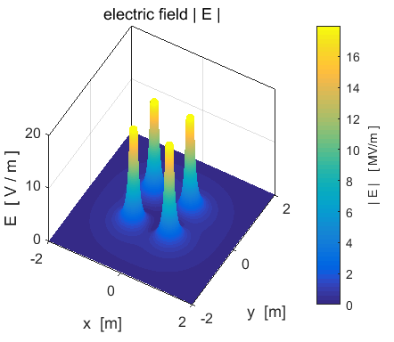

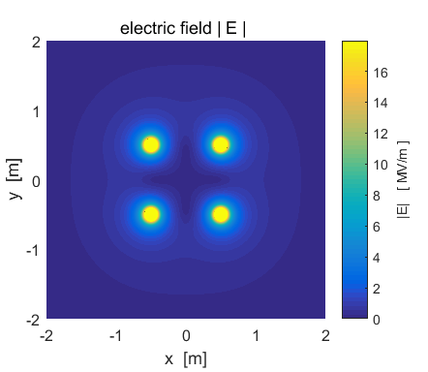

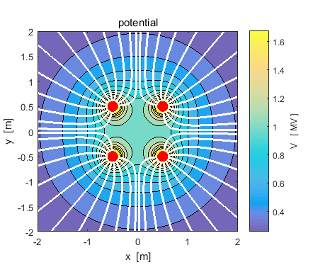

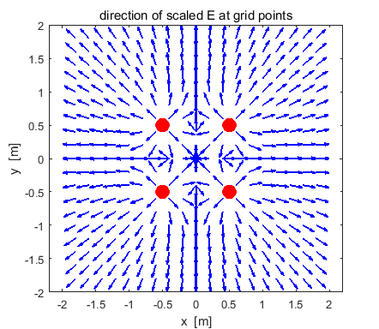

**Example 10: A short capacitor model cemVE10.m**

We can model a short capacitor as a row of positive charges and negative charges. For the plots shown below there are 50 positive circular charges and 50 circular negative charges. Each circular charge has a radius  m and the magnitude of the charge is  C.

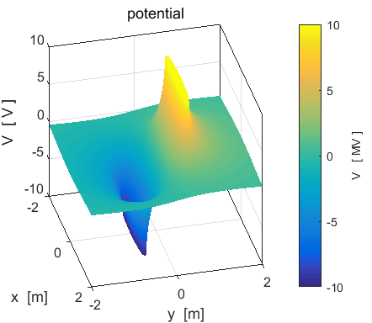

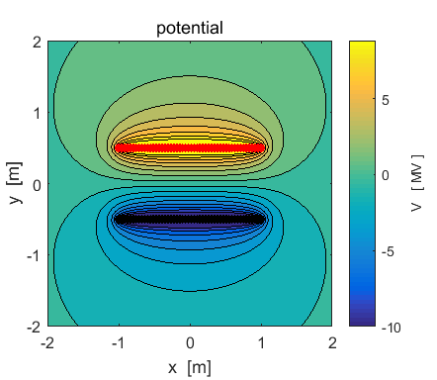

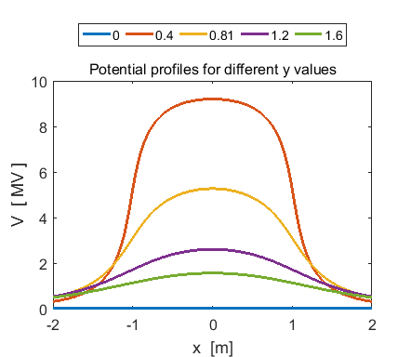

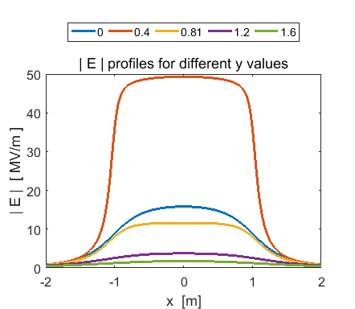

You can check numerical values using the Data Cursor or from the Command Window. We can test the relationship  near the centre of the region between the charged plates.



From the calculation of E from the superposition principle 

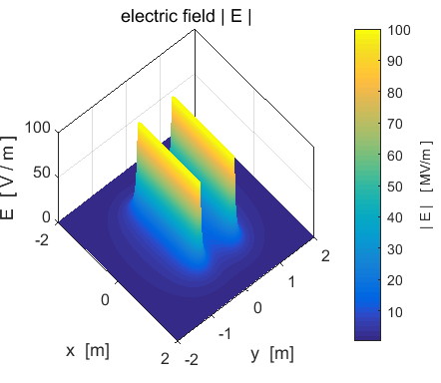

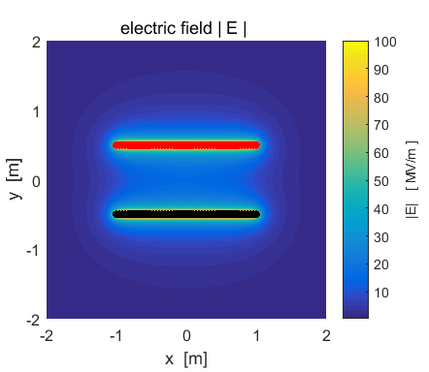

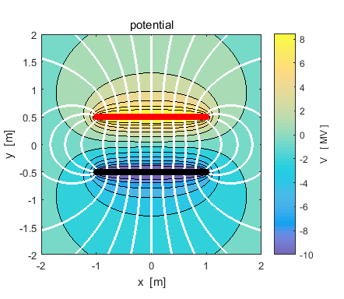

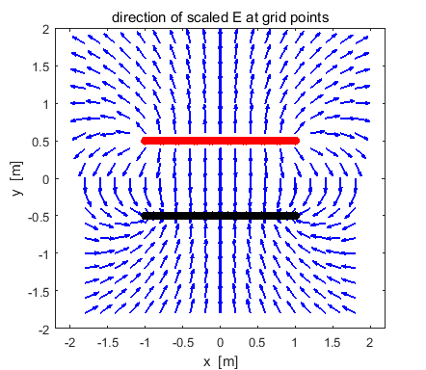

The starting positions for the streamlines need to be chosen carefully to give a good representation of the pattern of electric field lines.