**[DOING PHYSICS WITH MATLAB](https://d-arora.github.io/Doing-Physics-With-Matlab/)**

**Ian Cooper**

**matlabvisualphysics@gmail.com**

**A COMPUTATIONAL APPROACH TO**

**ELECTROMAGNETIC THEORY**

**ELECTRIC FIELD AND ELECTRIC POTENTIAL**

**INFINITE CONCENTRIC SQUARE CONDUCTORS**

**COAXIAL TRANSMISSION LINE**

**DOWNLOAD DIRECTORIES FOR MATLAB SCRIPTS**

[**Google drive**](https://drive.google.com/drive/u/3/folders/1j09aAhfrVYpiMavajrgSvUMc89ksF9Jb)

[**GitHub**](https://github.com/D-Arora/Doing-Physics-With-Matlab/tree/master/mpScripts)

**cemLaplace04.m**

Solution of the [2D] Laplace’s equation using a relaxation method for two infinite concentric squares

**simpson1d.m**

Function for calculating the integral of a [1D] function from a to b. The number of elements for the function must be an **odd** number.

For example, to calculate the charge of the inner square

Q2 = -4*eps0*simpson1d(Ey2',minY2,maxY2);

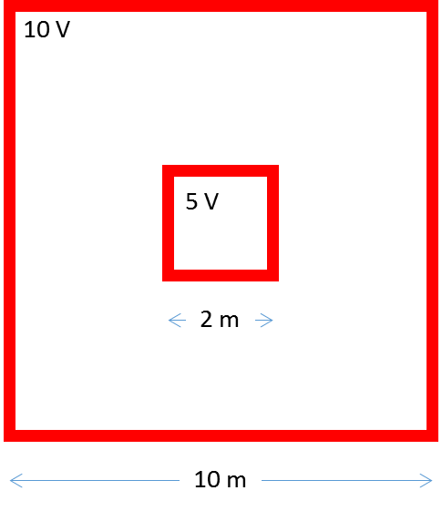Solving the [2D] Laplace’s equation to calculate the potential, electric field, capacitance and the charge distribution on the inner square for the system of two concentric square conductors of infinite length. Since the conductors are of infinite length, the potential and electric field are independent of the Z coordinate.

Outer square



Inner square 

**cemLaplace04.m**

**⇒**

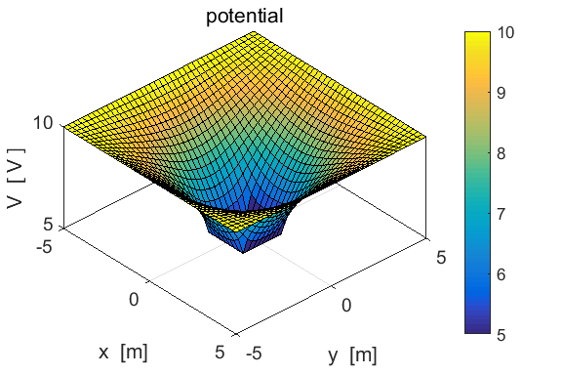

Fig. 1. Surf plot of the XY variation in potential in the region between the two concentric squares

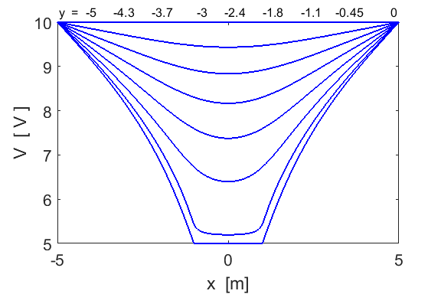

Fig. 2. Potential profiles in the X direction for different Y values.

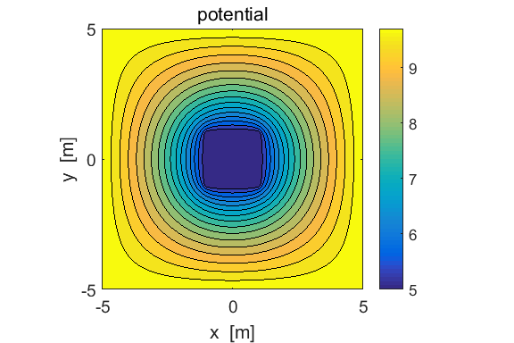

Fig.3 Contourf plot of the potential.

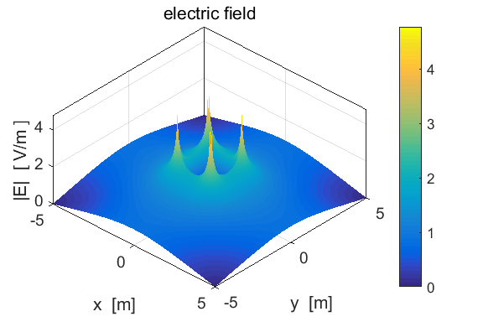

Fig. 4. Surf plot of the magnitude of the electric field. There are large spikes in the electric field at the corners of the inner square.

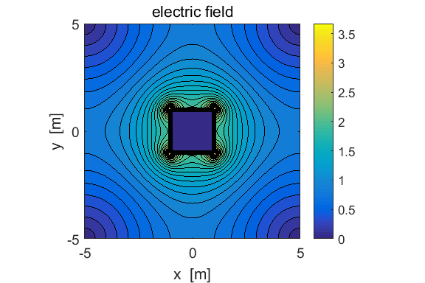

Fig. 5. Contourf plot of the magnitude of the electric field. Observe the peaks in the electric field at the corners of the inner square.

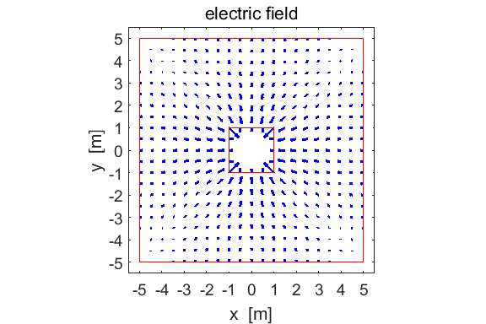

Fig. 6. Quiver plot of the electric field. The electric field has no spatial dimensions. An arrow in the plot shows the direction of the electrical force that would act on a positive test charge placed at that point (base of arrow). The length of the arrow is proportional to the magnitude of the force acting on the positive test charge at that point.

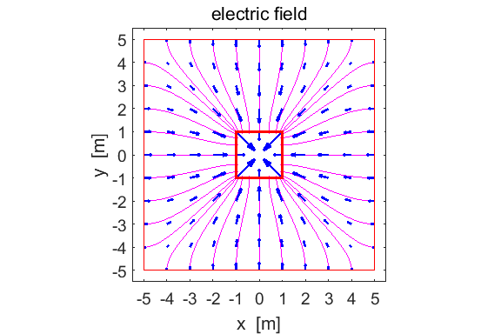

Fig. 7. Electric field lines are added to the quiver plot shown in figure 6 using the **streamline** command. Upon examination of figures 6 and 7, you can conclude that electric field lines are at right angles to the surface of the two square conductors. The streamlines drawn are not perfect, for example, the streamlines extend into the inner square slightly and not all streamlines are perpendicular to the conductors, but still the plots are “pretty good”. The electric field inside the inner square is zero.

The code for producing figure 7 indicates how to use of the **quiver** and **streamline** commands.

figure(3)

set(gcf,'units','normalized','position',[0.65 0.1 0.3 0.32]);

hold on

sx = -5;

for sy = -5:5

h = streamline(xx,yy,Exx,Eyy,sx,sy);

set(h,'linewidth',1,'color',[1 0 1]);

end

sx = 5;

for sy = -5:5

h = streamline(xx,yy,Exx,Eyy,sx,sy);

set(h,'linewidth',1,'color',[1 0 1]);

end

sy = -5;

for sx = -5:5

h = streamline(xx,yy,Exx,Eyy,sx,sy);

set(h,'linewidth',1,'color',[1 0 1]);

end

sy = 5;

for sx = -5:5

h = streamline(xx,yy,Exx,Eyy,sx,sy);

set(h,'linewidth',1,'color',[1 0 1]);

end

index1 = 1 : 10: Nx; index2 = 1 : 10 : Ny;

p1 = xx(index1, index2); p2 = yy(index1, index2);

p3 = Exx(index1, index2); p4 = Eyy(index1, index2);

h = quiver(p1,p2,p3,p4);

set(h,'color',[0 0 1],'linewidth',2)

xlabel('x [m]'); ylabel('y [m]');

title('electric field','fontweight','normal');

hold on

h = rectangle('Position',[minX2,minY2,2*maxX2,2*maxY2]');

set(h,'Edgecolor',[1 0 0],'lineWidth',2);

h = rectangle('Position',[minX1,minY1,2*maxX1,2*maxY1]');

set(h,'Edgecolor',[1 0 0],'linewidth',1);

axis equal

set(gca,'xLim',[-0.5 + minX1, 0.5 + maxX1]);

set(gca,'yLim',[-0.5 + minY1, 0.5 + maxY1]);

set(gca,'xTick',minX1:maxX1);

set(gca,'yTick',minY1:maxY1);

set(gca,'fontsize',14)

box on

We can use Gauss’s Law to determine the charge distribution on the two square conductors.

(1) 

The surface integral can be approximated by a summation over small area elements where  and we can let . From the symmetry properties of a square with 4 sides and using the fact that the electric field is perpendicular to a conductive surface, we can conclude

(2) 

The capacitance *C* is defined as the ratio of charge *Q* stored on the conductors to the potential difference between the conductors

(3) 

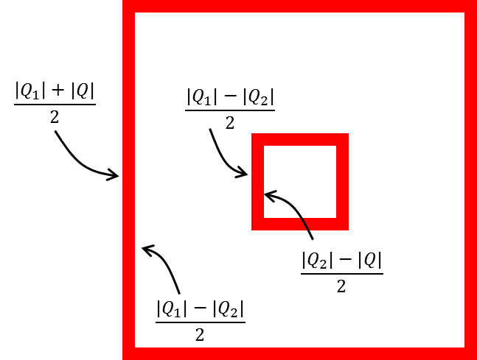In our concentric squares system, the charge on the outer square conductor is and the charge on the inner square conductor is  where . However, the charges arrange themselves on the surfaces on the conductor so that a charge  exists on the inner surface of the larger conductor and on the outer surface of the smaller conductor

(4) 

The charge given by equation 4, is the charge used in equation 3 to determine the capacitance.

From equation (2), we can estimate the variation in the charge density along one side of a square, as shown in figure 8 for the inner square.

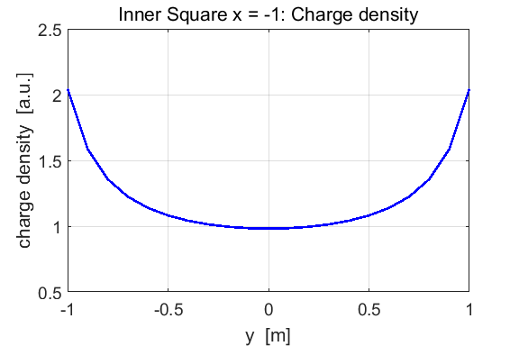

Fig. 8. Variation of the charge density along one side of the inner square. The charges accumulate towards the corners of the square and this is the reason where the electric field surrounding the inner square is greatest at the corners.

Inner square 

**Matlab simulation**

The parameters to produce the above figures and the results of the calculations are given below

grid points (must be **ODD** numbers) 

length of a side of outer square 

length of a side of inner square 

tolerance 

execution time 

charge on outer conducting square 

charge on inner conducting square 

charge for capacitance 

capacitance 

For comparison purposes: the capacitance of two infinite concentric cylinders is given by  where we will take  and 

capacitance (cylinders)  (same magnitude as Cap)

If the ratio  for the concentric cylinders is increased then the capacitance *C* decrease and if the ratio is decreased then the capacitance is increased. You can check this dependence. When the length of a side of the outer conductor is increased, the capacitance does decrease. Try it! Vary the dimensions of the squares. Also, the capacitance of the system is independent upon the potential difference between the conductors. Change the potentials, and confirm the prediction.

The potential can be calculated from the electric field by evaluating the line integral

(5) 

The integral can be evaluated numerically using the Simpson’s rule using the function **simpson1d.m**.

Integrating along a line in the X direction the potential difference between the conductors was computed to be

 the exact value is  (~ 1% difference)

**Sections of the mscript code**

* Setting the boundary conditions

% indices for inner square

ind1 = find(x >= minX2,1);

ind2 = find(x >= maxX2,1);

iS = ind1:ind2;

% boundary values

V = zeros(Ny,Nx);

V(:,1) = V1; V(:,end) = V1;

V(1,:) = V1; V(end,:) = V1; V(iS,iS) = V2;

* Solving Laplace’s equation

% dSum difference in sum of squares / n number of iterations

dSum = 1; n = 0;

while dSum > tol

sum1 = sum(sum(V.^2));

for ny = 2: Ny-1

V(iS,iS) = V2;

for nx = 2: Nx-1

V(ny,nx) = Ky * (V(ny,nx+1) + V(ny,nx-1)) + Kx * (V(ny+1,nx) + V(ny-1,nx));

V(iS,iS) = V2;

end

end

V(iS,iS) = V2;

sum2 = sum(sum(V.^2));

dSum = abs(sum2 - sum1);

n = n+1;

end

* Electric field / Potential / Line integral

[Exx, Eyy] = gradient(V,hx,hy);

Exx = -Exx; Eyy = -Eyy;

E = sqrt(Exx.^2 + Eyy.^2);

Ey1 = Exx(:,1);

Ey2 = Exx(iS,ind1);

Ex21 = Exx(ind1,1:ind1);

V21 = simpson1d(Ex21,minX1,minX2);

* Charge Q / capacitance per unit length / charge density

% charge Q / capacitance per unit length /

Q2 = -4*eps0*simpson1d(Ey2',minY2,maxY2);

Q1 = 4*eps0*simpson1d(Ey1',minY1,maxY1);

Q = abs(abs(Q2)-abs(Q1))/2;

Cap = Q/(V1-V2);

% charge density one side of inner square

sigma = Ey2;

% theoretical capacitance of two concentric cylinders

b = 8*maxX1/(2*pi); a = 8*maxX2/(2*pi);

CapT = 2*pi*eps0/log(b/a);