

[**DOING PHYSICS WITH MATLAB**](http://www.physics.usyd.edu.au/teach_res/mp/mphome.htm)

**ELECTRIC FIELD AND ELECTRIC POTENTIAL:**

**POISSON’S EQUATION**

Ian Cooper

School of Physics, University of Sydney

ian.cooper@sydney.edu.au

[**DOWNLOAD DIRECTORY FOR MATLAB SCRIPTS**](http://www.physics.usyd.edu.au/teach_res/mp/mscripts)

For details of solving Poisson’s equation and Laplace’s equation go to the link

<http://www.physics.usyd.edu.au/teach_res/mp/doc/cemLaplaceA.pdf>

**cemLaplace05.m**

Solution of the [2D] Poisson’s equation using a relaxation method. A number of different situations can be chosen by entering a value for the variable **flag** to select a particular case. You can easily add other cases.

flag = 9;

% flag == 1: uniform charge density distribution

% flag == 2; rho = eps0 x y

% flag == 3: constant voltage at origin

% flag == 4: charge Q at origin

% flag == 5: two points held at a constant voltage

% flag == 6: central square region held at a constant

% voltage

% flag == 7: centre square region - insulator

% constant charge density

% flag == 8; Linear variation of boundary conditions -->

% uniform electric field

% flag == 9; same as 8, except gradient for boundary

% conditions NEUMANN CONDITIONS

For different **cases**, you may have to change the code for the plotting.

Poisson’s equation can be solved for the computation of the potential *V* and electric field  in a [2D] region of space with fixed boundary conditions. We will consider a number of cases where fixed conditions are imposed upon internal grid points for either the potential *V* or the charge density .

The finite difference approximation for the potential at a grid point  is



Because of the way in which Matlab implements the **meshgrid** command, the Y index gives the rows and X index gives the columns, therefore, in the Matlab mscript we use V(ny,nx) and not V(nx,ny).

Download the mscript **cemLaplace05.m**. View the code so that you understand how the program calculates the potential and electrical field for different sets of boundary conditions and initial conditions.

Part of the code of the mscript **cemLaplace05.m** for the input parameters and for specifying the conditions imposed upon internal grid points.

% INPUTS ==============================================================

% Number of XY grid points ( ODD integer )

Nx = 101; % [101]

Ny = 101; % [101]

% Lx X length of region / Ly Y length of region

Lx = 10; % [10]

Ly = 10; % [10]

% tolerance for ending iterations

tol = 0.001; % [0.01]

flag = 9;

% flag == 1: uniform charge density distribution

% flag == 2; rho = eps0 x y

% flag == 3: constant voltage at origin

% flag == 4: charge Q at origin

% flag == 5: two points held at a constant voltage

% flag == 6: central square region held at a constant

% voltage

% flag == 7: centre square region - insulator

% constant charge density

% flag == 8; Linear variation of boundary conditions -->

% uniform electric field

% flag == 9; same as 8, except gradient for boundary

% conditions NEUMANN CONDITIONS

**Case 1:** The [2D] space has a uniform charge density  throughout its interior.

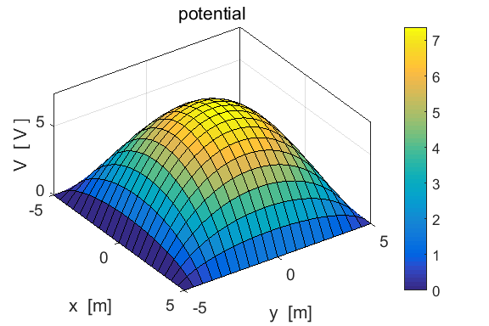

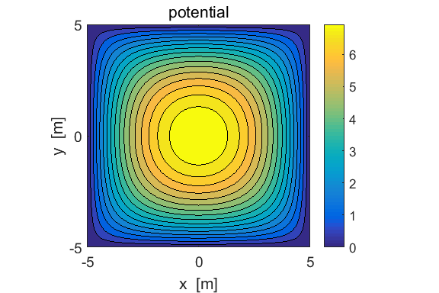

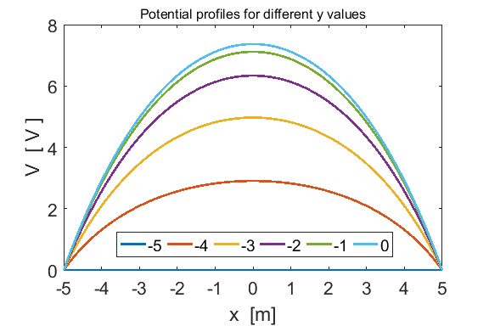

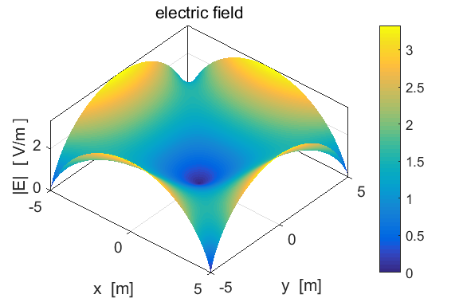

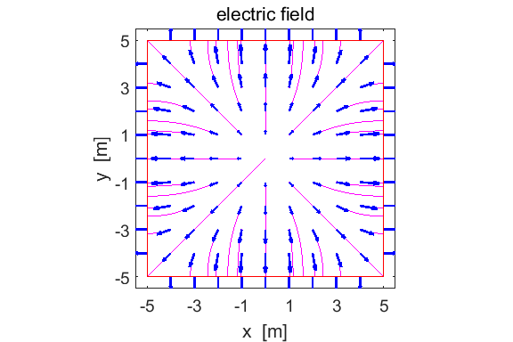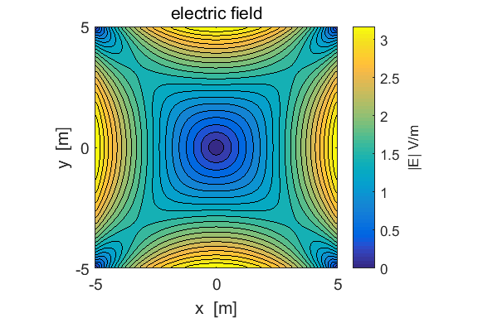

As expected, the potential drops from its maximum value at the origin to zero at the boundaries. The electric field is zero at the origin and increases towards the boundaries. The boundary acts like a conduction and so the electric field lines are perpendicular to the boundaries. The electric field is directed away from the origin towards the boundaries.

**Case 2:** The [2D] space has a charge density  throughout its interior.

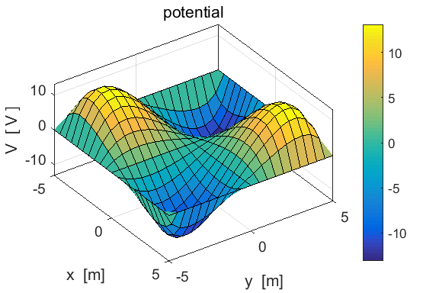

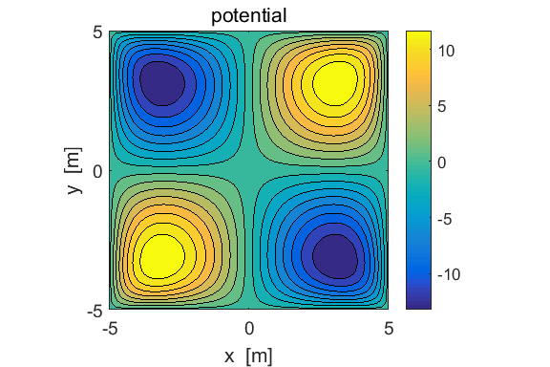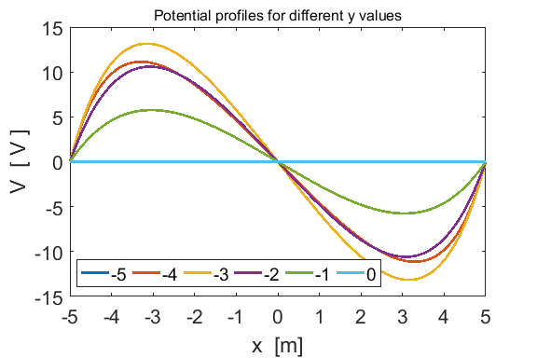

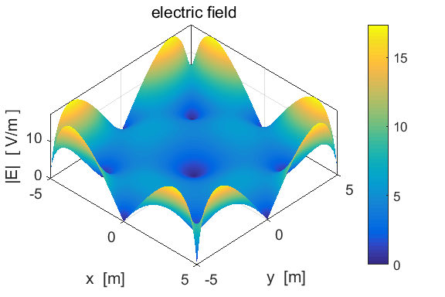

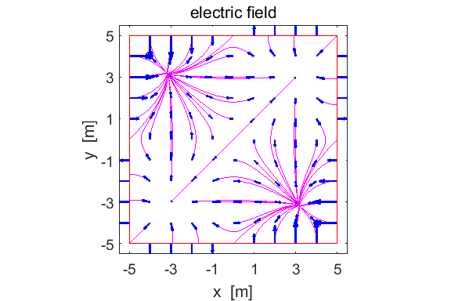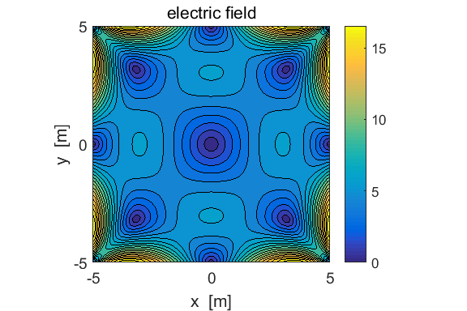

The electric field has a number of zeros at positions where the potential is either a maximum or minimum. At a maximum in potential, the electric field lines point in a direction away from the maximum and at a minimum in potential, the electric field is directed towards the minimum. The maxima occur towards the corners of the square.

**Case 3:** The [2D] space has a constant potential at the origin  V. This situation corresponds to an infinite wire aligned in the Z direction passing through the origin held at the constant voltage *V* or we can consider the potential field in the interior due to a point charge *Q* located at the origin.

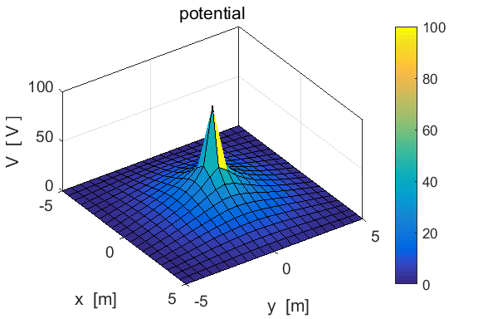

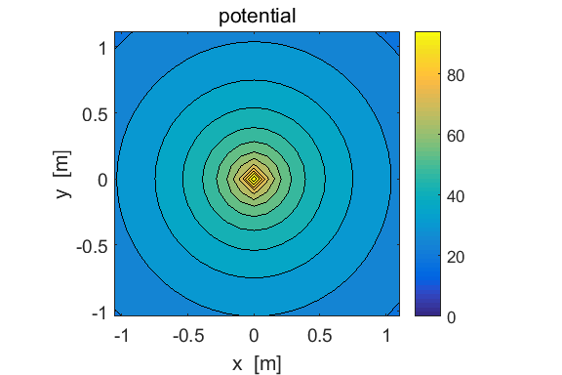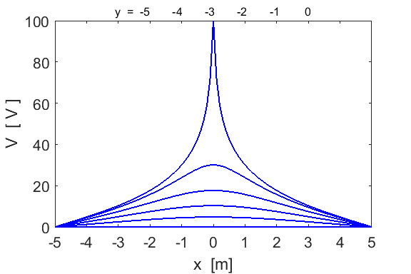

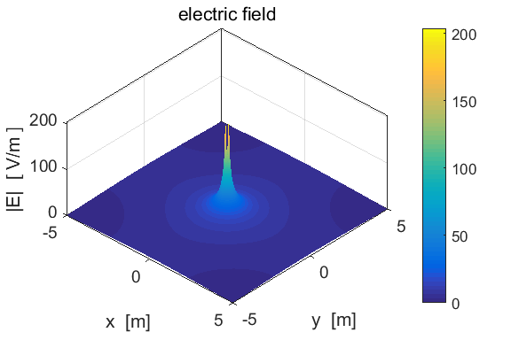

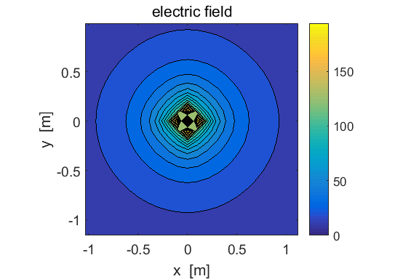

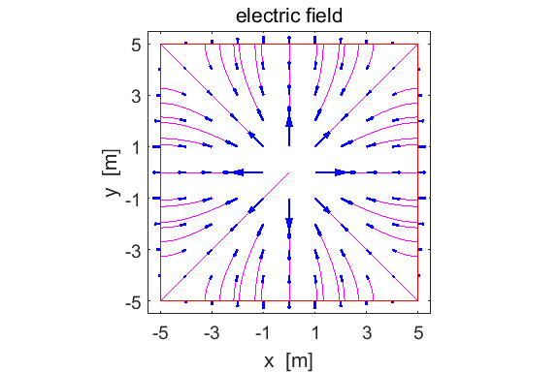

The potential at the origin is  V.

The potential at one grid position from the origin is



The potential at two grid positions from the origin is



For an estimate of the charge *Q* at the origin we can use the relationship



This is only a rough estimate of *Q* since in our model  at a boundary whereas in the mathematical model  as .

Calculations for *Q* can be done in the Command Window

Q = 4*pi*eps0*hx*V(52,51) 🡪 

Q = 4*pi*eps0*2*hx*V(53,51) 🡪 

Hence, we can conclude that the charge at the origin is .

See **Case 4**.

**Case 4:** The [2D] space has a charge *Q* placed at the origin. Assume that the charge is within a cell of dimensions  centred on the origin. The code to compute the charge density  at the origin is

case 4 % charge Q at origin

indx = ceil(Nx/2); indy = ceil(Ny/2);

Q = 1.0e-9;

rho = Q / (hx*hy);

rho_E(indy,indx) = K .* rho;

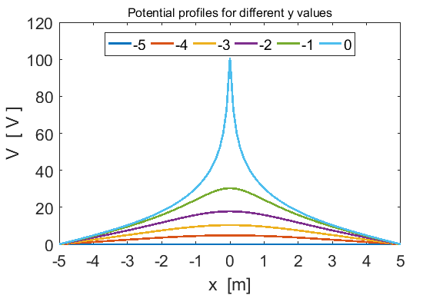

The potential and electric fields for **Cases 3** and 4 are almost identical as expected.

**Case 5:** Two wires are placed in the interior of the [2D] space and are held at potentials of +100 V and -100 V. The potential and electric field distributions are similar to an electric dipole.

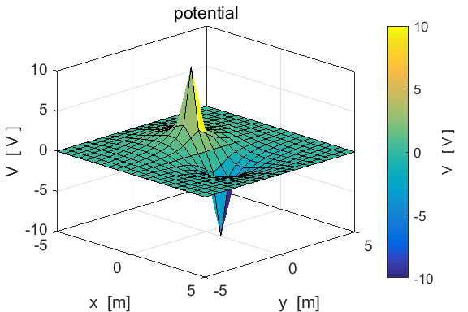

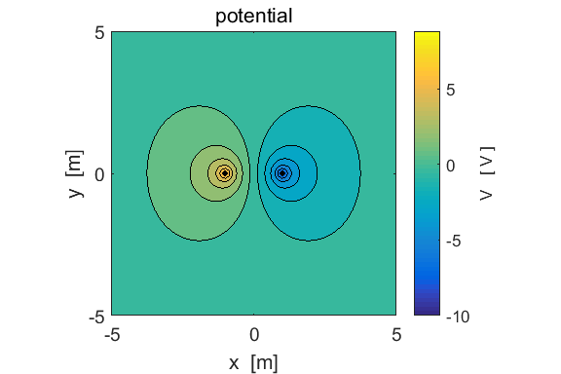

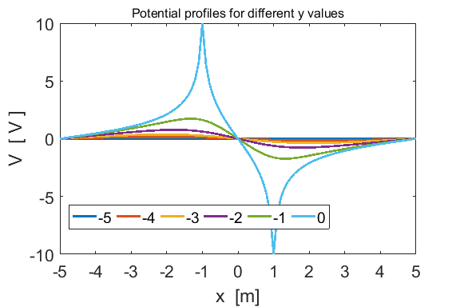

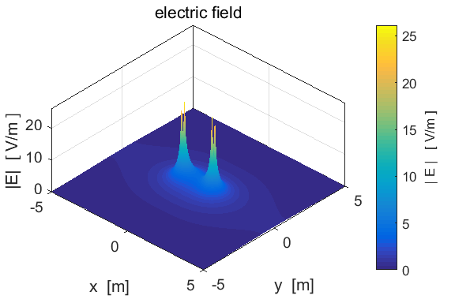

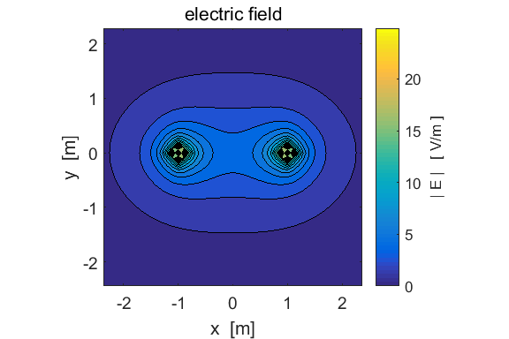

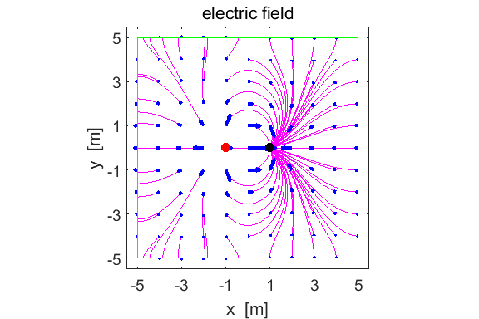

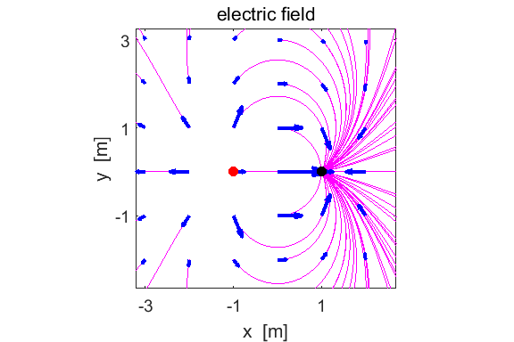

The plots of the electric field using the **quiver** and the **streamline** commands are only `so so’ but they do give an idea of the directions of the electric field in the [2D] region. Again, the boundary correspond to a conductor, and the electric field lines are perpendicular to the conductor at the boundaries. Many more streamlines are shown near the -100 V point than the +100 V point ???

**Case 6:** The boundary condition for the [2D] space is a conductor at a potential of . At the centre of the [2D] space is a square region of dimensions 2.0 m x 2.0 m whose boundary corresponds to a conductor at a potential of 1.4 V. This situation using the mscript **cemLapace04.m** is described in the documentation at

<http://www.physics.usyd.edu.au/teach_res/mp/doc/cemLaplaceB.pdf>

**Case 7:** The boundary condition for the [2D] space is a conductor at a potential of . At the centre of the [2D] space is a square region of dimensions 2.0 m x 2.0 m corresponding to an insulator with a constant charge density of .

You can run the mscript **cemPlace05.m** for **Cases 6** and **7** and compare the potential and electric field for the two situations. The figures below show the results for the square conductor and the square insulator at the centre of the [2D] region

|  |  |
| --- | --- |
| **Case 6: centre square conductor** | **Case 7: centre square insulator** |
|  |  |
|  |  |
|  |  |

|  |  |
| --- | --- |
| **Case 6: centre square conductor** | **Case 7: centre square insulator** |
|  |  |
|  |  |
|  |  |

|  |  |
| --- | --- |
| **Case 6: centre square conductor** | **Case 7: centre square insulator** |
| Electric field inside conductor is zero |  |

So far we have only consider using fixed values for the potential on the boundaries. This type of boundary condition is called the **Dirichlet conditions**. We can also consider **Neumann conditions** where the values of the normal gradient on the boundary are specified. In **Case 8** we will consider the boundary conditions that give rise to a uniform electric field in our [2D] space. In **Case 9**, we will consider the same setup as in **Case 8** except that we will apply Neumann conditions to the right hand boundary.

**Case 8:** **Uniform electric field in the [2D] space**

Boundary conditions

x = 0 V = 10 V x = xmax V = 5 V

y = 0 V decreases linearly from 10 V to 5 V

y = ymax  V decreases linearly from 10 V to 5 V

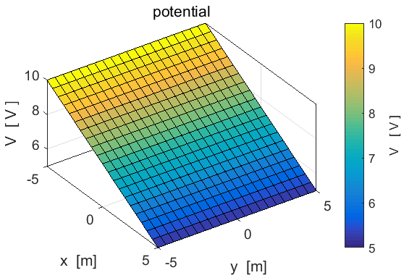

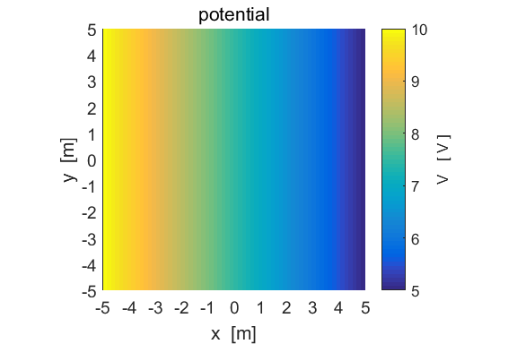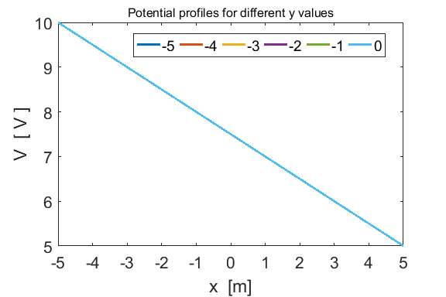

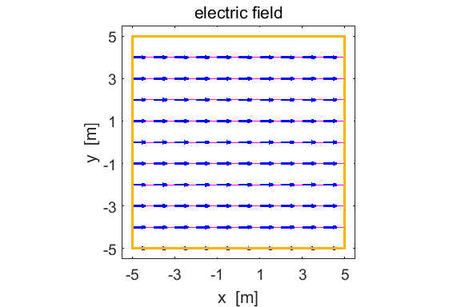

The electric field is uniform through the [2D] space



You may need to change the mscript for the plots when selecting different cases.

**Case 9: Neumann boundary conditions**

Boundary conditions

x = 0 V = 10 V

x = xmax 

y = 0 V decreases linearly from 10 V to 5 V

y = ymax  V decreases linearly from 10 V to 5 V

A finite difference formula is applied for the first derivative for the Neumann conditions. Segments of the mscript **cemLapace06.m**

case 9

V1 = 10; V2 = 5;

V(:,1) = V1;

V(:,Nx) = V2;

m = (V2-V1)/Lx;

b = V(1,1) - m * x(1);

V(1,:) = m .* x + b;

V(Ny,:) = V(1,:);

while dSum > tol

sum1 = sum(sum(V.^2));

for ny = 2: Ny-1

for nx = 2: Nx-1

if flag == 3; V(indy,indx) = V1; end;

if flag == 5; V(indy1,indx1) = V1; V(indy2,indx2) = V2; end;

if flag == 6; V(iS,iS) = V2; end;

**\*\*\*\***  if flag == 9; V(ny,Nx) = V(ny,Nx-1) + hx * y(ny)^2; end

V(ny,nx) = Ky * (V(ny,nx+1) + V(ny,nx-1)) + Kx * (V(ny+1,nx) +

V(ny-1,nx)) + rho_E(ny,nx);

end

end

