

[**DOING PHYSICS WITH MATLAB**](http://www.physics.usyd.edu.au/teach_res/mp/mphome.htm)

**ELECTRIC FIELD AND ELECTRIC POTENTIAL**

**Line Integral of the electric field**

Ian Cooper

School of Physics, University of Sydney

ian.cooper@sydney.edu.au

[**DOWNLOAD DIRECTORY FOR MATLAB SCRIPTS**](http://www.physics.usyd.edu.au/teach_res/mp/mscripts)

Download and inspect the mscripts and make sure you can follow the structure of the programs.

**cemVE011.m cemVE011a.m**

Calculation of the potential between two points by the evaluation of the line integral of the electric field



**simpson1d.m**

[1D] computation of an integral using Simpson’s rule. The function to be integrated must have an ODD number of the elements.

**Electrical Potential**

Electrostatic fields maybe represented by **equipotentials** and **electric field lines**. Equipotentials are surfaces of constant voltage. In the static case, the equipotentials are always perpendicular to the electric field lines, and this follows from

(1) 

Note that a [2D] representation of the electric field lines may distort the magnitude of a [3D] field, but it does not for the equipotentials.

If we know the electrical potential, then we can use equation 1 to calculate the electric field. Starting with the electric field, we can calculate the potential by evaluating the **line integral**

(2) 

 is the difference in electrical potential between the two the points  and .  is the potential at the point  with respect to the point  and  is the potential difference of point  with respect to point 



It is not always easy to evaluate a line integral because of the vector quantities  and . To compute a line integral using Matlab it is best to use Cartesian coordinates for the vectors where we calculate the line integral in a series of straight line paths in the directions of the X, Y and Z coordinate axes

(3) 

For point charges, the magnitudes of the potential or electric field go to infinity as an observation point approaches the location of the charge. Therefore, in choosing the integration path, it should not pass too close to any charge.

The components of the electric field and potential  due to a point charge *QC* located at the point  are

(4) 

(5) 

In writing mscripts to evaluate a [2D] line integral given by equation 3, we have to define the straight line segments for the integration paths from the point P1 to the point P­2 which are parallel to the X or Y axis. Each segment is defined in terms of its x and y components at its start (a) and end (b).

% Grid points: must be an ODD number

N = 101;

% Number of integration paths

Np = 5;

% XY path coordinates

x = [-1.5 -1.5 1 1 -1.5 -1.5];

y = [0 1 1 -1 -1 0];

The variable flag is used to specify whether the integration is in the X direction or Y direction and whether the x or y variable increasing or decreasing in moving from the start to the end of the segment.

% flag = 1: X integration / x inc

% flag = 2: X integration / x dec

% flag = 3: Y integration / y inc

% flag = 4: Y integration / y dec

flag(1) = 3;

flag(2) = 1;

flag(3) = 4;

flag(4) = 2;

flag(5) = 3;

The variable u is used for the constant value of the x or y of the segment and the variable v is used for the grid points from a to b. The electric field is calculated at N grid points along the length of the segment from a to b. For each segment, the integral



is computed using Simpson’s rule. Whether the function to be integrated is + or – is accounted for by the variable pm for each segment.

for n = 1 : Np

if flag(n) == 1

u = y(n);

a = x(n); b = x(n+1); pm = -1;

end

if flag(n) == 2

u = y(n);

a = x(n+1); b = x(n); pm = 1;

end

if flag(n) == 3

u = x(n);

a = y(n); b = y(n+1); pm = -1;

end

if flag(n) == 4

u = x(n);

a = y(n+1); b = y(n); pm = 1;

end

v = linspace(a,b,N);

R = sqrt(u.^2 + v.^2);

R3 = R.^3;

E = kC .* v .* Q ./R3;

fn = pm .* E;

V(n) = simpson1d(fn,a,b);

end

The integrals for each segment are then summed to give the potential difference between the two points P1 and P2.

% Potentials

V21 = sum(V); % value of the line integral of E

We will consider [2D] examples for a charge of 10 μC located at the origin.

The mscript **cemVE11a.m** is used for a closed loop starting at the point P1(-1.5,0) and ending at point 1. The line integration is composed of 5 segments as shown in figure 1.

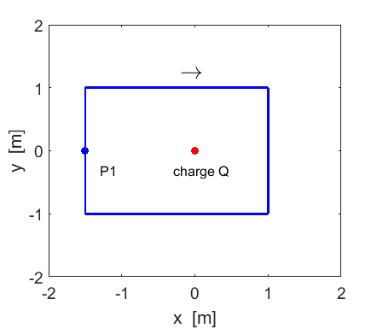

Fig. 1. Line integral for a closed loop made up of 5 straight line segments which are either parallel to the Y axis or parallel to the X axis.

**cemVE11a.m**

Numerical results are displayed in the Command Window

Line integral of E: V21 = 0.0000e+00 V

Computed potential at point P2 w.r.t point P1 dV = 0.0000e+00 V

For a closed loop, the value of the line integral is always zero



The mscript **cemVE11.m** is used to compute the value of the line integral from the point P1(-1.5,0) to the point P2(1,0). The integration path must avoid the origin. This can be done using three straight segments as shown in figures 2 and 3 for two different paths.

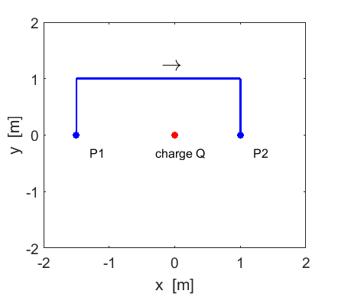

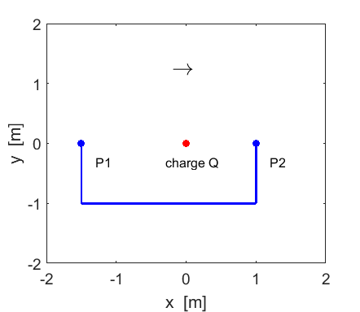

The potential between the two points P1 and P2 is displayed in the Command Window. The potential difference between the two points is independent of the integration path.

Line integral of E: V21 = 2.9959e+04 V

Computed potential at point P2 w.r.t point P1

dV = 2.9959e+04 V

The value of the potential at each point is a function of position and so it is obvious that the calculation of a potential difference between a pair of points must be the same regardless of the integration path.