

[**DOING PHYSICS WITH MATLAB**](http://www.physics.usyd.edu.au/teach_res/mp/mphome.htm)

**ELECTRIC FIELD AND ELECTRIC POTENTIAL**

**METHOD OF IMAGES**

Ian Cooper

School of Physics, University of Sydney

ian.cooper@sydney.edu.au

[**DOWNLOAD DIRECTORY FOR MATLAB SCRIPTS**](http://www.physics.usyd.edu.au/teach_res/mp/mscripts)

Download and inspect the mscripts and make sure you can follow the structure of the programs.

**cemVE012.m**

Calculation of the potential and electric field for a charged sphere near a grounded conductive plate using the method of images

**cemVE013.m**

Calculation of the potential and electric fields for a point charge near a **grounded** conductive sphere

**cemVE14.m**

Calculation of the potential and electric fields for a point charge near an **insulated** neutral conductive sphere

**simpson1d.m**

[1D] computation of an integral using Simpson’s rule. The function to be integrated must have an **ODD** number of the elements.

**Method of images**

**Charges between conducting plates**

An interesting result of electrostatics is the electric field pattern due to a set of point charges near a group of grounded conducting plate is the same as that due to the original charges and a set of reflected image charges. A charge and its reflected image charge have the same magnitude and opposite sign. Each image charge is the same distance behind the plate that the original charge is in front of the plate.

An exotic example of the method of images is the computation of the potential and electric field in the region where a point charge is located near a conducting sphere which is either grounded or insulated.

**Example 1 cemVE12.m**

A positive charged sphere near a grounded conducting plate.

Charged sphere: Q = 50 μC located at the origin (0,0)

Grounded plate parallel to the Y axis (V = 0 V) at x = -1 m

Image charge Q = - 50 μC located at x = -2 m and y = 0

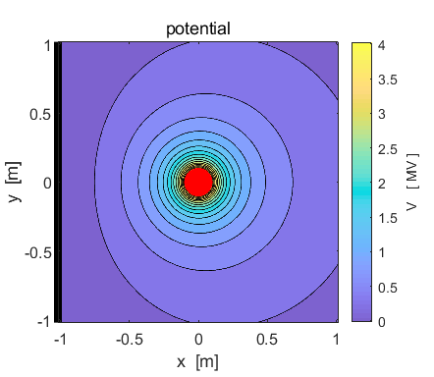

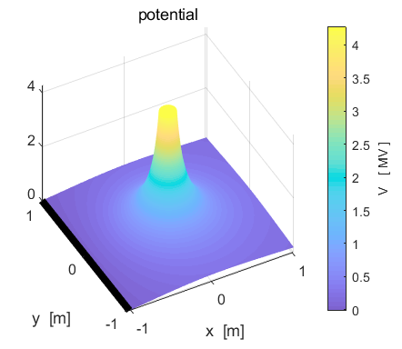

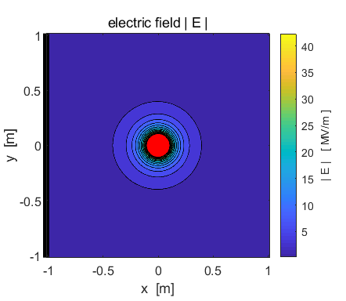

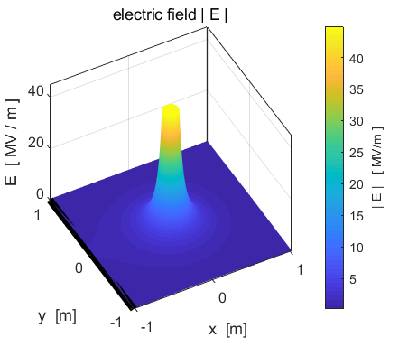

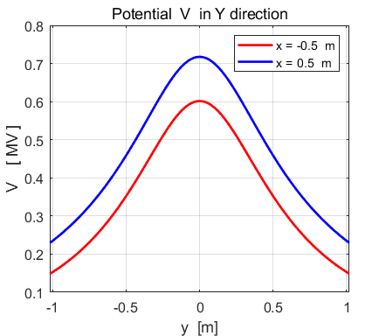

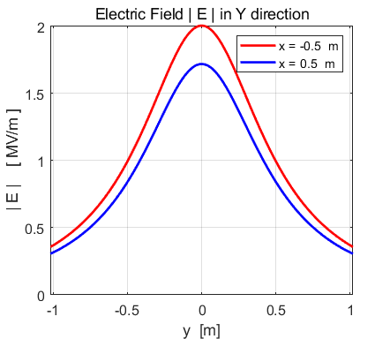

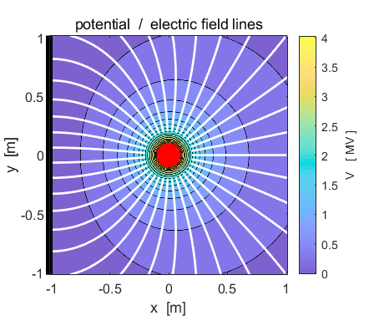

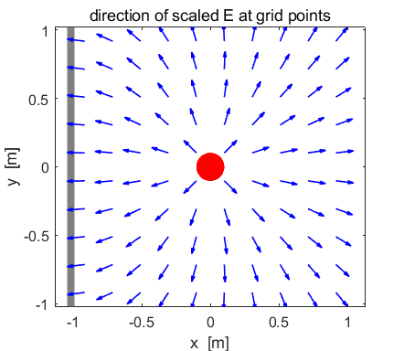

**Method of images**

**Point charge and a conducting sphere**

**Example 2 GROUNDED SPHERE**  **cemVE13.m**

A special case in which the method of images works is that of a **point charge** and a **grounded conducting sphere**. Take a sphere with its centre at the origin (0,0) and radius . The position of the positive point charge *Q* is where  and  (the charge is located outside the sphere on the X axis).

The potential everywhere on the sphere is **zero** since it’s a grounded conductor, so as the point charge is brought in, charges flow from the Earth and move around on the conductor to keep the potential at zero. Our goal to find the potential and electric field everywhere outside the sphere.

If we replace the sphere by an image charge 

 located inside the sphere at 

then the potential on the sphere is still zero.

We can use the superposition principles by adding the potentials and the electric fields from the charge *Q* and the image charge *QI* to find the potential and electric field in the region outside the sphere using the mscript **cemVE13.m**.

Download the mscript **cemVE13.m** and make sure you understand the structure of the program.

It is important that when a grid point is near a charge, the potential or electric field does not tend to infinity. In the code this is checked by using saturation values and minimum distances between a grid point and the location of a charge. Also, you have to test for grid points inside the spherical conductor, if so, the potential and electric field values are set to zero.

Parameters used for the following plots

Number of grid points N = 1001

Charge: Q = 200 μC xQ = 1.5 m yQ = 0 m (red disk)

Conducting sphere: radius RS = 0.25 m xS = 0 m yS = 0 m (black disk)

Computations

Image charge: QI = - 4.1667x10-5 C xI = 0.0521 m yI = 0 m (black disk)

Induced charge on outer surface of sphere: Qinduced = QI = - 4.1667x10-5 C

Attractive force between point charge and grounded sphere: F = - 56.839 N

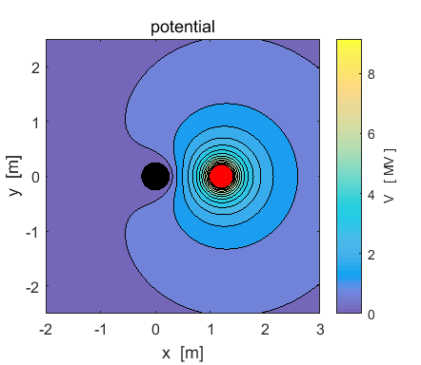

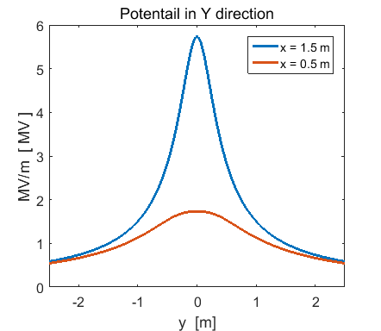

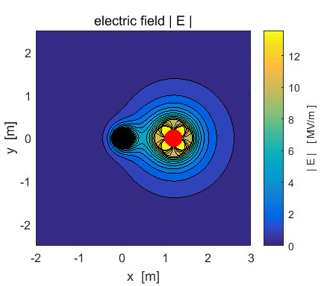

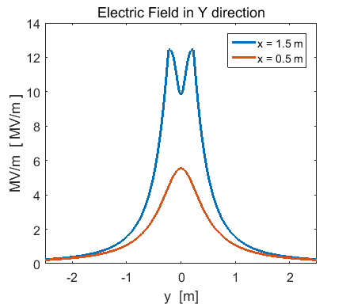

The following plot shows the angular variation of the potential in a circle centred on the origin of radius *R.* The top figure, shows the potential *VQ* from the charge *Q* (outside the sphere); the potential *VQI* for the image charge *QI* (inside the sphere) and the total potential  when the radius of the circle equals the radius of the sphere . The figure clearly shows that the combined potential from the charge and image charge add to **zero** around the surface of the conducting sphere. The bottom figure is the angular variation of the potentials surrounding the sphere at a radius of 0.450 m (*R* > *RS*). The total potential is no longer zero around the circle of radius *R* > *RS.*

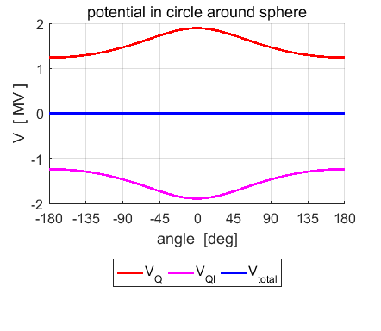

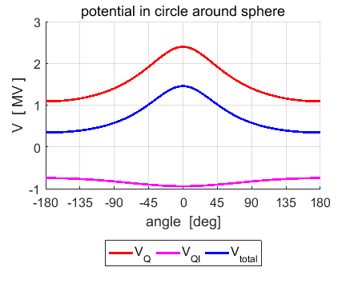

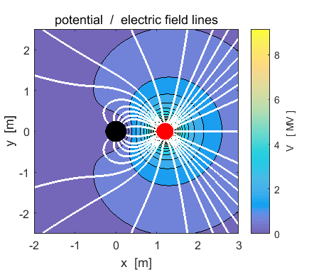

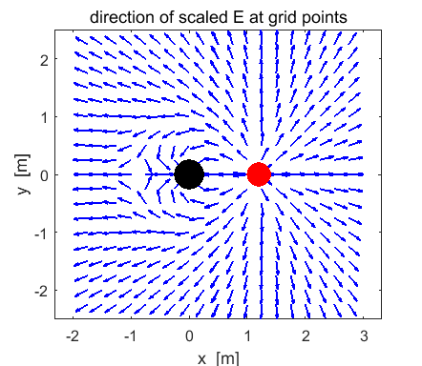The density of the electric field lines is proportional to the strength of the electric field. The direction of the electric field is from the positive charge to the negative induced charge on the sphere. At the surface of conductor, the field lines are perpendicular to the surface.

We can ask, how good is our simulation? We can calculate the induced surface charge density  on the sphere. After lots of algebra, we can derive an analytical formula for the distribution of the charge on the surface of the sphere



We can use out numerical approach to calculate the charge density  by calculating the electric field around the circle of radius *RS* and using Gauss’s Law

  

since the electric field is parallel to the outward pointing normal to the surface.

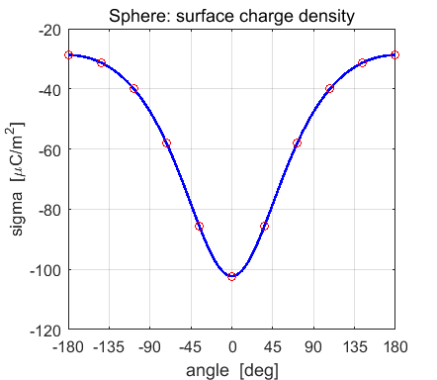

The plot show the excellent agreement between the computed charge density  (blue line) and the analytical charge density (red circles).

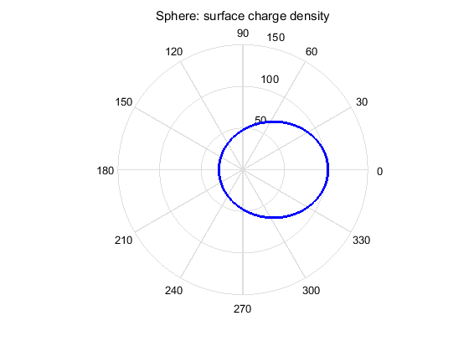

We can also show the induced charge distribution in a polar plot. The direction of the X axis is given when the angle is 0o.

We can find the magnitude of the induced charge on the surface of the sphere analytically by integrating over the surface area of the sphere and the total induced charge is simply equal to the magnitude of the image charge



We can also calculate the total induced charge by numerically integrating the charge density  using Simpson’s rule. The two values are displayed in the Command Window

Qinduced = -4.1667e-05

QI = -4.1667e-05

Again, excellent agreement in the two values predicted by the two different approaches.

A negative charge covers the entire outer surface of the conducting grounded sphere. The maximum concentration of charge occurs in the region closest to the charge *Q.* The conducting sphere becomes negative since it is grounded. The presence of the nearby positive charge causes electrons to flow from the Earth and distribute themselves around the sphere to keep the potential of the sphere zero.

Therefore, there is an attractive force between the positive point charge (*Q)* and the negatively charged conducting sphere (*QI*). The force is simply given by Coulomb’s Law



With the parameters used in our model, the value of the attractive force is

F = - 56.8393 N

**Example 3: Insulated conducting sphere and positive point charge**

**cemVE14.m**

If our conducting sphere is insulated and initially uncharged, the total charge on it must remain **zero**. It is therefore necessary to add a second image charge *–QI* at such a point that the surface of the sphere is an **equipotential surface**. This can be done by placing the second image charge *–QI* at the centre of the sphere.

The potential and electric field surrounding the field can be computed by the superposition of the potentials and electric field components due to the three charges: the point charge and the two image charges.

Download the mscript **cemVE14.m** and make sure you understand the structure of the program.

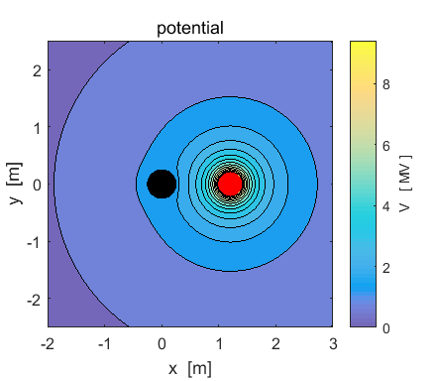

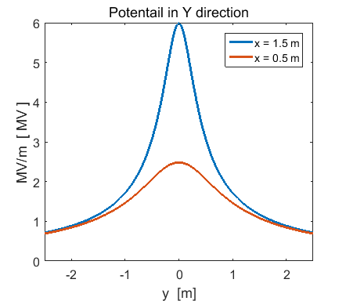

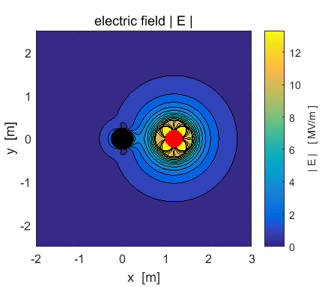

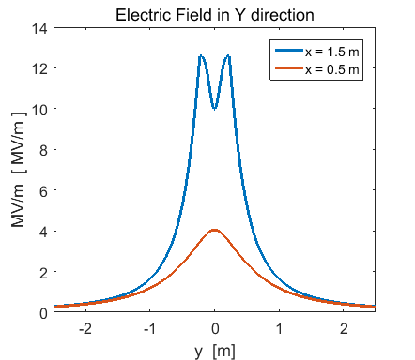

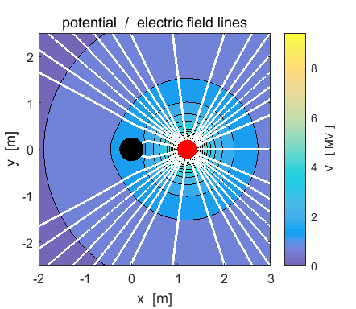

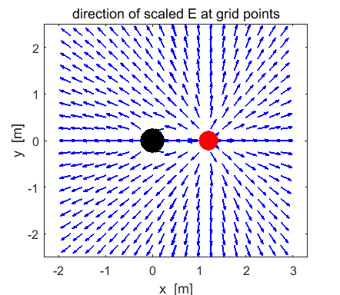

The uncharged sphere is insulated, therefore its charge must remain zero in the electric field due to the point charge and the surface of the conducting sphere is an equipotential surface. In an electric field free region, the potential at the surface of the uncharged sphere is zero. In the presence of the electric field created by the point charge, the potential at the surface of the sphere is raised to 1.5 MV.

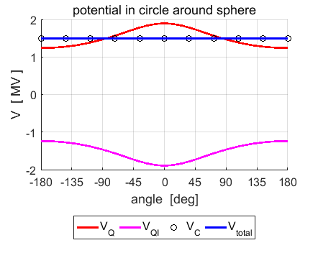The potential at the surface of the sphere

*R* = *RS*

VC is the potential due to the positive image charge at the centre of the sphere. The potentials due to the negative image charge and the positive point charge cancel each other on the surface of the sphere.

The angular distribution of the charge on the surface of the sphere 

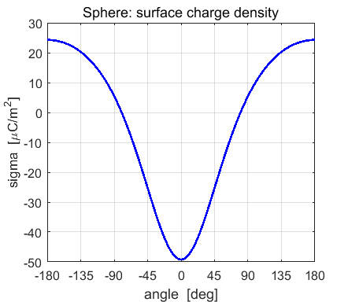

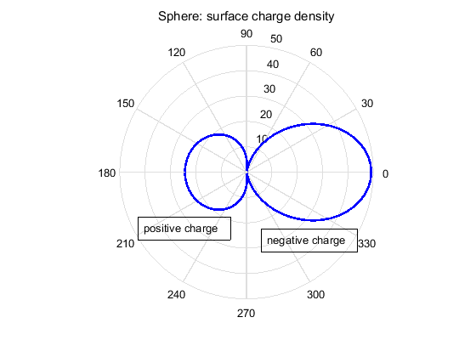

When you bring the positive charge near the conducting neutral sphere, the positive charge attracts negative charges to the side closer to itself and leaves a positive charge of the far side surface. The integration the surface charge density over the surface area of the sphere using Simpson’s rule gives a result of zero as expected, the total surface charge on the insulated and neutral sphere is zero. For -80o < polar angle < +80o the surface charge density is negative and for angles outside this range, the surface charge density is positive. So there are two regions on the surface of the sphere at angles of ±8 0o where the surface charge density goes to zero.

There is an attractive force between the point charge and the neutral (uncharged) insulated conducting sphere.

Where does the attraction come from?

When you bring the positive charge near the conducting neutral sphere, the positive charge attracts negative charges to the side closer to itself and leaves a positive charge of the far side surface. The attraction to the negative charge is greater than the repulsion of the positive charge, hence the attraction.

We can estimate the magnitude of this attractive force by computing the force on the positive point charge +*Q* in the electric fields produced by the image charges –*QI* and +*QI.* The attractive force is then simply the sum of these two forces.

The value of the attractive force F is displayed in the Command Window after running the mscript **cemVE14.m**.

F = - 4.8269 N

Note: this force is an order of magnitude less than the attractive between the point charge and the ground conducting sphere.