

[**DOING PHYSICS WITH MATLAB**](http://www.physics.usyd.edu.au/teach_res/mp/mphome.htm)

**ELECTROSTATICS**

**DIVERGENCE and CURL**

**RADIAL ELECTRIC FIELDS**

Ian Cooper

School of Physics, University of Sydney

ian.cooper@sydney.edu.au

[**DOWNLOAD DIRECTORY FOR MATLAB SCRIPTS**](http://www.physics.usyd.edu.au/teach_res/mp/mscripts)

Download and inspect the mscripts and make sure you can follow the structure of the programs.

**cemVE20.m**

Calculation of the divergence and curl of the electric field surrounding a point charge

**cemVE21.m**

Calculation of the divergence and curl of a radial electric field

**Related documents**

<http://www.physics.usyd.edu.au/teach_res/mp/doc/cemDifferentialCalculus.pdf>

<http://www.physics.usyd.edu.au/teach_res/mp/doc/cemVEA.pdf>

**Electric field surrounding a point charge cemVE20.m**

The mscript **cemVE20.m** can be used to find the spatial derivatives of the electric field surrounding a point charge located at the origin O(0,0,0). The program can be easily modified to change the electric field. The Cartesian coordinates of the point P(*x,y,z)* where the partial derivatives, the divergence and the curl are to be calculated are entered in the INPUT section of the mscript.

A vector field for the electric field  has three components  and each component has three possible partial derivatives with respect to *x,* *y* and *z*: . Thus, there are nine partial derivatives that need to be calculated. We will use the finite difference approximation to estimate each partial derivative

(1) 

and the similar equations for the other eight permutations. The smaller the increment  the better the approximation.

For the electric field surrounding a point charge located at the origin (0,0,0), the Cartesian components of the electric field are given by

(2) 

where  is the distance between the charge *Q* at the origin O(0,0,0) and the point P(*x,y,z)*.

From the partial derivatives we can calculate the divergence of the electric field and the curl of the electric field. For static electric fields

(3)  divergence: Gauss’s law for electric fields

(4)  curl: Faraday’s law for static electric fields

where  is the charge density.

The divergence and the curl are calculated from equations 5 and 6

(5) 

(6) 

The nine partial derivatives of the electric field calculated by the partial differentiation of equation 2 are



These theoretical values of the partial derivatives can be used to check the accuracy of computing the partial derivatives using equation 1.

**Matlab cemVE20.m**

The input section is used to input the charge *Q,* the Cartesian coordinates of the point P and the increment *h*

% Value of the point charge Q located at the origin (0,0,0)

Q = 3e-7;

% Increment h = dx = dy = dz

h = 0.0001;

% Cartesian coordinates(x,y,z) for the point P at which the

% partial derivatives, divergence and curl are calculated

p = [h/4, 0, 0];

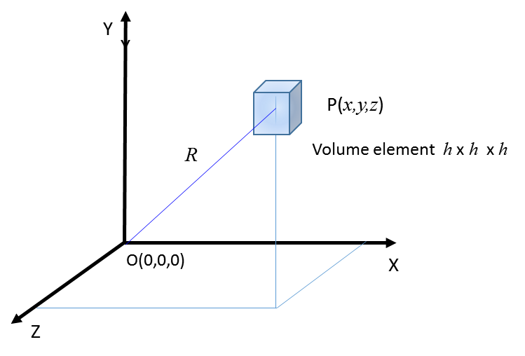

Distances are calculated from the origin O to the point P and the volume element corners surrounding the point P

% Distances from the origin (0,0,0) to the point P and increments around P

R = sqrt(x^2 + y^2 + z^2);

Rx2 = sqrt(x2^2 + y^2 + z^2);

Rx1 = sqrt(x1^2 + y^2 + z^2);

Ry2 = sqrt(x^2 + y2^2 + z^2);

Ry1 = sqrt(x^2 + y1^2 + z^2);

Rz2 = sqrt(x^2 + y^2 + z2^2);

Rz1 = sqrt(x^2 + y^2 + z1^2);

The gradients of the partial derivatives are given by the 3x3 matrices: gradE (numerical) and gradEA (analytical) and are calculated from the electric fields E2 and E1 at two adjacent corners of the volume element



% dEx/dx

E2 = k * x2 / Rx2^3;

E1 = k * x1 / Rx1^3;

gradE(1,1) = (E2 - E1) / h;

gradEA(1,1) = k * (1/R^3 - 3*x^2/R^5);

% dEx/dy;

E2 = k * x / Ry2^3;

E1 = k * x / Ry1^3;

gradE(1,2) = (E2 - E1) / h;

gradEA(1,2) = -k * (3*x*y/R^5);

% dEx/dz;

E2 = k * x / Rz2^3;

E1 = k * x / Rz1^3;

gradE(1,3) = (E2 - E1) / h;

gradEA(1,3) = -k * (3*x*z/R^5);

The code for the divergence and curl

% divergence of the electric field at the point P(x,y,z)

divE = gradE(1,1) + gradE(2,2)+ gradE(3,3);

divEA = gradEA(1,1) + gradEA(2,2)+ gradEA(3,3);

% curl of the electric field at the point P(x,y,z)

curlEx = gradE(3,2) - gradE(2,3);

curlEy = gradE(1,3) - gradE(3,1);

curlEz = gradE(2,1) - gradE(1,2);

The results of the calculations are displayed in the Command Window.

**Example 1**

Charge at origin Q = 3.000e-07 C

Charge density rho = 3.000e+05 C/m^3

rho / eps0 = 3.388e+16 V/m^2

Observation point P(x,y,z)

x = 1.000e+00 m y = 0.000e+00 m z = 0.000e+00 m

Displacement increment h = dx = dy = dz

h = 1.000e-04 m

Partial derivatives: numerical calculations

gradE =

1.0e+03 *

-5.3926 0 0

0 2.6963 0

0 0 2.6963

Partial derivatives: analytical calculations

gradEA =

1.0e+03 *

-5.3926 0 0

0 2.6963 0

0 0 2.6963

Divergence of E

divE = -4.719e-05 m 

divEA = 0.000e+00 m

Curl of E

curlEx = 0.000e+00 m

curlEy = 0.000e+00 m

curlEz = 0.000e+00 m

**Example 2**

Charge at origin Q = 3.000e-07 C

Charge density rho = 3.000e+05 C/m^3

rho / eps0 = 3.388e+16 V/m^2

Observation point P(x,y,z)

x = 7.100e-01 m y = 7.100e-01 m z = 7.100e-01 m

Displacement increment h = dx = dy = dz

h = 1.000e-04 m

Partial derivatives: numerical calculations

gradE =

1.0e+03 *

0.0000 -1.4498 -1.4498

-1.4498 0.0000 -1.4498

-1.4498 -1.4498 0.0000

Partial derivatives: analytical calculations

gradEA =

1.0e+03 *

0 -1.4498 -1.4498

-1.4498 0 -1.4498

-1.4498 -1.4498 0

Divergence of E

divE = 1.119e-05 m 

divEA = 0.000e+00 m

Curl of E

curlEx = 0.000e+00 m

curlEy = 0.000e+00 m

curlEz = 0.000e+00 m

**Example 3:** The volume element surrounds the charge located at the origin

Charge at origin Q = 3.000e-07 C

Charge density rho = 3.000e+05 C/m^3

rho / eps0 = 3.388e+16 V/m^2

Observation point P(x,y,z)

x = 2.500e-05 m y = 2.500e-05 m z = 2.500e-05 m

Displacement increment h = dx = dy = dz

h = 1.000e-04 m

Partial derivatives: numerical calculations

gradE =

1.0e+16 *

1.1850 -0.7120 -0.7120

-0.7120 1.1850 -0.7120

-0.7120 -0.7120 1.1850

Partial derivatives: analytical calculations

gradEA =

1.0e+16 *

-0.0000 -3.3210 -3.3210

-3.3210 -0.0000 -3.3210

-3.3210 -3.3210 -0.0000

Divergence of E

divE = 3.555e+16 m

divEA = -3.160e+01 m

Curl of E

curlEx = 0.000e+00 m

curlEy = 0.000e+00 m

curlEz = 0.000e+00 m

In example 3, the numerical and analytical values do **not** agree ???

The volume element encloses the charge, therefore, the divergence of the electric field is non-zero. From the numerical calculation, the divergence is



which is in reasonable agreement with  as expected from Gauss’s law for electric fields in differential from.

In examples 1 and 2, the divergence is zero as zero charge is enclosed by the small volume element. The divergence is a measure of how much the electric field vector  spreads out (diverges) from the point in question. Although for the point charge the electric field is radiating outward, the magnitude is decreasing to give a zero divergence at all point except at the location of the charge.

In all three examples, each component of the curl of the electric field is zero as expected from Faraday’s law for static electric fields  .

**Radial electric field cemVE21.m**

Suppose the electric field in some region is found to be

 radial electric field

We can find the find the electric field, the divergence of the electric field, the charge density and curl of the electric field at various points in the region of the electric field.

We can also vary the radial distance *R* from the origin O(0,0,0) to find variation of the electric field *E,* charge density and the charge  contained in a sphere of radius *R,* centred at the origin.

The Cartesian coordinates of the point in the region and the distance increment are entered in the input section of the code. The components of the electric field are specified by the inline function

Ex = @(x,R)K .* x .* R.^2;

Using this function, the nine partial derivatives, the divergence and curl of the electric field function are computed. The results of the computation are displayed in the Command Window, for example:

Observation point P(x,y,z)

x = 2.000e+00 m y = 0.000e+00 m z = 0.000e+00 m

Displacement increment h = dx = dy = dz

h = 1.000e-04 m

Electric field strength at point P

E = 8.000e+00 V/m

Partial derivatives: numerical calculations

gradE =

12.0000 4.0000 4.0000

4.0000 4.0000 4.0000

4.0000 4.0000 4.0000

Divergence of E

divE = 2.000e+01 m

Average charge density at point P rho = 1.771e-10 C/m^3

Curl of E

curlEx = 0.000e+00 m

curlEy = -4.658e-12 m

curlEz = 4.658e-12 m

The results show that the divergence is not zero indicating a charge enclosed in a volume element at the point P . The curl of the electric field is zero  since the electric field is radial (no twisting of the electric field lines).

The second part of the mscript **cemVE21.m** calculates the variation in the divergence as a function of *x* from 0 to 10 m along radial line . From the divergence, the charge density  is calculated. The charge enclosed by a sphere of radius *R* is given by the integral



This integral is evaluated by successively adding the area of rectangles of width *dR* and height 

% Charge Q enclosed by a sphere of radius R

dx = x(2)-x(1); Q(1) = x(1)^2 * rhoR(1); Q = zeros(N,1);

for n = 2 : N

Q(n) = Q(n-1) + x(n)^2 * rhoR(n);

end

Q = Q .* (4*pi*dx);

Graphical outputs are shown in Figure Windows

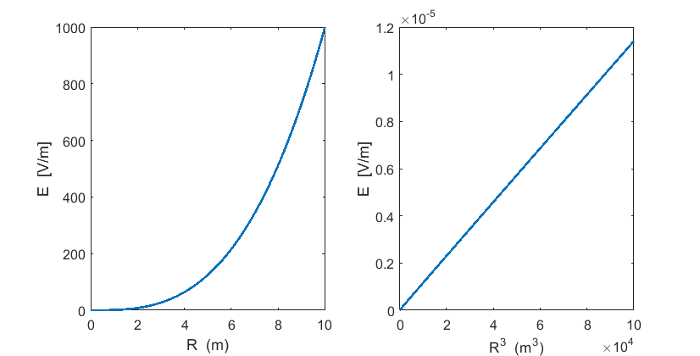

Fig. 1. Radial variation in the electric field 

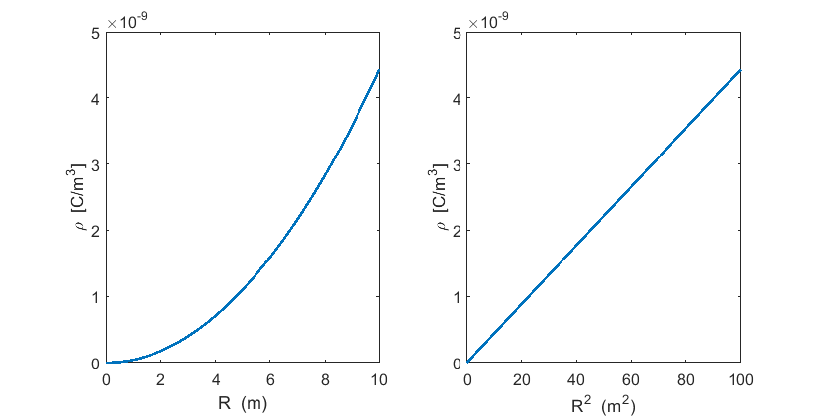

Fig. 2. Radial variation in the charge density 

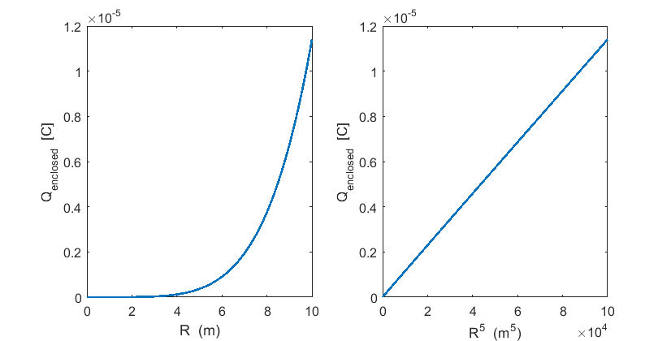

Fig. 3. Radial variation in the charge enclosed 