# 

[**DOING PHYSICS WITH MATLAB**](http://www.physics.usyd.edu.au/teach_res/mp/mphome.htm)

**DYNAMICS OF NONLINEAR SYSTEMS**

**PHASE PLANE ANALYSIS FOR LINEAR SYSTEMS**

# 

Ian Cooper

School of Physics, University of Sydney

ian.cooper@sydney.edu.au

[**http://www.physics.usyd.edu.au/teach_res/mp/mphome.htm**](http://www.physics.usyd.edu.au/teach_res/mp/mphome.htm)

*Arguably the most broad-based evolution in the world view of science in the twentieth century will be associated with chaotic dynamics.*

S.N. Rasband Chaotic Dynamics of nonlinear Systems*.*

[**DOWNLOAD DIRECTORY FOR MATLAB SCRIPTS**](http://www.physics.usyd.edu.au/teach_res/mp/mscripts)

**chaos10.m**

The script is used to find the solutions of a pair of coupled first order differential equation with constant real coefficients. The trajectories for a set of initial conditions are plotted in a phase plane. The vector field of the state variables and the nullclines are also shown in the plot. For different simulations, most of the parameters are changed in the INPUT section of the script.

**Phase plane analysis** is one of the most important techniques for studying the behaviour of nonlinear systems, since there are usually no analytical solutions.

In this document, we will consider the solutions to a pair of coupled first order differential equations with real and constant coefficients for the state variables  of the general form

(1) 

If  then we have a homogeneous system, otherwise an inhomogeneous system.

The first step is to find an **equilibrium solution** to the problem when



An equilibrium solution corresponds to a **fixed point** called a **critical point** or a **stationary point**.

For a linear system, the solutions to find the equilibrium point  can be found by writing the equations in matrix form





The values  are computed with the Matlab statement



We now make the translations



to give the homogeneous linear system

(2A) 

or in matrix form

(2B) 

The critical point for the homogeneous linear system is the Origin (0, 0) if det(K) ≠ 0. If det(K) = 0, then there are infinitely many solutions. We will only consider the case where

det(K) ≠ 0. Since det(K) ≠ 0, both eigenvalues of the matrix K are non-zero.

The two systems (before and after the translations) have the same coefficient matrix K. Hence, their respective critical points will also have identical type and stability classification but with the critical point given by

.

A solution to equation 2 can be expressed in terms of the two 2x2 matrices for the **eigenfunctions** a and **eigenvalues** b of the matrix K. The solutions can be written as

(2A) 

where *C*1 and *C*2 are determined by the initial conditions .

The final solution is expressed as

(2B) 

The eigenfunctions a and eigenvalues b are computed using the function **eig**

[a, b] = eig(K)

The matrices for the coefficients C and c are computed by the Matlab statements

% Initial conditions

xI = [x1I(c);x2I(c)];

% C coefficients

C = a\xI;

% c coefficients

cc = zeros(2,2);

cc(:,1) = a(:,1)*C(1);

cc(:,2) = a(:,2)*C(2);

|  |
| --- |
| **Example 1**    Command Window Output  D.E. coefficients k11 k12 k13 / k21 k23 k23  -1.00 1.00 0.00  0.00 -4.00 0.00    Eigenvalues b =  -1 0  0 -4    Eigenfunction a =  1.0000 -0.3162  0 0.9487  Initial conditions: t =0 corresponds to array index 1.  x1(1) = 9 x2(1) = -9  cc =  6.0000 3.0000  0 -9.0000  Therefore, the solution is    Graphical output:      The upper diagram shows two trajectories starting from the initial locations (x1(1) = 9, x2(1) =+9 and x2(1) = -9). The solutions converge to the fixed equilibrium (critical) point at the Origin (0, 0). The lower diagram shows the time evolution of the state variables for the initial condition x1(1) = 0 and x2(1) = -9. |

Our starting point to look at the dynamics of a system is to set up a **phase plane**. A phase plane plot for a two-state variable system consists of curves of one state variable versus the other state variable , where each curve called a **trajectory** is based on a different initial condition. The graphical representation of the solutions is often referred to as a **phase portrait**. The phase portrait is a graphical tool to visualize how the solutions of a given system of differential equations would behave in the long run.

We can set up a **vector field** which is constructed by assigning the following vector to each point on the *x*1-*x*2 plane:



The slope of these vectors is



Thus, the vector field can be computed without knowing the solutions  and . This allows you to visualize the solution of the system for any given initial condition  as the vector field must be **tangential** to any solutions at all point of the system.

Next we can plot the  and  **nullclines** of the phase plane plot, where the nullclines are the straight lines determined by:

-nullcline 

-nullcline 

Theses nullclines lines show the points where is independent of time  and the points where  is also no longer changing with time. The interscetion of the two nullclines represent **steady-state values** of fixed points of the system.

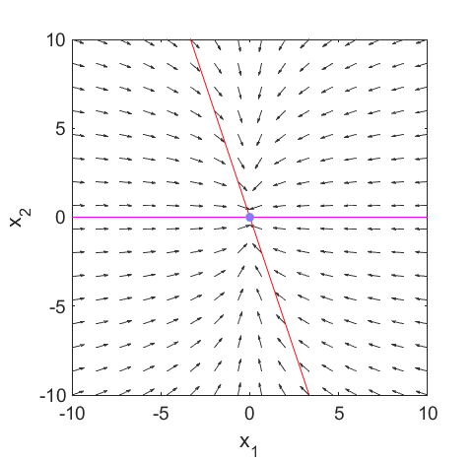

Fig. 1. Vector field (**quiver** function) and **x1** and **x2** nullclines. The arrows point in the direction of increasing time *t.* The critical point is at the intersection of the two nullclines.

The coupled differential equations (equation 1) are specified by the matrix K and the solution for the two state variables depends upon the eigenvalues b and eigenfunctions a of the matrix K. The nature of the eigenvalues (real / imaginary) determine the type of equilibrium for the system. If the eigenvalue is greater than zero, then the term increases exponentially with time and if less than zero, the term decreases exponentially with time, since a solution is of the form: 

where *b*1 and *b2* are the eigenvalues.



The larger the eigenvalue, the faster the response and the smaller the value of the eigenvalue, the slower the response.

Due to the two-dimensional nature of the parametric curves, we will classify the type of those critical points by the shape formed of the trajectories about the critical point.

For distinct real eigenvalues, the trajectories either move away from the critical point to an infinite-distant away (when the eigenvalues are both positive) or move toward from infinite-distant out and eventually converge to the critical point (when eigenvalues are both negative). This type of critical point is called a **node**. It is asymptotically stable if eigenvalues are both negative, unstable if both are positive values.

**Case 1: real eigenvalues of opposite sign**

There is a **saddle** point at the intersection of the two nullclines.

The equilibrium point is **unstable**.

**Case 2: real eigenvalues and both negative**

The **stable** fixed-equilibrium point is called a **nodal sink**.

**Case 3: real eigenvalues and both positive**

The **unstable** fixed-equilibrium point is called a **nodal source**.

**Case 4: imaginary eigenvalues and negative real parts**

The **stable** fixed-equilibrium point is called a **spiral sink**.

**Case 5: imaginary eigenvalues and positive real parts**

The **unstable** fixed-equilibrium point is called a **spiral source**.

**Case 6: purely imaginary eigenvalues**

This gives a generic equilibrium called a **center**.

You can investigate the different types of solutions by running the script **chaos10.m** for each of the following cases.

**Case 1: real eigenvalues of opposite sign**

**The unstable equilibrium point called a saddle.**

D.E. coefficients k11 k12 k13 / k21 k23 k23

1.00 1.00 0.00

4.00 1.00 0.00

Eigenvalues b =

3.0000 0

0 -1.0000

Eigenfunction a =

0.4472 -0.4472

0.8944 0.8944

If the initial condition for , then the trajectory reaches the Origin. Otherwise, the solutions will always leave the origin. Hence, the point (0,0) is an **unstable** equilibrium point for the system and is called a **saddle point**.



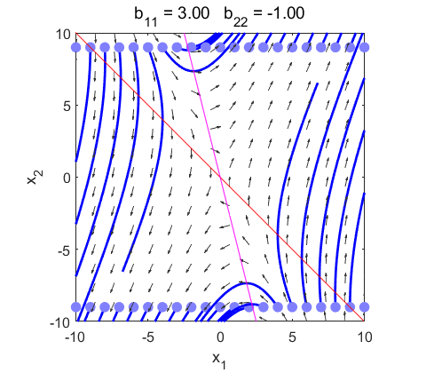

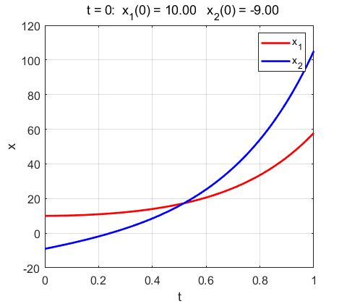

Fig. 1.1. The trajectories are always directed away from the Origin (0, 0). The Origin (0, 0) is an **unstable** equilibrium point called a **saddle point**.

D.E. coefficients k11 k12 k13 / k21 k23 k23

-1.00 0.00 0.00

0.00 4.00 0.00

Eigenvalues b =

-1 0

0 4

Eigenfunction a =

1 0

0 1

Initial conditions: t = 0 x1(1) = 10 x2(1) = -0.2

cc =

10.0000 0

0 -0.2000



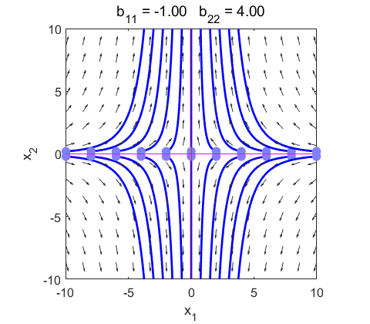

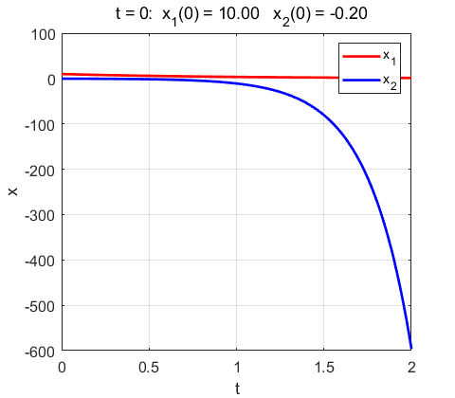

Fig. 1.2. The trajectories are always directed away from the Origin (0, 0). The Origin (0, 0) is an unstable equilibrium point called a **saddle point**.

D.E. coefficients k11 k12 k13 / k21 k23 k23

2.00 1.00 0.00

2.00 -1.00 0.00

Eigenvalues b =

2.5616 0

0 -1.5616

Eigenfunction a =

0.8719 -0.2703

0.4896 0.9628

Initial conditions: t = 0 x1(1) = 10 x2(1) = - 9

cc =

6.4552 3.5448

3.6249 -12.6249



The trajectories given by the eigenvectors of the negative eigenvalue initially start at infinite-distant away, move

toward and eventually converge at the critical point. The trajectories with the eigenvector of the positive eigenvalue move in exactly the opposite way: start at the critical point then diverge to infinite-distant out. Every other trajectory starts at infinite-distant away, moves toward but never converges to the critical point, before changing direction and moves back to infinite-distant away. All the while it would roughly follow the two sets of eigenvectors. This type of critical point is always unstable and is called a **saddle** point.

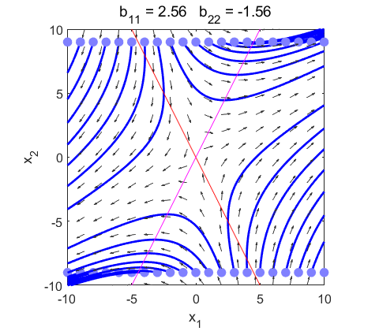

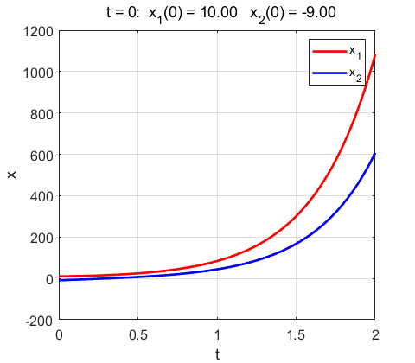

Fig. 1.3. The trajectories are always directed away from the Origin (0, 0). The Origin (0, 0) is an unstable equilibrium point called a **saddle point**.

**Case 2: real eigenvalues and both negative**

**The stable fixed-equilibrium point is called a node sink**.

D.E. coefficients k11 k12 k13 / k21 k23 k23

-1.00 0.00 0.00

0.00 -4.00 0.00

Eigenvalues b =

-4 0

0 -1

Eigenfunction a =

0 1

1 0



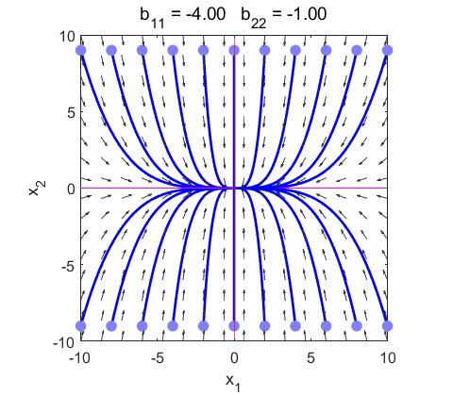

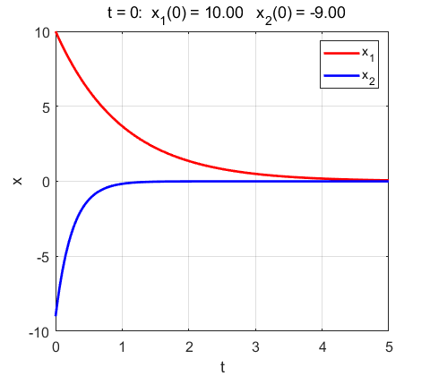

Fig. 2.1. The solutions converge to the Origin (0, 0) for all initial conditions. The point (0,0) is a stable equilibrium point for the system and is called a **stable node** or **nodal sink**.

D.E. coefficients k11 k12 k13 / k21 k23 k23

-2.00 0.00 0.00

1.00 -4.00 0.00

Eigenvalues b =

-4 0

0 -2

Eigenfunction a =

0 0.8944

1.0000 0.4472



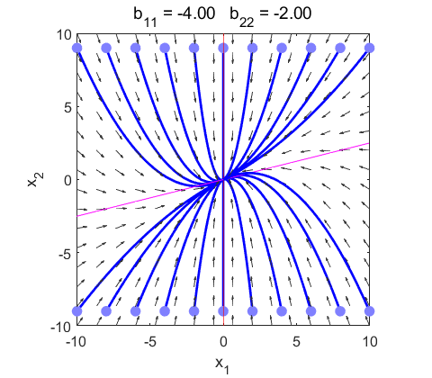

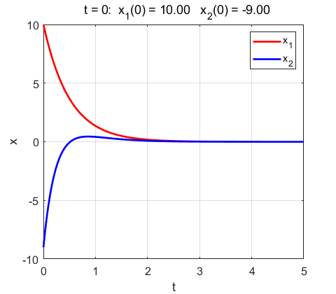

Fig. 2.2. The solutions converge to the Origin (0, 0) for all initial conditions. The point (0,0) is a stable equilibrium point for the system and is called a **stable node** or **nodal sink**.

Nonhomogeneous Linear Systems with Constant Coefficients

D.E. coefficients k11 k12 k13 / k21 k23 k23

1.00 -2.00 -1.00

2.00 -3.00 -3.00

Eigenvalues b =

-1.0000 0

0 -1.0000

Eigenfunction a =

0.7071 0.7071

0.7071 0.7071

The critical point is at (3, 1). It has repeated eigenvalues equal to -1. Hence, there is only one linearly independent eigenvector. Therefore, the critical point at (3, 1) is an **asymptotically stable improper node**.

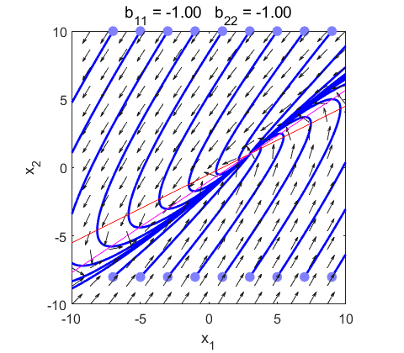

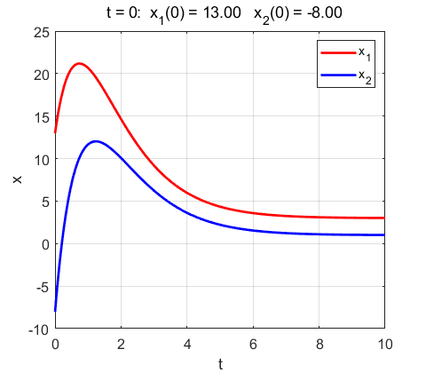

Fig. 2.3 **Asymptotically stable improper node.** The critical point is (3,1).

**Case 3: real eigenvalues and both positive**

**The unstable equilibrium point is called a node source**.

D.E. coefficients k11 k12 k13 / k21 k23 k23

3.00 1.00 0.00

1.00 3.00 0.00

Eigenvalues b =

2 0

0 4

Eigenfunction a =

-0.7071 0.7071

0.7071 0.7071



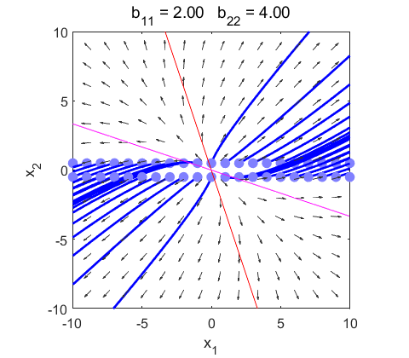

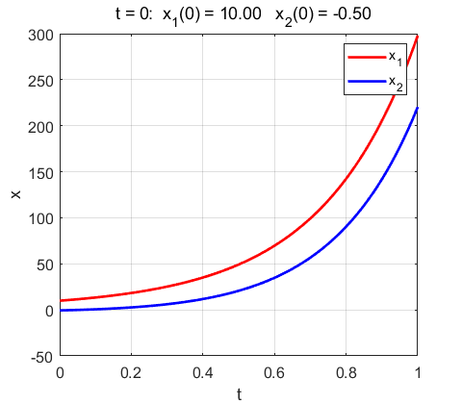

Fig. 3.1. The solutions diverge to the Origin (0, 0) for all initial conditions. The point (0, 0) is an unstable equilibrium point for the system and is called a **nodal source**.

**Case 4: Imaginary eigenvalues with negative Real parts**

**The stable equilibrium point is called a spiral sink**.

D.E. coefficients k11 k12 k13 / k21 k23 k23

-0.20 1.00 0.00

-1.00 -0.20 0.00

Eigenvalues b =

-0.2000 + 1.0000i 0.0000 + 0.0000i

0.0000 + 0.0000i -0.2000 - 1.0000i

Eigenfunction a =

0.7071 + 0.0000i 0.7071 + 0.0000i

0.0000 + 0.7071i 0.0000 - 0.7071i

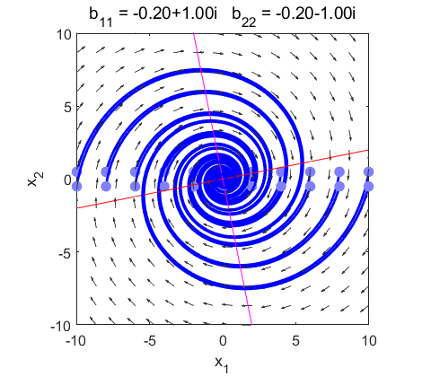

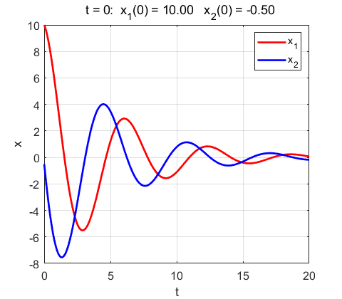

Fig. 4.1. **Spiral sink**. The solutions for the state variables oscillates as they decay towards zero.

D.E. coefficients k11 k12 k13 / k21 k23 k23

4.00 -3.00 0.00

15.00 -8.00 0.00

Eigenvalues b =

-2.0000 + 3.0000i 0.0000 + 0.0000i

0.0000 + 0.0000i -2.0000 - 3.0000i

Eigenfunction a =

0.3651 + 0.1826i 0.3651 - 0.1826i

0.9129 + 0.0000i 0.9129 + 0.0000i

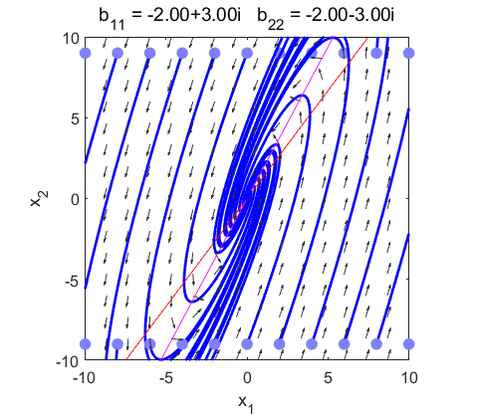

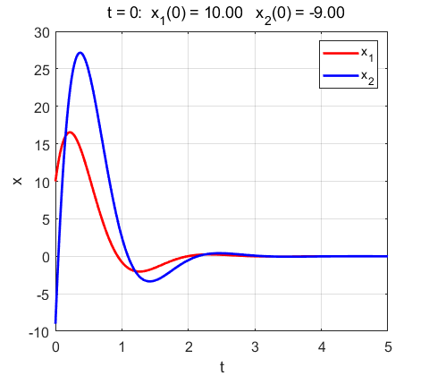

Fig. 4.2. **Spiral sink**. The solutions for the state variables oscillates as they decay towards zero.

**Case 5: Imaginary eigenvalues with positive Real parts**

**The unstable equilibrium point is called a spiral source**

D.E. coefficients k11 k12 k13 / k21 k23 k23

2.00 -1.00 0.00

2.00 0.00 0.00

Eigenvalues b =

1.0000 + 1.0000i 0.0000 + 0.0000i

0.0000 + 0.0000i 1.0000 - 1.0000i

Eigenfunction a =

0.4082 + 0.4082i 0.4082 - 0.4082i

0.8165 + 0.0000i 0.8165 + 0.0000i

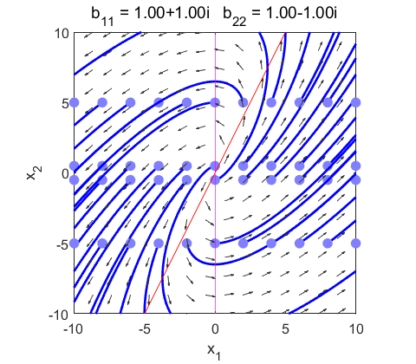

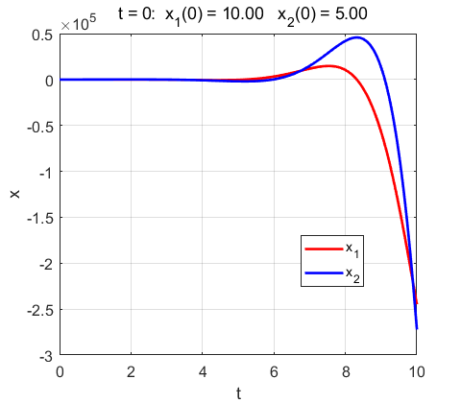

Fig. 5.1. An unstable spiral source.

D.E. coefficients k11 k12 k13 / k21 k23 k23

2.00 -1.00 0.00

2.00 0.00 0.00

Eigenvalues b =

1.0000 + 1.0000i 0.0000 + 0.0000i

0.0000 + 0.0000i 1.0000 - 1.0000i

Eigenfunction a =

0.4082 + 0.4082i 0.4082 - 0.4082i

0.8165 + 0.0000i 0.8165 + 0.0000i

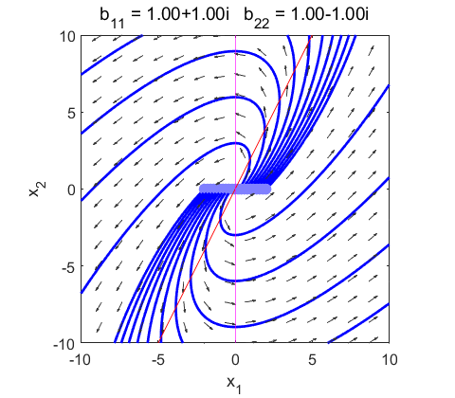

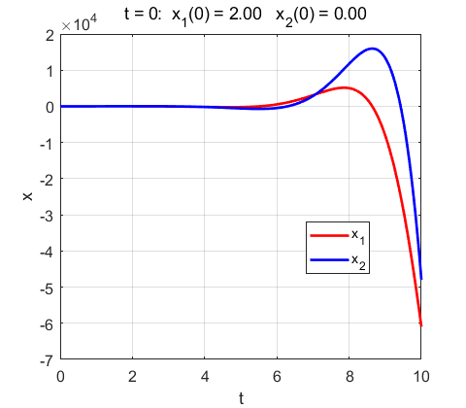

Fig. 5.2. An unstable spiral source.

D.E. coefficients k11 k12 k13 / k21 k23 k23

-2.00 -6.00 8.00

8.00 4.00 -12.00

Eigenvalues b =

1.0000 + 6.2450i 0.0000 + 0.0000i

0.0000 + 0.0000i 1.0000 - 6.2450i

Eigenfunction a =

-0.2835 + 0.5901i -0.2835 - 0.5901i

0.7559 + 0.0000i 0.7559 + 0.0000i

The critical point is at (1, 1). It has complex eigenvalues with positive real parts, therefore, the critical point at (1, 1) is an unstable spiral point.

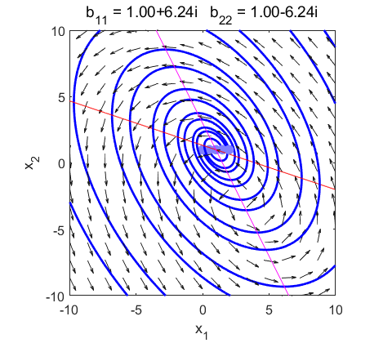

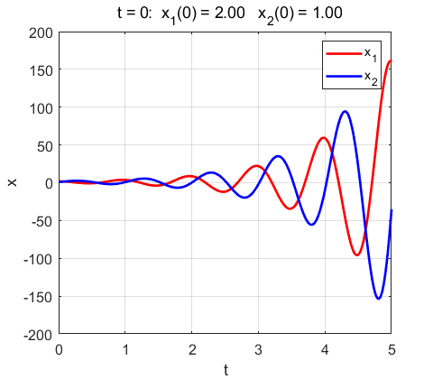

Fig. 5.3. Unstable spiral with the critical point at (1, 1).

**Case 6: Imaginary eigenvalues with zero Real parts**

**The equilibrium point is called a center**.

D.E. coefficients k11 k12 k13 / k21 k23 k23

0.00 -1.00 0.00

1.00 0.00 0.00

Eigenvalues b =

0.0000 + 1.0000i 0.0000 + 0.0000i

0.0000 + 0.0000i 0.0000 - 1.0000i

Eigenfunction a =

0.7071 + 0.0000i 0.7071 + 0.0000i

0.0000 - 0.7071i 0.0000 + 0.7071i

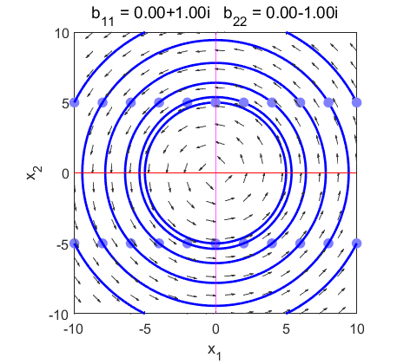

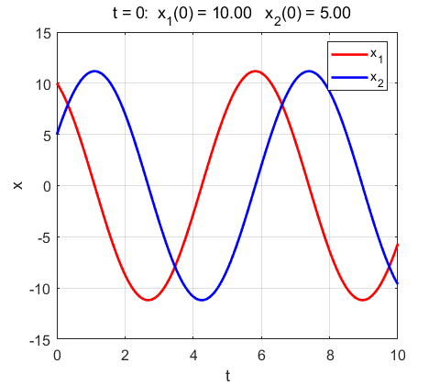

Fig. 6.1. System shows center stability.

D.E. coefficients k11 k12 k13 / k21 k23 k23

-1.00 -1.00 0.00

4.00 1.00 0.00

Eigenvalues b =

0.0000 + 1.7321i 0.0000 + 0.0000i

0.0000 + 0.0000i 0.0000 - 1.7321i

Eigenfunction a =

-0.2236 + 0.3873i -0.2236 - 0.3873i

0.8944 + 0.0000i 0.8944 + 0.0000i

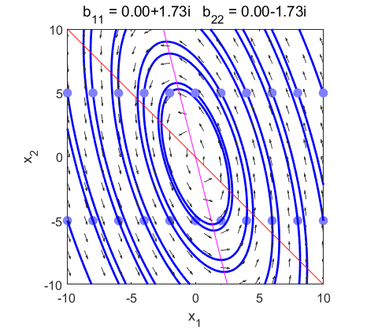

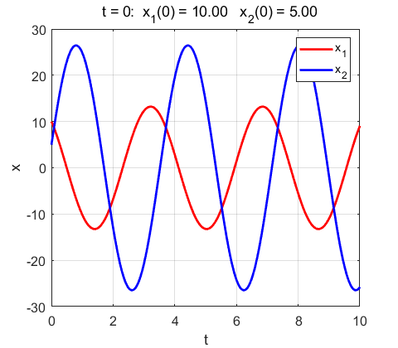

Fig. 6.2. System shows center stability.

**Summary**

**Asymptotically stable**: All trajectories converge to the critical point as . Stable critical point: K eigenvalues are all negative or have negative real part for complex eigenvalues.

**Unstable critical point**: All trajectories (or all but a few, in the case of a saddle point) start out at the critical point at , then move away to infinitely distant out as . A critical point is unstable if at least one of the K eigenvalues is positive or has positive real part for complex eigenvalues.

**Stable (or neutrally stable)**: Each trajectory moves about the critical point within a finite range of distance and never moves out to infinitely distant, nor (unlike in the case of asymptotically stable) does it ever go to the critical point. A critical point is stable if the K eigenvalues are purely imaginary.

As *t* increases, if all (or almost all) trajectories

1. Converge to the critical point → **asymptotically stable**.
2. Move away from the critical point to infinitely far away → **unstable**.
3. Stay in a fixed orbit within a finite (i.e., bounded) range of distance away from the critical point → stable (or neutrally stable).

An application of phase plane analysis which model the retina uses the mscript **chaos10eye.m**

A Simple model of the retina: C-cell / H-cell negative feedback interaction:

<http://www.physics.usyd.edu.au/teach_res/mp/doc/chaos10.pdf>