# 

[**DOING PHYSICS WITH MATLAB**](http://www.physics.usyd.edu.au/teach_res/mp/mphome.htm)

**DYNAMICS OF LINEAR SYSTEMS**

**PHASE PLANE ANALYSIS:**

**SIMPLE MODEL OF THE RETINA**

# 

Ian Cooper

School of Physics, University of Sydney

ian.cooper@sydney.edu.au

[**http://www.physics.usyd.edu.au/teach_res/mp/mphome.htm**](http://www.physics.usyd.edu.au/teach_res/mp/mphome.htm)

[**DOWNLOAD DIRECTORY FOR MATLAB SCRIPTS**](http://www.physics.usyd.edu.au/teach_res/mp/mscripts)

**chaos10eye.m**

The script is used to find the solutions for a pair of coupled first order differential equation with constant real coefficients which model the negative feedback interaction between a cone of the retina and the horizontal cells. The script **chaos10eye.m** is a modification of the script **chaos10.m**.

**chaos10.m**

Phase plane analysis of linear systems.

Reference: [Phase Plane Analysis of Linear Systems](http://www.physics.usyd.edu.au/teach_res/mp/doc/chaos10.pdf)

**The Eye**

The retina is the part of the eye that transforms light into an electrochemical message sent to the brain for processing. The retina is composed of five cell layers. The layer responsible for processing the incident light falling upon the retina is composed mainly of two different cells types called **cones** and **rods**. Rods are mainly responsible for sensing brightness and cones are responsible for detecting color. There are three types of photoreceptor cells in the retina of the human eye called **cone cells** (**S**-cones, **M**-cones and **L**-cones: each cone is sensitive to visible wavelengths of light that correspond to short-wavelength, medium-wavelength and long-wavelength light). Each type of cone detects a certain colour: red, green or blue. Another type of photoreceptor are **rod cells**.

Cone cells are densely packed in the fovea centralis, a 0.3 mm diameter rod-free area. The densely of the cones quickly reduces towards the periphery of the retina. There are about six to seven million cones in a human eye and are most concentrated towards the macula. Rods are usually found concentrated at the outer edges of the retina and are used in peripheral vision. On average, there are approximately 90 million rod cells in the human retina.

Rod cells function in less intense light than the cone cells. Hence, rod cells are more sensitive than cone cells and are almost entirely responsible for night vision. However, rod cells have little role in color vision, which is the main reason why colors are much less apparent in dim light, and not at all at night. On the other hand, cone cells responsible for color vision and function best in relatively bright light.

**Horizontal cell**s are the laterally interconnecting neurons having cell bodies in the inner nuclear layer of the retina. They help integrate and regulate the input from multiple photoreceptor cells. Among their functions, horizontal cells are responsible for allowing eyes to adjust to see well under both bright and dim light conditions. Horizontal cells provide inhibitory feedback to rod and cone photoreceptors.

In this document we will only consider the **negative feedback** interaction between a cone cell (**C**)and a horizontal cell (**H**).



The incident light on a cone cell (C-cell) causes it to hyperpolarize as current no longer enters the C-cell due to the closure of ion channels on its cell membrane. The C-cell has a synaptic connection to the horizontal cells (H-cells) in the next retinal layer. The hyperpolarization of the C-cells reduces the release of glutamate (excitatory neurotransmitter) which decreases the activity in the postsynaptic H-cells. But the H-cells have synaptic connections back to the C-cells as well as postsynaptic connection to the bipolar cells in the next retinal layer. H-cells release GABA (inhibitory postsynaptic effects), so the cones become less inhibited. Thus, there is a **negative feedback loop**: the initial light induces C-cells to hyperpolarize which causes the H-cells to feed back upon the cones in a way to oppose the initial hyperpolarization.

**Model of the C-cell / H-cell negative feedback interaction**

We can model the negative feedback loop interaction between a C-cell and a H-cell by a system of two linear differential equations. The two state variables are:

 current leaving a cone cell (C-cell)

 current leaving a horizontal cell (H-cell)

The system is represented as follows



 Change in C-cell current is proportional to the negative value of the current leaving a C-cell.

 change in C-cell current is proportional to the negative value of the current leaving a H-cell.

 Change in C-cell current is proportional to the light level *L.* If the light level is high, then many photons will pass through the pupil onto the retina and activate the cones which results in a large cone current.

 Change in H-cell current is proportional to the value of the current leaving a C-cell.

 Change in C-cell current is proportional to the negative value of the current leaving a H-cell.

**Simulation 1: High light levels**

Typical values for system parameters

Initial conditions 



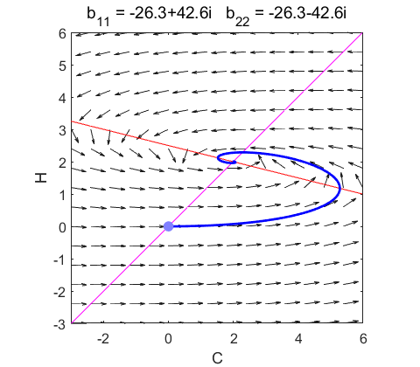

Fig. 1.1. The eigenvalues of the K matrix are complex with negative real parts. The phase space portrait is a **stable spiral** with the critical point (fixed-equilibrium point) at C = 2 and H = 2.

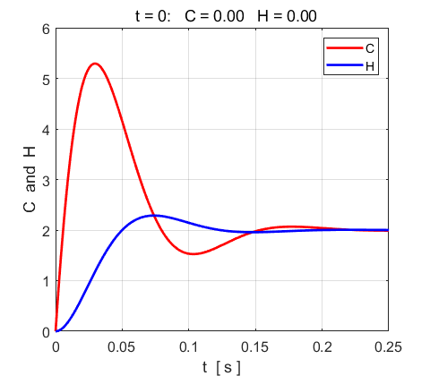

Fig. 1.2. C is the current leaving a C-cell and H is the current leaving a H-cell. There is a negative feedback loop between the C-cells and the H-cells: the increasing H value results in a decrease in the C value so that the values of C and H evolve from their initial values (C =0 and H = 0) to their steady state values, C= 2 and H = 2.

**Simulation 2: Low light levels**

Typical values for system parameters

Initial conditions 



For low light levels it takes longer for the cells to respond.

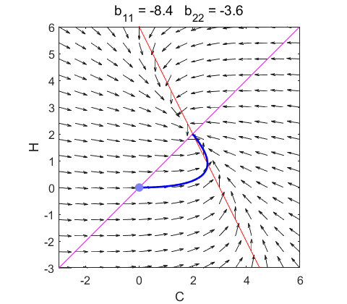

Fig. 2.1. The eigenvalues of the K matrix are complex with negative real parts. The phase space portrait is a **stable spiral** with the critical point (fixed-equilibrium point) at C = 2 and H = 2.

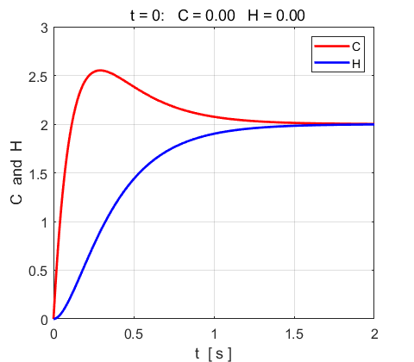

Fig. 2.2. C is the current leaving a C-cell and H is the current leaving a H-cell. There is a negative feedback loop between the C-cells and the H-cells: the increasing H value results in a decrease in the C value so that the values of C and H evolve from their initial values (C =0 and H = 0) to their steady state values: C= 2 and H = 2.

In low light levels, the response of the both the C-cells and H-cells is much slower and the current levels significantly smaller than high light levels.

The document is based on a chapter from the book

***Matlab for Neuroscientists*** by Pascal Wallisch …