**[DOING PHYSICS WITH MATLAB](https://d-arora.github.io/Doing-Physics-With-Matlab/)**

**BURSTING NEURON MODEL USING TWO AND THREE COUPLED FIRST ORDER DIFFERENTIAL EQUATIONS**

**Ian Cooper**

**matlabvisualphysics@gmail.com**

**MATLAB Download Directories and Scripts**

https://drive.google.com/drive/u/3/folders/1j09aAhfrVYpiMavajrgSvUMc89ksF9Jb

https://github.com/D-Arora/Doing-Physics-With-Matlab/tree/master/mpScripts

**cnsHindmarshB.m**

Uses ode45 function to solve two / three coupled first order equations which describe a bursting neuron.

Solution Variables

y(:,1) membrane potential v

y(:,2) recovery variable w

y(:,3) adaptation current z

Input Variables

Simulation time: tSpan

Initial conditions: y0 = [v(0) w(0) z(0)]

Current pulse: K(7) pulse height Imax

K(11) pulse on / K(12) pulse off

K(12) - K(11) pulse duration

2 coupled ODEs constants: K(1) to K(6)

3 coupled ODEs constants: K(9) K(10)

K(8) adaptation variable: K(8) = 0 --> 2 coupled ODEs model

For different models, it may be necessary to make changes to the Script

Outputs

* Time evolution plots
* PHASE PLANE ANALYSIS: phase space plot (v-w trajectory)

v - w vector field, v and w nullclines

Equilibrium (critical) points vC and wC

ode45

[t,y] = ode45(@(t,y) FNode(t,y,K), tSpan,y0);

function dydt = FNode(t,y,K)

% y(1) == v; y(2) == w; y(3) == z

Imax = 0;

if t > K(11); Imax = K(7); end

if t > K(12); Imax = 0; end

dydt(1) = K(1)*y(2)+K(2)*y(1)^3+K(3)*y(1)^2+Imax+y(3);

dydt(2) = K(4) + K(5)*y(1)^2 + K(6)*y(2);

dydt(3) = K(8)*( K(9)*(y(1) - K(10)) - y(3) );

dydt = dydt';

end

This document is based upon the paper by J. L. Hindmarsh and R. M. Rose

*A model of neuron bursting using three coupled first order differential equations*

Proceedings of the Royal Society of London. Series B, Biological Science, Volume 221, Issue 1222, (Mar 22, 1984)87-102.

**NEURON BURSTING MODEL**

The Hindmarsh and Rose model considers the following system of three coupled ODEs to generate action potentials

(1) 

where *v* represents the membrane potential, *w* is a recovery variable, *Iext* is an applied external current stimulus, and *z* is an adaptation current, and *k*1 to *k*10 are constants. The constant *k*10 is determined from the *v*-*w* coordinates (*vC*1, *wC*1) of the stable equilibrium point (left most) of the model for *I*(*t*) = 0 and without adaption, *k*10 = *vC*1. The external current stimulus *Iext* (*t*) is specified by *k*7 for its height and pulse duration by *k*11 (on) and *k*12 off.

If *z*(0) = *z*0 = 0 and *k*8 = 0 which gives , then only two coupled equations are necessary to describe the system.

(2) 

This model is similar to the Fitzhugh-Nagumo model except that the time rate of change of the recovery variable  includes a quadratic term rather than a linear term.

Figure 1 shows an intracellular recording of a neuron in the visceral ganglion of the small snail, lymnaea stagnalis when it was stimulated by a short depolarizing current stimulus. After the current excitation, a series of action potentials are generated (bursting). The cell is usually silent, but when depolarized for about 100 ms, it spikes several times and then continues to spike even after the cessation of the current stimulus before the membrane potential falls to a value less than its initial value.

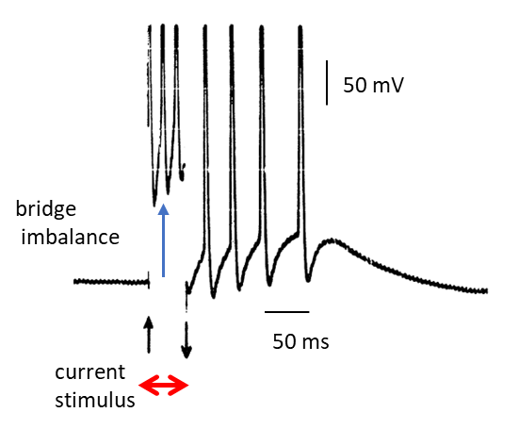

Fig. 1. Intracellular recording of a neuron in the visceral ganglion of the small snail, lymnaea stagnalis [Hindmarsh & Rose].

The neuron bursting model can be used to simulate a bursting neuron and the results of the model can be compared with recordings of neurons to external current stimuli as shown in figure 1. The set of equations 1 are solved in Matlab using the ode45 function. The solution of the set of equations 1 give the time evolution of the three variables: membrane potential *v*, recovery variable *w* and the adaptation current *z* in response to an external current stimulus *Iext*.

The firing behaviour of a neuron can be better understood more easily by examining the *v-w* phase space plot which shows the vector field by *v*-*w* arrows of unit length, the *v*-*w* trajectory, the *v* and *w* nullclines, the equilibrium (critical) points *vC* and *wC*, the initial conditions v0 and *w*0 and the final values for *v*(*t*) and *w*(*t*).

The nullclines for *v* and *w* are obtained from equation 1 by setting  and 

*v*-nullcline (cubic function in *v*)

(2A) 

*w*-nullcline (quadratic function in *v*)

(2B) 

The *v*-nullcline is a function of *Iext*(*t*). When *Iext*(*t*) changes, the position of the *v*-nullcline would change in the phase space plot. To overcome this problem, the *v*-nullcline and equilibrium points *vC* and *wC* are calculated by setting *Iext*(*t*) = 0 and with zero adaptation current, *z*(*t*) = 0.

The equilibrium points *vC* and *wC* are the points of intersection of the two nullclines where  and . The critical points are found using the Matlab symbolic function **vpasolve**. There are three equilibrium points, the stable, saddle, and unstable shown in figure 2 when *Iext* = 0 and *z*(*t*) = 0. When the peak external current is increased to *Imax* = 1.00, there is only the unstable equilibrium point as shown in figure 2.

The two coupled ODEs model will first be used, followed by the three coupled ODEs model.

My simulation results are similar but different from the results given by Hindmarsh and Rose when essentially the same model parameters were used. Not sure why the discrepancy !!!

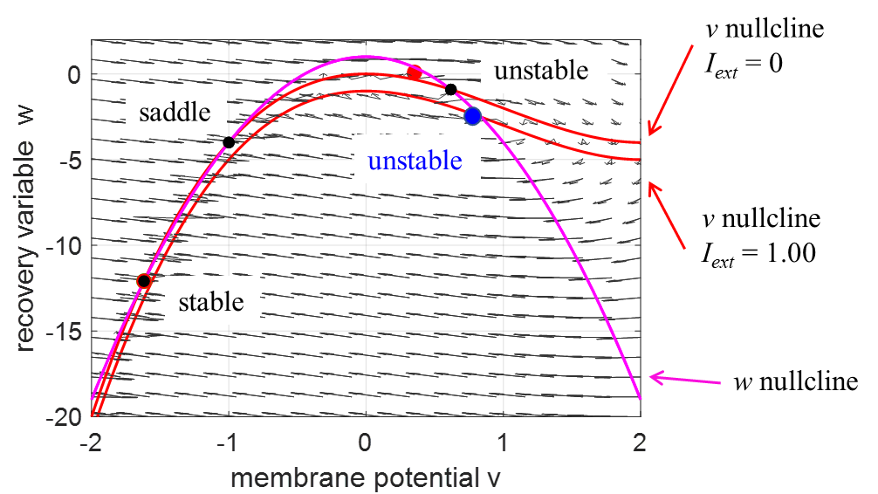

Fig. 2 *v-w* vector field showing the three equilibrium points (black dots: stable, saddle and unstable) when *Iext* = 0 and *z* = 0 at the intersection of the *v* nullcline and the *w* nullcline. When the external current increases to *Iext* = 1.00, the *v*-nullclines is lower and the only intersection point of the two nullclines is the unstable equilibrium point (blue dot).

**TWO COUPLED ODEs NEURON BURSTING MODEL**

By setting the adaptation parameter to zero , then the two coupled ODEs (equation 2) describe the system. The solution of the two coupled ODEs depends upon the initial conditions  and the external current stimulus *Iext*(*t*) for a given set of model parameters *k*1 to *k*6.

**Simulation 1 *Iext*(*t*) = 0**

Model parameters

Initial conditions



Constants

*k*1 = 1 *k*2 = -1 *k*3 = 3 *k*4 = 1 *k*5 = -5 *k*6 = -1

Current stimulus

***k*7 = 0** k11 = 50 *k*12 = 70

Adaptation current

***k*8 = 0** *k*9 = 0 *k*10 = 0.84

Equilibrium points



We can consider the simulation when the external current stimulus is set to zero, *Iext*(*t*) = 0. For the case in which *Iext*(*t*) = 0, there are three equilibrium (critical) points and are shown as black dots in figure 3. Figure 3 shows the phase space plot which includes the *v-w* vector field, the *v* and *w* nullclines, the equilibrium points, the initial points and finals points. The equilibrium point at  is unstable. If the initial conditions  are set near this equilibrium point, the *v-w* trajectory will be attracted to the limit cycle surrounding this unstable equilibrium point and the neuron will fire repetitively even without any external current stimulus.

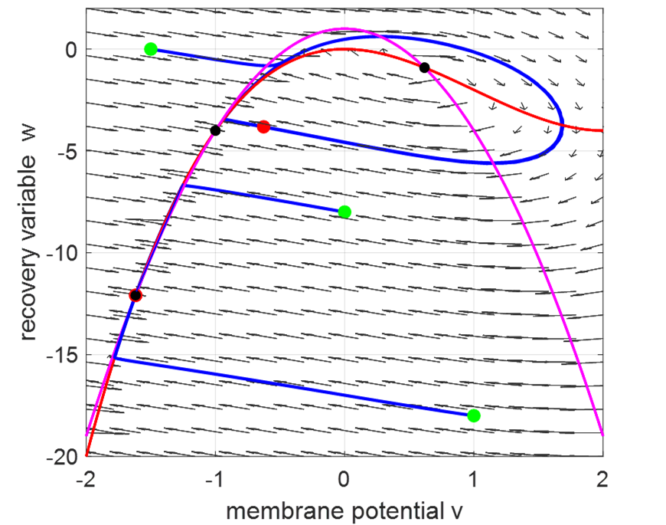

Fig. 3 Phase space plot for three different initial conditions. There are three equilibrium or critical points (**black** dots) at the intersection of the *v*-nullcline (red) and *w*-nullcline (magenta) with *Iext* = 0. The green dots indicate the initial conditions used in the simulation and the red dots the final values for *v* and *w*.

The equilibrium point at  is a stable. The equilibrium point at  is a saddle point. If the initial conditions  are set near the saddle point, then the *v*-*w* trajectory will either be attracted to the limit cycle and a spike train will occur or to the stable equilibrium point and the neuron will not fire (figure 4).

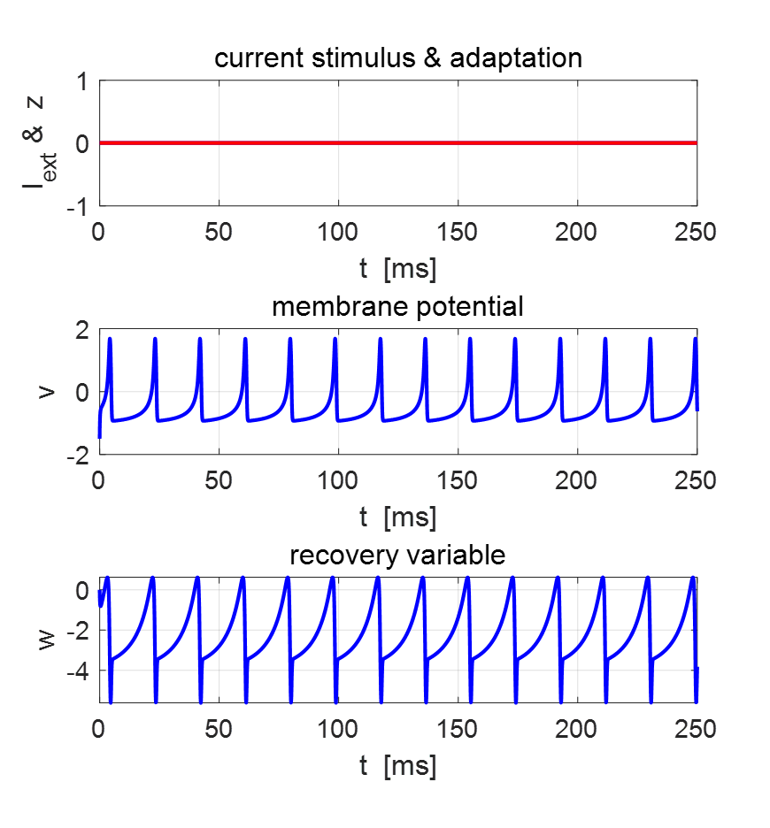

Fig. 4 Time evolution plot for the current stimulus *Iext* = 0, adaptation current *z* = 0, membrane potential *v* and recovery variable *w*. The neuron fires repetitively even though the external current stimulus is zero. 



Fig. 5 Time evolution plots for the current stimulus *Iext* = 0, adaptation current *z* = 0, membrane potential *v* and recovery variable *w*. The neuron does not fire. 

Thus, the phase space is divided into two regions. Depending on the initial conditions, the trajectory will be attracted to the limit cycle and the cell fires continuously or the trajectory is deflected to the stable equilibrium point and no firing occurs.

**Simulation 2 Square pulse current stimulation**

Model parameters

Initial conditions



Constants

*k*1 = 1 *k*2 = -1 *k*3 = 3 *k*4 = 1 *k*5 = -5 *k*6 = -1

Current stimulus

*k*11 = 50 *k*12 = 70

Adaptation current

***k*8 = 0** *k*9 = 0 *k*10 = 0.84

Equilibrium points



Figure 6 shows the phase space plot and time evolution plots for zero external current stimulus given the initial conditions.. The system evolves to the stable equilibrium point and the neuron fails to spike. However, figure 7 shows that if the neuron is excited by a square pulse of height 1.00 and duration 25 ms with the same initial conditions , then the *v*-*w* trajectory is now attracted to the limit cycle centred on the single unstable equilibrium point . The neuron fires rapidly during the time of the pulse. After a short delay following the termination of the current stimulus, the neuron fires repetitively at a constant rate. The rise in the membrane potential *v* is caused by external current stimulus which depolarized the neuron.





Fig. 6 Phase space plot and time evolution plots for zero current stimulus. The neuron does not fire and the *v*-*w* trajectory is attracted to the stable equilibrium point. 





Fig. 7 Phase space plot and time evolution plots. The neuron is stimulated by a current pulse of height 1.0 and duration 25 ms. The neuron fires rapidly during the pulse and then fires periodically. The *v*-*w* trajectory is attracted to the unstable equilibrium point. 

If the current stimulus increases, then *v*-nullcline will move down and move up when the current stimulus decreases. So, if the current stimulus changes with time, this could result in a transition between one or three equilibrium points and the cell either repetitive firing or no firing.

**Simulation 3 Square pulse stimulation – limited firing**

Model parameters

Initial conditions



Constants

*k*1 = 1 *k*2 = -1 *k*3 = 3 *k*4 = 1 *k*5 = -5 *k*6 = -1

Current stimulus

*k*11 = 50 *k*12 = 70

Adaptation current

***k*8 = 0** *k*9 = 0 *k*10 = 0.84

Equilibrium points



When the neuron is stimulated by a square current pulse of height 1.00 and duration 25 ms and with initial conditions , the neuron responses by only firing during the pulse. After the cessation of the current stimulus, both the membrane voltage and recovery variable monotonically decrease to their resting values (figure 8).





Fig. 8 Phase space plot and time evolution plots. and the neuron stimulated by a current pulse of height 1.0 and duration 25 ms. The neuron fires only for the duration of the current stimulus.

 

The Hindmarsh and Rose’s two coupled model can give an adequate qualitative representation which described the bursting behaviour observed in some neurons. The two coupled ODEs model can reproduce the initial burst of repetitive firing of observed in the cell the lymnaea visceral ganglion except that it did not fire indefinitely, but slowed down and was terminated by a slow after-hyperpolarizing wave (figure 1). A simple way to introduce this effect into the model is by adding an adaption slow current that hyperpolarizes the cell. This leads to a set of three coupled ODEs model given by equation 1.

**THREE COUPLED ODEs NEURON BURSTING MODEL**

Figure (1) shows an intracellular recording of a neuron in the visceral ganglion of the small snail lymnaea stagnalis when it was stimulated by a short depolarizing current stimulus. After the current excitation, a series of action potentials are generated (bursting). The cell is usually silent, but when depolarized for about 100 ms, it spikes several times and then continues to spike even after the cessation of the current stimulus for some time. The firing sequence is terminated with a slow after-hyperpolarizing wave. This may be the result of a slowing increasing outward current which produced the repolarization.



Fig. 1. Intracellular recording of a neuron in the visceral ganglion of the small snail lymnaea stagnalis [Hindmarsh].

However, in the two couple ODEs, once the firing is initiated, the cell continuous to undergo repetitive firing. To account for the repolarization of the cell after firing, we can introduce an adaptation current *z* into the model to give three coupled ODEs (equation 1). The depolarizing current depends upon the values of *k*8 and *k*9.

**Simulation 4 Square pulse stimulation – adaptation**

Model parameters

Initial conditions



Constants

*k*1 = 1 *k*2 = -1 *k*3 = 3 *k*4 = 1 *k*5 = -5 *k*6 = -1

Current stimulus

*k*11 = 50 *k*12 = 75

Adaptation current

***k*8 = …** *k*9 = 1 *k*10 = -1.680

Equilibrium points (*I*(*t*) = 0, *z*(*t*) = 0)



Figures 9 and 10 shows the response of the neuron to a short current stimulus. Figure 9 is for the case of no adaptation (*k*8 = 0) where the response is a persistent spike train.



Fig. 9 Time evolution plots of the stimulus current *I*, adaptation current *z*, membrane potential *v* and recovery variable *w* for a short current stimulus and with no adaptation (*k*8 = 0). The continuous spike train of action potential is generated.

When the adaption current is added (*k*8 = 0.001) to the model, the response is an isolated burst of action potential and the membrane potential has similar characteristics of the intracellular recording of a neuron in the visceral ganglion of the small snail lymnaea stagnalis shown in figure 1.



Fig. 10 Time evolution plots of the stimulus current *I*, adaptation current *z*, membrane potential *v* and recovery variable *w* for a short current stimulus and with adaptation (*k*8 = 0.001, *k*9 = 1.00). A burst of action potentials is triggered.

The strength of the adaptation is controlled by the adaptation variable *k*9. As *k*9 is increased, the repolarizing current *z* increases and the shorter the bursting activity of the neuron becomes and if *k*9 is decreased, firing occurs for a longer time as shown in figure 10 (*k*9  = 1.00), figure 11 (*k*9 = 0.70) and figure 12 (*k*9 = 4.00)



Fig. 11 Time evolution plots of the stimulus current *I*, adaptation current *z*, membrane potential *v* and recovery variable *w* for a short current stimulus and with adaptation (*k*8 = 0.001, *k*9 = 0.70). A burst of action potentials is triggered that is longer than the burst with *k*9 = 1.00.



Fig. 12 Time evolution plots of the stimulus current *I*, adaptation current *z*, membrane potential *v* and recovery variable *w* for a short current stimulus and with adaptation (*k*8 = 0.001, *k*9 = 4.00). A burst of action potentials is triggered that is much shorter than the spike train with *k*9 = 1.00.

A current stimulus results in a lowering of the *v* nullcline compared with the instance when *I*(*t*) = 0. For the example where *Imax* = 1.00 as shown in figures 10 and 13, there is no longer three equilibrium pointsbut only one equilibrium point  which is unstable.



Fig. 13 Phase space plot of figure 10 for a short current stimulus with adaptation and parameters (*Imax* = 1.00, *k*8 = 0.001, *k*9 = 1.00).

We can explain the bursting sequence using the details shown in a phase space plot (figure 13) and its corresponding time evolution plot (figure 10). Consider the model neuron, initially at rest with initial conditions  and there will be three equilibrium points



A short current pulse stimulus is applied to the neuron. The current stimulus causes the *v* nullcline to be displaced downward such that the only equilibrium point is the unstable one . As a consequence, the phase point moves into the limit cycle and each time an action potential occurs, the adaptation current *z* is incremented and the *v* nullcline will be displaced upward on successive cycles. The firing rate will decrease as the *v* nullcline and *w* nullcline become closer together at the saddle point  until the two nullclines cross each other and the firing stops and the phase point slowly moves downward in the narrow channel between the *v* nullcline and the *w* nullcline towards the stable equilibrium point  as shown in figure 14. This slow left and downward movement of the phase point gives rise to the hyperpolarizing of the membrane potential where the value of the membrane potential *v* is below the initial value *v*0. After a long time, the adaptation current *z* will relax back to zero and the final membrane potential *v* will move back to its initial value *v*­0.

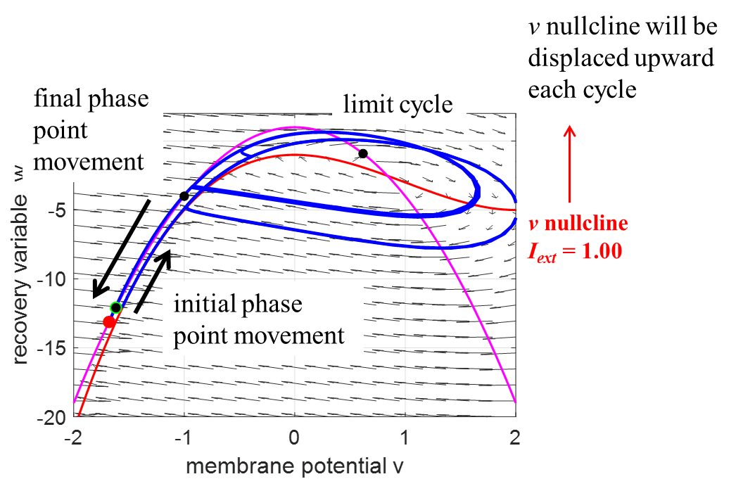

Fig. 14 Phase space plot. The three black dots show the positions of the three equilibrium points : stable , saddle , and unstable . The magenta curve is the *w* nullcline and the red curve is the *v* nullcline when *I* = 1.00. The green dot is located at the point which is the stable equilibrium point and the red dot the final *v-w* position.

The snail recording (figure 1) and the model (figures 10 and 15) both show an interesting feature. After the cessation of the bursting, the neuron becomes hyperpolarized with the membrane potential more negative than its initial value (-1.6180 > -1.6816). However, the membrane potential *v* will very slowly return to its starting value (stable equilibrium point ).

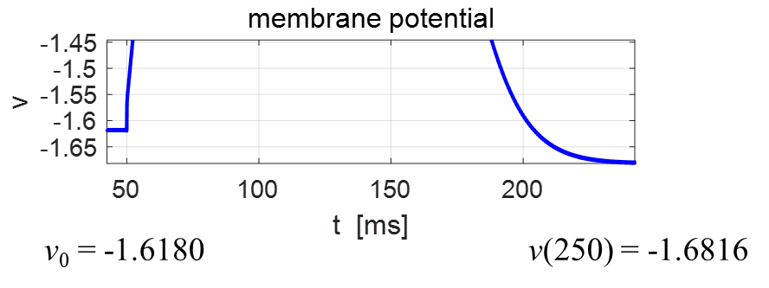

Fig. 15 Expanded view of the membrane potential which shows the hyperpolarizing effect after the cessation of the bursting activity.

We can plot a three-dimensional plot of the three variables (figure 16): membrane potential *v*. recovery variable *w*, and adaptation current *z*. The adaptation variable changes more slowly the membrane potential *v*. and recovery variable *w*.

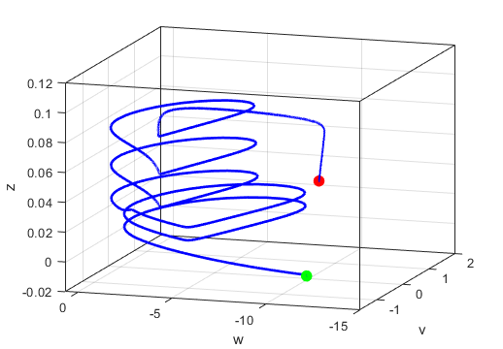

Fig. 16 [3D] phase space plot of membrane potential *v*. recovery variable *w*, and adaptation current *z*.

(*Imax* = 1.00, *k*8 = 0.001, *k*9 = 1.00*, tmax*= 500 ms)

**Simulation 5 BURST GENERATION**

We can consider the response of the membrane potential to a step current stimulus. The model parameters are

Initial conditions



Constants

*k*1 = 1 *k*2 = -1 *k*3 = 3 *k*4 = 1 *k*5 = -5 *k*6 = -1

Current stimulus

*k*11 = 50 *k*12 = 5002

Adaptation current

*k*8 = 2x10-3 *k*9 = 2 *k*10 = -1.6180

Equilibrium points (*I*(*t*) = 0, *z*(*t*) = 0)



The adaptation current *z* acts as a hyperpolarizing current that rises and falls triggering a sequence of isolated bursts separated by hyperpolarized periods as shown in figure 17. Different burst generation patterns are obtained by using different values for the parameters *Imax* and *k*9. This burst generation pattern can be explained in terms of the *v*-*w* phase space plot as was done for figure 14.



Fig. 17 Burst generation (*k*8 = 2.0x10-3, *k*9 = 2).

**CONCLUSION**

The bursting neuron model only gives a qualitative explanation of the bursting behaviour of real neurons and it may be difficult to relate model parameters to biological features. However, the model does provide insights into the behaviour of why neurons can exhibit bursting patterns.