[**DOING PHYSICS WITH MATLAB**](http://www.physics.usyd.edu.au/teach_res/mp/mphome.htm)

**ELECTROMAGNETISM**

# MOVING CHARGES IN ELECTRIC

# AND MAGNETIC FIELDS

# 

Ian Cooper

School of Physics, University of Sydney

ian.cooper@sydney.edu.au

[**DOWNLOAD DIRECTORY FOR MATLAB SCRIPTS**](http://www.physics.usyd.edu.au/teach_res/mp/mscripts)

**em_vBE_01.m**

mscript used to calculate the trajectory of charged particles moving in a constant magnetic field or a constant electric field or constant crossed magnetic and electric fields. The input parameters are changed within the mscript.

The mscript could be changed to study the motion of charged particles where the fields are non-uniform in space and time.

**Introduction**

A charged particle of mass *m* and charge *q* will experience a force acting upon it in an electric field . Also, the charged particle will experience a magnetic force acting upon it when moving with a velocity *v* in a magnetic field .

If the charged particle is moving in the presence of both the an electric field and magnetic field, the force  acting on it is called the **Lorentz force**

(1)  **Lorentz force**

If the charged particle is stationary (*v* = 0), the force depends only of the electric field. The direction of the electric force is in the same direction as the electric field if *q* > 0 and the electric force is in the opposite direction to the electric field if *q* < 0.

When a charged particle is moving only in a magnetic field, the direction of the magnetic force is at right angles to both the direction of motion and the direction of the magnetic field as given by the right hand palm rule.





The magnetic force  is always perpendicular to the velocity  and so it does no work on the particle and does not change its speed or kinetic energy. The magnetic force only changes the direction of motion, which tends to make the charged particle go in a circle or in a helix.

The charged particle will move in a circular path of radius *R* in a uniform magnetic field when  and are perpendicular to each other. In this situation, the centripetal force is simply the magnetic force



(2) 

The radius of the circular orbit depends on the momentum of the particle, its charge and the strength of the magnetic field.

A charged particle trapped going in circles in a **B** field displays a characteristic **cyclotron frequency**  (or *f* )*.* The period *T* is the time for one revolution

(3a) 

(3b)  **cyclotron frequency**

The period *T a*nd the cyclotron frequency  are both independent of the velocity of the particle. This fact is made use of in many applications.

If the charge particle’s velocity is neither parallel nor perpendicular to the magnetic field, the trajectory of the particle is a helix. If the **B** field is parallel to the Z axis and the initial velocity is parallel to the XZ plane, then, the particle moves in the Z direction with uniform speed *vz* while it continues to go in circles of radius  where the is the velocity of the charged particle in an XY plane.

If there is region of crossed **E** and **B** fields  then the magnitudes of the fields can be adjusted so that a particle can move without any deflection when

(4)  velocity *v i*ndependent of the mass *m*

In the region of the crossed **E** and **B** fields, the trajectory will be a cycloid if the speed is not too great. The charged particle starts from rest, then, it tends to migrate in the direction of the vector .

The motion of charged particle, usually electrons or positive ions, under the action of **E** and **B** fields is the basis of many fundamental experiments in physics, for example, magnetic focusing, measurement of charge to mass ratio (*q /* *m)* in a mass spectrometer, cyclotron and magnetron.

**Numerical analysis of the trajectories**

The equation of motion of the charged particle moving in the **E** and **B** fields can be found from the Lorentz force and Newton’s Second law of Motion and from which we can give the acceleration  of the particle at any instant as

(5) 

We will only consider trajectories of a charged particle in regions of uniform crossed **E** and **B** fields  where the **E** field is in the direction of the Y axis and the **B** field in the direction of the Z axis. The vectors for the **E** field and **B** field and there Cartesian components are

 and cross

The description of the trajectory is given its terms of a charged particles displacement, velocity and acceleration vectors and there Cartesian components

Acceleration 

Velocity 

Displacement 

The acceleration, velocity and displacement are approximated at *N* discrete times where the *nth* step is given by



where  represents a very small time increment.

For , each component of the acceleration is approximated using a **finite difference** formulation

(6) 

Also, for  each component of the velocity is approximated by

(7) 

The cross product  can be expressed as





The components of the acceleration from the Lorentz force are

(8) 

Combining equation (6), (7) and (8) we can get expressions for the displacement components at the *n*th time step where 







Since  then at all time steps 



Let

(9) 

then







Rearranging expressions for  and 



The initial conditions for the trajectory are

(10) 

After the first time step

(11) 

For time steps when 

(12) 

**Matlab Programming**

We need to specify the XYZ dimensions of a volume element in which the trajectory of the particle is calculated and the XY regions in which the **E** and **B** fields are zero and uniform.

Then the following input parameters are specified: the values of the **E** and **B** fields; the initial position and velocity; the charge and mass of the particle; the time step *h;* and the number of time steps *N.* A rough guide for stability is to set *h* such that



The code to assign the time step is

% time step

if B == 0; h = 1e-9;

else

h = abs(0.01 * m / (q * B));

end

It is always good practice to run the program with smaller and smaller time steps and check that you get convergence in the results.

We can then use equations (7) to (12) to calculate the trajectory of the charged particle.

The Matlab variables to specify the volume element and field region are

xMin, xMax, yMin, yMax, zMin, zMax

xFMin, xFMax, yFMin, yFMax, zFMin, zFMax

Matlab input variables

Mass of particle m

Charge on particle q

Electric field E

Magnetic field B

Initial velocities ux uy uz

Number of time steps N

Order of Matlab calculations

Constants (equation 8) k1 k2

Initial displacement, velocity and acceleration (equation 10) at time step 1 (t = 0 and n = 1)

Displacement, velocity and acceleration (equation 11) at time step 2 (t = h and n = 2)

Displacement For loop from n = 3 to n = N

displacement components (equation 12)

Velocity For loop from n = 3 to n = N

velocity components (equation 7)

acceleration For loop from n = 3 to n = N

acceleration components (equation 8)

**Simulations**

The mscript **em_vBE_01.m** is used for the modelling of a charged particle through a region of uniform magnetic and electric fields. The direction of the magnetic field is in the Z direction and the electric field is in the Y direction.

**Uniform circular motion**

We can test the accuracy of our model by comparing the theoretical and simulation results for the uniform circular motion of a proton in a uniform magnetic field.

The graphical output of the mscript **em_vBE_01.m** includes a Figure Window which gives a summary of the parameters used in a simulation. Figure (1) gives the parameters used to test the numerical model. Figure (2) to (6) show the trajectory, the displacement, velocity and acceleration of the charged particle.

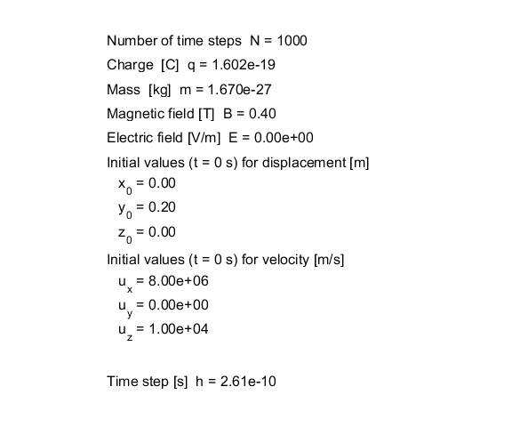

Fig. 1. Parameter summary for the circular motion of a proton in a uniform magnetic field.

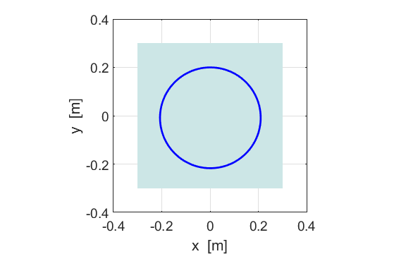

Fig. 2. The path of the proton in an XY plane. The shading shows the region of uniform magnetic field which is in the direction of the +Z axis.

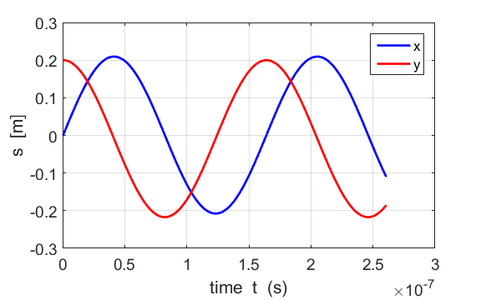

Fig. 3. Displacement vs time graph. The X and Y components of the displacement vary sinusoidally with time. The charged particle executes simple harmonic motion in the X and Y directions.

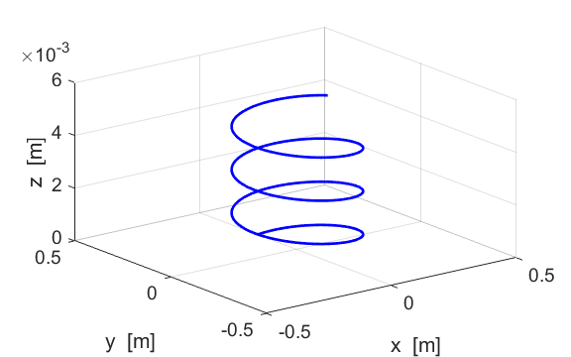

Fig. 4. The [3D] trajectory of the proton. The path of the proton is in the shape of a helix. The number of time steps was increased to *n*  = 2000 to show more rotations about the Z axis.

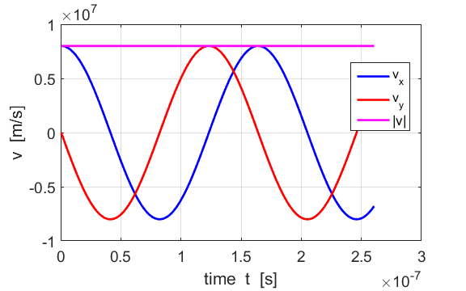

Fig. 5. Velocity vs time graph. The X and Y components of the velocity vary sinusoidally with time. The magnitude of the velocity |*v|* is constant. The magnetic force does zero work on the charged particle when it moves through the uniform **B** field.

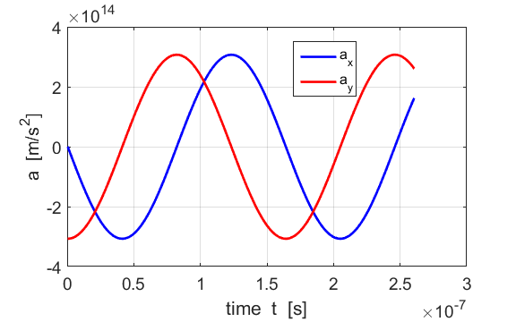

Fig. 6. Acceleration vs time graph. The X and Y components of the acceleration vary sinusoidally with time.

From figure (2) the radius in the X and Y directions and the period were measured using the Matlab Data Cursor tool.

The measures are

*Rx* = 0.2084 m *Ry* = 0.2085 m *T* = 1.64x10-7 s

The theoretical radius using equation (2) is

*R* = 0.2085 m

And from equation (3a), the period is

*T* = 1.64x10-7 s

The numerical model value for the radius and period are in excellent agreement with the theoretical predictions.

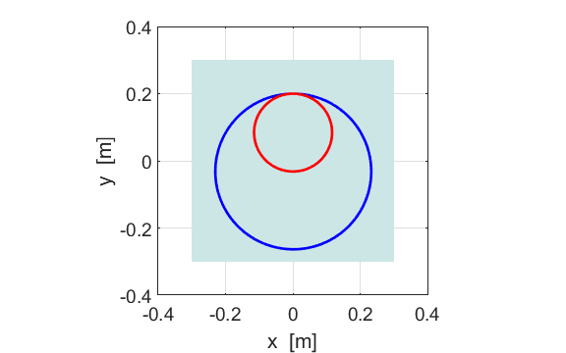

Fig. 7. Paths of the proton in an XY plane.

Blue curve *B* = 0.36 T Red curve *B* = 0.72 T

The larger the **B** field, the greater the strength of the magnetic force acting on the charged particle, hence, the smaller the radius of the circular orbit.

**Magnetic deflection**

Magnetic fields are commonly used to control the path of charged particles. Figure 8 shows the parameterFigure 8 show the trajectories of a proton launched with initial speed *ux* = 8.0x106 m.s-1 and *uy* = 0 m.s-1 into uniform magnetic fields of various strengths. When *B* > 0 the **B** field is in the +Z direction (out of page) and *B* < 0 the **B** field is in the –Z direction (into page). The deflection of the particle is given by the right hand rule. The greater the strength of the magnetic field, then the greater the deflection of the charged particle as it traverses the magnetic field.

To obtain the multiple plots in a Matlab Figure Window, the statements in the mscript **em_vBE_01.m** that closes all Matlab Figure Windows and the shading of the field region

close all

h_rect = rectangle('Position',[xFMin, yFMin 2*xFMax 2*yFMax]);

col = [0.8 0.9 0.9];

set(h_rect,'FaceColor',col,'EdgeColor',col);

are set as comments when the mscript is executed for the different values of the **B** field. When you have finished, then the statements should be uncommented.

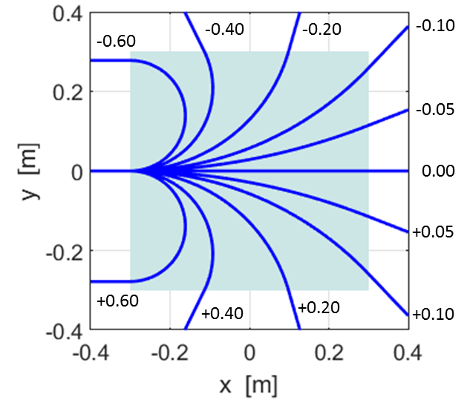

Fig. 8. The trajectories of a proton traversing a uniform magnetic field of different strengths. The numbers give the magnetic field strengths [T].

We will consider in more detail one of the trajectories shown in figure 8. Figure 9 gives the parameters for the deflection of a proton launched into a region of uniform magnetic field.

Figure 10 shows the trajectory and figure 11 the X and Y components of the displacement. The particle travels in a straight line when *B* = 0 and is deflected by the magnetic field when *B*  0 which tends to cause the charged to move in a circular orbit.

Figures 12 and 13 show the velocity and acceleration graphs. In the zero field zero the acceleration of the particle is zero and the particle moves with a constant velocity.

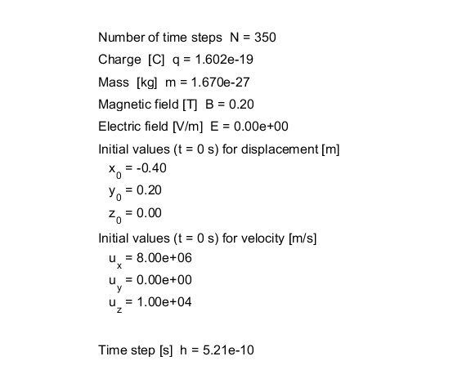

Fig. 9. Matlab Figure Window giving the parameters used for the simulation of the deflection of a proton.

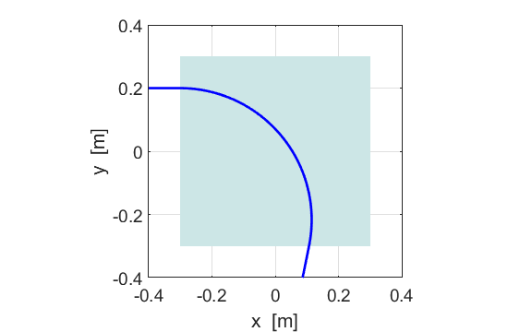

Fig. 10. Trajectory of the proton.

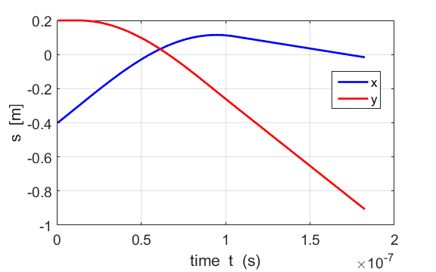Fig. 11. Displacement vs time graph for the motion of the proton.

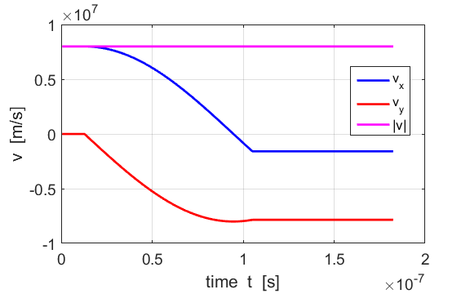Fig. 12. Velocity vs time graph for the motion of the proton.

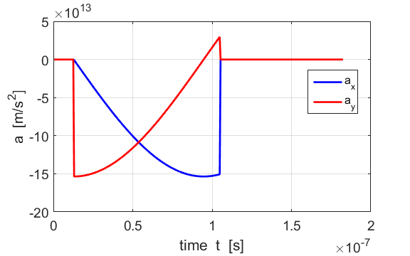 Fig. 13. Acceleration vs time graph for the motion of the charged particle.

**Electric field deflection**

A positively charge particle in an electric field will an electrical force acting in the same direction as the electric field. Therefore, a positively charged particle entering an electric field will be accelerated in the direction of the electric field. We will consider the simulation of a proton initially travelling in the +X direction that enters a uniform electric field which his directed in the +Y direction. Figure 14 shows the parameters used in the simulation.

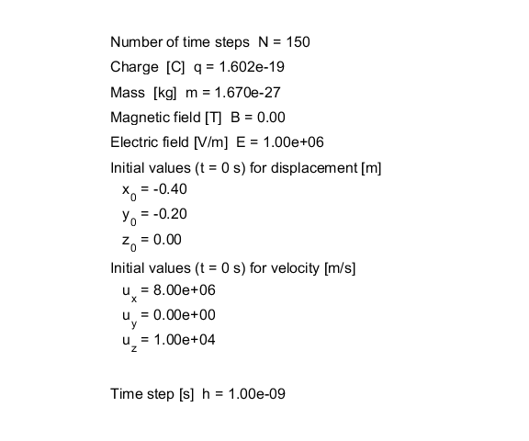

Fig. 14. Parameters for the simulation of a proton entering a uniform electric field which is directed in the +Y direction.

Figure 15 shows the trajectory of the positively charged particle. Figures 16, 17 and 18 show the displacement, velocity and acceleration vs time graphs for the motion respectively. The acceleration of the particle is constant in the non-zero electric field region. The motion of the charged particle is similar to a projectile in a gravitational field.

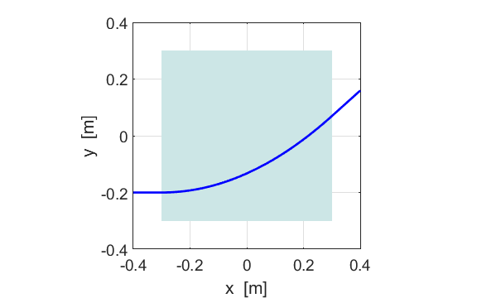

Fig. 15. Trajectory of the positively charged particle in the electric field.

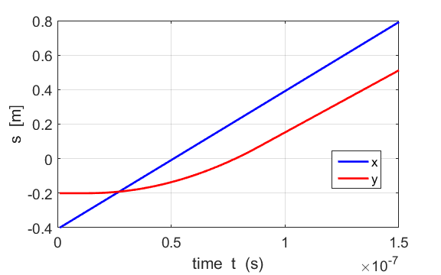

Fig. 16. Displacement vs time graph for the motion of the proton.

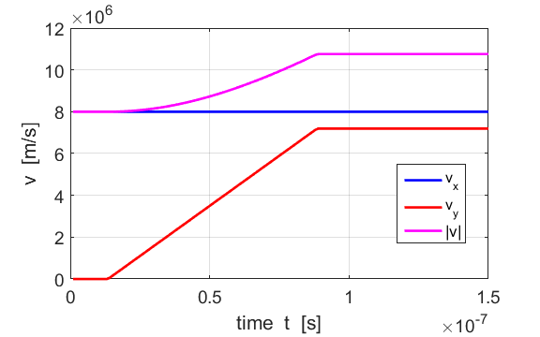

Fig. 17. Velocity vs time graph for the motion of the proton.

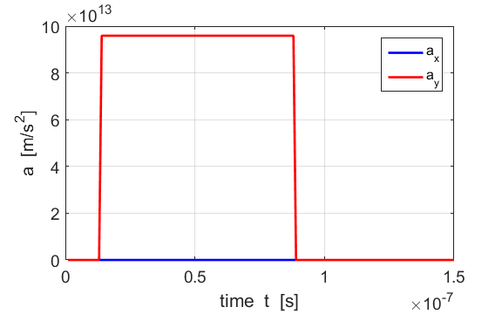

Fig. 18. Acceleration vs time graph for the motion of the charged.

**Motion in uniform crossed magnetic and electric fields**

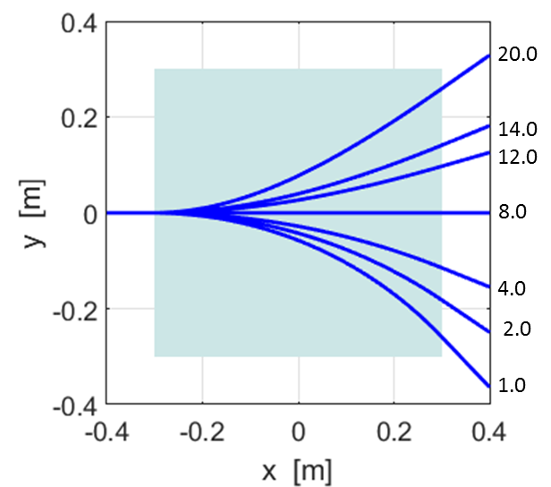

Fig. 19. The trajectories of the proton in a uniform magnetic field *B* = 0.2 T and varying electric field strengths. The numbers give the strength of the electric field [x105 V.m-1]. *ux* = 8.0x106 m.s-1.

When the magnetic force balances the electric force, the charged particle moves with constant velocity

Magnetic force = electric force



The theoretical prediction agrees with the result of the numerical simulation.

Figure 20 shows the parameters used for a simulation with cross magnetic and electric fields.

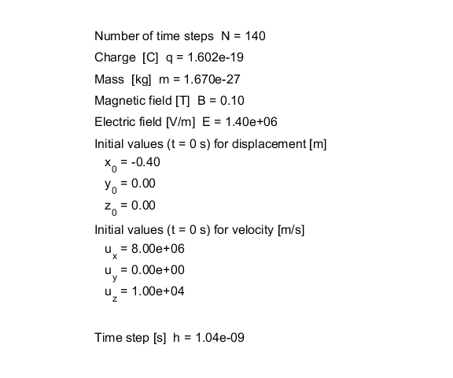

Fig. 20. Parameters for the simulation of a proton entering a region of uniform magnetic field in the +Z direction and a uniform electric field which is directed in the +Y direction.

Figure 21 shows the trajectory of the positively charged particle. Figures 22, 23 and 24 shows the displacement, velocity and acceleration vs time graphs for the motion respectively.

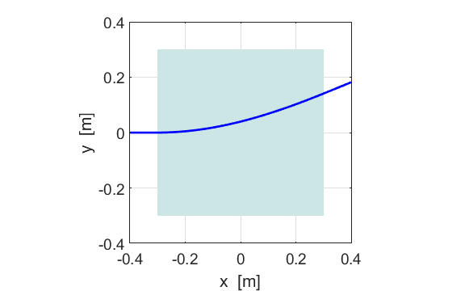

Fig. 21. Trajectory of the positively charged particle in the electric field.

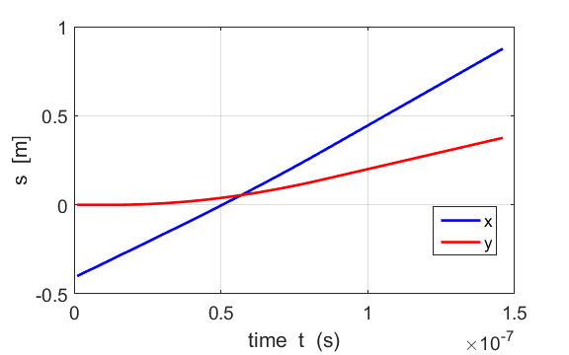

Fig. 22. Displacement vs time graph for the motion of the proton.

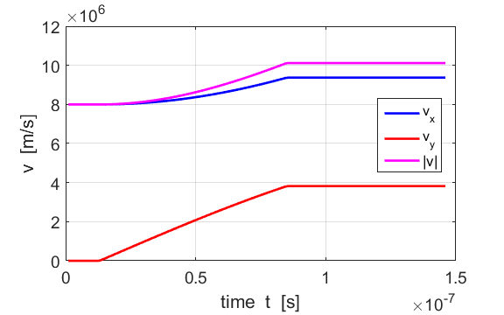

Fig. 23 Velocity vs time graph for the motion of the proton.

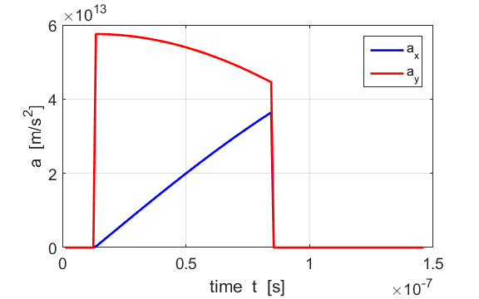

Fig. 24. Acceleration vs time graph for the motion of the charged.

**Cycloid Motion**

Consider the motion of a charged particle in uniform magnetic and electric fields. The magnetic field is directed in the +Z direction and the electric field is in the +Y direction.

When a positively charged particle enters the electromagnetic field region so that it is travelling in an XY plane, the electric field accelerates the charge particle resulting in an increase in the Y component of the velocity *vy.* Since the positive charged particle is moving in an XY plane, the magnetic field exerts a force on the positive charge and the faster the charge is moving, the greater the magnetic force. The direction of the force causes the charged particle to be deflected back around towards the Y axis. When the positive particle moves against the electric force it starts slowing down. As the velocity magnitude in the XY plane decreases, magnetic force decreases and the electric force takes over until the charged particle’s Y component of velocity comes zero, *vy* = 0. The positively charged particle is then accelerated again in the Y direction and the cycle is repeated, giving the **cycloid motion**. The period *T* for the cycloid motion is



Figure 25 is a Matlab Figure Window giving the parameters used for the simulation for the cycloid motion of a proton. Using the parameters given in figure 25, the theoretical value for the period is

*T* = 8.19x10-8 s

Figure 26 shows a plot of the trajectory of the proton undergoing cycloid motion. The [3D] path of the proton is shown in figure 27 and the X and Y components of the displacement is shown in figure 28. The velocity and acceleration time graphs are shown in figures 29 and 30.

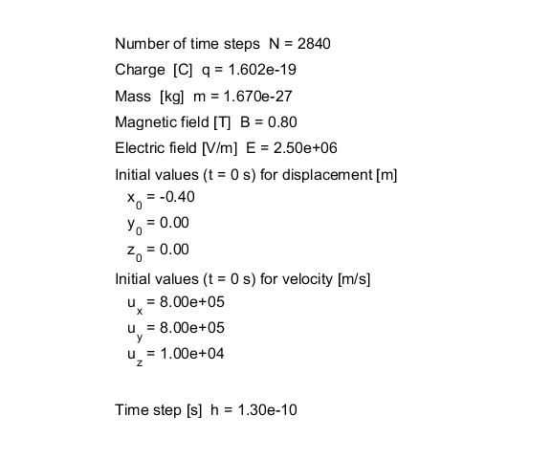

Fig. 25. Parameters for the simulation of a proton entering the uniform crossed magnetic and electric fields region. The magnetic field is directed in the +Z direction and the electric field in the +Y direction.

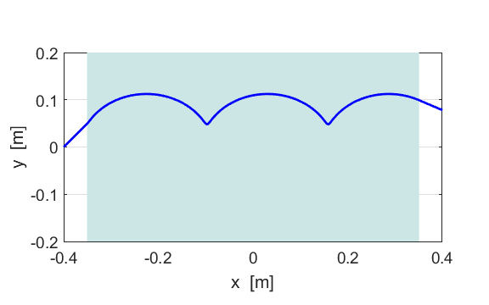

Fig. 26. Trajectory of the proton in the crossed magnetic and electric fields showing the cycloid motion.

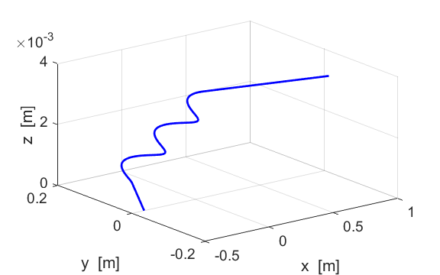

Fig. 27. [3D] path of the proton in the crossed B field and E field.

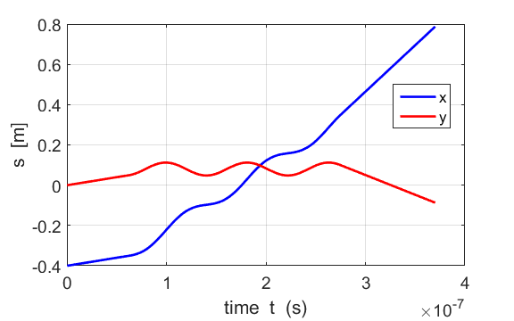

Fig. 28. The X and Y components of the displacement of the proton.

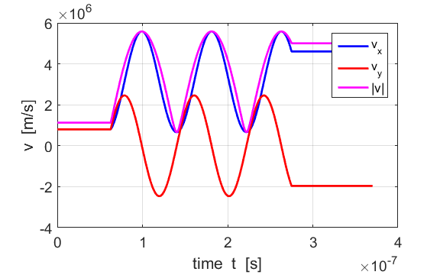

Fig. 29. The velocity vs time plots for the motion of the proton.

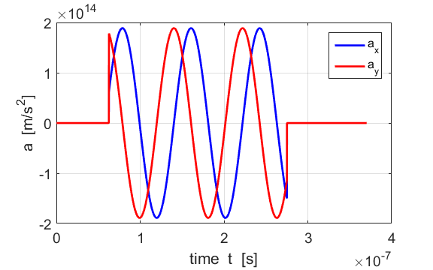

Fig. 30. The acceleration vs time plots for the motion of the proton.

The period of the cycloid motion can be measured using the Matlab Data Cursor tool using either the velocity or acceleration time graphs. The graphical measurement for the period is *T* = 8.19x10-8 s which is the same as the theoretical prediction.