[**DOING PHYSICS WITH MATLAB**](http://www.physics.usyd.edu.au/teach_res/mp/home.htm)

**INVESTIGATING ELECTROMAGNETISM USING THE FDTD METHOD**

**One-dimensional propagation of electromagnetic waves**

Ian Cooper

School of Physics, University of Sydney

ian.cooper@sydney.edu.au

[**Directory containing the Matlab m-scripts and files**](http://www.physics.usyd.edu.au/teach_res/mp/mscripts/)**:**

empulse01a.m empulse01a_ag.m ag_empulse01a.gif

The Finite-Difference Time-Domain method (FDTD) is one of the most popular techniques used in solving problems in electromagnetism because it is very easy to write the computer code even for three-dimensional problems. The method was first proposed by K. Yee in the early 1970s. In this document, solutions to Maxwell’s equation will be given for the one-dimensional propagation of electromagnetic waves generated from a point source.

**MAXWELL’S EQUATIONS and the FDTD Method**

The theory on which the FDTD is simple. To solve problems in electromagnetism, you simply discretise in both space and time the Maxwell’s curl equations with a central difference approximation.

Maxwell’s equations predict the existence of electromagnetic waves that propagate through free space at the speed of light *c*0. The electric field and the magnetic field are time dependent and influence each other - a time varying magnetic field induces a time varying electric field and the time varying electric field induces a time varying magnetic field and the process just continues.

The time-dependent Maxwell’s curl equations in a non-magnetic lossy dielectric material with a dielectric constant  and the losses determined by the medium’s conductivity *σ* are

(1a)  (1b) 

where the current density  is



For the one-dimensional case where a plane electromagnetic wave propagates in the z direction due to a time varying electric field component *Ex* and a magnetic field component *Hy*, Maxwell’s curl equations reduce to

(2a)  (2b) 

This mode of propagation is called a **TEM wave** (electric field polarized in x direction with *Ez* =0 and *Hz* = 0).

The values of  and  differ by several orders of magnitude and hence *Ex* and *Hy* will also differ by several orders of magnitude when *Ex* and *Hy* are measured in S.I. units. This problem can be overcome by making a change of variable where *E* is replaced by a scaled value *Es* for the electric field

(3) 

which gives

(4a)  (4b) 

We can approximate both the spatial and temporal partial derivatives using the **central difference method**

(5a)



To find the latest value for the electric field, equation 5a is rearranged to give

(5b) 

and equation (4b) becomes

(5c) 

We can simulate an electromagnetic propagating from one medium to another by making both the relative dielectric and conductivity functions of z. To simply the coding, we can define a series of functions which maybe also dependent upon the position z.

(6a)  (6b)  (6c) 

(6d)  (6e) 

For stability of the iterative method is often given by the **Courant Condition**

(7) 

where *D* is the dimension of the simulation and we will take the equality sign for the stability condition. Thus, a given cell size or grid spacing Δ*z* determines the time step Δ*t* in a simulation

(8) 

The default value used in the simulation is ***D* = 4**giving

(9) 

Substituting equations 6 into equations 5b and 5c gives

(10a) 

(10b) 

Equations 10a and 10d are interleaved, the new value of *Esx* at position *z* is calculated from the previous value of *Esx* at position z and the most recent pair values of *Hy* at *z*-Δz/2 and z+Δz/2. *Hy* is calculated at z+Δz/2 from its previous value at z+Δz/2 and the most recent values of *Ex* at z and z+Δz. This **interleaving** is at the heart of the FDTD method, that is, the equations are solved in a **leap-frog** manner where the electric field is solved at a given instant in time, then the magnetic field is solved at the next instant in time, and the process is repeated over and over again.

To write the m-script to solve iteratively equations 10a and 10b we need to assign indices for time ct and position cz, where ct = 1, 2, 3, … , nt and cz = 1, 2, 3, … , nz :

For the electric field *Ex*

Time: 

Position: 

For the magnetic field *Hy*

Time: 

Position: 

Equations 10a and 10b can now be expressed in a format that is now straight forward to write the computer code

(11a) 

(11b) 

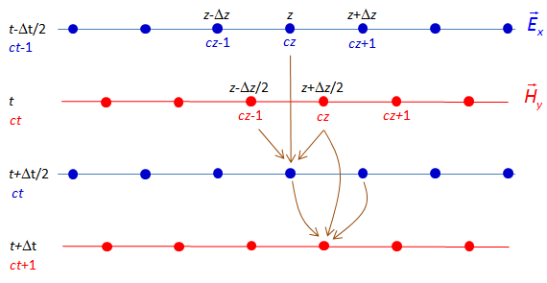

Fig. 1. Interleaving of the *E* and *H* fields in space and time in the FDTD method.

**POINT SOURCES**

**Gaussian pulse**

A Gaussian pulse in the electric field at a grid point produces an electromagnetic wave pulse that propagates away in both directions from the fixed source point.

The values of *Esx* and *Hy* are calculated by separate loops due to the interleaving of the *Esx* and *Hy* values. After *Esx* has been calculated, the *Esx* value at the source point is over-written by the value calculated from the Gaussian source function when its value is greater than some threshold value. This is referred to as a **hard source** because a specific value is imposed on *Esx* on the FDTD grid.

The Gaussian pulse is given by equation 12

(12) 

where zS is the index specifying the location of the point source, *A* is the maximum height of the pulse, *t*0 determines the time step index for the peak value of the pulse, *s* is the spread of the pulse and ct is the index for the time step.

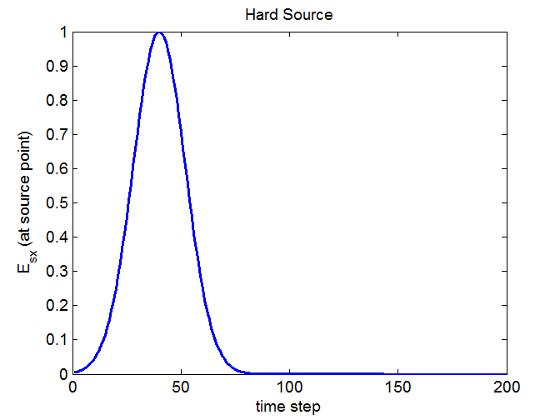

Fig. 2. Hard source: Gaussian time variation in *Esx* at source point.

(*A* = 1, *s* = 12, *t*0 = 40).

Modulated Gaussian Pulse

**BOUNDARY CONDITIONS**

A fundamental assumption in the FDTD method is that in calculation the *E* and *H* fields, we need to know the surrounding *H* and *E* field values, but at the edges of the z space we do not have values for *E* and *H*. Normally, the initial values at the boundary for *E* and *H* are set to zero. This means that when a pulse arrives at the ends of the z space, the boundary conditions are imposed on the solution resulting in reflection of both the electric and magnetic fields.

We can solve this problem by assuming that there are no sources outside the z space and that the wave propagates outward across the boundary. From the stability condition given by equation 9 with *D* = 4

(9) 

it takes two time steps for the wave to propagate that from one grid position to the next. Hence, to apply absorbing boundary conditions at the ends of the z space, the values of the fields at the boundaries of the z space are set to the values of the adjacent z position two time steps earlier. In terms of the space cz and time ct indices, the boundary conditions are:

(13) 

These boundary conditions are easy to code, we need to simply store the values for the fields adjacent to the end points of the z space for the previous two time steps.

**MATLAB**

The Matlab m-script **empulse99.m** can be used for many different types of simulations showing the one dimensional propagation of an electromagnetic wave produced by a point source Gaussian pulse. You should run the m-script **empulse99.m** using the default values and view the code making sure you understand what the program does. Then you can change the values in the INPUT section of the m-script to run different simulations.

The **INPUT** section of the m-script is used to specify:

* The type of simulation - free space propagation, propagation through single lossy dielectric medium or free space to a lossy dielectric medium.
* The boundary conditions (reflection or absorption) and the boundary position between mediums 1 and 2.
* Saving or not saving a file for the animated gifs.
* Parameters - z space (nz, zmin, zmax); number of time steps (nt); medium: relative dielectric constant (epsR) and conductivity (sigma).
* Parameters and position for the Gaussian pulse.

The follow examples are simulations produced by running the m-script **empulse99.m**.

A point source is simulated by a Gaussian variation in the electric field at one point in z space. The change in electric field produces a change in the magnetic field and the change in magnetic field produces a change in the electric field. Thus the pulse moves away in both directions from the source point until it reaches the boundaries where the pulse maybe reflected or absorbed.

**Example 1. Propagation of a pulse in a single medium**

The point source is located at the centre of the z space and the pulse propagates through free space towards the boundaries.

|  |
| --- |
| % INPUTS ===============================================================    nz = 400; % number of grid points for z space (default 400)  nt = 800; % number of time steps (default 800);    D = 4; % stability dimension (default D = 4)  epsR = 1; % relative permittivity of medium (default 1);  sigma = 0; % conductivity of medium (default 0);  cM = 200; % index for boundary between medium 1 and 2 (default 1);    zmin = 0; % min value for z space;  zmax = 200; % max value for z space    % Gaussian point source  zS = round(200); % z position of point source (default round(nz/2)  s = 12; % width of pulse  A = 1; % pulse height  to = 40; % time step for pulse to switch on  threshold = A / 100; % pulse off if pulse height < threshold |

[VIEW](http://www.physics.usyd.edu.au/teach_res/mp/mscripts/ag_empulse99.m) **Animation of the pulse through free space**

The FTFD simulation of the electromagnetic pulse propagating way from the source point after 100 and 200 time steps is shown in figure 3.

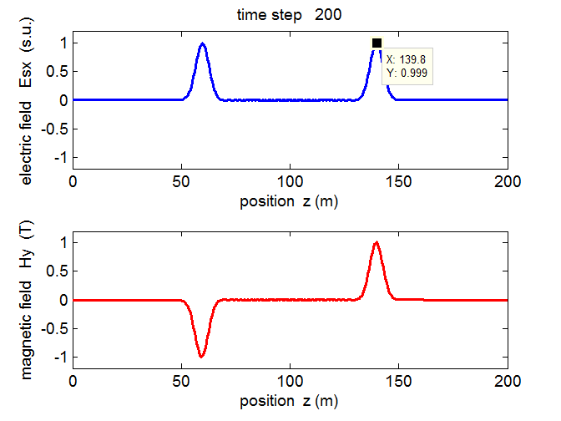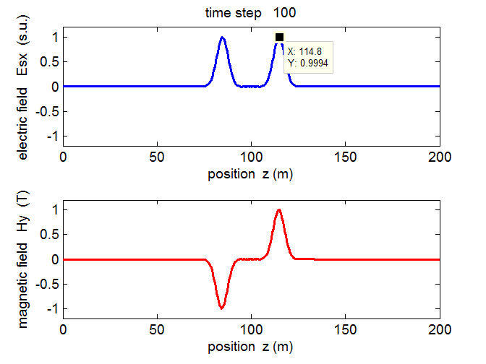

Fig. 3. Free space propagation of the pulse after 100 and 200 time steps.

***How good is the simulation?***

Theory : free space speed of light 

Simulation (pulse after 100 and 200 time steps):

Grid spacing Δz = 0.5013 m

Time step interval (equation 9) Δt = 8.3580x10-10 s.

Time interval for 100 time steps is dt = 8.3580x10-8 s

Pulse moves from *z* = 114.8 m to position *z* = 139.8 m (figure 3)

Displacement of the peak is dz = (139.8 – 114.8) m = 25.0 m

Speed of the pulse moving towards the right is

*v* = *dz*/*dt* = (25.0 / 8.3580x10-8) m.s-1 = 2.9911x108 m.s-1

Uncertainty in displacement of peak = Δz = 0.5 m

Uncertainty in speed = v (Δz/dz) = 6x106 m.s-1

Speed of the pulse moving towards the rights is v = (2.99 ± 0.06)x108 m.s-1

The theoretical free space speed of 2.9986x10-8 m.s-1 is within the range predicted by the simulation = (2.99 ± 0.06)x108 m.s-1.

From equations 2a and 2b it can be shown that in S.I. units

(14) 

and in terms of the scaled variables given by equation 3

(3) 

gives

(15) 

The simulation result for the ratio given by equation 15 is



and again the result is in excellent agreement with the theoretical value of 1.

The energy in an electromagnetic wave resides in the medium through which it propagates, even if that medium is free space. The flow of energy is measured by the pointing vector 

(16)  and for our one-dimensional example 

Therefore, for the pulse propagating to the right (+ z direction) both *Esx* and *Hy* are positive. For the pulse propagating to the left (-z direction) *Esx* and *Hy* must be of opposite signs and this is shown in figures 3 and 4 where *Esx* > 0 and *Hy* < 0.

The speed of propgation is a medium with dielectric constant *εr* is

(17) 

For a simulation with *εr* =4 gives *c* = c0/2. Figure 4 shows a pulse being generated at the junction between free space and the dielectric with *εr* = 4.

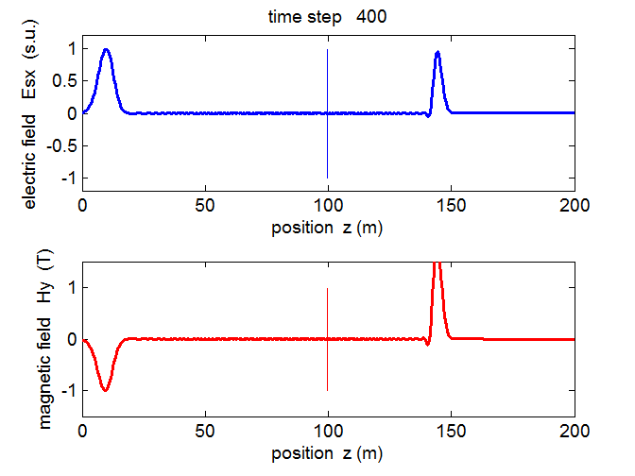

The pulse traveling to the left in free space moves a distance (90.5 ± 0.5) m while the pulse traveling to the right in the dielectric medium moves a distance (44.4 ± 0.5m).

The ratio of the speed in free space to the speed of propagation in the medium is

(17) 

which is in agreement with the theoretical prediction.

A pulse (variation in