# 

[**DOING PHYSICS WITH MATLAB**](http://www.physics.usyd.edu.au/teach_res/mp/mphome.htm)

[**http://www.physics.usyd.edu.au/teach_res/mp/mphome.htm**](http://www.physics.usyd.edu.au/teach_res/mp/mphome.htm)

**A VISUAL APPROACH TO UNDERSTANDING COMPLEX FUNCTIONS**

# 

John Sims

Biomedical Engineering Department

Federal University of ABC Sao Bernardo Campus Brazil

john.sims@ufabc.edu.br

Ian Cooper

School of Physics, University of Sydney

ian.cooper@sydney.edu.au

Complex numbers and the Fourier Transform

<http://www.physics.usyd.edu.au/teach_res/mp/doc/mathComplex4.htm>

Background notes on complex numbers

<http://www.physics.usyd.edu.au/teach_res/hsp/math/math.htm>

[**DOWNLOAD DIRECTORY FOR MATLAB SCRIPTS**](http://www.physics.usyd.edu.au/teach_res/mp/mscripts)

<http://www.physics.usyd.edu.au/teach_res/mp/mscripts>

**mathComplex2.m**

The script is used to visualize the nature of a time dependent complex function. The real, imaginary parts, magnitude and phase of the complex function are displayed in a variety of ways. It may take many seconds to update the screen for the plots.

**mathComplex3.m**

The script is used to visualize a complex-valued function of two variables.

**Colorcode.m**

Function to assign a color to a phase angle.

The application of visualization techniques is very rewarding as it allows us to depict phenomena that cannot be observed by other means.

***A picture is worth a thousand words***

Concepts presented in a visually appealing way are often easier to remember and lead to a deeper understanding. Also, visualisation may provide more motivation and trigger interest so that a better understanding of concepts may be evoked.

An excellent book which stresses the importance of visualization techniques is ***Visual Quantum Mechanics*** by Bernd Thaller. A quote from Thaller:

“Although nobody can tell how a quantum-mechanical particle looks like, we can nevertheless visualize the complex-function (wavefunction) that describes the state of the particle.”

A complex function can be written in several forms



**real** part 

**imaginary** part 

**absolute** value (**magnitude**) 

argument (**phase**) 

The **phase** of a complex number (function) is a very important physical quantity. Phase is a fundamental concept that pops-up in many branches of physics. The concept of phase is an abstract quantity and often is difficult to appreciate its meaning. For example, consider looking at a clock with a spinning second hand. At one instance, the second-hand points to the 1 am position and a little later it points to the 5 am position. Time represents a certain point on the circle.

We measure the angle from **3 o'clock** on the circle to the point considered, in an **anticlockwise** direction, and this is the **phase angle** (figure 1).

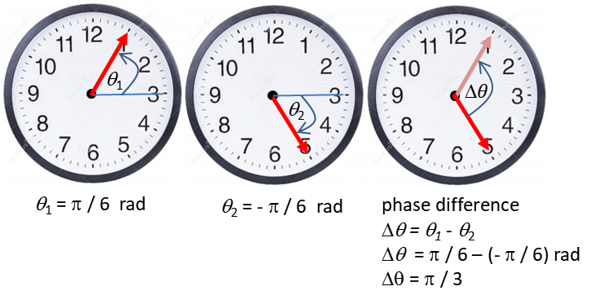

Fig. 1. The phase of the **red** second hand is measured as an angle in radians from the 3 am position in anticlockwise sense. If you rotate the second hand through any integer multiple of  in a clockwise or anticlockwise sense, the second hand will again point in the same direction (there is no change in phase). Generally, the phase is restricted to the range .

The phase of a complex quantity can be represented by a color as shown in figure 2.

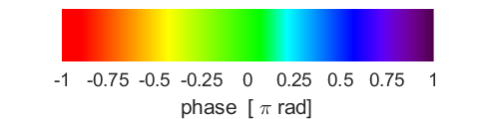

Fig. 2. Color can be assigned to give the phase of a complex number. **mathComplex2.m colorCode.m**

Using Matlab, we can produce a series of plots to illustrate the time evolution of a complex function in a very visual appealing manner.

**Example 1**  **mathComplex2.m**

Consider the periodic complex function



where *t* is time, *R* is the amplitude,  is the angular frequency, *f* is the frequency and *T* the period.



The plots shown in figures 1A to 1E are for a simulation with parameters:

T = 1 🡪  and 

R = 10

nT = 3 number of periods displayed.

Any of these parameters can be changed within the INPUT SECTION of the script **mathComplex2.m**. You can also add other functions within the script.

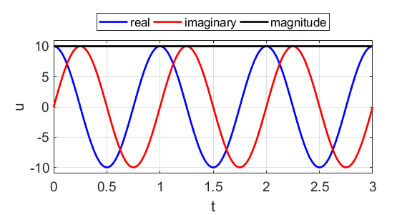

Fig. 1A. The time evolution of the **real**, **imaginary** parts of the complex function and its **absolute value**. The absolute value of the function is independent of time. Notice that the imaginary part of u is a **sinusoid** (**red**) and the real part a cosinusoid (**blue**).



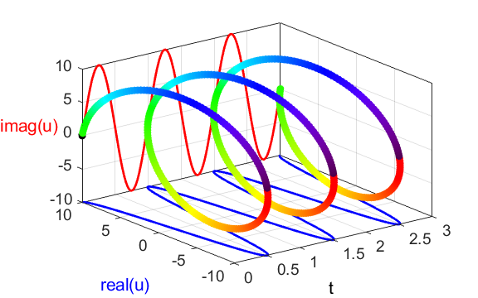



Fig. 1B. The time evolution of the **real**, **imaginary** parts of the complex function and its **absolute value** shown as a [3D] plot. The absolute value varies with time as a helical function in the [3D] space. The real(u) and imag(u) are off-set from the Origin (0, 0) for display purposes. We see that the helix touches the zero line of each axis whenever it is touches a maximum on the other axis. Imagine if the helix were a coil of wire. If we shone a light down from above, vertically above the wire, it would cast a shadow as shown by the blue cosine. Similarly, if we shone a light from right to left, the shadow cast by the coiled wire would cast a shadow as shown by the **red sinusoid**. Taking real and imaginary parts of the exponential function is therefore like finding its projections on the real and imaginary axes.



Another projection we can take is from the front. Imagine now shining the light along the length of the helix. The projection is a circle (figures 1C & 1D). The value of the exponential at any point along its length, projects onto a single point on that circle. as shown by the “head-on” view of the magnitude, real part and imaginary part of figure 1B.

Figure 1C (Figure 2 is the active Figure Window) can be displayed by typing into the Command Window:

view(-90,0)

axis square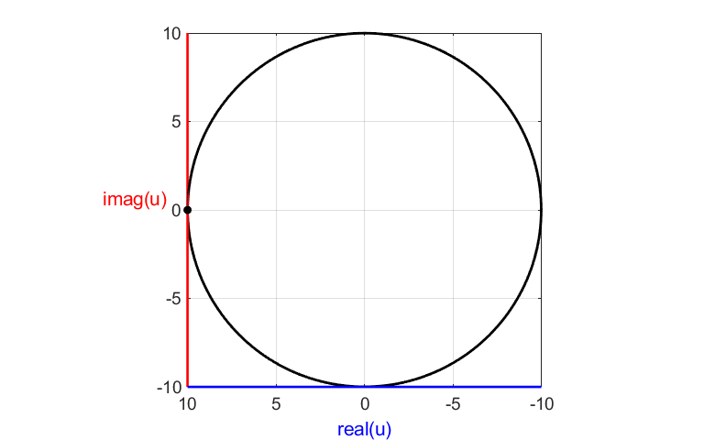

Fig. 1C. The **trajectory** of the magnitude of the complex function is a **circle** of radius 10. The trajectory can be shown as a black curve or a colored coded to show the phase of the complex number as a function of time (figure 1E). The real(u) and imag(u) are off-set from the Origin (0, 0).



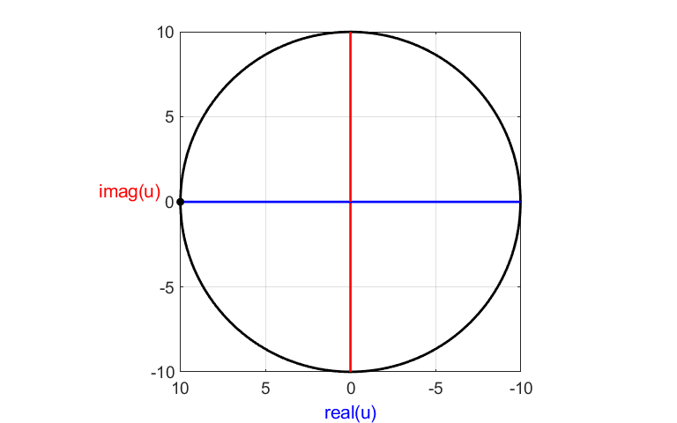

Fig. 1D. The **trajectory** of the magnitude of the complex function is a **circle** of radius 10. Zero off-set for real(u) and imag(u).



Figure 1E shows the phase of the complex function represented by color.



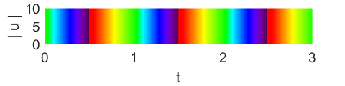

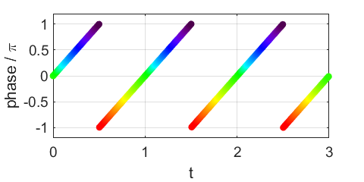

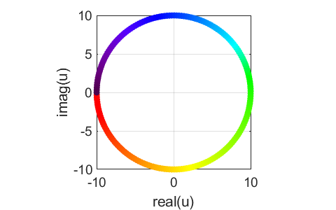

Fig. 1E. The color coding for the phase angle of the complex function and the **phase** as a function of time.



**Example 2**  **mathcomplex2.m**

We can now look at the visualization of a more complex function



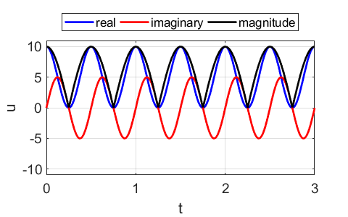

Fig. 2A. The real, imaginary parts and the magnitude of the complex function as a function of time.



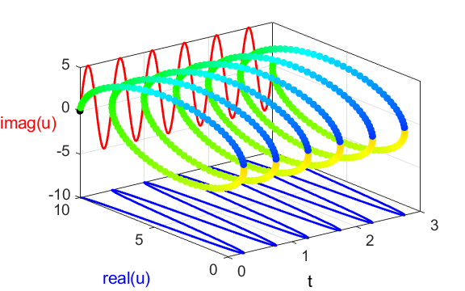

Fig. 2B. Real part, imaginary part and magnitude of the complex-valued function . The phase of the complex function is color coded.





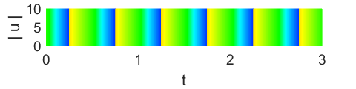

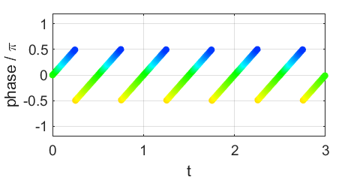

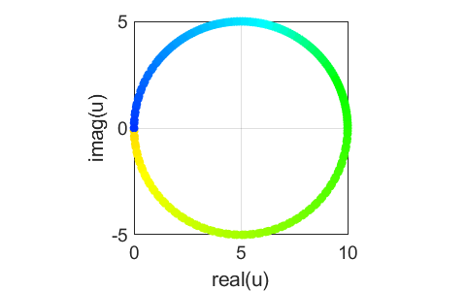

Fig. 4B. Phase of the complex-valued function

.

Notice the surprising results in comparing the plots in figures for Examples 1 and 2. The frequency of the compound function has doubled, the real part now oscillates between 0 and 10 (not between -5 and 5) and the centre of the phase plot is (5, 0) and not the Origin (0, 0) and the phase has doubled.

**Why? The following mathematics will explain.**



**Visualiztion of Complex-Valued Functions**

**mathComplex3.m**

The use of color is a very useful means for the qualitative visualization of a complex-valued function. For example, consider the complex-valued function of two variables *x* and *y*.



We can visualize the complex-valued function by surface plots of the real part, imaginary part, absolute value and phase. You can use the **Rotate [3D]** tool to view the surface plot from different aspects.

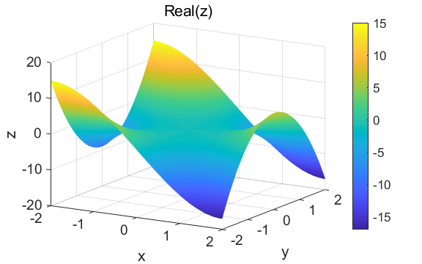

Fig. 3. Surf plot of the real part.

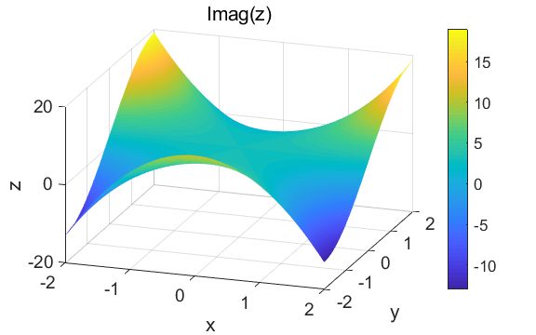

Fig. 4. Surf plot of the imaginary part.

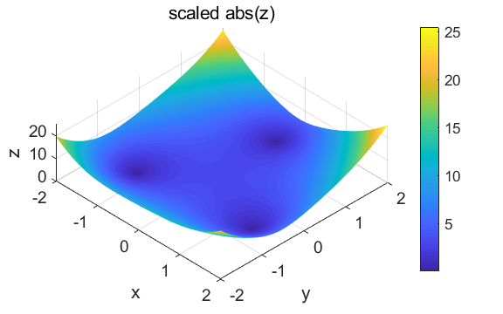

Fig. 5. Surf plot of the absolute value with scaling set to 1.

sF = 1; % scaling factor

xP = xx; yP = yy; zP = zzA.^sF;

surf(xP,yP,zP)

view(19,28)

shading interp

colorbar

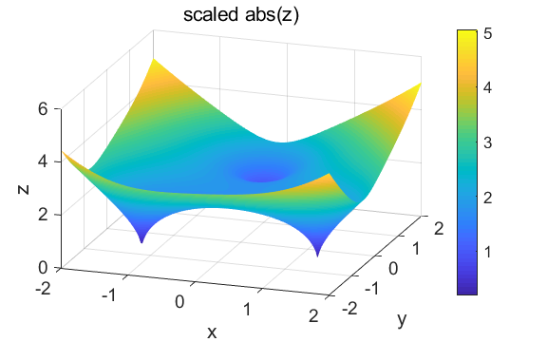

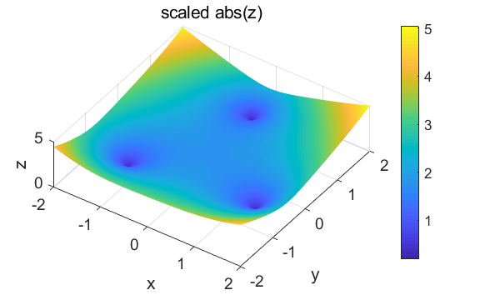

Fig. 6. Surf plots of the absolute value with scaling set to 0.5 for two different views using **Rotate [3D]**. You can see immediately using the **Rotate [3D]** tool the function has three zeros.

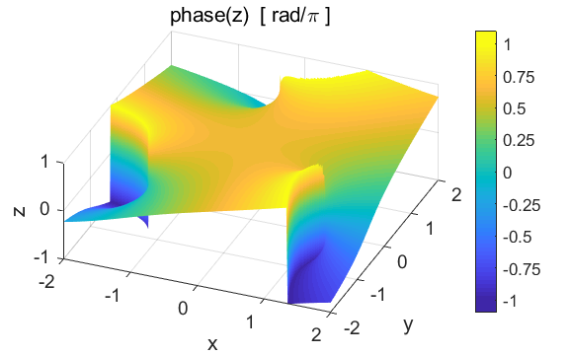

Fig.7. Surf plot of the phase (phase angle in radians / ).

A complex number *z* can be interpreted as a two-dimensional vector with components given by its real and imaginary parts. We can visualize the function by plotting a **vector field** (figure 8) as arrows using the **quiver** function. This method does not provide fine details of the function, but it does clearly show a unique relationship between the real and imaginary parts at each grid point

s = 20; % spacing of arrows

P1 = xx(1:s:N,1:s:N); P2 = yy(1:s:N,1:s:N);

P3 = zzR(1:s:N,1:s:N); P4 = zzI(1:s:N,1:s:N);

HH = quiver(P1,P2,P3,P4);

set(HH,'LineWidth',1,'MaxHeadSize',1,

… 'AutoScaleFactor',1.5)

set(gca,'xlim',[-2.5,2.5])

set(gca,'ylim',[-2.5,2.5])

axis square

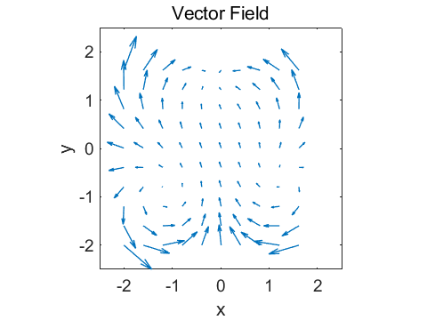

Fig.8. The function as a vector field .

We can also display the function as a contour plot as shown in figures 9 and 10. These figures clearly shows the three distinct zeros of the complex-valued function. By adding a circle to the plot, we see that the three zeros are located on a unit circle.

xP = xx; yP = yy; zP = zzA; v = 1:1:10;

contourf(xP,yP,zP,20,'ShowText','off');

% contourf(xP,yP,zP,v,'ShowText','on');

shading interp

colorbar

hold on

% plot unit circle with centre (0, 0)

t = linspace(0,2*pi,200); R = sqrt(2);

plot(R.*cos(t),R.*sin(t),'r','linewidth',2)

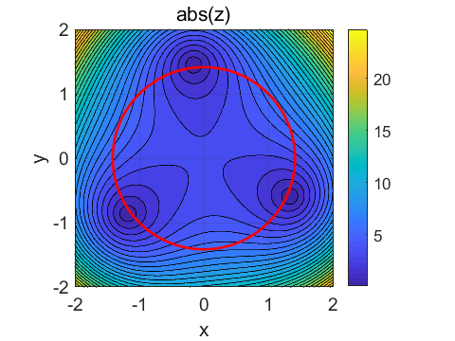

Fig. 9. Contourf plot of the complex function showing the three zeros located on a unit circle.

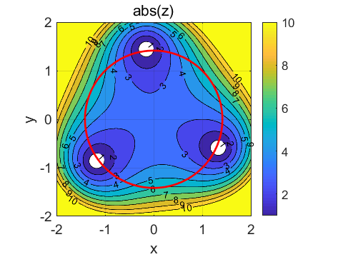

Fig. 10. Contourf plot of the complex function showing numerical values on the contours.