[**DOING PHYSICS WITH MATLAB**](http://www.physics.usyd.edu.au/teach_res/mp/mphome.htm)

**MATHEMATICAL ROUTINES**

# SOLVING QUADRATIC EQUATIONS

Ian Cooper

School of Physics, University of Sydney

ian.cooper@sydney.edu.au

[**DOWNLOAD DIRECTORY FOR MATLAB SCRIPTS**](http://www.physics.usyd.edu.au/teach_res/mp/mscripts)

**math_qe.m math_qe.m_cal.m**

mscripts used to solve Quadratic Equations using a GUI

**[sol_p sol_m] = eq_quadratic(a,b,c)**

Function for finding the roots of a quadratic equation

**THE QUADRATIC FUNCTION**

A **quadratic function** has the general form



and its graph is a **parabola**.

If there are real values for *x* for which



the curve will intersect the X-axis and the values of *x* are given by the formula

**roots** 

If  then there are no real roots or roots are imaginary numbers

If  then there is only one real root 

If then there are two real roots.

A Matlab graphical user interface (GUI) can be used to solve a quadratic equation. The values of *a*, *b* and *c* and the roots of the quadratic equation are displayed in a Figure Window.

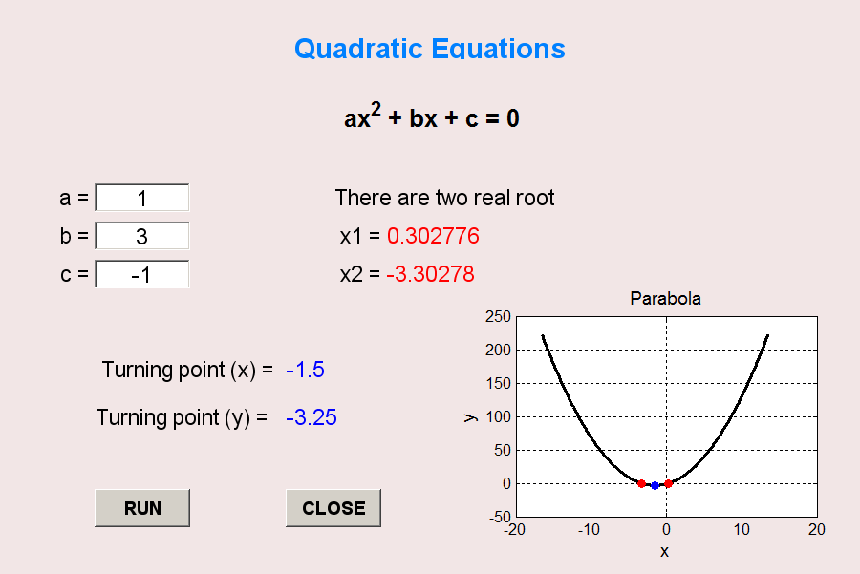

Figure Window created for the solving a quadratic equation using the mscripts **math_qe.m math_qe.m_cal.m**

The function **eq_quadratic(a,b,c)** can be used to find the roots of a quadratic equation from the Command Window or called within a mscript.

For example

[sol_p sol_m] = eq_quadratic(1,3,-1)

returns

sol_p = 0.3028 sol_m = -3.3028

The GUI is based upon the mscript written by A/Prof Hadi Khabbaz (University of Technology, Sydney)